17 January 2018
Our Ref: HP6935

Dear Parents/Guardians

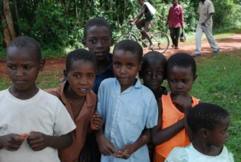
Derby County Community Trust (DCCT) work tirelessly to enhance the lives of people within the local Derbyshire community. Over the past 6 years DCCT and African Adventures have teamed up to support community projects in profoundly poor areas where families live off less than 75p a day. There are a number of volunteering roles working in three schools based in Nakuru, Kenya. The duration of the Kenya trip lasts for 13 nights from 19th May to the 4th June 2018.

The Children will have an assembly on Monday 22nd January explaining more about what the volunteering is about and why it is so important.

Mrs Tomordy, class teacher of the Terrific Tigers and Mrs Sandhu will be taking part on this volunteering programme to continue building a Kenya Link Project between Hardwick Primary School and St Trizah (school in Nakuru).

To take part on this trip requires raising as much money as possible. On Friday 26th January we will be holding a Kenya Link Project Day where children can come dressed in the colours of the Kenyan flag (red, green and black) in return for a £1 donation. We will also be selling biscuits during the school day at 20p each.

Thank you for your support.

Yours sincerely

Mrs R Sandhu
Head of School

