14 November 2017

Our Ref: HP6829

Dear Parents/Guardians
I would like to remind you that children should use their school book bags for transporting work to and from school and PE drawstring bags should be used for transporting PE Kit.

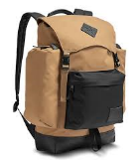
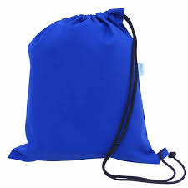

A number of children have been bringing in rucksacks; we cannot accommodate large bulky bags in the classrooms. Rucksacks are hung in the cloakrooms resulting in coats falling on the floor and personal belongings such as pencil cases being stolen from the rucksacks.
Book bags and drawstring PE bags are kept safely in storage boxes in the classrooms.
Book bags can be purchased from the School Office (£3.50). PE bags can be purchased from our School Uniform Suppliers: Unique Uniforms on Bateman Street (£3.50) or from Tesco online (tesco.com/ues).
Please ensure all items of school uniform are labelled clearly with your child’s name and class.
Thank you for your assistance in this matter.

Yours sincerely

Mrs R Sandhu
Head of School

