Derby City Schools Alliance

- Do you want to train for a career in teaching?
- Do you enjoy the diversity of City Life?
- Would you like to train with supportive, experienced and high quality practitioners?
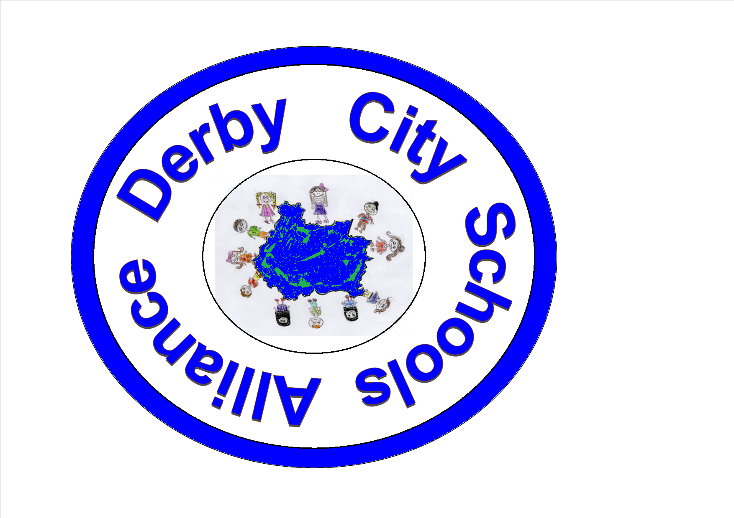
Then Derby City Schools Alliance is for you!
Beckett Primary School
Brookfield Primary School
Central Community Nursery School
Griffe Field Primary School
Hardwick Primary School
Mickleover Primary School
Ravensdale Junior School
Silverhill Primary School
Springfield Primary School
St Joseph’s Catholic Primary School
St Werburgh’s CoE (Aided) Primary

We are a group of 11 good and outstanding schools who have successfully trained teachers who have ALL gained employment. As an alliance we are small but offer big training in partnership with the University of Nottingham and Derby City Local Authority. Interested? Please contact:
Zoe Cannon on head@ravensdalej.derby.sch.uk

