27 February 2018

Our Ref: HP7034

Dear Parents/Guardians

Assessing writing at Hardwick Primary School

This year, we are assessing pupils’ writing in a new way called comparative judgement.

Twice a year, pupils will produce a piece of writing that will be assessed along with the work of other pupils nationally. This will allow us to give pupils a more accurate and reliable grade that shows how they are doing relative to other pupils across the country.

Teachers in our school and in other schools across the country will be responsible for doing the assessing. Pupils’ work will be fully anonymized before it is assessed.

At the end of the process, we will be able to share the results with you. This is a national process, but it is not a government assessment, so there are no formal consequences of the assessment. It is simply a chance for you to see how your child is doing compared to other pupils of the same age. We hope that over time it will give you and your child a way to chart the progress they make across primary as they develop as writers.

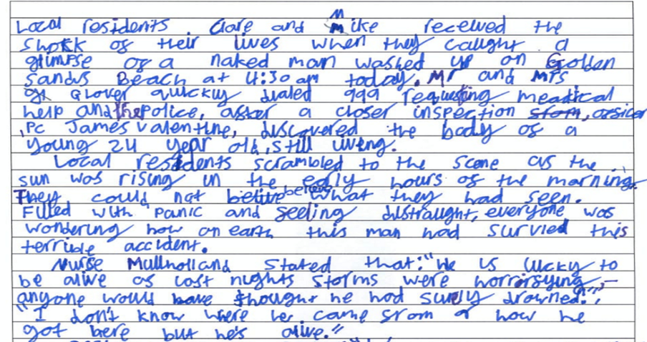
We will also be able to share examples of pupils’ writing with you from our schools and other schools, so you can see what is typical of pupils at different ages. For example, here is a piece of writing by an 11-year-old in year 6 which received an average score.

Continued overleaf…...
And here is a piece of writing by a 9-year-old in year 4 which received an average score.
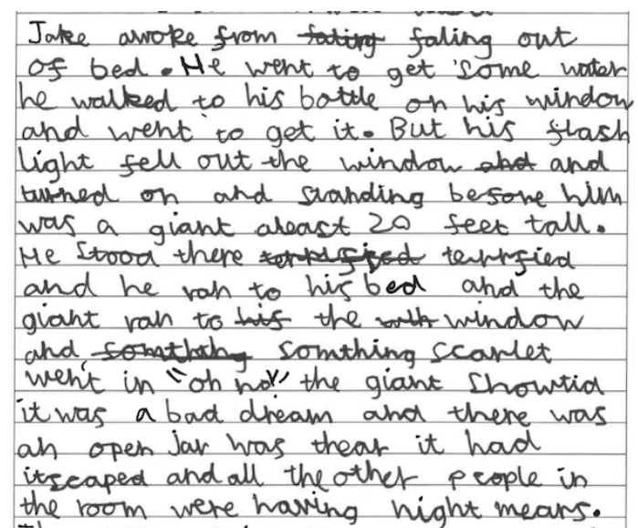

You can read more about this process, and see more examples of pupils’ work at this link here: https://s3-eu-west-1.amazonaws.com/images.nomoremarking.com/SharingStandards/overview.pdf

Different year groups will take part in the assessments at different times of year. Year 2 & Year 6 will only take part once a year, as they will do their writing SATs at the end of the year instead. Below you can see the schedule. We will share the results with you when they are available.

 | Year 1 | Year 2 | Year 3 | Year 4 | Year 5 | Year 6
Autumn Term 1 |  |  | Writing assessment
Autumn Term 2 |  |  |  |  | Writing assessment
Spring Term 1 | Writing assessment |  |  | Writing assessment
Spring Term 2 |  | Writing assessment |  |  |  | Writing assessment
Summer Term 1
Summer Term 2 | Writing assessment |  | Writing assessment | Writing assessment | Writing assessment

In order to facilitate the assessment we need to share some pupil information with No More Marking Ltd. The data we will share is:

Pupil Name,
Pupil Date of Birth,
Pupil Gender,
Pupil Teaching Group,
Pupil Premium Status.

You can read the privacy statement of No More Marking Ltd here: https://www.nomoremarking.com/privacy

Yours Sincerely

Mrs R Sandhu
Head of School

