6 November 2017

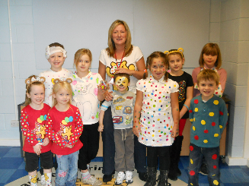
Our Ref: HP6694

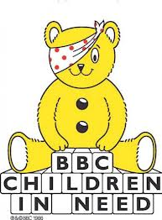

Dear Parents/Guardians

Children in Need – Friday 17th November 2017

In order to support Children in Need we will be holding a non-uniform day on Friday 17th November 2017. Children can come to school dressed up in “spotty” themed clothes for a small donation of £1.00.

Teachers will collect the money in their classrooms, but buckets will be available at the school gates for those parents who would like to throw in any extra coins.

Money raised helps to transform lives of children across the UK.

Thank you for your support.

Yours sincerely

Mrs R Sandhu
Head of School

