Year 2 Home Learning
Week Commencing: 8th June 2020
Year 2 teachers: Mrs Nicholson and Mrs Tomordy
Year 2 TAs: Mrs Rowland and Ms Shaista
Message from staff: Hello to you all. Hope you are all well and getting out for some exercise every day as this is just as important as the learning that is here. We have all been working hard as usual and looking forward to when you are able to come back into school. Mrs Tomordy has been going on lots of walks around Elvaston Castle and listening to a lot of different birds. Do you hear the birds when you go outside? She has also been doing lots of reading about new things to try in the classroom which hopefully we will be able to do soon. Have you read anything new or exciting this week?

Hope you enjoy and work hard at this week’s learning.

Your Home Learning this Week:
Every day (Monday to Friday), make sure you choose a *reading, *writing, *spelling/handwriting, *maths and *theme learning activity. There are also further activities to choose from should you wish to.

Reading Home Learning
Monday | Tuesday | Wednesday |  | Thursday | Friday
You will be reading a text about the sunflower life cycle. Make connections with what you already know about plants. How does a plant grow? Are there any interesting facts you know? Have you heard anything on the television or in books about sunflowers and their life cycle? Ask the people you live with if they know anything.  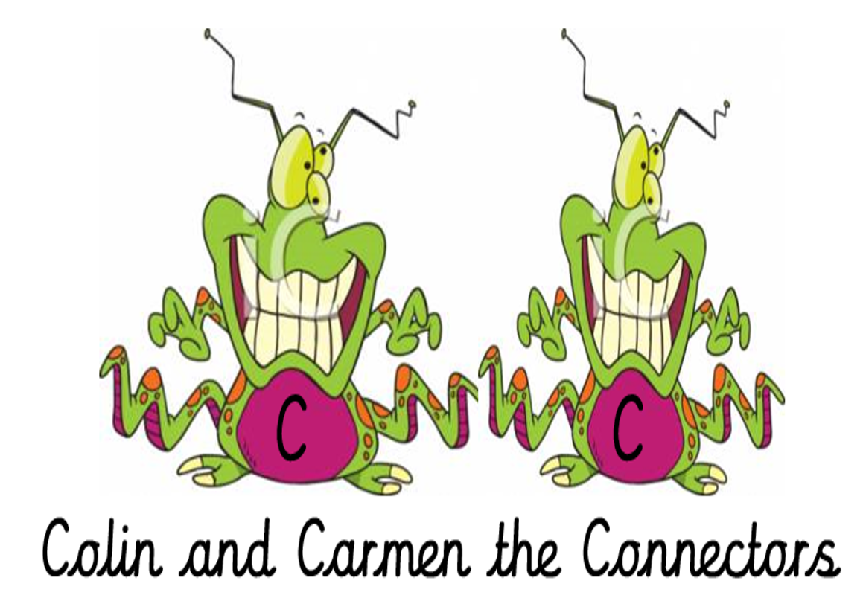 | Read ‘Sunflower Plant Life Cycle’, using reading skills to help you understand as you go through it. Highlight any words you do not understand and find the meaning of them.  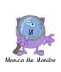 | Summarise what you have read in the text. A summary covers the very important parts of the text (VIP). Which parts in the text do you think are important?  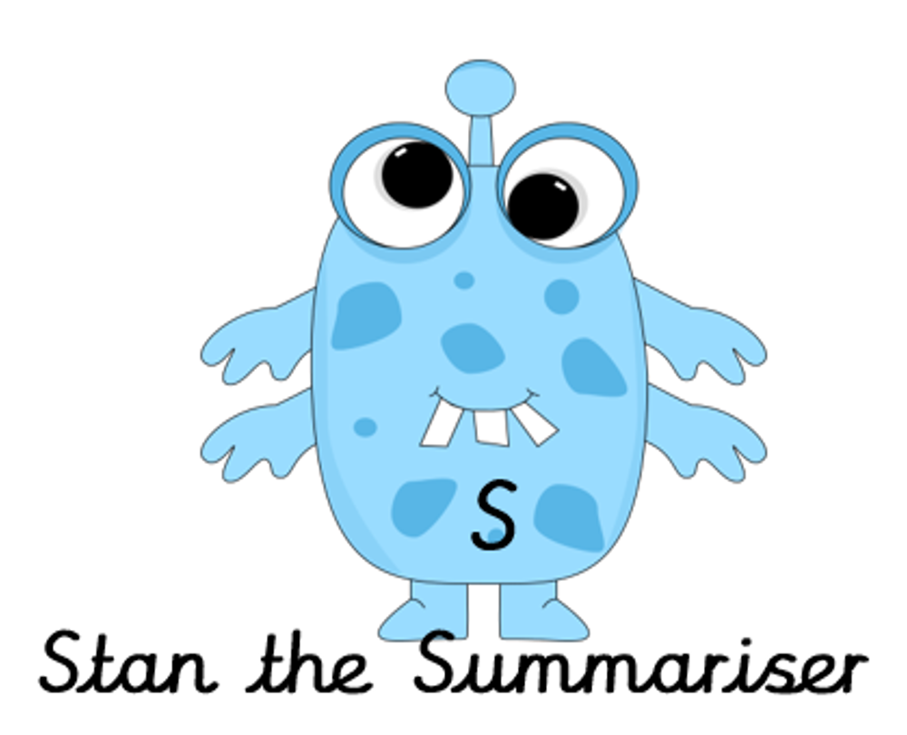 |  | Now try answering these questions:  - What are sunflowers?  - How many different types are there?  - Name a colour that sunflowers can be other than yellow.  - What is the seed planted in?  - When is the sunflower seed planted?  - What colour are the seeds?  - What grows underground?  - What does the plant grow towards? | After reading the text on ‘Sunflower Plant Life Cycle’, think of any questions you may have. Is there anything you were left wondering that was not answered? Write these questions down. Reread the text again and this time, try to answer the questions you have. Can you answer them? If not, try to research the answers or, save the questions for when we come back to school so you can research at school.  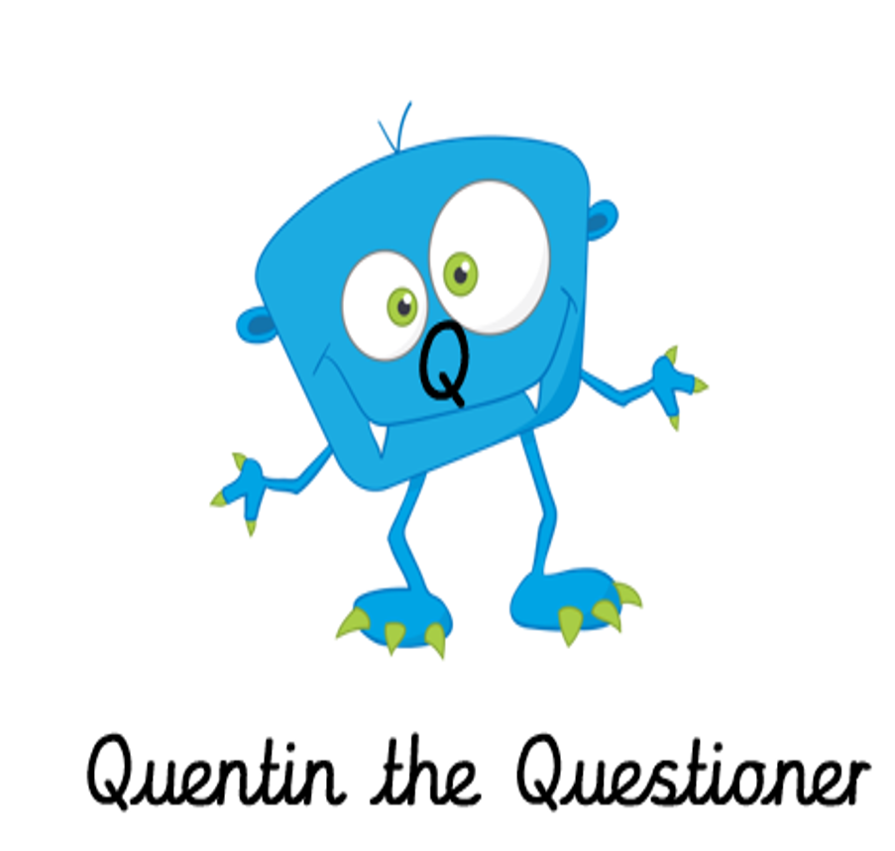
Easier:  Do as many of the above activities as you can. If you are finding some of the activities challenging, try these as they are a little easier:  - Read the text ‘Birds in your garden’, using reading skills to help you understand as you go through it. Highlight any words you do not understand and find the meaning of them.  - What type of text is this and how do you know? What do you notice about how it is set out? Have you seen anything like this before?  - Now try to answer these questions:  - What are the names of the birds in the text?  - What colour are robins?  - Which bird is noisy?  - Which bird lives in garden nesting boxes?  - Which bird eats other birds’ eggs?  - What do you think jackdaws might steal? |  |  | Challenge:  If you feel you need a further challenge, try these:  - Test yourself! On a blank piece of paper, write down everything you know about the sunflower plant life cycle.  - Using ‘Sunflower Plant Life Cycle’ text, create your own information sheet, adding any of your facts you know about it too.  - Predict which section you may find the following information in ‘Sunflower Plant Life Cycle’ text if it were to be written:  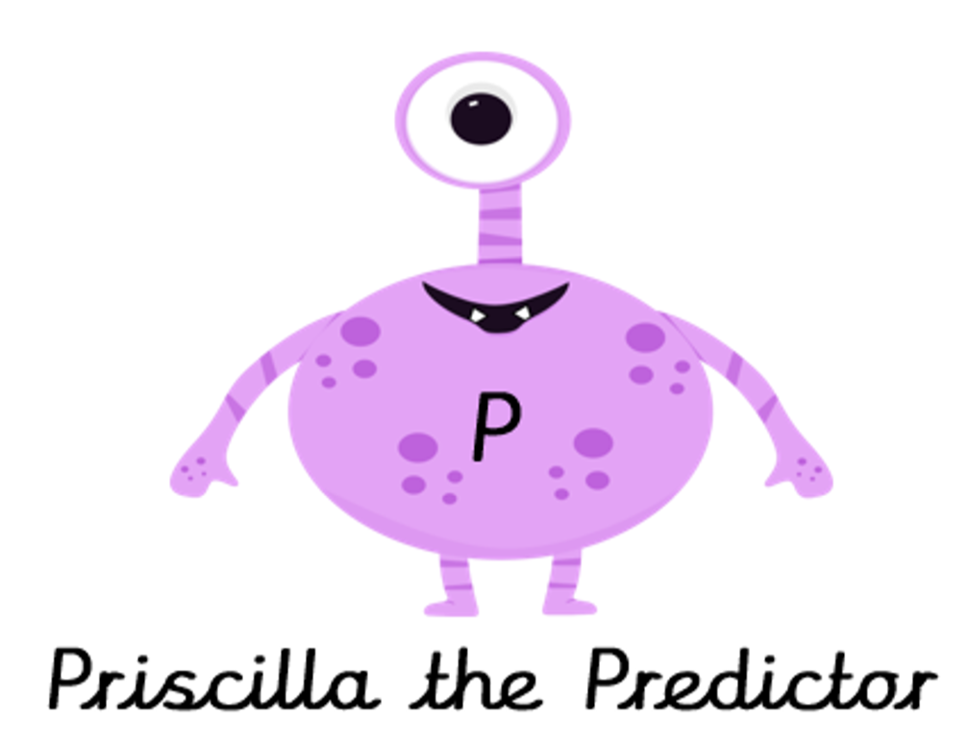  -Sunflowers can be used to make oil, food and dye.  -The plant starts to grow and a tiny root reaches into the soil.  -This stage is when you see the fully flowered, beautiful plant.

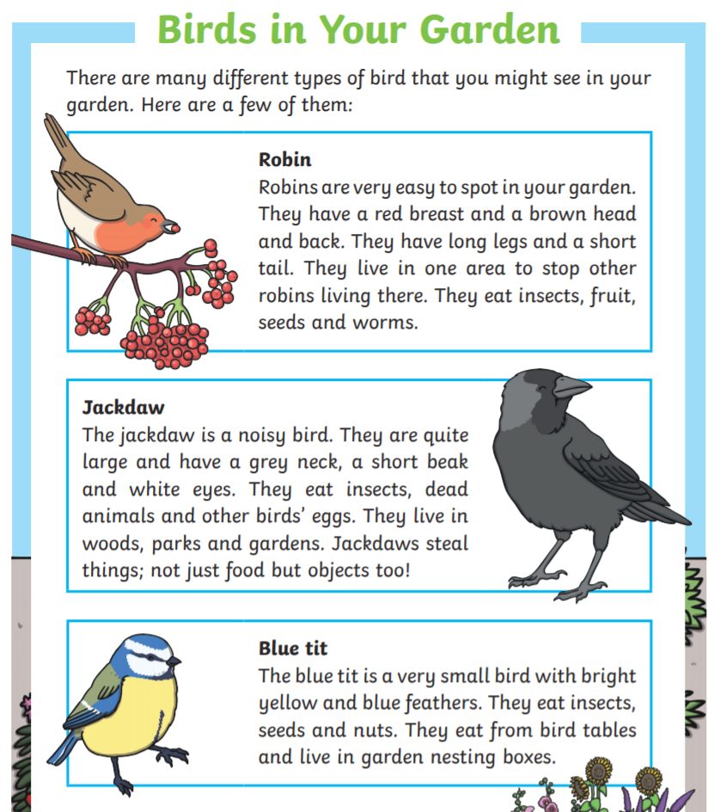
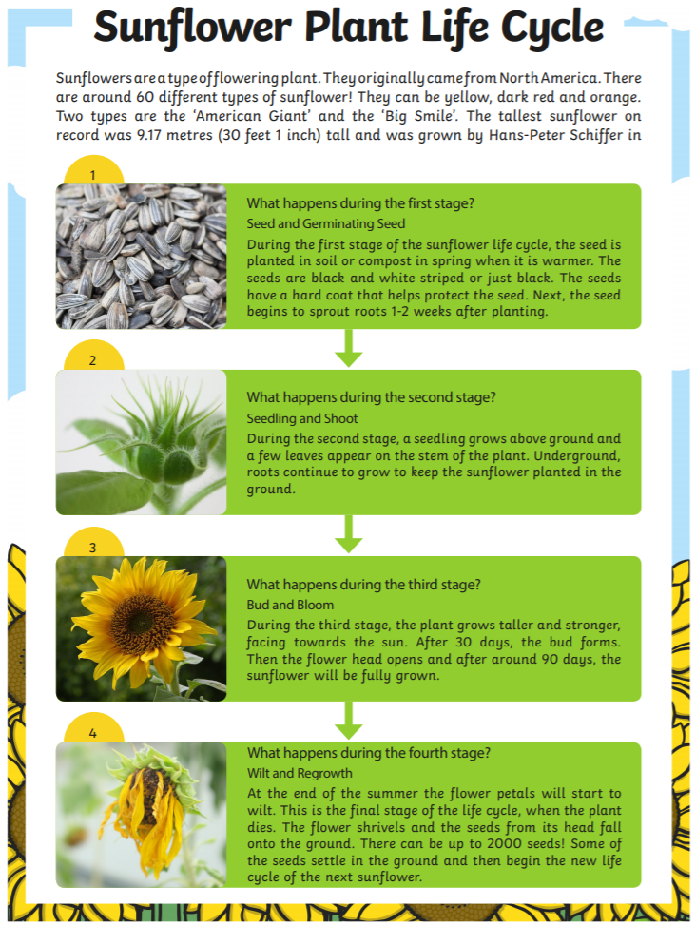

Writing Home Learning

Writing home learning
Monday | Tuesday | Wednesday |  | Thursday | Friday
Read the poem A Summer Garden. Read it to yourself and then read it out loud to someone else. Try to use the rhythm of the lines. | Find out the meaning of the words which are new to you.  Write the new words in a sentence. | Text map the poem to learn it off by heart. Draw a picture or symbol in place of words. |  | Recite the poem to someone using only your text map.  Now try to write it using only your text map.  Check your version with the original. | Write a new poem, using this pattern and different things you can see in a garden.  Draw an illustration for your poem.
Easier:  Do the above activities with the shorter poem.  - What else could you see in a garden? Try writing down their names using your sounds.  - Draw a picture for these words, and practise writing them:  hot  sun  buzz  bug  hop  frog  cat  sit  ant  run |  |  | Challenge:  If you feel you need a further challenge, try these:  Task 1  Write an acrostic poem, the first word of each line begins with a letter of a word:  S  U  M  M  E  R  Task 2  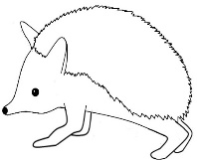  Draw the shape of an animal that lives in the garden. Write as many adjectives as you can to describe it, inside the shape.
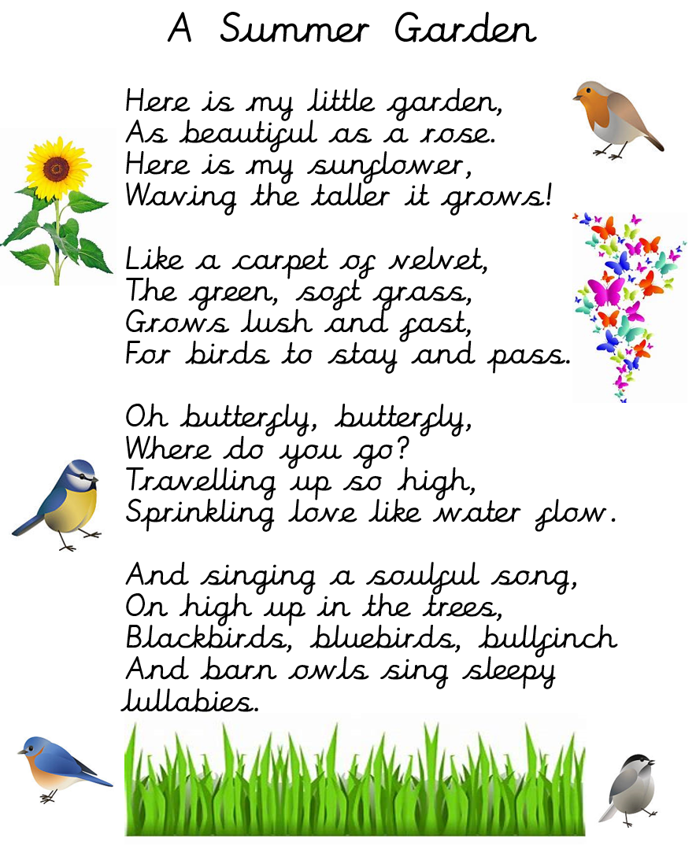
Spelling/Handwriting Home Learning
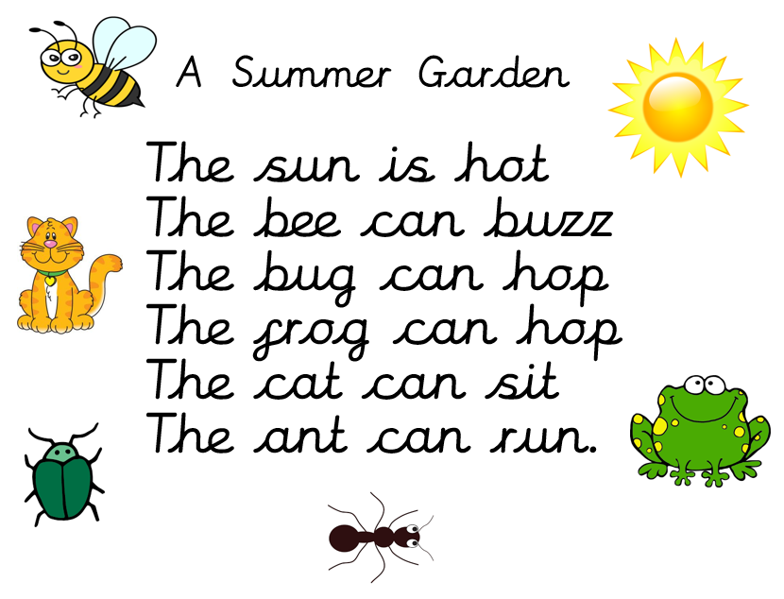

Spelling and handwriting practise
Monday | Tuesday | Wednesday |  | Thursday | Friday
This week we are going to practise the ‘ure’ phoneme as it is one we often forget how to write.  Try look, cover write then check ten times with the following words.  treasure  sure  pure  lure  manure  cure  insure  capture  mixture | Using yesterday’s words now have a go at rainbow writing them. | Today see if you can create a picture for each of the words on Monday to help you remember how to spell them. |  | Today is handwriting day and so find some lined paper and spell the words from Monday but make sure you concentrate on the joins and how the letters sit on the line. You do not have to join the r to the e. | Now you know how to spell all of these words see if you can create an exciting sentence with each of them. Try to include an adjective and conjunction in each sentence.
Easier:  Do as many of the above activities as you can. If you are finding some of the activities challenging, try these as they are a little easier:  - 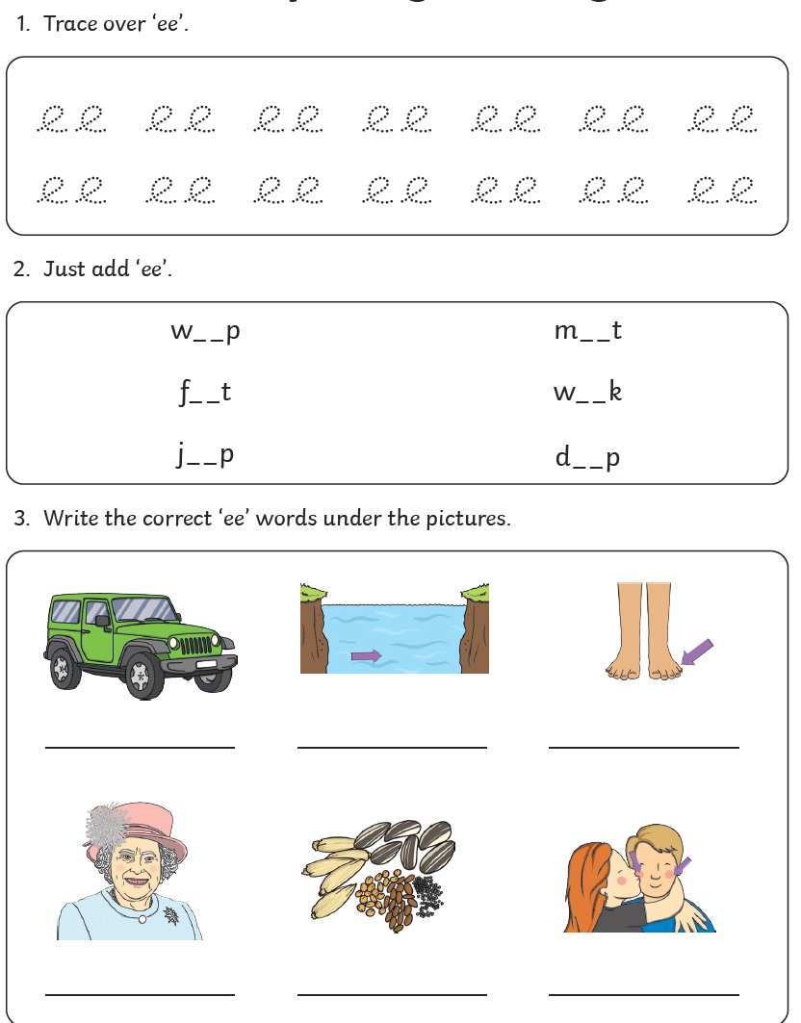  - 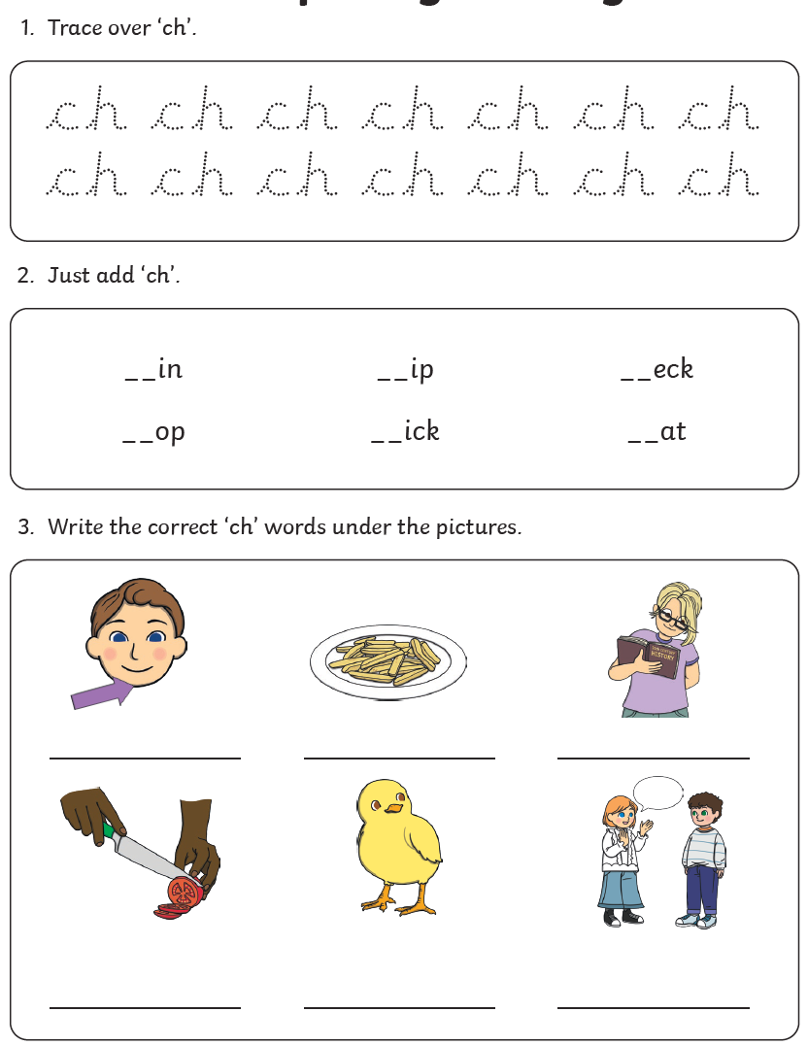 |  |  | Challenge:  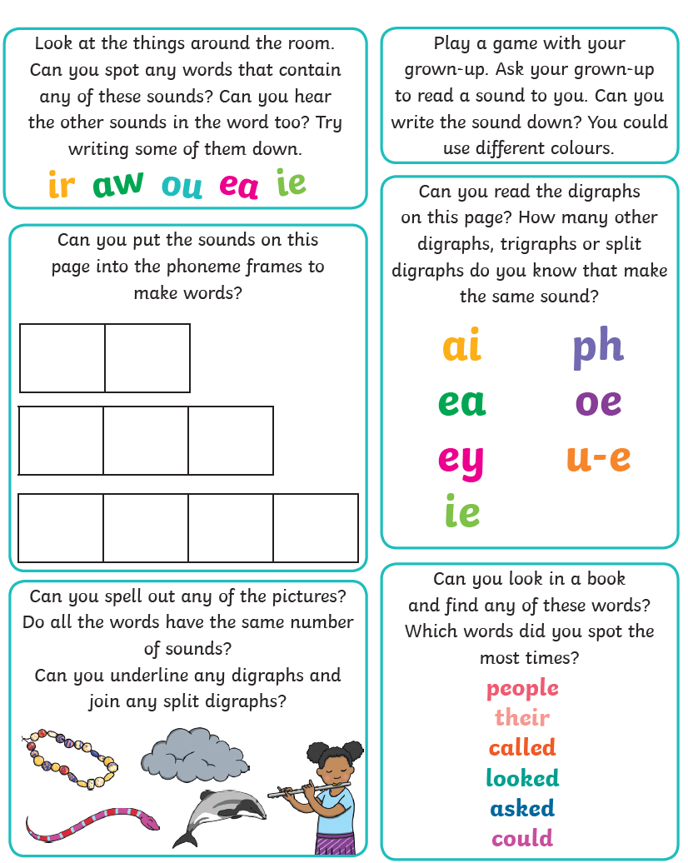  If you feel you need a further challenge, try these:

Maths Home Learning
Monday | Tuesday |  | Wednesday
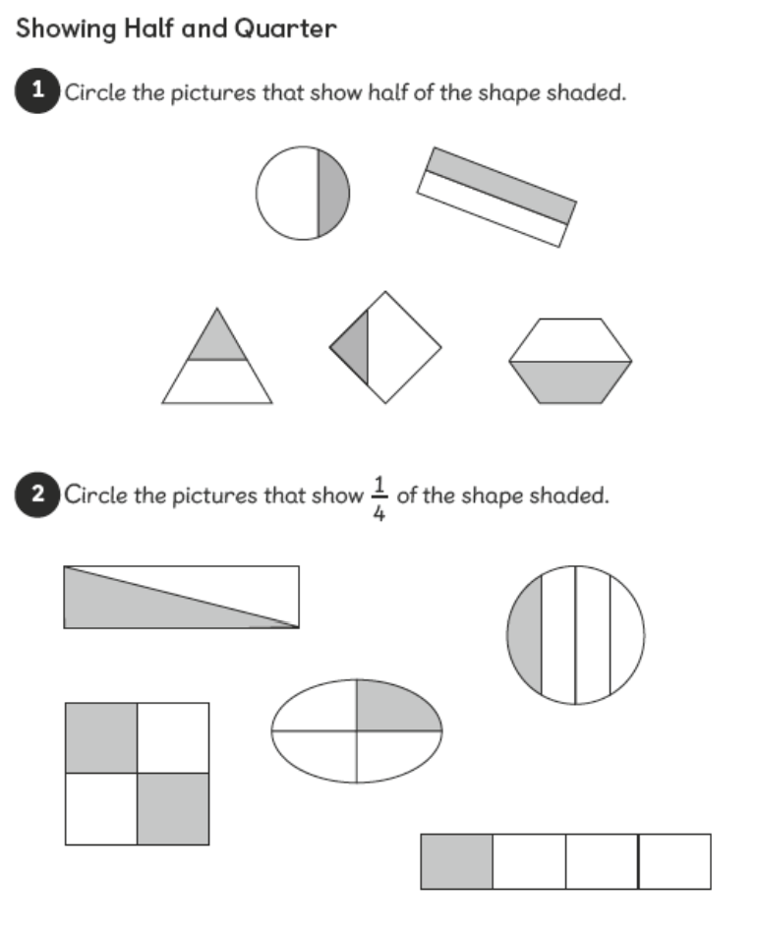 | 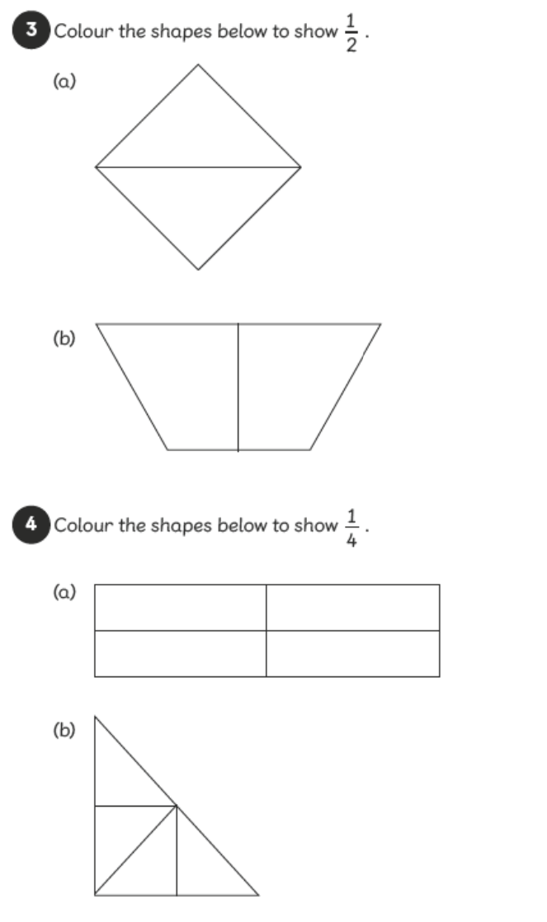 |  | 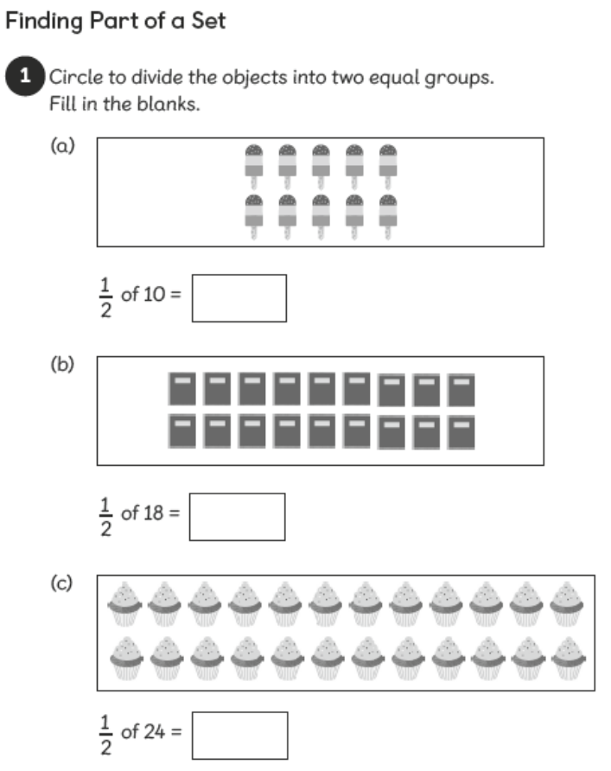
Thursday | Friday
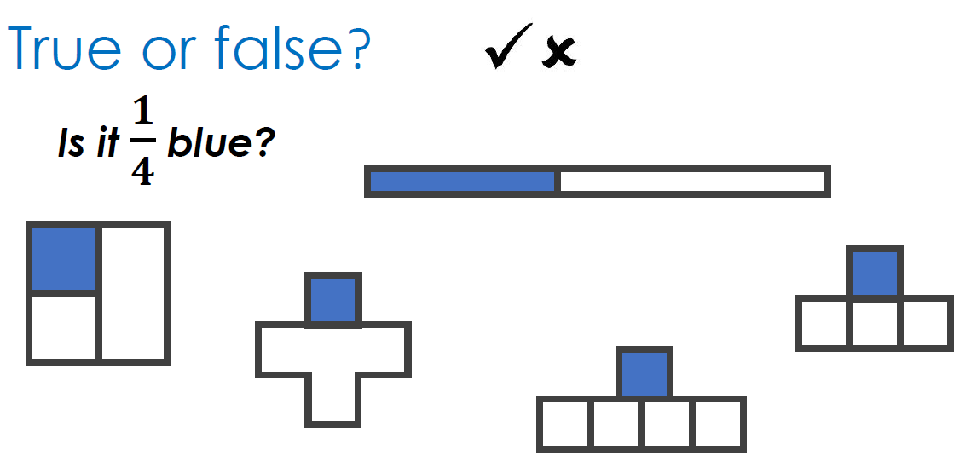 | 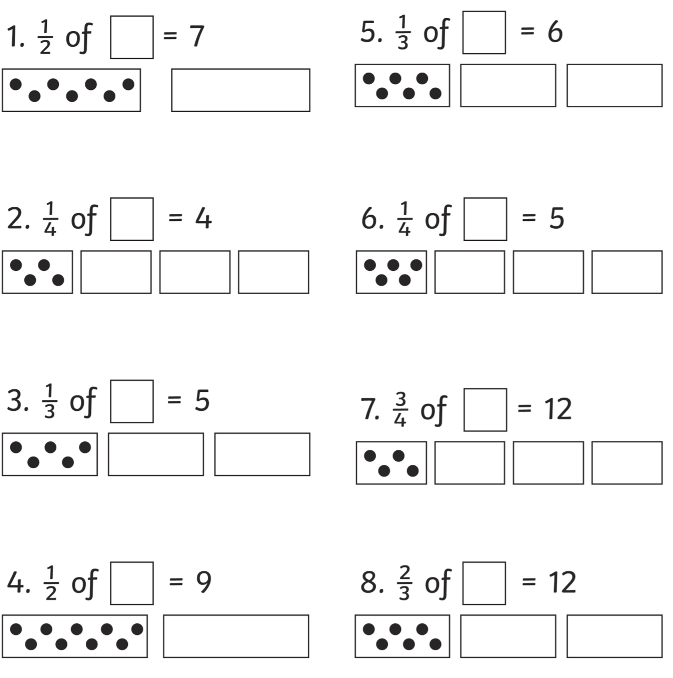
Easier:  Do as many of the above activities as you can. If you are finding some of the activities challenging, try these as they are a little easier:  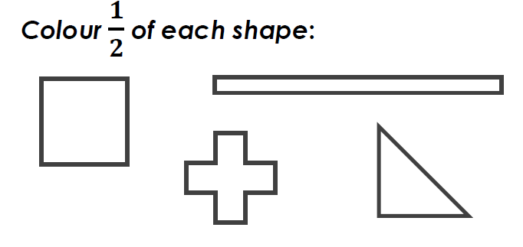  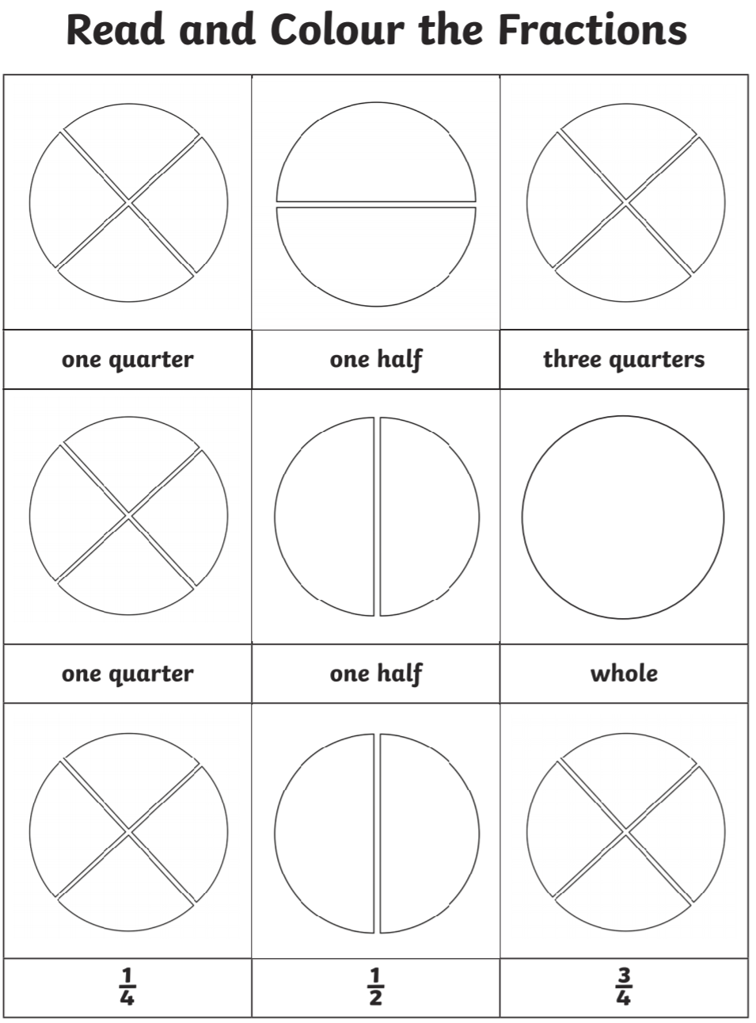  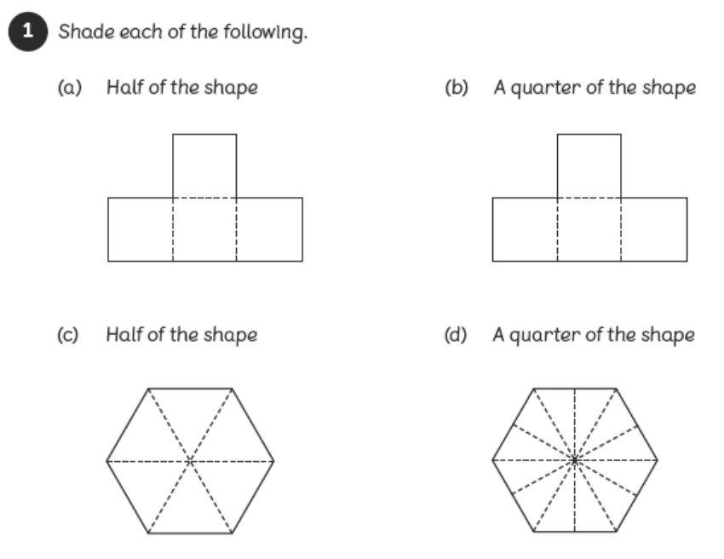 |  | Challenge:  If you feel you need a further challenge, try these:  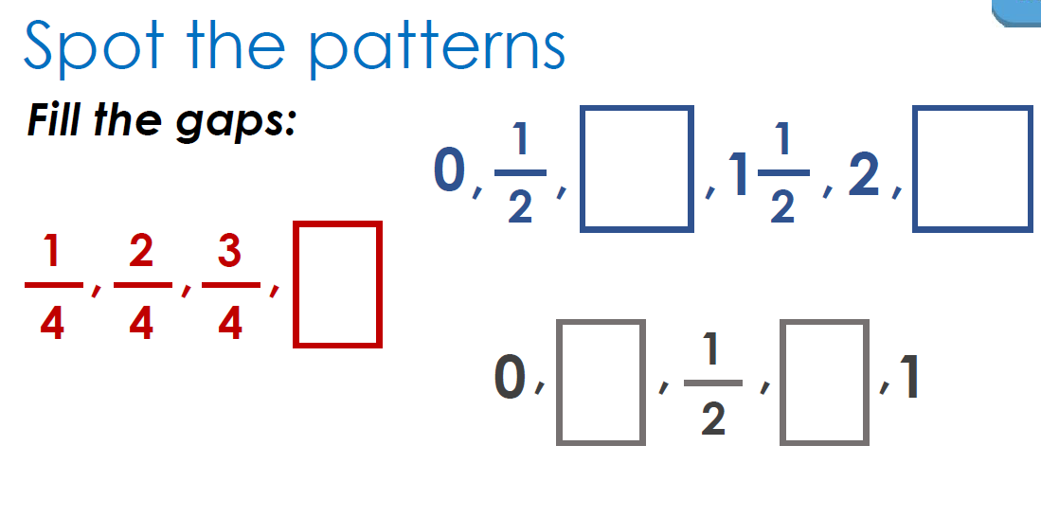  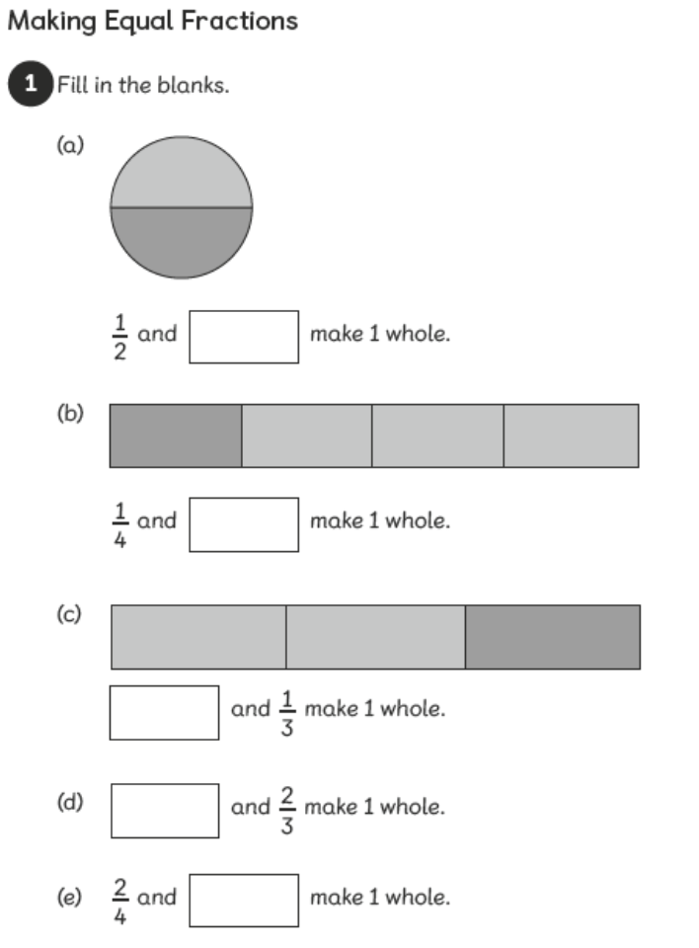  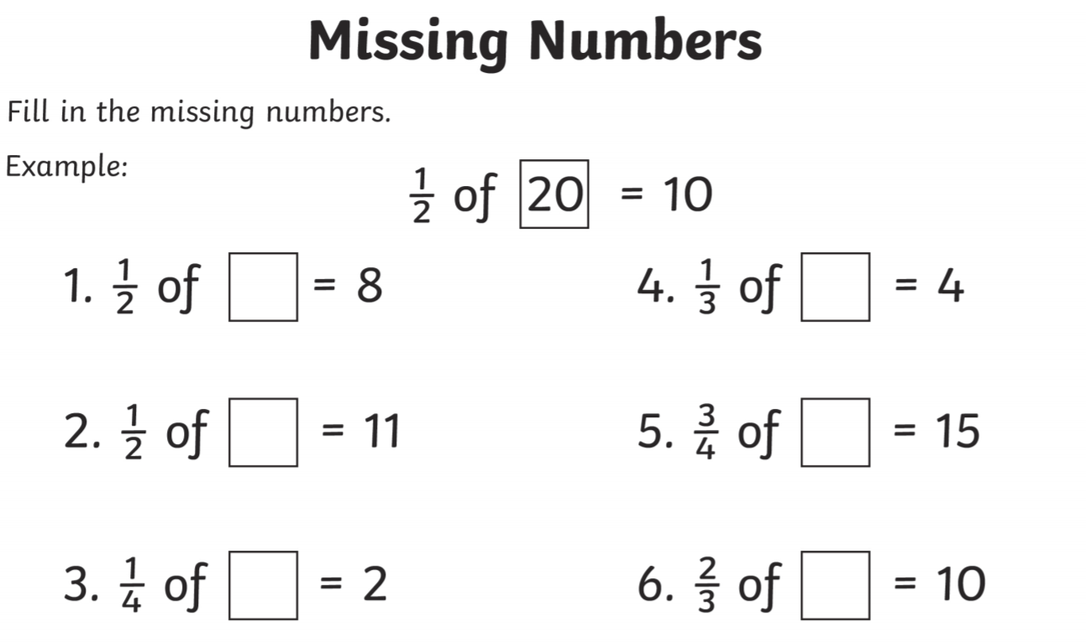
Theme Home Learning
Monday | Tuesday | Wednesday |  | Thursday | Friday
Geography  Tides, waves, and water currents (flow) shape the land to form these coastal features.  Humans have also built coastal features, such as harbours, coastal defences, and artificial islands.  Label the coast lines features below. | Geography  Look at the pictures below of Scarborough and Whitby seaside. Discuss and describe the human and physical features in the right column. | Science  Complete the Beach habitat worksheet below in the right box. |  | History  Complete the table below with the activities are done in the past and the present or both. What difference do you see? | D&T  Design a seaside in a bottle.  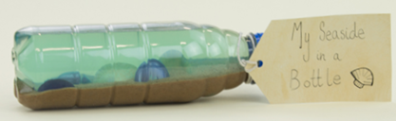  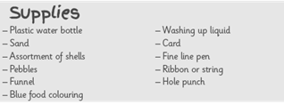
Easier:  Do as many of the above activities as you can. If you are finding some of the activities challenging, try these as they are a little easier:  - Draw sea creatures and label them.  - Label the seaside picture below  - Find Scarborough and Whitby seaside on the map. |  |  | Challenge:  If you feel you need a further challenge, try these:  - The coastline of the UK provides many different habitats for wildlife including sandy beaches, rocky shores, towering cliffs and dark, damp caves. These habitats are home to many different plants and animals. Use books or the internet to find out about seashore wildlife.

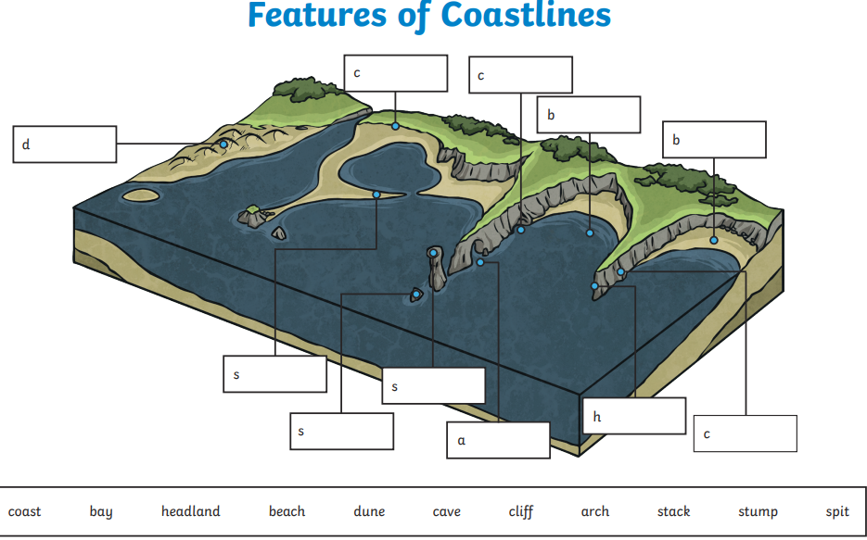

Geography – Scarborough and Whitby

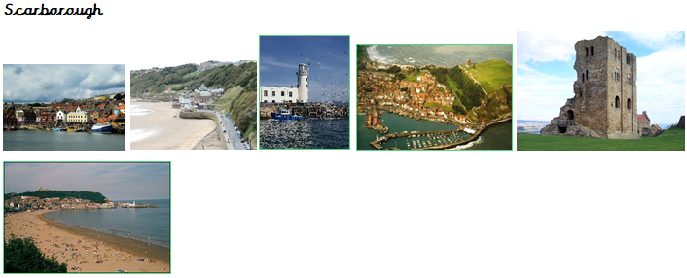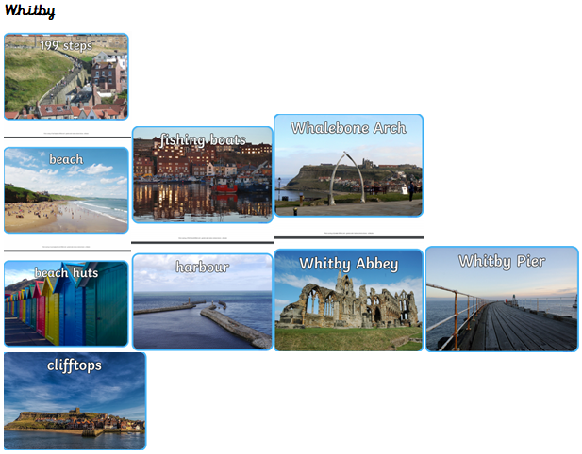
Science – Beach habitat sorting:
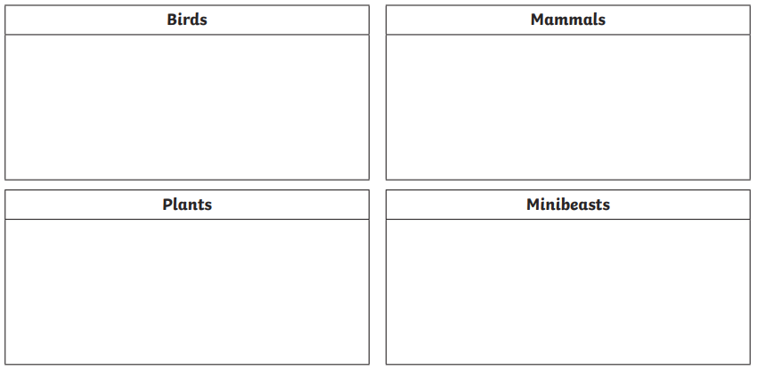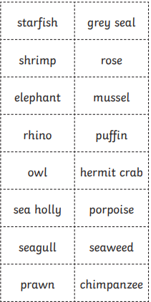

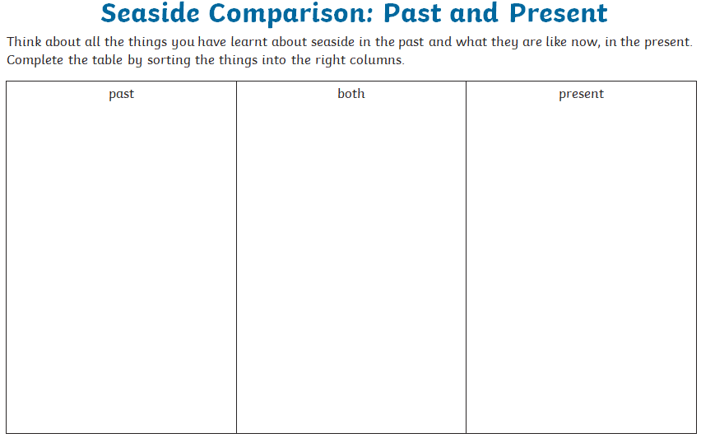

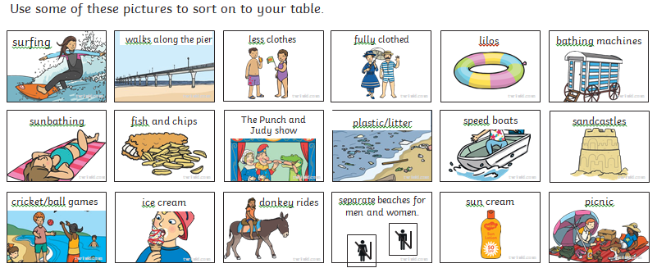

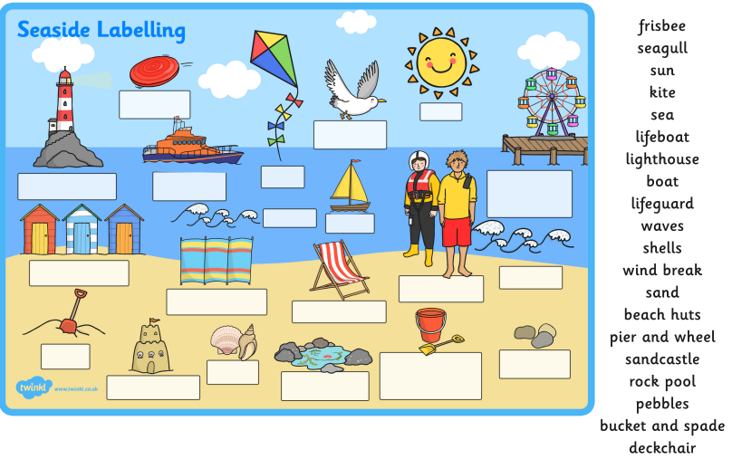

Other Activities  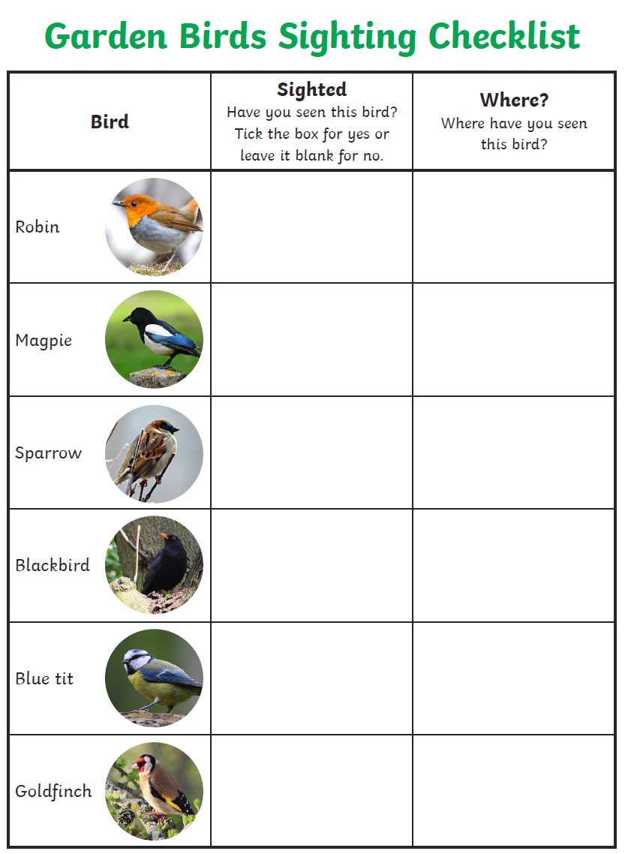 | 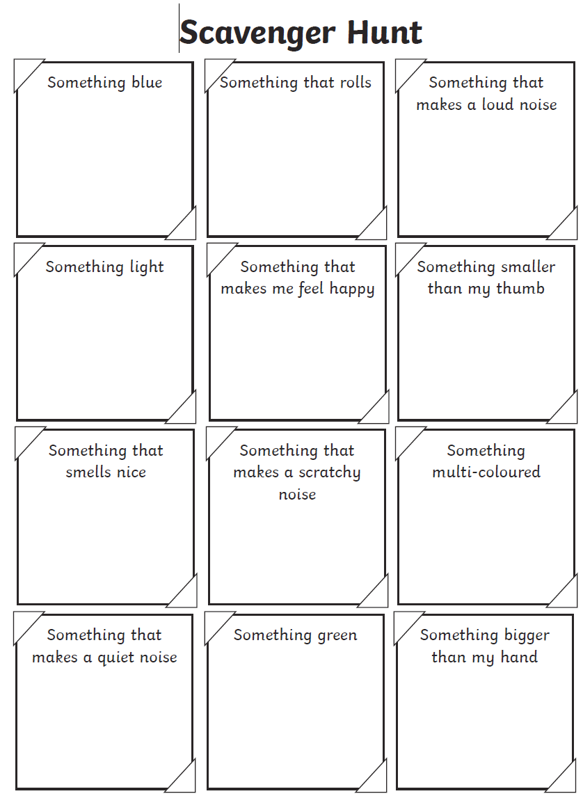
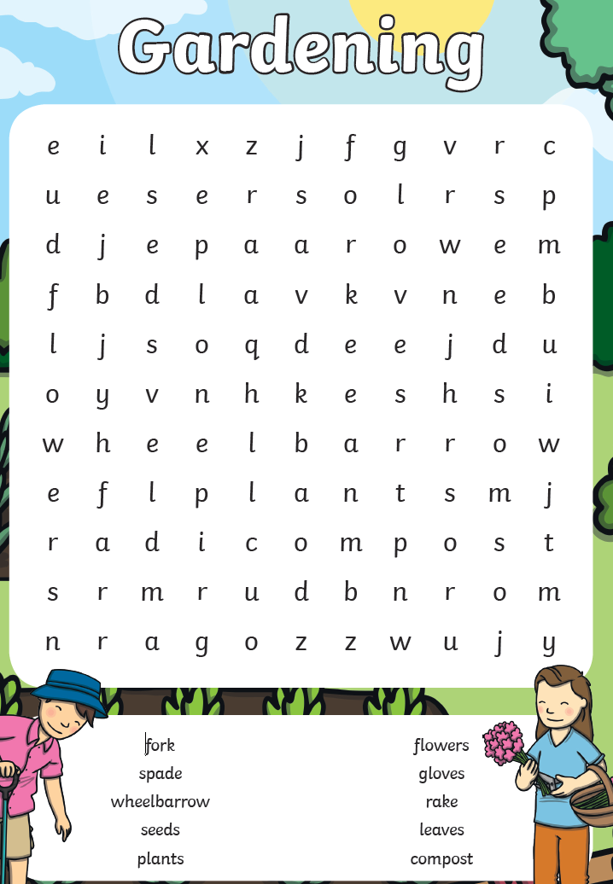 | 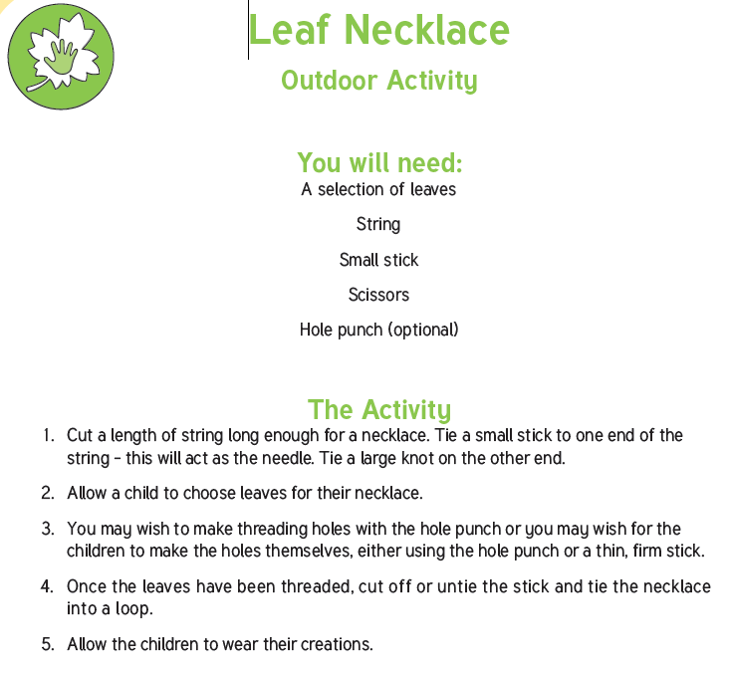

Key skills to continue practising weekly:
- Times table rock stars – I have had another look at this and some of you are having a go but lots of you haven’t yet. It is fun to do plus keeps your skills going. If you have forgotten your log on details then just e mail the school.
- Oxford Owl – lots of books to read
- Telling the time throughout the day to the nearest 5 minutes
- Play shops and work out the change
- Common exception words both reading and spelling

If you are able to access the internet, try these useful websites:
- https://www.bbc.co.uk/bitesize/primary
- https://www.bbc.co.uk/bitesize/clips/z4tmhyc
- New lessons are uploaded every day for children to interact with
- https://scratch.mit.edu/
- A chance to have a go at computer programming and create your own games, all completely free.
- Plus remember to check the list of other useful websites which are under home learning on a separate sheet.
- This link will take you to a book all about the coronavirus for children and explains a lot of what is happening in a child friendly way.

If you or your child has any further queries regarding their learning projects, please contact admin@hardwick.derby.sch.uk, clearly stating your child’s name and class teacher, and the staff will be in touch to support you and your child.

Thank you and stay safe.

