Year 2 Home Learning
Week Commencing: 4th May 2020
Year 2 teachers: Mrs J Tomordy, Mrs C Nicholson
Year 2 TAs: Ms Shaista, Mrs C Rowland

Message from staff:

Hello to all of you from all of us. We hope you and your families are keeping well. As always we are missing you but thinking about you and planning some exciting tasks for you to complete. As Ramadan begins, it is a special time for many of you but please remember the important advice from the government. If you need a musical reminder, follow the link to the baked potato song and see how many instruments you can recognise!
https://www.youtube.com/watch?v=f0HMHVD8bag

Your Home Learning this Week:
Every day (Monday to Friday), make sure you choose a *reading, *writing, *spelling/handwriting, *maths and *theme learning activity. There are also further activities to choose from should you wish to.

Reading Home Learning
Task 1  Re-read Jack and the Beanstalk story from last week. Find all the nouns in the text (hint: these are things, places or people). Now add an adjective to describe them. Example: ‘He grabbed an axe.’ will become ‘He grabbed a heavy axe.’ | Task 2  Create a text map of the story. Draw pictures instead of words and try to recite the story using only your text map. | Task 3  Find all the verbs in the story. Remember these are ‘doing’ words.  Write them in the present tense:  Past Present  threw throw  found find | Task 4  Practise your text map. Put a circle around the beginning (character), build-up (setting), problem, solution and ending.  Use your hand to retell each part of the story. | Task 5  List all the key vocabulary in the story using your story hand:  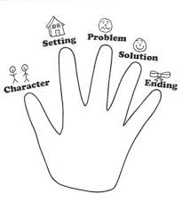

Writing Home Learning
Task 1  Imagine that you have just walked into your kitchen to find this. You can only ask 3 questions to the octopus. What would you ask and why?  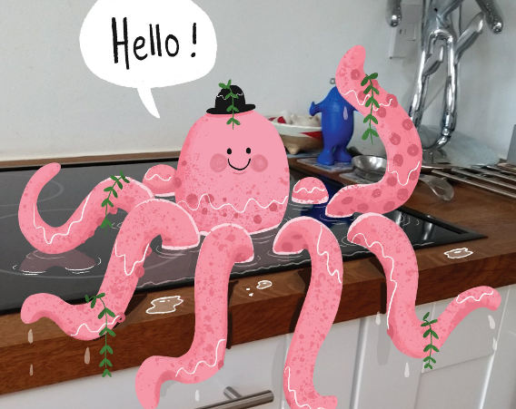 | Task 2  Write the story of how the octopus came to be here, and what happens next. | Task 3  Watch the following short film: https://www.literacyshed.com/butterflies.html  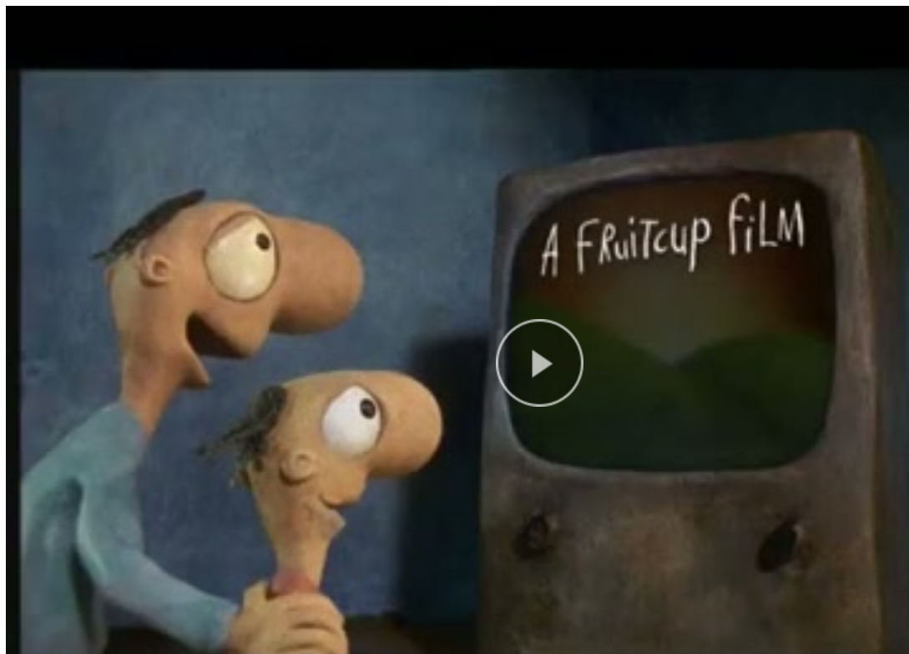  How would you describe the room before he opens the book? How could you describe it afterwards? Think of some different ways to describe the butterflies and how they fly. | Task 4  What would happen if lions and tigers came out of the book into the classroom? What would happen if fish came out? - | Task 5  Now using all the work from the other tasks, create a story based on the film. Give the man a name and think about where he found the book and what happens next?  Use conjunctions  and, or, but, because, if, when.

Spelling/Handwriting Home Learning
Rainbow write these words:  badge  edge  bridge  fudge  age  change  village  huge  germ  giant  energy | Draw a picture for the words from yesterday. If you are not sure what the word means, look it up. | Using lined paper if possible write these words 10 times each. Check that your tall letters are tall!  above  almost  always  school  sister  should  another | Check you know how to spell each of these without looking:  hour  eye  sugar  sure  everybody  father  who | Write a sentence for each of the words from day 1. Remember to think about your punctuation and handwriting.

Maths Home Learning
Task 1  Telling the time to the five minutes.  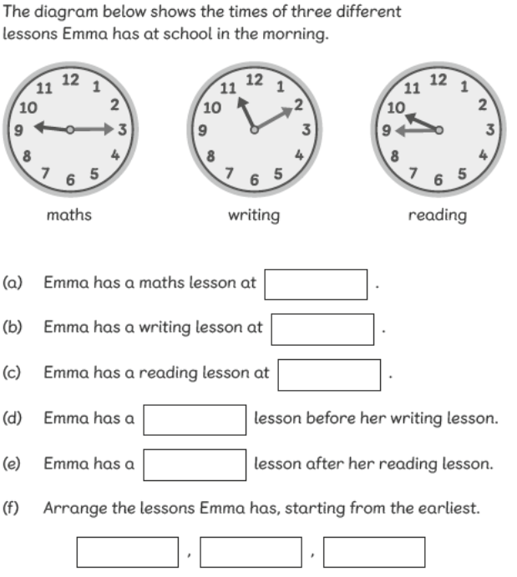 | Task 2  Telling the time to the five minutes.  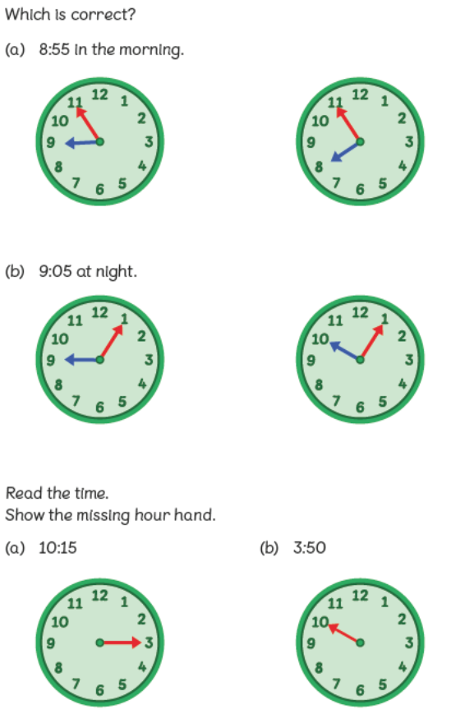
Task 3  Please draw on the other hand and check whether it is the longer minute hand or the shorter hour hand.  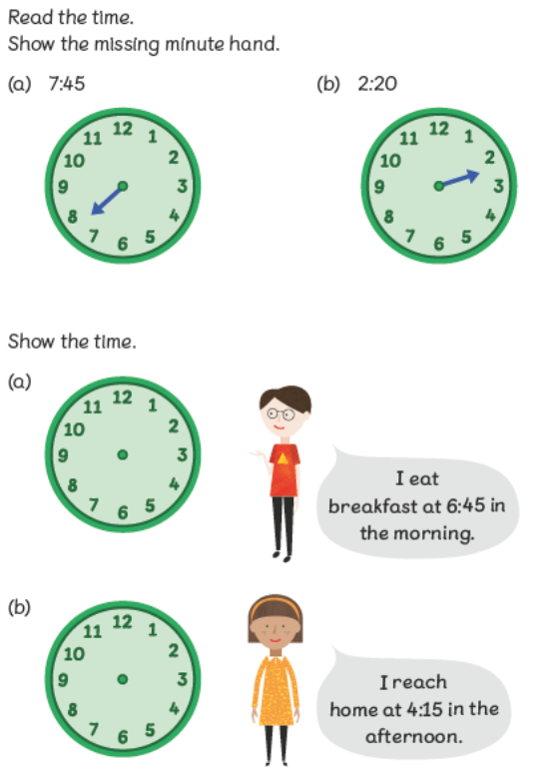 | Task 4  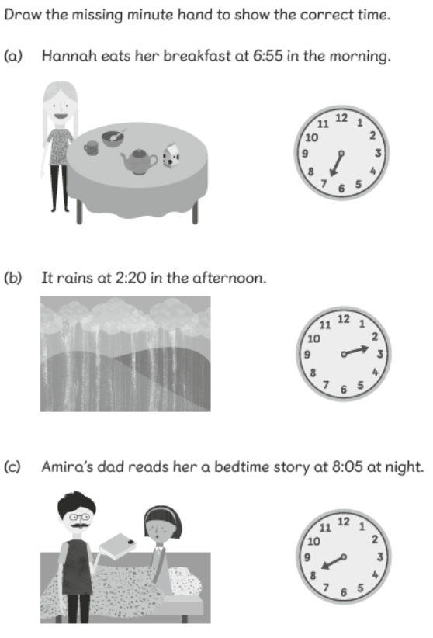

Task 5 for maths is to draw a clock face for the times that are important to you. Do you leave for school at 8.30am? Do you go to bed at 7.45pm?
Theme Home Learning
Art  Can you draw a summer scene? What would you expect to see? Can you use your pencils to create different textures? Remember the techniques we learnt in class.  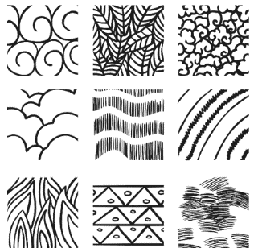 | Computing  Technology is all around us. Write about how the technology that you have in your home or on your street helps us. Think about:  - Cash machines  - Speed cameras  - Washing machines  - Game consoles  - CCTV cameras  - Street lights | Science  We planted some potatoes in school in Spring. Can you research how the potato will grow? Describe what happens at each stage.  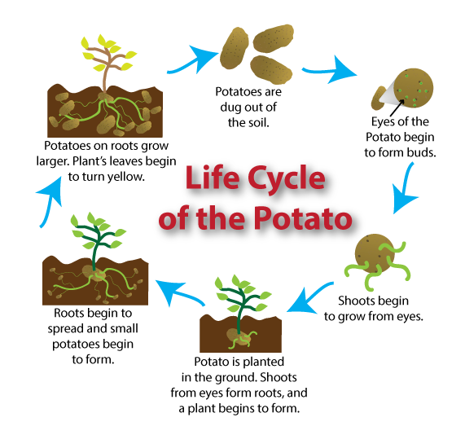 | Geography  Imagine you are walking to school. What can you see along the way? Create a map to show your journey to school. Can you create a key to show symbols instead of drawing pictures? | PSHE  Create a poster to show what is important when being a good friend. What do you think is important in your friends?  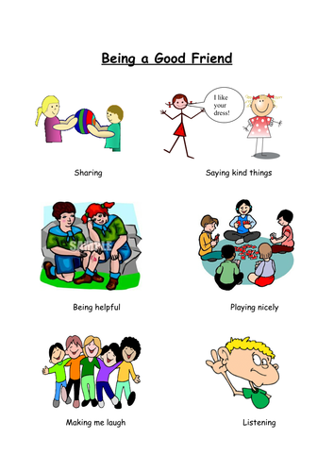

Other Activities
On your daily walk see if you can make a number sentence for the numbers you see.  2 x 6 = 12 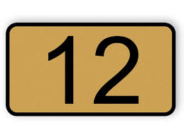 | Create a tally chart for the number of cars or people going past your house. Is it more or less on the following day? | Follow an alphabetical treasure hunt in your house and garden. Find something beginning with a, b, c, etc. | Ask your adult if you can help prepare some food. Draw pictures to show the steps and instructions you followed. | Draw a picture of something that makes you feel:  - Anxious  - Excited  - Worried  - Happy  - Surprised

Key skills to continue practicing weekly:
Times Table Rocks Stars
Reading with Oxford Owl – you need to register but it is free to read lots of books online!
Read, read and read again.
Telling the time to the nearest 5 minutes
Practise reading and spelling your common exception words.
Handwriting out a passage from a book

Useful websites:
https://www.bbc.co.uk/bitesize This is a very useful website. It is run by the BBC and they are running daily lessons for children so why not have a look and see what they have.
On Youtube every morning at 9am, type in Joe Wicks. He is running an exercise session for children and adults to join in with.
If you or your child has any further queries regarding their learning projects, please contact admin@hardwick.derby.sch.uk, clearly stating your child’s name and class teacher, and the staff will be in touch to support you and your child.

Thank you and stay safe.

