Year 3 Home Learning
Week Commencing: 29.6.20
Year 3 teachers: Mrs Begg, Mrs Lumsden, Mrs Priestland, Mr Rogers
Year 3 TAs: Miss Batool, Mrs Stringer
Message from Mrs Begg
Hi everyone – Isn’t it great to have the lovely sunny weather back. Mr Begg and I have been going for a walk every evening when the weather is a bit cooler. We have been to Elvaston Castle, Staunton Harrold Reservoir and been up into the Peak District. I have been in school teaching our key worker children and Mrs Stringer has been helping me. We have made Viking swords, shields and longhouses!! Mr Rogers has been handing out the Learning Packs and chatting to your parents as they come in. Mrs Priestland has been planning learning for next year and Mrs Lumsden has been finding exciting things for you to do at home. So you can see we are very busy.
Enjoy the sunshine but don’t forget to use sun screen, wear your sunglasses and hats, play in the shade and remember to drink plenty of water.

Your Home Learning this Week:
Every day (Monday to Friday), make sure you choose a *reading, *writing, *spelling/handwriting, *maths and *theme learning activity. There are also further activities to choose from should you wish to.

Reading Home Learning
Monday | Tuesday | Wednesday |  | Thursday | Friday
Read the text.  Can you tell us:  The Setting  The Characters  The problem  The solution  What might happen next and why? | How exactly did the ‘good friend’ help and why did it work?  Draw a picture and write what the characters might have said to each other here. You can use speech marks or speech bubbles if you like. | Anna and Misha had argued. What did they fight about? Where do you think the fight happened? Why?  Draw their 3 pictures of fight and write speech bubbles to show what they are saying to each other. |  | Can you make some links to this text?  Text to self: Have you ever fought with a friend? What about? What happened?  Text to text: does this story remind you of any other stories? (books or TV) | Can you draw a picture of Oliver?  I have written a description of him next to the text. Read it carefully several times, there are lots of clues to find!
Easier:  Do as many of the above activities as you can. If you are finding some of the activities challenging, try these as they are a little easier:  - Get someone at home to help you read the story.  - Draw a picture of what is happening in this part of the story.  - The title is “good friend”….Who is the “Good Friend” in the story?  - Who was Misha jealous of?  - Who cheered Misha up?  - What had Misha done?  - Where is Misha in this part of the story? |  |  | Challenge:  If you feel you need a further challenge, try these:  Some tricky questions! (these use inference…putting together what is read AND what you know)  - Which part of Oliver the cat touched Misha’s arm? How do you know?  - Why did Misha go to her bedroom? Why not the front room with an adult?  - Why did Misha take steps to correct her mistake of shouting at Anna?  - Why did the writer use the word ‘sank’?  - Which words did the writer use to show that Misha is starting to feel better?

Glossary
Affectionate – friendly, loving, giving
Chilly - cold enough to cause shivering
Chuckled - laugh
Petted - stroked
Stocky – sturdy, solid, heavy
Stumble - walk clumsily, trip or fall
Ragged – rough, jagged edges, ‘in tatters’
Thoughtless – lack of thought, careless
Tenderly - gently, sweetly

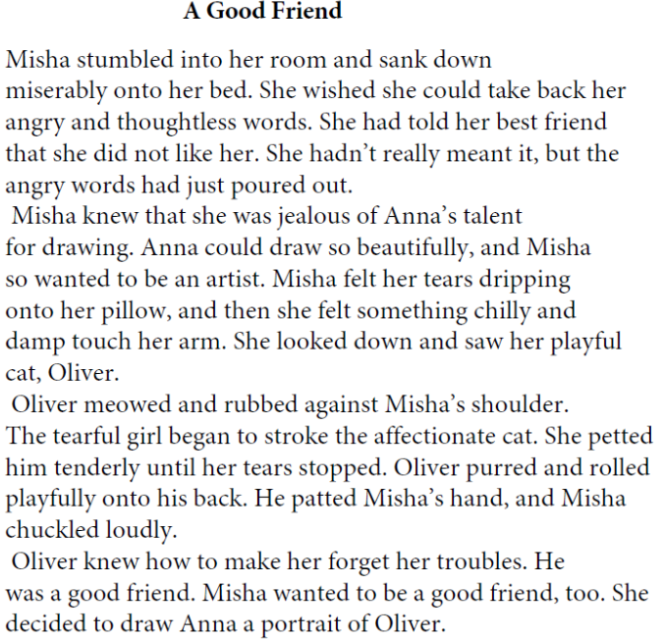
Oliver
We got Oliver when he was a tiny kitten. I chose him because of his stripes. I remember choosing his shiny new collar with the bell on, but now it looks old and tatty. He has grown into such a large, stocky cat. People say looks rough and tough because he has a ragged ear and sharp teeth, but we know he is sweet. My mum hates it when his ginger fur is left all over my bed but I don’t mind! I love it when he curls up with me and sleeps on my bed with me.

Monday | Tuesday | Wednesday |  | Thursday | Friday
Read the poem “Day the world stayed home”  What is this poem about?  When might it have been written?  Why was it written?  Who is writing it? | Draw your own text map, showing each verse.  (a verse is each ‘paragraph’ or 4 lines of writing) and begin to learn the poem by heart. | This poem rhymes.  Write pairs of words from the poem that rhyme.  Can you find other pairs of rhyming words to add to your list. |  | Document what is happening in your house:-  Write down things that people in your home say. Make sure you use speech marks.  Write about how you feel when you hear about or watch the news. | Document what is happening in your house:-  Write about the games you are playing at home. Have you made up any new games? What are the rules?  Have you started a new hobby of learn something new? Write about what you have learnt.
Easier:  Do as many of the above activities as you can. If you are finding some of the activities challenging, try these as they are a little easier:  Read the ‘home is’ poems. These were written by children. What in their poems is the same and different to what happens in your house?  Draw what happens in their houses.  Write your own version making sure you include:  People in your house  Things you do together  Things you do on your own  Things you don’t enjoy  Things you do enjoy  Things only your family does. |  |  | Challenge:  If you feel you need a further challenge, try these:  - Have a go at writing your own poem about what is happening in your life now. Make sure you include information about how you feel and include descriptions about what you see and do. It doesn’t have to rhyme.  - See LOCKDOWN poem written by another child for ideas.
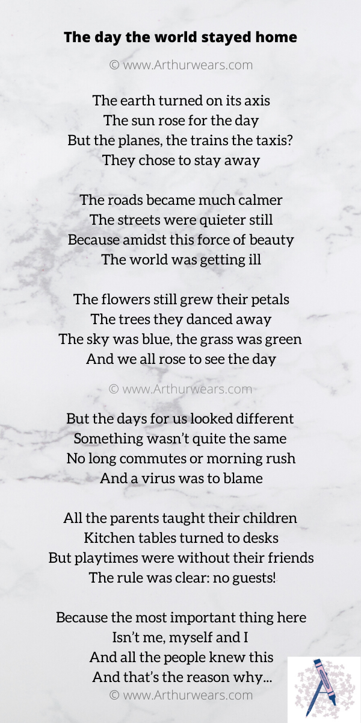
Home
Home is every time we find some change, putting it in the jar.
Home is watching sports on TV with my step father and brother.
Home is eating tilapia with my family.
Home is my step father waking my up by putting on the light.
Home is going into the back yard to play.
Home is staying up late, eating food with friends.
Home is my baby cousin coming to visit.
Home is on my phone watching Instagram.
M (age 10)

Home
Home is playing games on my pad.
Home is mum telling me to tidy up.
Home is playing with my sister upstairs.
Home is ordering a pizza as a treat!
Home is my cat, Fluffy.
Home is shouting, but then making up.
Home is cooking with my mum and helping to hoover up.
Home is dancing and singing together.
Home is everyone watching The X-Factor together.
Home is losing my shoes because I don’t put them by the door.
D (age 6)

Spelling/Handwriting Home Learning
Monday | Tuesday | Wednesday | Thursday |  | Friday
A prefix is added to the beginning of the word to change the meaning.  Super=over or above  Sub= under or below  Superman, supermarket, supervisor, subway, subtract, submerge, subheading, submarine | Put the words from yesterday into sentences to show their meanings. | Draw pictures to help you remember the meaning of these homophones.  Where - wear  Waste – waist  Main – mane  Reed - read  Cheap – cheep  Steel - steal  Past – passed  Mist - missed | Put the homophones from yesterday into sentences to show their meanings. |  | Syllables are the ‘beat’ in the spoken word. For example  Elephant=3  Helicopter=4  Make a list 10 of words with 3, 4 and 5 syllables in.
Easier:  Do as many of the above activities as you can. If you are finding some of the activities challenging, try these as they are a little easier:  - Verbs are actions. They can be happening in the past, present or future. Write lists of actions and what the word would be if it was happening now or in the past. For example, run – ran, skip- skipped, dance- danced, write-wrote.  - ‘Wh’ sounds like w, wheel whip, while, whale, where, white, while, which.  - The ch sound at the end of words:  - ‘tch’ follows a single short consonant catch, fetch, ditch, notch, hutch.  - ‘ch’ follows a consonsant (often a letter n) pinch bench torch lunch branch |  |  |  | Challenge:  If you feel you need a further challenge, try these:  Can you put the words from this week alphabetical order?  Remember to look at their spelling closely.  Order by the first letter. If the first letter is the same, compare and order the second letters.  (you may need to look at the third or even the fourth letter! It is ‘the challenge’ after all!!)
Maths Home Learning
Monday | Tuesday | Wednesday |  | Thursday | Friday
Read and complete lesson 3, adding fractions  Because the denominators (bottom numbers) are the same, you can just add the numerators (top number) together!  Go for it! Don’t be scared of fractions! Look for the patterns to help you! | Read and complete lesson 4, subtracting fractions  Again, because the denominators are the same, you can subtract normally across the top! | Lesson 5, equivalent fractions.  Do you see the pattern? Whatever happens to the top, happens to the bottom! If the numerator (top) is doubled, the denominator (bottom) is also doubled. If the top was x2 that’s what you would need to do to the bottom number. |  | Have a go at writing out your own equivalent fractions wall.  Don’t just copy the one above. Study it and then see if you can complete the blank one without looking.  Go for it! Don’t be scared of fractions! Look for the patterns to help you! | Have a go at writing out some equivalent fractions using the fractions wall.  How many 8ths in a half?  How many 6ths in a half?  How many 12ths in a quarter?  How about how many 12s in three quarters?
Easier:  Do as many of the above activities as you can. If you are finding some of the activities challenging, try these as they are a little easier:  - Practise folding paper into halves and quarters. You could cut out circles, squares or rectangles.  - Can you fold a square into three equal pieces? (thirds)  - Is it possible to fold a triangle into 4 equal pieces that are all the same size? |  |  | Challenge:  If you feel you need a further challenge, try these:  Have a go at the Roman Numerals worksheets below! Look at the symbols used and see if you can work out the pattern.  HINT…..Look closely at the symbols- compare 4 and 5, then compare 9 and 10.  Why is the I BEFORE the V and BEFORE the X instead of AFTER like with 7 and 11?
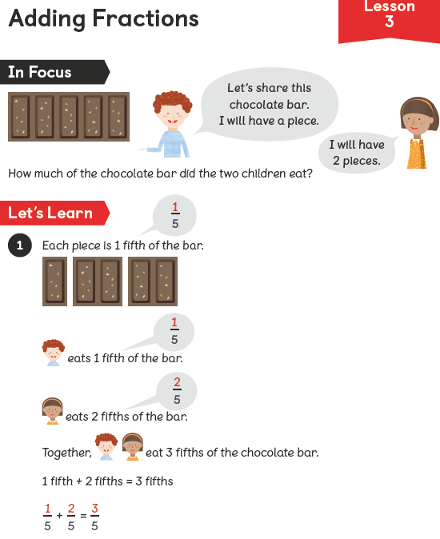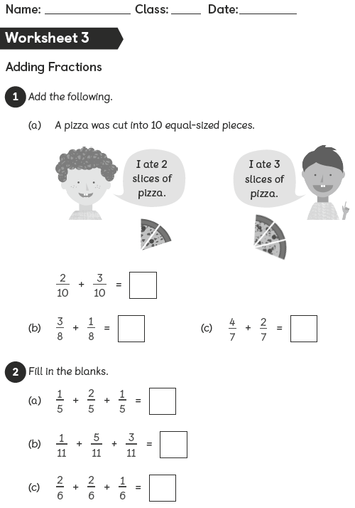
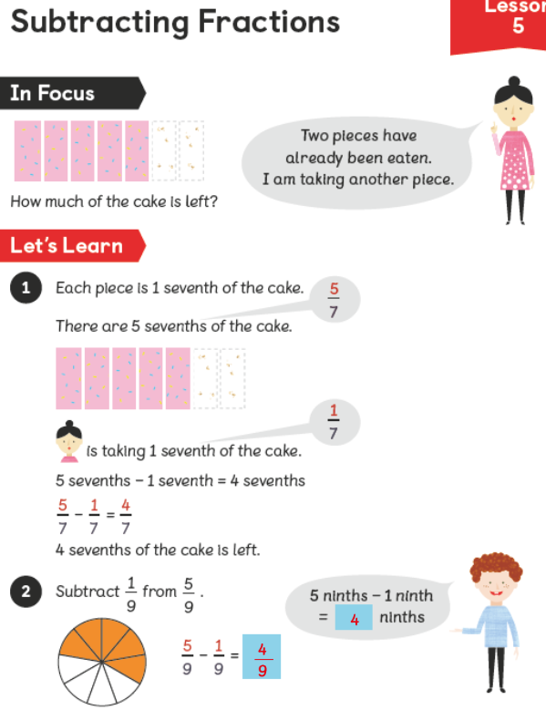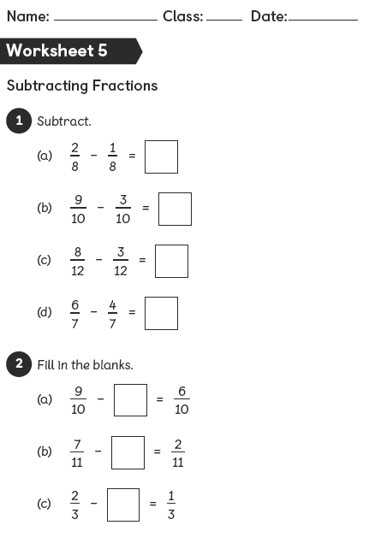
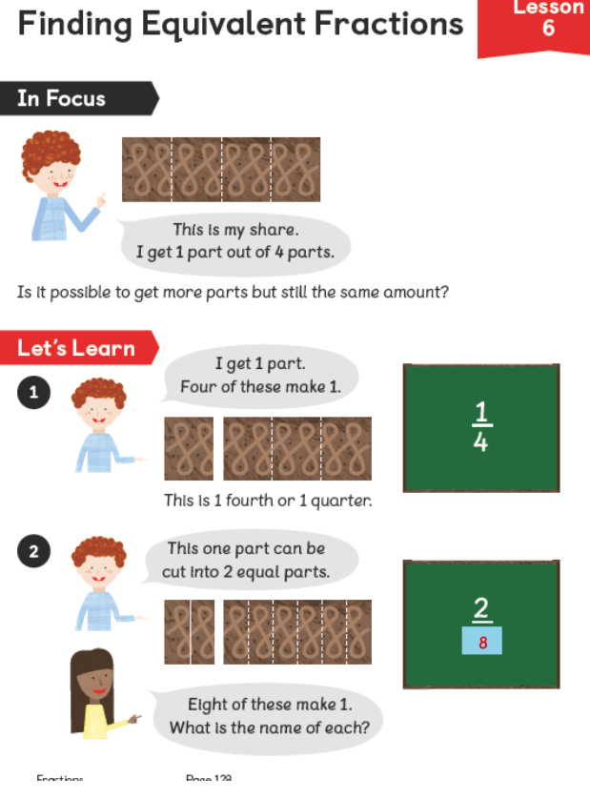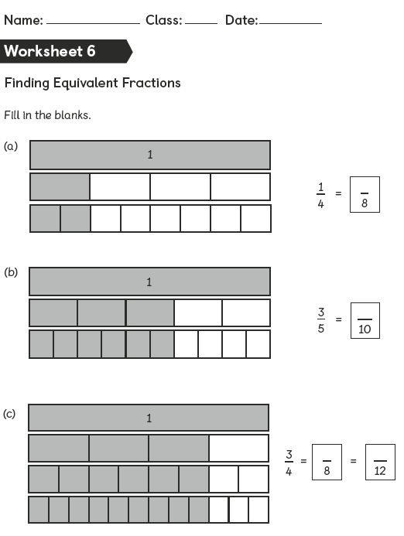

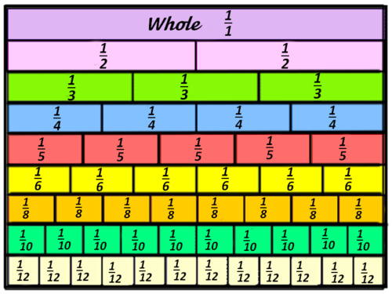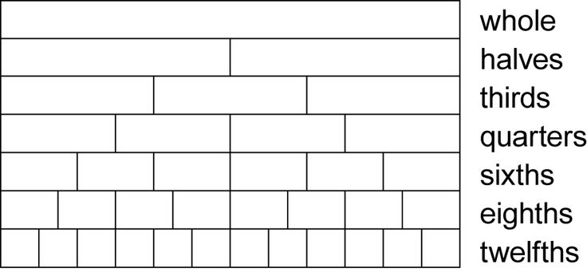
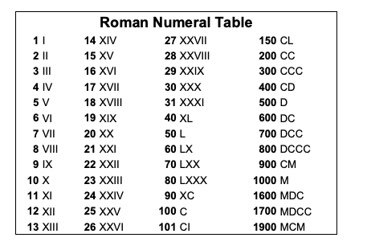
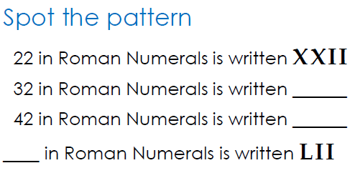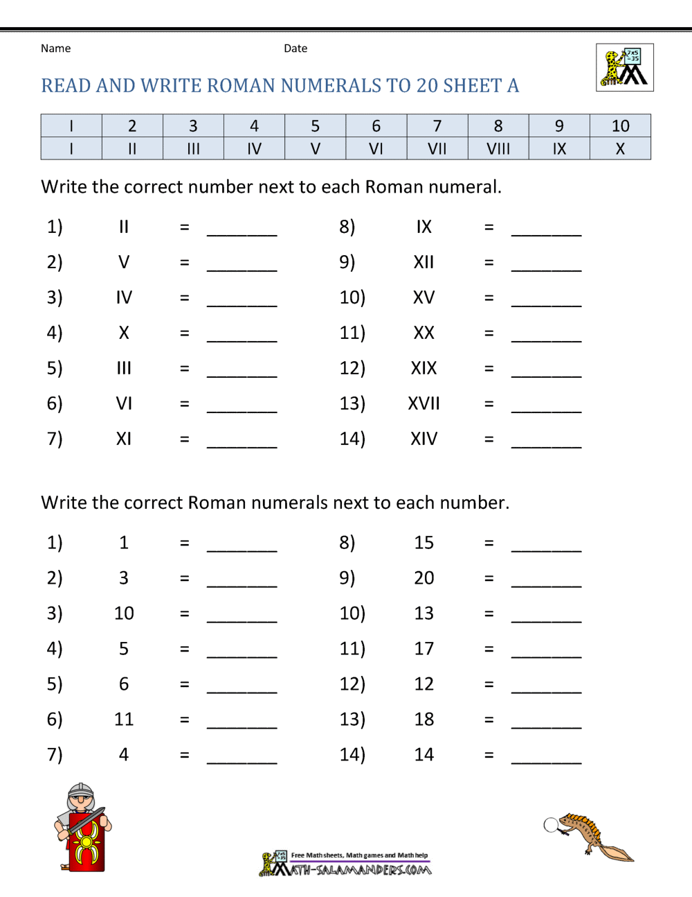

Theme Home Learning –
Monday | Tuesday | Wednesday | Thursday | Friday
Art: a ‘still life’ collect some objects from around your home. Put them on a table in front of you so that they are grouped together, but you can still see them all.  Draw carefully what you see, making sure that the objects overlap one another at the right places. It helps to imagine the lines behind the objects that you cant see. | Oracy:  Phone or video call a grandparent (or another, older family member) and find out more about them!  Ask them the 21 questions below on the sheet:  - What was the most surprising thing you found out!  - Did you find out anything that your family didn’t already know?  (when the questions ask about celebrations such as Christmas, you can ask about the festivals your family celebrates) | Philosophy:  Would you rather?  - Have a pet lion  - Have a pet slug  - Have a pet crocodile.  - Have a pet wolf.  Remember to give reasons why you have picked yours, and why not the others. Compare your answer with someone else in your family. Do you change their mind? Do you change your mind? | Oracy: choose a topic from the “talk about food for 1 minute” and time yourself speaking about the question.  You can have 1 minute to think about the question before you have to talk.  Can you talk without lots of gaps?  Do you explain your answer clearly? | Philosophy:  The BIG question.  Is it better to regret doing something you did do, rather than, regret something you have never been brave enough to do?  What do you think? Do your ideas match other’s in your family or not?

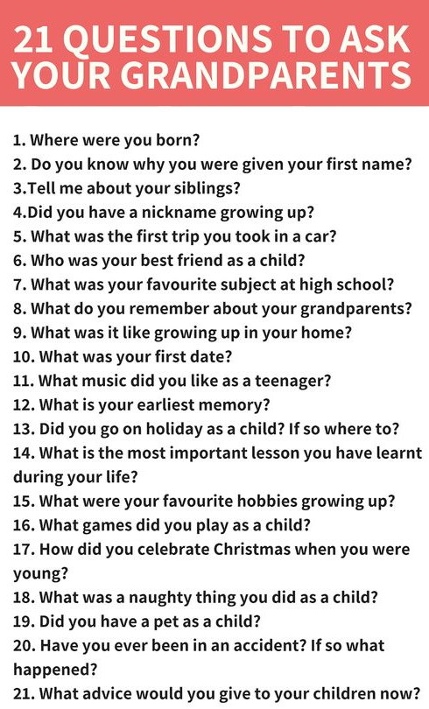

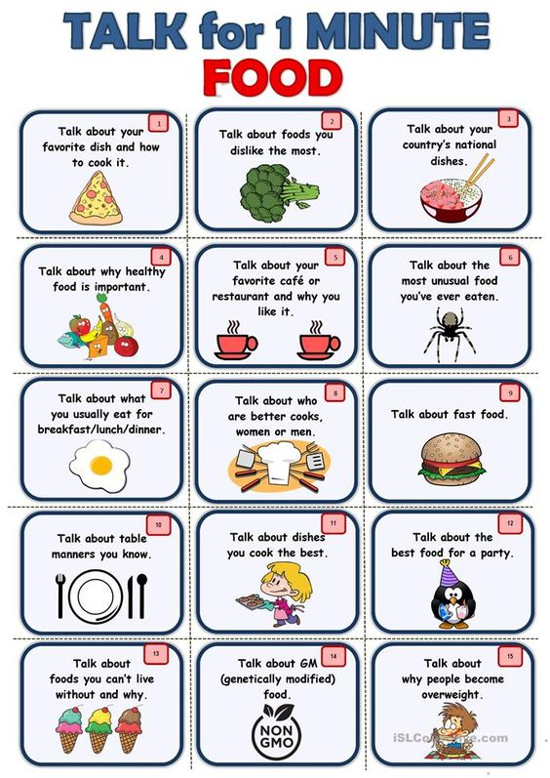

Other Activities This week we will look more closely at personality traits
Read all of the personal qualities and circle the ones you thin apply to you. Include the good and the bad ones.  Write your top 5 which best describe you at the bottom.  Remember to do some mindful breathing every day. | Complete the sheet about your strengths.  Include what you think as well as what others have said to you before.  Remember to do some mindful breathing every day. | Learn about the good and bad personal qualities.  Can you use the sheet to look at the upside and downside to each personality trait.  Remember to do some mindful breathing every day. | Write a build a friend sheet. Think carefully about what you’d like in a friend, not just when things are good, but also when you need help or someone is being treated unkindly. What you would you want your friend to do?  Remember to do some mindful breathing every day. | Complete the mindful breathing activities for the week.  Follow the sheet to do your mindful breathing, once you are nice and calm, read  ‘the tunnel’ and ‘The river’. Think about what they mean to you.

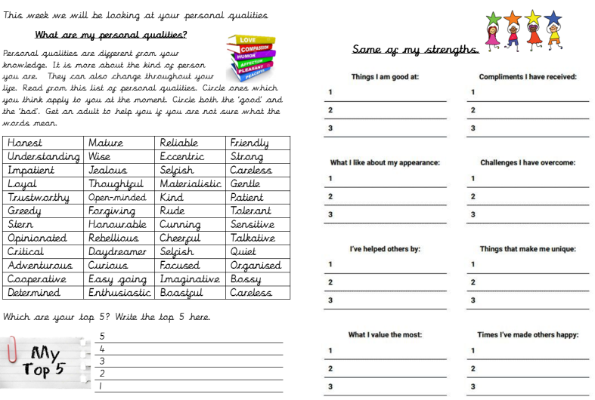

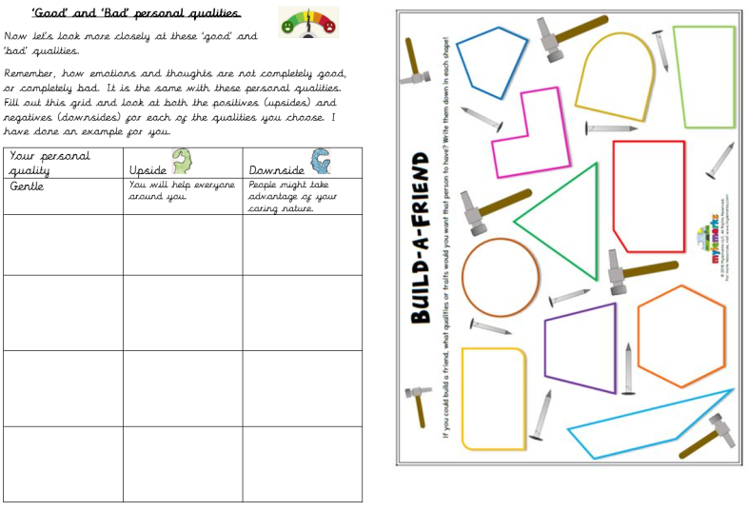

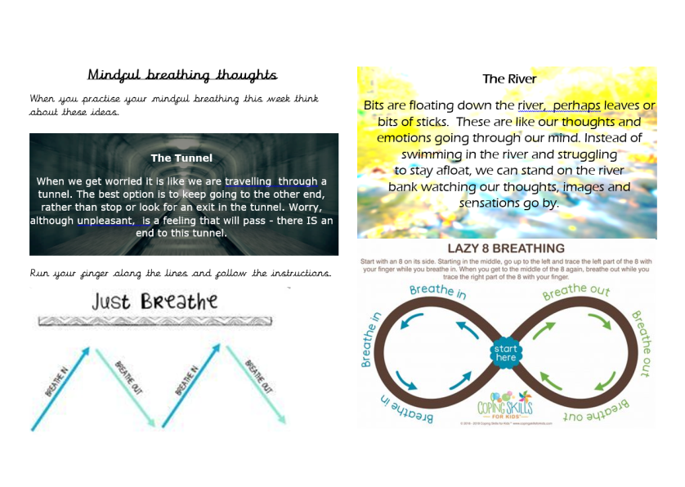

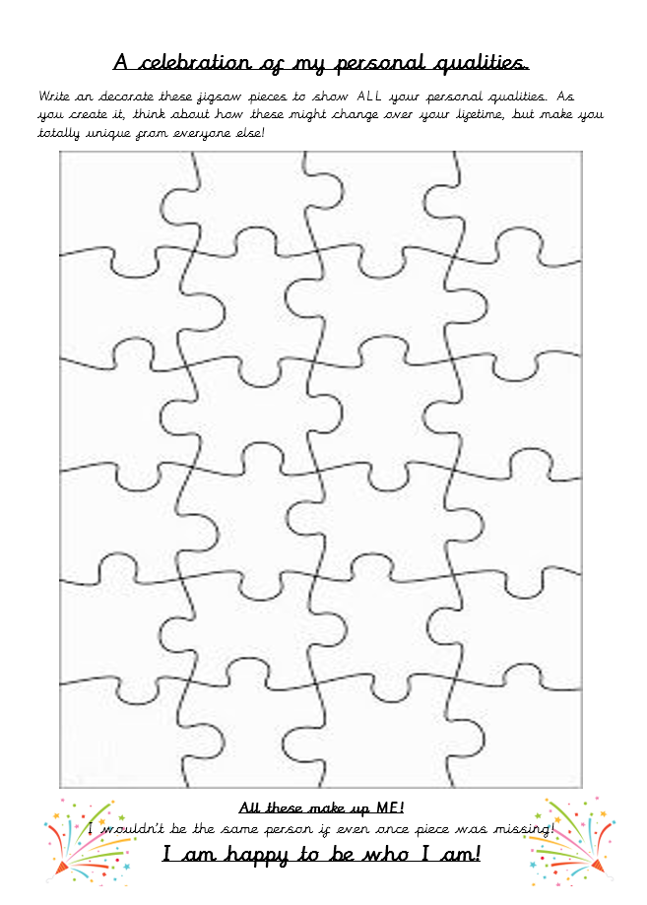

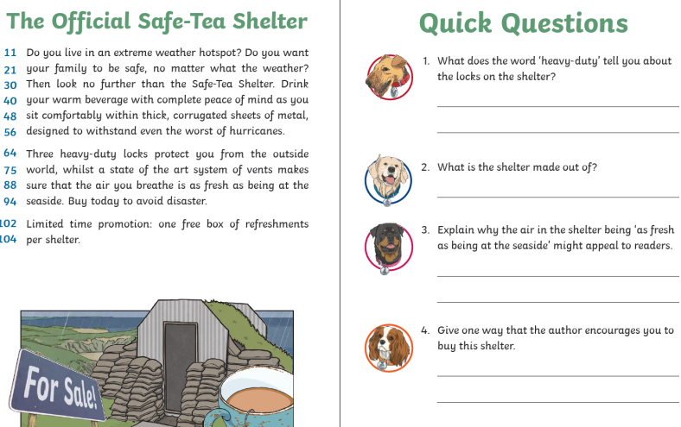

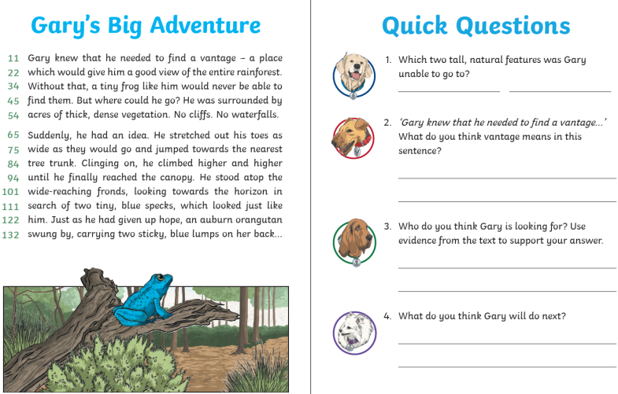

Key skills to continue practising weekly:
- 2, 3, 4, 5, 8, 10 times tables
- Quick addition and number facts 9+7 11 - 5
- Year One, two and three spelling sheets
- Reading any books, newspapers, cereal packets, websites you can find
- Learn your date of birth, home address and a phone number of a trusted adult by heart (always useful if you were to get lost at the shops!)
If you are able to access the internet, try these useful websites:
- BBCbitesize/daily lessons
- https://www.youtube.com/user/CosmicKidsYoga- Cosmic Yoga is amazing. There are lots of yoga stories, mindfulness activities and active exercises for you to do.
- https://scratch.mit.edu/- we would be doing this if we were at school. Have an explore of Scratch and learn how to code. Make the cat move, speak and even dance. Create new characters, change the background and have some fun.
- Use your purple Mash log on to have a go at some of the internet learning being set for you.

If you or your child has any further queries regarding their learning projects, please contact admin@hardwick.derby.sch.uk, clearly stating your child’s name and class teacher, and the staff will be in touch to support you and your child.

Thank you and stay safe.

