
Pupil Premium / Recovery Strategy Statement – 3-Year Plan
Hardwick Primary School – September 2021-July 2024
This statement details our school’s use of pupil premium (and recovery premium for the 2021 to 2022 academic year) funding to help improve the attainment of our disadvantaged pupils.

It outlines our pupil premium strategy, how we intend to spend the funding in this academic year and the effect that last year’s spending of pupil premium had within our school.

School overview
Detail | Data (updated 10/10/2023)
School name | Hardwick Primary School
Number of pupils in school | 577 (additional nursery intakes taken at January and April)
Proportion (%) of pupil premium eligible pupils | 55.5%
Academic year/years that our current pupil premium strategy plan covers | 2021/22-2023/2024
Date this statement was published | 12/11/2021
Date on which it will be reviewed | Review 1: 15/07/2022  Review 2: 21/07/2023 (+ data update 10/10/2023)  Review 3: 19/07/2024
Statement authorised by | Rani Sandhu
Pupil premium lead | Aisha Awaan
Governor / Trustee lead | Clive Sayers

Funding overview
Detail | Amount
Pupil premium funding carried forward from previous years (enter £0 if not applicable) | £0
Pupil premium funding allocation 2021-2022 | £335,465
Recovery premium funding allocation 2021-2022 | £36,105
Pupil premium funding allocation 2022-2023 | £365,071
Pupil premium funding allocation 2023-2024 | £424,011

Part A: Pupil premium strategy plan

Statement of intent
At Hardwick Primary School, our intention is that all pupils, irrespective of their background or the challenges they face, are equipped and enabled to become caring, critical and creative individuals who can contribute positively to their community and to society as a whole. We intend that all pupils are supported to make good progress and achieve their potential across all subject areas.

Our intentions are underpinned by our school values – CARE:
Caring where everyone cares about each other and our school;
Achieving where everyone always does better than their previous best;
Respectful where everyone remembers their manners and respects one another;
Exciting where everyone enjoys learning and experiencing new challenges.

The focus of our pupil premium strategy is to achieve these goals, with recognition of, and planned action to address, key challenges faced by our vulnerable pupils.

The provision of high-quality teaching is central to our Pupil Premium Strategy, as this is proven to have the greatest impact on closing the disadvantage attainment gap whilst benefiting all pupils. This is particularly important given the widening of some attainment gaps, which had previously been closing or closed, following the COVID-19 pandemic. Through the recruitment of HLTAs as part of our strategy, we aim to support and enhance classroom provision, as well as providing targeted interventions, to enable our disadvantaged pupils to attain and achieve on a par with their non-disadvantaged peers.

Our school data, assessments and consultations demonstrate to us that our disadvantaged pupils experience barriers to achieving the above learning progress, particularly in the form of attendance and punctuality, vocabulary and oracy, wider life experiences and social, emotional and mental wellbeing. Our Pupil Premium Strategy therefore plans to address these aspects, to enable the subsequent progress and attainment of our disadvantaged pupils.

This Pupil Premium Strategy sits alongside wider school plans for education recovery for all our pupils, particularly the National Tutoring Programme and provision of ‘Catch-Up’ tuition.

Challenges

This details the key challenges to achievement that we have identified among our disadvantaged pupils.
Challenge number | Detail of challenge
1 | Many of our children have gaps in their learning, arrive in school outside of normal transition points and are generally well below age-related expectations when they start school. This has been exacerbated by the COVID-pandemic, with disadvantaged pupils often being disproportionately affected. Our data shows that, whilst some attainment gaps have continued to close, others have widened when compared to pre-pandemic end-of-year data. Therefore, our Pupil Premium Strategy will focus on ensuring all disadvantaged children receive consistently high-quality personalised teaching and learning that ensures they make accelerated progress.
2 | Our assessments and observations show that for many of our children, limited vocabulary, poor phonics and/or poor oracy skills are a barrier to their progress and attainment. This is the case both for our pupils for whom English is a first language and for our EAL and NtE pupils. Therefore, our Pupil Premium Strategy will focus on improving disadvantaged pupils’ vocabulary, reading and oracy skills to support their whole curriculum learning and development.
3 | Our discussions and observations show that many children have limited access to wider life and extracurricular activities. This further limits their vocabulary, wider knowledge of the world and ability to attach their learning to prior experiences. Therefore, our Pupil Premium Strategy will focus on improving disadvantaged children's access to a wide variety of life experiences and extracurricular activities.
4 | Attendance and punctuality is a barrier for many of our most disadvantaged children. The attendance of pupil premium children at the end of 2020/21 was 1-2% lower in all year groups than their non-PP peers and below national averages (in 2018/19, attendance of PP children was generally equal to, or in some cases slightly higher, than non-PP). A higher percentage of PP children are also persistent absentees when compared to their non-PP peers, which impacts on their progress, attainment and wider wellbeing. In addition to lower attendance rates, the families of some of our most disadvantaged children struggle to provide uniform, equipment and to ensure that their children arrive at school ready to learn. Therefore, our strategies will provide mechanisms and support for children and families to ensure that children can arrive on time, with good attendance, ready to learn and feeling a part of their school community.
5 | Many of our children enter school with social, emotional, physical and mental health needs, and require support with their mental health and wellbeing in order to be able to access and participate in learning. This, similarly to Challenge 1, has also been heightened as a result of the COVID pandemic, as is demonstrated in pupil and parent surveys. Therefore, our Pupil Premium Strategy will focus on improving the mental health and wellbeing of all children and will, in particular, support disadvantaged children and families.

Intended outcomes
This explains the outcomes we are aiming for by the end of our current strategy plan, and how we will measure whether they have been achieved.
Intended outcome | Success criteria
Improved attainment and progress of disadvantaged pupils by securing high quality teaching and learning across the school. | All disadvantaged pupils receive appropriate high-quality, engaging provision that helps them catch up any lost learning and enables accelerated progress so that they have achieved their school FFT targets by July 2024.  Negative attainment gaps between Pupil Premium and non-Pupil Premium children are closing by July 2024.  2021/22 Review: The impact of COVID-19 is particularly apparent for our disadvantaged pupils with the concurrent reopening of attainment gaps, particularly when compared with July 2019 data; non-pupil premium children outperformed pupil premium children across statutory assessments this year. However, pupil premium children are closing the gaps between their current attainment and school FFT targets in all subjects and year groups other than one (Y2 maths), though most are not yet achieving their FFT targets. Across KS1 and KS2, pupil premium children are now on average 4.15 away from their FFT scaled score targets in reading, 5.5 away from their FFT scaled score targets in writing and 4.1 away from their FFT scaled score targets in maths (as compared to being 8.4 away in reading, 10.4 away in writing and 10.0 away in maths at the end of the autumn term). Pupil Premium children, on average, are now closer to their FFT targets in maths than non-Pupil Premium children whilst non-Pupil Premium children are closer to their FFT targets in reading and writing.  2022/23 Review:  Summer 2023 Teacher Assessment Analysis:  - Non-PP outperform PP (in %ARE) in all year groups in KS1 and KS2 in RWM.  - From Baseline 2022 to Summer 2023, the %ARE+ gap between PP and Non-PP children:  -decreased in Reading: Y6; Writing: Y5; Maths: Y2, 5  -increased in Reading: Y1, 3, 4, 5; Writing: Y1, 2, 3, 4, 6; Maths: Y1, 3, 6  -stayed the same in Reading: Y2; Maths: Y4  - PP children are closer to their individual FFT targets in 13 out of 18 year group/subject combinations, as broken down below.  - From Baseline 2022 to Summer 2023:  - In Y1 – PP children are closer to their FFT targets in M and further from their FFT targets in R, W. Non-PP children are closer to their FFT targets in R, W, M.  - In Y2 - PP children are closer to their FFT targets in R, W, M. Non-PP children are further from their FFT targets in R, W, M.  - In Y3 – PP children are closer to their FFT targets in R, W, M. Non-PP children are closer to their FFT targets in R, W and further from their FFT targets in M.  - In Y4 – PP children are closer to their FFT targets in R, W, M. Non-PP children are closer to their FFT targets in R, W, M.  - In Y5 – PP children are closer to their FFT targets in R, W, M. Non-PP children are closer to their FFT targets in R, W, M.  - In Y6 – PP children are further from their FFT targets in R, W, M. Non-PP children are further from their FFT targets in R, W, M.  - PP children have made more progress towards their FFT targets than non-PP children in Reading: Y2, 3, 4, 6; Writing: Y2, 3, 5; Maths: Y2, 3, 4, 5, 6.  - Non-PP children have made more progress towards their FFT targets than PP children in Reading: Y1, 5; Writing: Y1, 4, 6; Maths: Y1.  2023/24 Review:  Summer 2024 Teacher Assessment Analysis:  - Non-PP outperform PP (in %ARE) in all year groups in KS1 and KS2 in RWM, with the exception of Y2 Reading  - From Baseline 2023 to Summer 2024, the %ARE+ gap between PP and Non-PP children (see table below):  -decreased in Reading: Y1, Y2, Y5, Y6; Writing: Y1, Y2, Y4, Y6; Maths: Y1, Y2, Y6  -increased in Reading: Y3, Y4, Writing: Y3, Y5; Maths: Y3, Y4, Y5  - From Baseline 2023 to Summer 2024, PP children are closer to their individual FFT targets in 15 out of 18 year group/subject combinations, as broken down below.  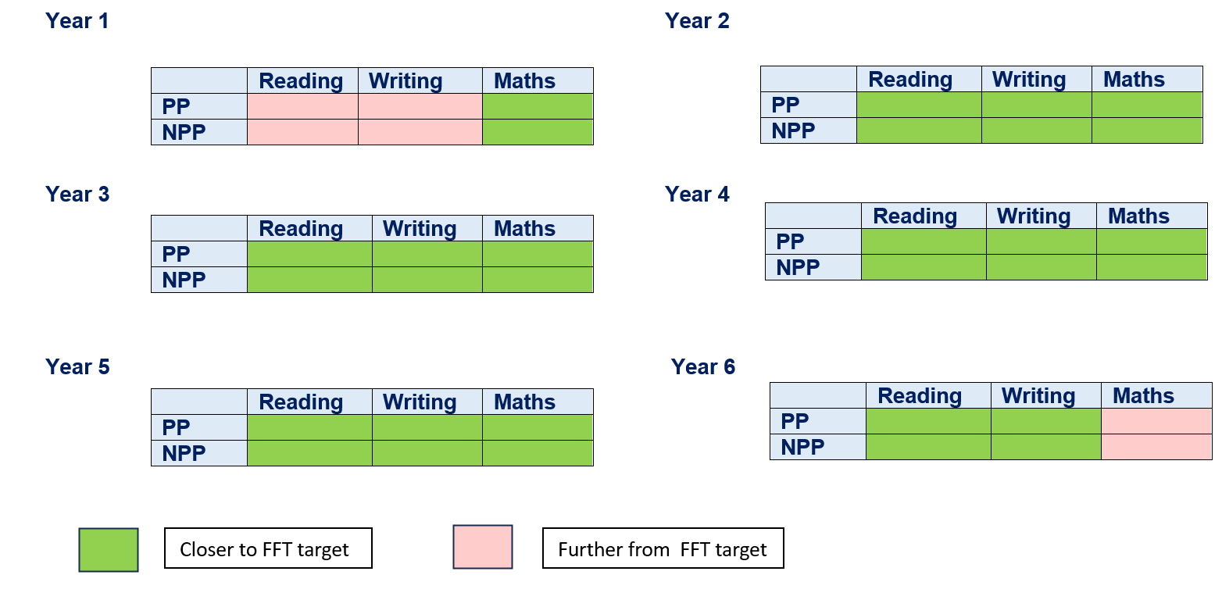  - PP children have made more progress towards FFT targets than NPP groups in the following:  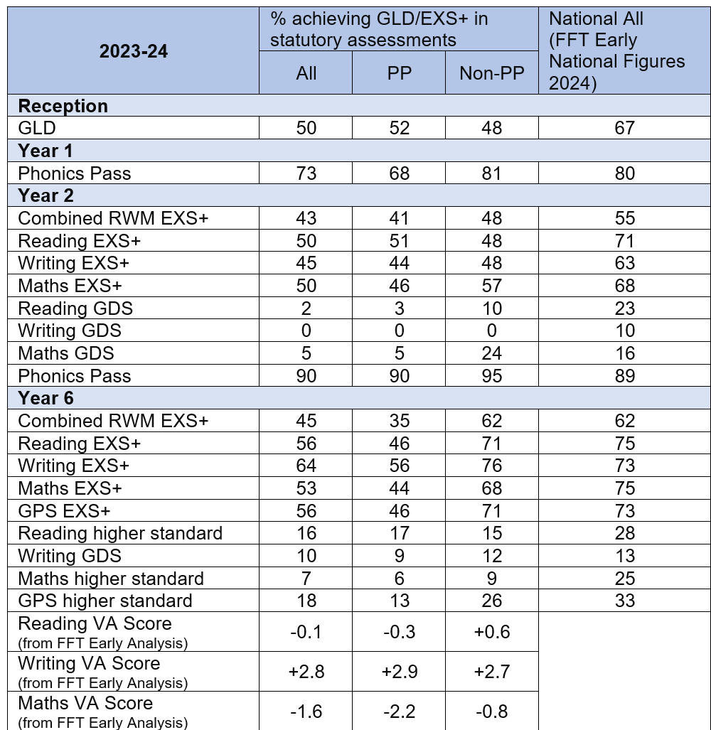
  2022-23 | % achieving GLD/EXS+ in statutory assessments |  |  | National All  (FFT Early National Figures 2023)
  2022-23 | All | PP | Non-PP | National All  (FFT Early National Figures 2023)
  Reception
  GLD | 50 | 33 | 56 | 67.6
  Year 1
  Phonics Pass | 63 | 55 | 68 | 80.5
  Year 2
  Combined RWM EXS+ | 45 | 28 | 50 | 57
  Reading EXS+ | 48 | 34 | 61 | 69
  Writing EXS+ | 47 | 28 | 65 | 61
  Maths EXS+ | 57 | 41 | 71 | 71
  Reading GDS | 7 | 7 | 6 | 19
  Writing GDS | 5 | 0 | 10 | 8
  Maths GDS | 8 | 7 | 10 | 17
  Phonics Pass | 85 | 79 | 90
  Year 6
  Combined RWM EXS+ | 38 | 29 | 49 | 61
  Reading EXS+ | 48 | 39 | 59 | 74
  Writing EXS+ | 56 | 41 | 73 | 73
  Maths EXS+ | 47 | 33 | 63 | 74
  GPS EXS+ | 50 | 39 | 63 | 73
  Reading higher standard | 9 | 10 | 7 | 29
  Writing GDS | 7 | 8 | 5 | 13
  Maths higher standard | 10 | 8 | 12 | 25
  GPS higher standard | 21 | 14 | 29 | 31
  Reading VA Score  (from FFT Early Analysis) | -3.2 | -2.7* | -4.0* | *Data for FSM6 children, rather than PP
  Writing VA Score  (from FFT Early Analysis) | -1.0 | -1.2* | -0.9* | *Data for FSM6 children, rather than PP
  Maths VA Score  (from FFT Early Analysis) | -2.2 | -2.3* | -2.2* | *Data for FSM6 children, rather than PP
  %ARE+ gap between PP and NPP (baseline 2023 – summer 2024)
  Year | Reading | Writing | Maths
  1
  2
  3
  4
  5
  6
   | Reading | Writing | Maths
  Year 1 | NPP | NPP | NPP
  Year 2 | NPP | NPP | NPP
  Year 3 | PP | PP | NPP
  Year 4 | PP | PP | PP
  Year 5 | PP | PP | PP
  Year 6 | PP | PP | PP
Improved language and communication skills among disadvantaged pupils. | Assessments and observations indicate significantly improved oral language among disadvantaged pupils. This is evident when triangulated with other sources of evidence, including engagement in lessons, book scrutiny and ongoing formative assessment.  All children have passed their Phonics Screening Test within two years of starting full-time education by July 2024.  2021/22 Review: The embedding of oracy within all classrooms and across the curriculum has continued this year with additional staff training, support for the embedding of whole school oracy strategies and audit by Voice21. Oracy assemblies have also been introduced this year as well as an extra-curricular debating club. Subject reviews note an increase in pupils’ ability to articulate their learning within lessons and in sharing their work in books.  50% of PP children passed the Y1 phonics screening test this year, as compared to 58% of all children. 74% of PP children in Y2 have now passed the phonics screening, as compared to 80% of all Y2s.  Additional widespread phonics teaching has continued in Y3 this year to reflect the particularly disrupted phonics teaching these children have received in previous years due to COVID-19. Intervention groups have targeted children in Y4, 5 and 6 who had/have not yet passed the phonics screening test.  2022/23 Review:  Further staff training has been delivered for Oracy this year alongside support from Oracy Champions in school. Talk outcome progression grids have been finalised and implemented in all classrooms, culminating in spoken English competitions in Years 1-6. ‘Curious Chats’ for lunchtimes have been introduced to KS2 children through assemblies, aiming to give children every possible opportunity to talk using their oracy skills. Oracy displays have been introduced in all classrooms in KS1 and KS2, displaying discussion guidelines, roles, groupings and scaffolding.  Depending on their needs and starting phonics score, children in KS2 who have not yet passed their phonics screening test, including New to English pupils, have received either ’Rapid Catch-Up’ programmes of Little Wandle phonics or precision teaching interventions. Of 65 children receiving either of these programmes/interventions this year in KS2, including international new arrivals and pupils with SEND, 60% have now passed their phonics screening within the year (74% excluding pupils with SEND).  55% of PP children passed the Y1 phonics screening this year, as compared to 63% of all children (an increase of 5% from last year for both PP and All). 79% of PP children in Y2 have now passed the phonics screening, as compared to 85% of all Y2s (again, an increase of 5% from last year for both PP and All).  2023/24 Review:  Hardwick Primary gained the Voice 21 accreditation for Oracy Centre of Excellence in May 2024.  Further staff training has been delivered for Oracy this year alongside support from Oracy Champions in school. Talk outcome progression grids have been amended taking into account the development of children’s oracy skills. An Oracy Open Day was held in Summer where schools visited Hardwick to see good practice. Children are now more actively engaged in assemblies, with children beginning to lead in some assemblies.  Depending on their needs and starting phonics score, children in KS2 who have not yet passed their phonics screening test, including New to English pupils, have received either ’Rapid Catch-Up’ programmes of Little Wandle phonics or precision teaching interventions. Of 52 children receiving either of these programmes/interventions this year in KS2, including international new arrivals and pupils with SEND, 60% have now passed their phonics screening within the year (79% excluding 13 pupils with SEND).  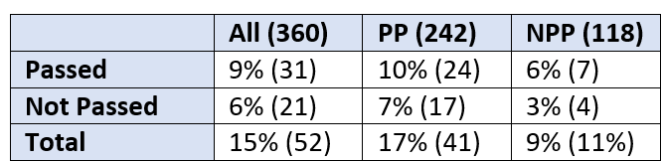  68% of PP children passed the Y1 phonics screening this year, as compared to 73% of all children (an increase of 13% from last year for PP and 10% for All).  90% of PP children in Y2 have now passed the phonics screening, as compared to 90% of all Y2s (an increase of 11% from last year for both PP and 5% for All).
Disadvantaged pupils access a range of extra-curricular opportunities which enrich their access to the curriculum and build cultural capital. | All disadvantaged children take part in at least 2 extracurricular activities and 3 visits per year by July 2024.  2021/22 Review: All year groups (with all children included as present at the time) from FS2 to Y6 have completed at least 2 visits over the course of the academic year. The provision of extra-curricular activities has significantly increased this year, with teachers and TAs offering blocks of extra-curricular tuition and enrichment activities. 79% of PP children have attended at least one extra-curricular activity this year (compared to 73% of non-PP children).  *Please note: data limitation due to all sports clubs being recorded this year on SIMS as one yes/no attendance, so not possible to breakdown attendance at multiple sports clubs. True figure therefore likely to be higher.  2022/23 Review:  All year groups (with all children included as present at the time) from FS2 to Y6 have completed at least 3 visits over the course of the academic year. A significantly expanded offer of enrichment clubs has continued this year, with teachers and TAs delivering blocks of after-school tuition and enrichment clubs. Including tuition groups, 77.6% of children eligible for PP attended at least one extra-curricular activity (similar to in 2021-22), with 47.9% attending at least two and 22.8% attended 3 or more.  *Please note: data limitation due to all sports clubs being recorded this year on SIMS as one yes/no attendance, so not possible to breakdown attendance at multiple sports clubs. True figure therefore likely to be higher.  2023/24 Review:  All year groups (with all children included as present at the time) from FS2 to Y6 have completed at least 3 visits over the course of the academic year. A significantly expanded offer of enrichment clubs has continued this year, with teachers and TAs delivering blocks of after-school tuition and enrichment clubs. Including tuition groups, 71% of children eligible for PP attended at least one extra-curricular activity, with 43% attending at least two and 17% attended 3 or more.  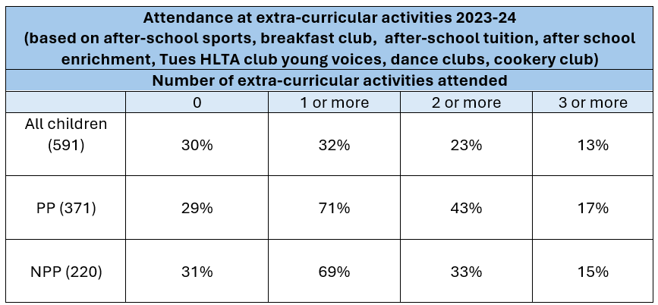
To achieve and sustain improved attendance for all pupils, particularly our disadvantaged pupils. | All disadvantaged pupils are showing good or improving attendance, so that their average attendance is above 95% and the school’s attendance is at least in line with national by July 2024.  2021/22 Review: The school average attendance of both pupil premium and non-pupil premium children has increased since 2020-21. The whole school attendance of pupil premium children is slightly lower than the % attendance for all pupils (92.0% compared to 92.6%) and the percentage of persistently absent children is slightly higher amongst pupil premium children as compared to all (27.2% for PP children; 26.1% for all).  Meetings have, and are continuing, to take place with parents with school, NCAT and EWOs to seek to improve attendance.  The provision of a free breakfast club has been particularly successful this year, with 75-80 children attending on an average day. This has also been a key provision when discussing attendance with parents and seeking strategies for improvement.  2022/23 Review:  Both whole-school and PP attendance figures are lower in 2022-23 than in 2021-22 with an increase in persistent absence also. Attendance will be the first priority in the whole school development plan for 2023-24 with a new in post Attendance Officer supporting the Head of School, Leadership Team and EWO in analysing and targeting poor attendance. The school will be involved in a city-wide Priority Education Investment Area (PEIA) project focusing on raising school attendance.  2023/24 Review:  Both whole-school and PP attendance figures have improved in 2023-24 than in 2022-23. Attendance has been the first priority in the whole school development plan for 2023-24. The school has been involved in a city-wide Priority Education Investment Area (PEIA) project focusing on raising school attendance. This will continue to be a priority for the next academic year 2024-25.
  2022-23 Attendance | End of year % |  |  | National Data
  2022-23 Attendance | All | PP | Non-PP | National Data
  Attendance inc. Nursery | 91.0 | 90.6 | 91.3 | (FFT National Data 2023)  All:93.8%  FSM6: 91.3%  Non-FSM6: 94.7%
  Attendance exc. Nursery | 91.5 | 91.0 | 92.0
  Persistent Absence inc. Nursery | 37.7 | 40.6 | 35.0 | (Pupil Absence in Schools in England: Autumn term 2022/23 – data for primary schools)  All: 20.9%
  Persistent Absence exc. Nursery | 34.6 | 38.4 | 31.0
   | Attendance 2018-19 |  |  | Attendance 2020-21 |  |  | Attendance 2021-22 |  |  | Attendance 2022-23 (as at 21/7/23)
   | PP | Non-PP | Gap  (Internal PP compared to Non-PP) | PP | Non-PP | Gap  (Internal PP compared to Non-PP) | PP | Non-PP | Gap  (Internal PP compared to Non-PP) | PP | Non-PP | Gap  (Internal PP compared to Non-PP) | FFT National attendance average 2022-23  All:93.8%  FSM6: 91.3%  Non-FSM6: 94.7%
  FS2 | 92.1% | 93.0% | -0.9% | 86.8% | 88.2% | -1.4% | 90.7% | 91.2% | -0.5% | 86.2% | 89.4% | -3.2%
  Y1 | 95.8% | 95.7% | +0.1% | 91.8% | 93.2% | -1.4% | 89.9% | 93.2% | -3.3% | 91.9% | 91.4% | +0.5%
  Y2 | 95.5% | 95.3% | +0.2% | 91.1% | 93.1% | -2.0% | 93.6% | 95.0% | -1.4% | 92.7% | 90.8% | +1.9%
  Y3 | 95.6% | 95.6% | = | 93.0% | 94.9% | -1.9% | 92.3% | 94.4% | -2.1% | 90.7% | 92.4% | -1.7%
  Y4 | 96.6% | 96.3% | +0.3% | 91.6% | 93.2% | -1.6% | 93.5% | 94.5% | -1.0% | 90.7% | 93.0% | -2.3%
  Y5 | 96.5% | 96.3% | +0.2% | 94.0% | 95.2% | -1.2% | 91.6% | 93.7% | -2.1% | 92.0% | 92.9% | -0.9%
  Y6 | 95.6% | 96.6% | -1.0% | 91.5% | 92.9% | -1.4% | 92.9% | 95.7% | -2.8% | 90.7% | 94.0% | -3.3%
  2023-24 Attendance | End of year % |  |  | National Data
  2023-24 Attendance | All | PP | Non-PP | National Data
  Attendance exc. Nursery | 92.5 | 91.1 | 94.9 | (FFT National Data 2024)  All:94.3%  FSM6: 91.3%  Non-FSM6: 94.7%
  Persistent Absence exc. Nursery | 28.1 | 35 | 16 | All: 16%  PP – 29%  NPP – 11%
   | Attendance 2020-21 |  |  | Attendance 2021-22 |  |  | Attendance 2022-23 (as at 21/7/23) |  |  |  | Attendance 2023-24
   | PP | Non-PP | Gap  (Internal PP compared to Non-PP) | PP | Non-PP | Gap  (Internal PP compared to Non-PP) | PP | Non-PP | Gap  (Internal PP compared to Non-PP) | PP |  | Non-PP | Gap  (Internal PP compared to Non-PP) | School:  All – 92.5  FSM6: 91.1%  Non-FSM6: 94.9%  FFT National attendance:  94.3
  FS2 | 86.8% | 88.2% | -1.4% | 90.7% | 91.2% | -0.5% | 86.2% | 89.4% | -3.2% | 88.3% |  | 90.9% | -2.6
  Y1 | 91.8% | 93.2% | -1.4% | 89.9% | 93.2% | -3.3% | 91.9% | 91.4% | +0.5% | 89.4% |  | 93.9% | -4.5
  Y2 | 91.1% | 93.1% | -2.0% | 93.6% | 95.0% | -1.4% | 92.7% | 90.8% | +1.9% | 93.4% |  | 95.6% | -2.2
  Y3 | 93.0% | 94.9% | -1.9% | 92.3% | 94.4% | -2.1% | 90.7% | 92.4% | -1.7% | 90.9% |  | 96.0% | -5.1
  Y4 | 91.6% | 93.2% | -1.6% | 93.5% | 94.5% | -1.0% | 90.7% | 93.0% | -2.3% | 91.5% |  | 95.2% | -3.7
  Y5 | 94.0% | 95.2% | -1.2% | 91.6% | 93.7% | -2.1% | 92.0% | 92.9% | -0.9% | 90.5% |  | 95.9% | -5.4
  Y6 | 91.5% | 92.9% | -1.4% | 92.9% | 95.7% | -2.8% | 90.7% | 94.0% | -3.3% | 92.6% |  | 95.9% | -3.3
To achieve and sustain improved wellbeing and resilience for all pupils in our school, particularly our disadvantaged pupils. | Increased mental health and wellbeing due to personalised support programmes in nurture for pupils identified with a specific need to (ELSA, Nurture ABC, Theraplay, Nurture).  Pupils receiving nurture intervention make good or accelerated progress in RWM and increase in confidence.  Class engagement increases and pupils are engaged in lessons, after school clubs and other extracurricular activities.  2021/22 Review: The provision of mental health and wellbeing support this year has been increased and widened to include lunchtime and after-school groups, in addition to nurture groups, ELSA support, Nurture ABC and individual direct work. 78 different children have accessed at least one of these nurture provisions this year – 58% of whom have been pupil premium children (42% non-pupil premium).  Class teachers report an increase in the engagement and confidence of these pupils within the classroom. 85% of all children and 93% of PP children attending some form of nurture/wellbeing support have accessed at least one extra-curricular activity this year (both figures above the rates from those children not attending a nurture/wellbeing provision).  Pupils receiving nurture intervention are, on average, 6 points closer to their reading and writing FFT targets at Summer 2022 than at Baseline 2021, and 7 points closer to their maths FFT targets (based on scaled scores for pupils with FFT targets, baseline and summer assessments). 86% of children receiving nurture interventions made good or accelerated progress from Baseline 2021 to Summer 2022 in reading, 88% in writing and 88% in maths.  2022/23 Review:  An extended mental health and wellbeing offer has been continued this year. 60 different children have accessed at least one of Nurture Group, after-school enrichment, ELSA or Nurture ABC, with many accessing multiple provisions based on their individual needs. Of these children, 59% have been pupil premium children.  Class teachers report an increase in the engagement and confidence of these pupils within the classroom. Of the pupil premium children attending some form of nurture/wellbeing support this year, 88% have accessed at least one extra-curricular activity and 53% have accessed at least two extra-curricular activities (both figures above the rates from those children not attending a nurture/wellbeing provision).  Pupils with full year data receiving nurture intervention (FFT Baseline 2022 to FFT Summer 2023 TA with target data) are on average 0.9 points closer to their FFT targets in reading, 1.5 points closer in writing and 2.6 points closer in maths.  2023/24 Review:  An extended mental health and wellbeing offer has been continued this year. 113 different children have accessed at least one of Nurture Group, after-school enrichment, ELSA or Nurture ABC, with many accessing multiple provisions based on their individual needs. Of these children, 76% have been pupil premium children.  Class teachers report an increase in the engagement and confidence of these pupils within the classroom.

Activity in this academic year
This details how we intend to spend our pupil premium (and recovery premium funding) this academic year (2023-24) to address the challenges listed above.

Teaching (for example, CPD, recruitment and retention)
Budgeted cost: £321,500
Activity | Evidence that supports this approach | Challenge number(s) addressed
Employment of 8 HLTAs to support quality of teaching and learning across year groups, to deliver and enable teacher delivery of targeted support and intervention in all lessons, including targeted EAL support and extra-curricular provision (including resources for extra-curricular sessions).  (£320,000) | OFSTED Research (2019) suggests that effective pedagogy consists of both teaching and the provision of instructive and stimulating learning environments.  Findings from the recent Ofsted report (COVID-19 series: briefing on schools, October 2020 visits) show how the gap has widened for the most vulnerable pupils. It concluded that many schools are focussing on reading, mathematics and stamina for writing to help combat lost learning.  There is strong evidence of very high impact for oral language interventions, including targeted reading, extending pupils’ vocabulary, structured questioning and dialogic activities. Oral language interventions | EEF (educationendowmentfoundation.org.uk)  There is also strong evidence of very high impact of feedback which redirects or refocuses the learner’s actions to achieve a goal, including that possible through additional HLTA support.  Oral language interventions | EEF (educationendowmentfoundation.org.uk) | 1, 2, 3, 4
Purchase of Widgit Online software for production of visual resources, plus EAL add-on for translated resources.  (£1,500) | Bell Foundation (2021) Effective Teaching of EAL – ‘EAL learners will benefit from being provided with additional contextual support to help them make sense of the information conveyed to them in English. The use of images and graphic organisers (e.g. diagrams, grids, charts, timelines) are very useful for this purpose.’  ‘Visuals provide context so that EAL learners can make sense of what is being taught in the curriculum. Visuals can be used with EAL learners at all stages of English language proficiency, at any age and across the curriculum.’ | 1, 2

Targeted academic support (for example, tutoring, one-to-one support structured interventions)
Budgeted cost: £19,300
Activity | Evidence that supports this approach | Challenge number(s) addressed
Provision (and 25% cost of) tuition to support COVID catch-up, including tutor training.  (£17,000) | Small group tuition has impact on supporting learners to ensure effective progress, teach challenging topics or skills, or to support those who are falling behind.  Small group tuition | EEF (educationendowmentfoundation.org.uk)  Where this is offered on a 1-2-1 basis, there is moderate evidence of high impact.  One to one tuition | EEF (educationendowmentfoundation.org.uk) | 1, 2
Purchase of diagnostic assessment materials for identification of learning gaps and barriers.  (£2,300) | Small group tuition has impact on supporting learners to ensure effective progress, teach challenging topics or skills, or to support those who are falling behind. Small group tuition is most likely to be effective if it is targeted at pupils’ specific needs. Diagnostic assessment can be used to assess the best way to target support.  Small group tuition | EEF (educationendowmentfoundation.org.uk)  Where this is offered on a 1-2-1 basis, there is moderate evidence of high impact.  One to one tuition | EEF (educationendowmentfoundation.org.uk) | 1, 2

Wider strategies (for example, related to attendance, behaviour, wellbeing)
Budgeted cost: £83,200
Activity | Evidence that supports this approach | Challenge number(s) addressed
Provision of a free daily breakfast club to support attendance and punctuality and pupil wellbeing and readiness to learn.  (£20,000) | EEF Improving Behaviour in Schools research on breakfast clubs suggests that it can improve behaviour and outcomes for those that attend. Institute for Fiscal Studies and National Children’s Bureau (2016) ‘Magic Breakfast: evaluation report and executive summary. | 3, 4, 5
Provision of targeted year group Nurture groups, including required resources for sessions.  (£15,000) | DFE (2018) ‘Mental Health and Behaviour in Schools’ suggest that effective Early Help and multi-agency working is a protective factor in mental health in schools. Therefore offering quicker access to support is increasing the protective factors of our vulnerable children and families.  There is some evidence of positive impact of social and emotional learning on pupil outcomes. Evidence suggests that children from disadvantaged backgrounds have, on average, weaker social and emotional skills than their more affluent peers, which is likely to influence their mental health and academic attainment. SEL interventions that are shown to improve SEL skills and therefore likely to support disadvantaged pupils to understand and engage in healthy relationships with peers and emotionally regulate, both of which may subsequently increase academic attainment.  Social and emotional learning | EEF (educationendowmentfoundation.org.uk) | 5
Provision of free uniform and bookbag for PP children.  (£7,700) | DFE (2018) ‘Mental Health and Behaviour in Schools’ suggest that effective Early Help and multi-agency working is a protective factor in mental health in schools. Therefore offering quicker access to support is increasing the protective factors of our vulnerable children and families.  The EEF’s guide to Behaviour (2021) recognises the value of understanding pupil context and the factors that may influence pupils’ behaviour and engagement in learning.  Improving behaviour in schools (d2tic4wvo1iusb.cloudfront.net) | 4
Provision of free trips and extra-curricular visits for pupil premium children.  (£23,000) | The Sutton Trust (2015) found that the role of schools as places of cultural and social as well as academic learning has become even more critical. They recommend that schools’ pupil premium money could be used for enrichment vouchers to offer middle class experiences to those who actually need them most. As we have found many of our children do not gain much/any cultural capital from home, it is essential we provide these experiences at school. | 2, 3
Provision of free after-school enrichment and tuition clubs, including required resources.  (£14,000) | The Sutton Trust (2015) found that the role of schools as places of cultural and social as well as academic learning has become even more critical. They recommend that schools’ pupil premium money could be used for enrichment vouchers to offer middle class experiences to those who actually need them most. As we have found many of our children do not gain much/any cultural capital from home, it is essential we provide these experiences at school.  There is evidence of positive impact of arts participation on both academic outcomes and wider benefits such as more positive attitudes to learning and increased well-being.  Arts participation | EEF (educationendowmentfoundation.org.uk) | 1, 2, 3, 5
Staffing for free holiday clubs for pupil premium children.  (£3,500) | There is evidence of positive impact of summer schools, including when involving non-academic activities such as sports, arts or cultural enrichment which are valuable in their own right.  Summer schools | EEF (educationendowmentfoundation.org.uk) | 3, 5
Total budgeted cost: £424,000

Part B: Review of outcomes in the previous academic year

Pupil premium strategy outcomes
This details the impact that our pupil premium activity had on pupils in the 2020/21 and 2021/22 academic years.
Summary of actions taken 2021-22:
In reviewing attainment and progress data for 2021/22, the impact of COVID-19 was particularly apparent for our disadvantaged pupils with the concurrent reopening of attainment gaps, particularly when compared with July 2019 data; non-pupil premium children outperformed pupil premium children across statutory assessments in 2021/22. However, during 2021/22, pupil premium children closed the gaps between their current attainment and school FFT targets in all subjects and year groups other than one (Y2 maths), though most were not yet achieving their FFT targets. At the end of 2021/22, across KS1 and KS2, pupil premium children were on average 4.15 away from their FFT scaled score targets in reading, 5.5 away from their FFT scaled score targets in writing and 4.1 away from their FFT scaled score targets in maths (as compared to being 8.4 away in reading, 10.4 away in writing and 10.0 away in maths at the end of the Autumn term 2021). At the end of 2021/22, Pupil Premium children were, on average, closer to their FFT targets in maths than non-Pupil Premium children whilst non-Pupil Premium children were closer to their FFT targets in reading and writing. To support a focus on quality first teaching across the school, pupil premium funding was utilised for the employment of HLTAs supporting classroom learning, small group and 1:1 support for the lowest 20% of readers, as well as provision of after school clubs.
The journey of embedding oracy within all classrooms and across the curriculum continued in 2021/22, with additional staff training, support for embedding of whole school oracy strategies and the completion of an audit by Voice21. Oracy assemblies were introduced in 2021/22 as well as an extra-curricular debating club. Subject reviews subsequently recognised an increase in pupils’ ability to articulate their learning within lessons and to share their work in books.
In 2021/22, 50% of PP children passed the Y1 phonics screening test, as compared to 58% of all children. 74% of PP children in Y2 had passed the phonics screening (either in Y1 or Y2), as compared to 80% of all Y2s. Additional widespread phonics teaching continued in Y3 to reflect the particularly disrupted phonics teaching these children received in previous years due to COVID-19. Intervention groups targeted children in Y4, 5 and 6 who had not yet passed the phonics screening test.
In 2021/22, all year groups (with all children included as were present at the time) from FS2 to Y6 completed at least 2 visits over the course of the academic year. The provision of extra-curricular activities significantly increased, with teachers and TAs offering blocks of extra-curricular tuition and enrichment activities. 79% of PP children attended at least one extra-curricular activity in 2021/22 (compared to 73% of non-PP children).

The school average attendance of both pupil premium and non-pupil premium children increased in 2021/22 compared with 2020/21. The whole school attendance of pupil premium children was slightly lower than the % attendance for all pupils (92.0% compared to 92.6%) and the percentage of persistently absent children was slightly higher amongst pupil premium children as compared to all (27.2% for PP children; 26.1% for all). Meetings took place throughout the year with parents with school, NCAT and EWOs to seek to improve attendance.

The provision of a free breakfast club was particularly successful, with 75-80 children attending on an average day during 2021/22. This was a key provision when discussing attendance with parents and seeking strategies for improvement.

The provision of mental health and wellbeing support in 2021/22 increased and widened to include lunchtime and after-school groups, in addition to nurture groups, ELSA support, Nurture ABC and individual direct work. 78 different children accessed at least one of these nurture provisions during the year – 58% of whom were pupil premium children (42% non-pupil premium). Class teachers reported an increase in the engagement and confidence of these pupils within the classroom. 85% of all children and 93% of PP children attending some form of nurture/wellbeing support accessed at least one extra-curricular activity during the year (both figures above the rates for those children not attending a nurture/wellbeing provision). Pupils receiving nurture intervention were, on average, 6 points closer to their reading and writing FFT targets at Summer 2022 than at Baseline 2021, and 7 points closer to their maths FFT targets (based on scaled scores for pupils with FFT targets, baseline and summer assessments). During 2021/22, 86% of children receiving nurture interventions made good or accelerated progress from Baseline 2021 to Summer 2022 in reading, 88% in writing and 88% in maths.

All PP children were provided with free school uniform and book bags, as well as free access to extra-curricular opportunities including a Y5/6 residential and summer term. Free Breakfast Club access continued for pupil premium children.
Summary of actions taken 2020-21:
Funding utilised for the employment of HLTAs focussed on quality first teaching, small group and 1:1 support for the lowest 20% of readers, as well as provision of after school clubs. Reading was a key focus including providing children with opportunities to access books online and via online learning through the use of Purple Mash and Teams. Children’s speech and language needs were targeted through Talk Boost and SaLT interventions.
Staff received training on ‘Reading for Fluency’ during the summer term and were able to implement this during after-school clubs and tuition sessions. Teachers reported an increase in children’s confidence when reading using these strategies and an improvement in phonics ability. Staff also received Oracy training which was embedded into live TEAMs lessons and in-school teaching, with improvements in children’s interaction and communication being subsequently noted.
All PP children were provided with free school uniform and book bags, as well as free access to extra-curricular opportunities including a Y5/6 residential and summer term. Free Breakfast Club access continued for pupil premium children.
Year 1 and Year 3 pupils benefited from access to ELSA sessions, whilst other children requiring SEMH support were able to access direct therapy work, with group Nurture sessions limited by COVID-19 restrictions. An increase in reports of children with SEMH needs was seen, with further SEMH support being essential for the next academic year.
Pupil outcomes saw variations due to school closures and prolonged lockdowns, whilst percentages of children meeting age-related expectations was significantly impacted by COVID-19 closures and disruption. Some year group cohorts continued to narrow gaps between PP and non-PP, or had PP children outperforming non-PP, whilst in others, the gap widened. In Reception, non-PP pupils outperformed PP pupils, with the percentage of pupils at a good level of development by 12% (45%). In Year 1 PP pupils outperformed non-PP pupils by 1% in Writing and Maths and the gap was narrowed by 2-3%. In Reading, non-PP pupils outperformed PP pupils by 3%. Non-PP pupils in Year 1 were ahead of PP pupils by 2% with the percentage of pupils who passed their phonics screening (54%). In Year 3-5, non-PP pupils were ahead of PP pupils in reading, writing and maths. In Years 3 and 5 the gap in writing and maths continued to widen. There was some narrowing of the gap in reading. However, in Year 4, although non-PP pupils were ahead, the gap narrowed in all three subjects (RWM - 6% in reading, 11% writing and 7% in maths). In Year 6, PP pupils outperformed non-PP pupils in reading, writing, maths and RWM. The gap was closed significantly when compared to last year’s Year 6 pupils. This emphasises the importance of maintaining a key focus on high-quality teaching as a significant means of addressing learning gaps and encouraging accelerated progress.
Across the school (and nationally) attendance was lower in 2020-2021 than prior to the COVID pandemic. In 2018-19, PP attendance was in line with non-PP and national averages. However, in 2020-21, PP attendance was lower than the attendance of non-PP children by 1-2% in all year groups, and rates of persistent absence higher in PP children when compared to non-PP. This emphasises the importance of a continuing focus on attendance for our PP children in this next Pupil Premium Strategy.

Externally provided programmes
Programme | Provider
N/A for 2020/2021

