Year 5 Home Learning
Week Commencing: 8th June 2020
Year 5 staff: (Mrs Nisa, Mr Caldwell and Mrs Hollingworth, Miss Gent, Mrs Begum)

Message from staff:
Hi year 5, we hope you are enjoying the beautiful warm weather and had a relaxing time during the holidays. Those of you who celebrated Eid last week, we hope you had a wonderful time.
Please make sure you go out in your garden or park with your families- stay safe and remember to stay 2 meters away from members of different households. It is really nice to speak to you over the phone and we look forward to hearing about what you have been up too.

Your Home Learning this Week:
Every day (Monday to Friday), make sure you choose a *reading, *writing, *spelling/handwriting, *maths and *theme learning activity. There are also further activities to choose from should you wish to.

Reading Home Learning
Monday | Tuesday | Wednesday |  | Thursday | Friday
You will be reading a text about healthy eating. Read the text carefully and highlight or underline any word you do not understand.  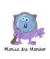 | Re-read the text and find the meaning of the words you do not understand from yesterday. | Using Stan Summariser, summarise the main information about healthy eating and why it is important– do not forget to use your VIP’s (very important parts).  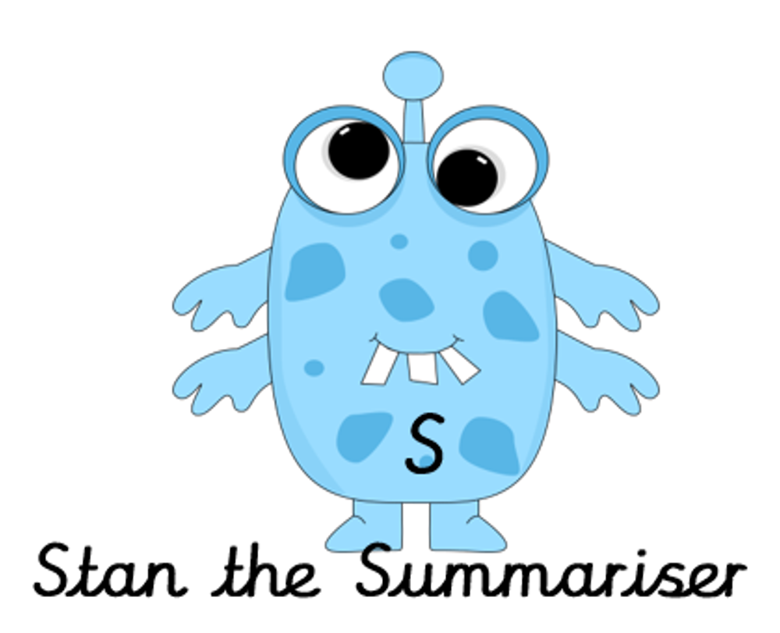 |  | Now try answering these questions:  - Why is a balanced diet important?  - What is the function of protein?  - What does the word ‘excessive’ mean?  - Can you give examples of foods we should try to avoid eating excessive amounts of?  - Chose the word closest in meaning to the underlined word. With a balanced diet, your body obtains the fuel and nutrients it needs to function properly.  rest work eat healthy | After reading the text on healthy eating think of any questions you may have. Is there anything you were left wondering that was not answered? Write these questions down. Reread the text again and this time, try to answer the questions you have. Can you answer them? If not, try to research the answers
Easier:  Do as many of the above activities as you can. If you are finding some of the activities challenging, try these as they are a little easier:  - Read the easier version of the text.  - Highlight any words you do not understand and find out what they mean.  Try and answer these questions:  - Why is a balanced diet important?  - Meat, fish and eggs are a good source of…  - What do fruit and vegetables give our bodies?  - How much fatty food should we eat? |  |  | Challenge:  If you feel you need a further challenge, try these:  Answer the following questions:  - What affect does too much saturated fat have on the body and heart?  - Why should we reduce the amount of salt we eat?  - Research what ‘diabetes’ is and how a healthy diet can help to control it.

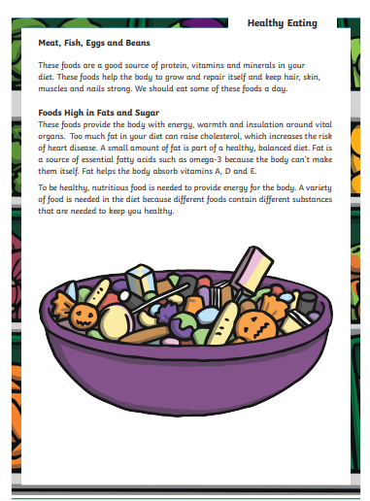
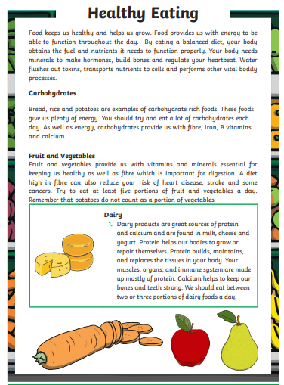
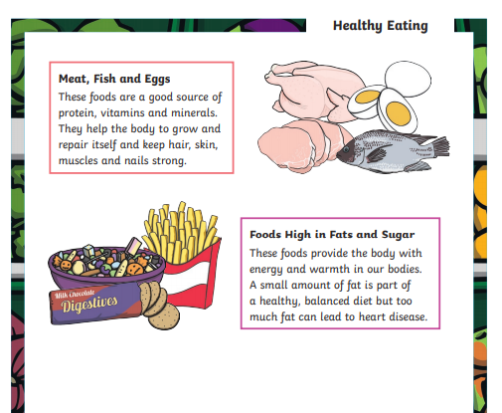
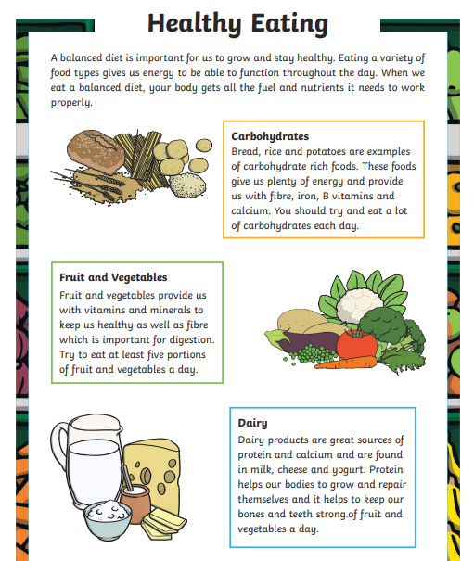
Easier text

Writing Home Learning
Monday | Tuesday | Wednesday |  | Thursday | Friday
This week Mrs Nisa, Mr Caldwell and Mrs Hollingworth want you to have a go at writing a persuasive letter to Mrs Awaan about junk food and healthy food. Read the text below – Junk food or healthy food and think about what your opinions are. | Mind map as many reasons as possible for why you should eat healthy. You will use this information to help you persuade Mrs Awaan that you should eat healthy but how occasional junk food is not a bad thing. | Mind map reasons why you should be able to eat junk food sometimes and think about how you will include this information to persuade Mrs Awaan that some junk food is ok. |  | Write your introduction for your persuasive text – remember to begin with the question ‘Junk food or healthy food?’ Explain to Mrs Awaan why you are writing to her. | Using your mind map ideas, write 3 good reasons why we should eat a healthy diet, then 2 reasons why we should be able to eat junk food sometimes (maybe once a week as a treat).
Easier:  Do as many of the above activities as you can. If you are finding some of the activities challenging, try these as they are a little easier:  - Create a fact file instead to explain why exercise is important.  - Include a section in your fact file about healthy foods and what type of foods you should and shouldn’t eat.  - Include diagrams of possible exercises you can do. |  |  | Challenge:  If you feel you need a further challenge, try these:  - Research how too much saturated fat and salt from junk food can affect your heart and include this in your letter to Mrs Awaan.  - Include more sophisticated persuasive vocabulary from the vocabulary mat below.  - Try to alternate your paragraphs between reasons to eat healthy and reasons why a little junk food is O.K. – use comparative conjunction below:  - Furthermore, on the other hand and however.

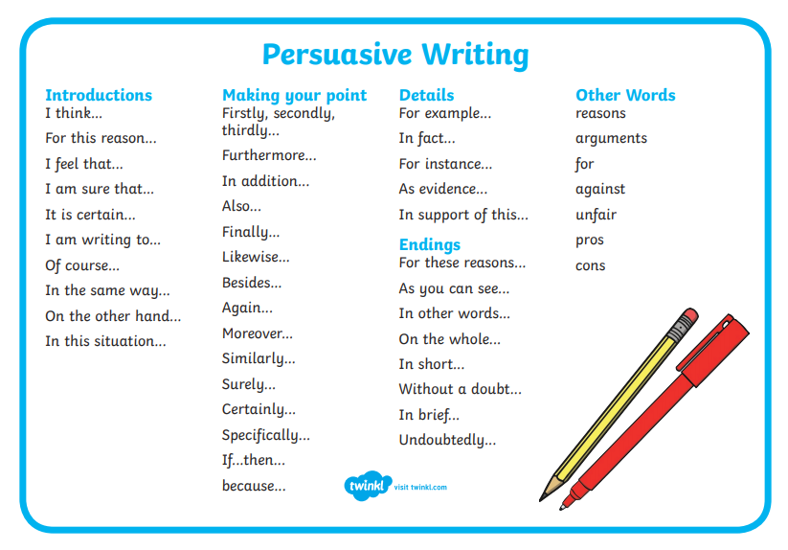
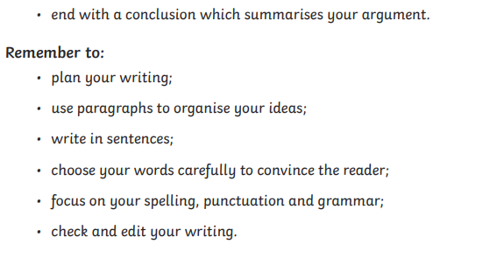
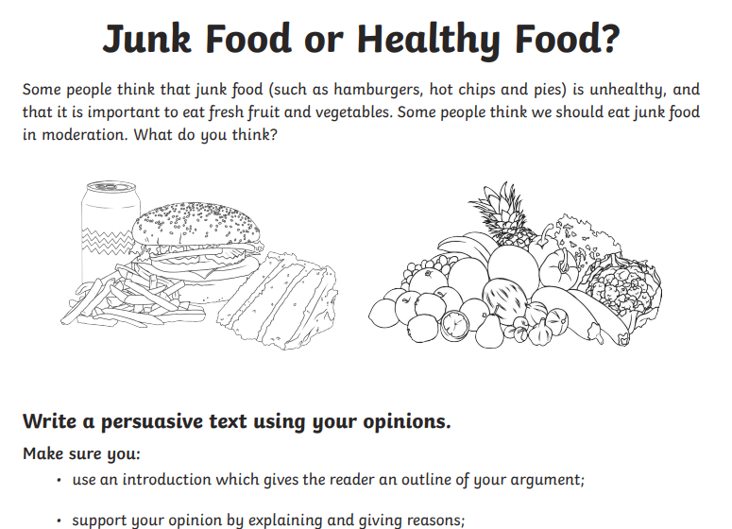

Spelling/Handwriting Home Learning
Monday | Tuesday | Wednesday |  | Thursday | Friday
Pick out some challenging words from a book you are reading or the new text chosen from the reading activities. Create your own spelling list to practice this week. | Practice your spellings. Use one of the many techniques you have been taught.  -Different colour syllables.  -Say it the way you see it.  -Word pyramid.  -Look cover, write check. | Copy out your reading text in your best joined up writing.  Do it again to see if you can make it even neater.  (remember- Not too small, not too big, letters in proportion to each other, CONSISTENCY. |  | Using the spellings you have chosen on Monday, practice your cursive handwriting.  This time do some SPEED WRITING. Challenge your family members.  How many of one word can you write in ONE minute? | Get your siblings or parents or anyone that can help, to test you on the spellings you have been revising.  Any you get wrong can go on a permanent list to practice another time.
Easier:  Do as many of the above activities as you can. If you are finding some of the activities challenging, try these as they are a little easier:  - Pick out words from any books you have, that are tricky for you and practice them. Get someone to test at the end of the week.  - Use the same words for handwriting practice.  - Play hangman with the words you have chosen. |  |  | Challenge:  If you feel you need a further challenge, try these:  - Continue with some of your old spelling lists (if you found them last week) practice the ones you struggled with the most.  - Find year 4 and 5 spellings lists online and pick out the ones you are most unsure about.  - Find the definitions of words you do not know.  - Play games like hangman. Or BIG challenge: INVENT your own game using the words.

Maths Home Learning
Monday | Tuesday | Wednesday |  | Thursday | Friday
1 year =12 months  Half a year= ?  ¼ year = 3 months  2 years =24 months  3 years=?  3 ½ years =?  4 years=  41/4 years =  Carry on the pattern | Copy out your 7 times table.  1 week =7 days  2 weeks=? Days  Carry on up to 10 weeks  2 weeks and 4 days= 14+4=18 days  28 days = 4 weeks  To get the answer divide by 7 | 1 hour =60 mins  ½ hour =  ¼ hour=  2 ½ hours=  3 ¼ hours =  70 mins =? Hours m  90 m= ?h ?mins |  | 1 day =24 hours  1 ½ days =24 +12h  Explain  2 ¼ days =?  2 ½ days =?  Write your own number sentences using days and hours | Write 2 number sentences linked to hours and days. Ask an adult to work out the answer
Easier:  Do as many of the above activities as you can. If you are finding some of the activities challenging, try these as they are a little easier:  1 hour = ? 2 hours = ? 3hours= ? 4hours= ?  Write out your 7 times table start with 7 and keep adding 7  Write out your 12 times table start with 12and keep adding 12. |  |  | Challenge:  If you feel you need a further challenge, try these:  Decide if the following involve thinking about length or area.  Write your own word problems linked to time. Draw a diagram to show your answers.  Write number sentences linked to hours, days weeks, months and years. (look at the examples above)

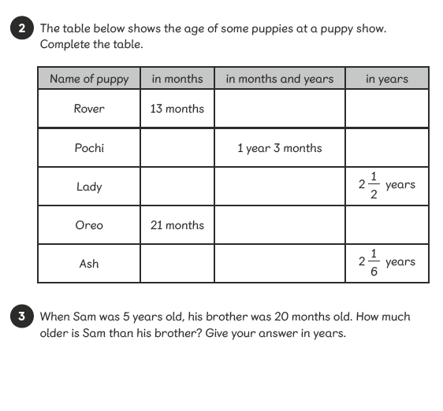
Activity 1

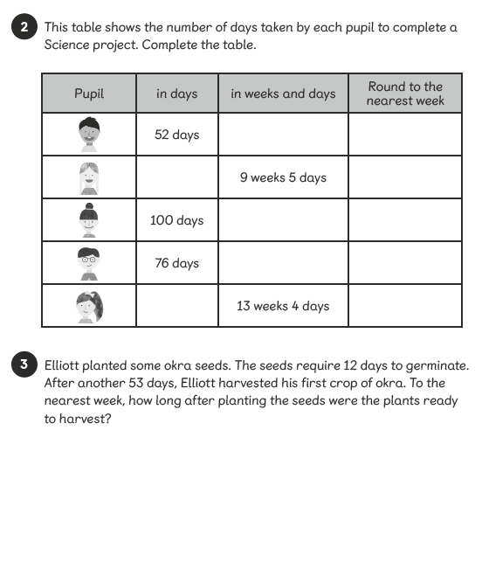
Activity 2

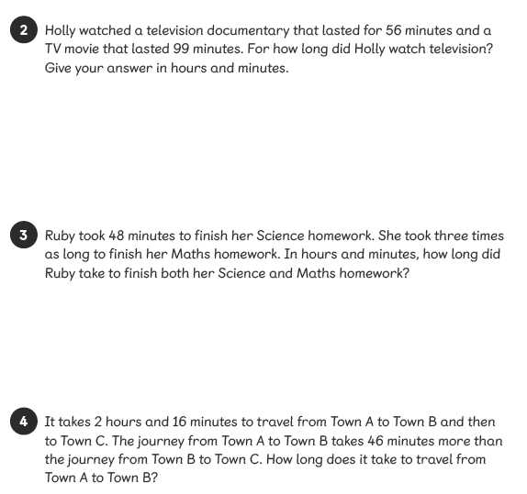
Activity 3
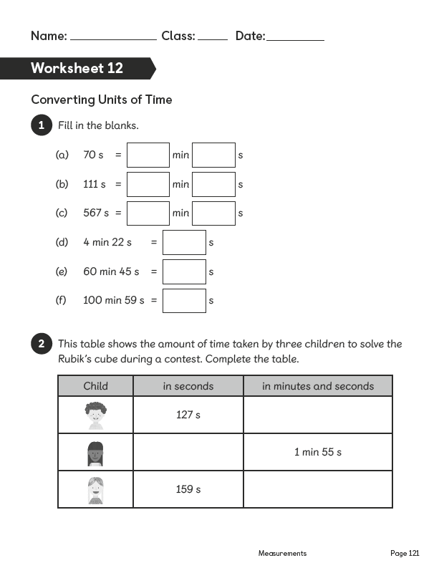
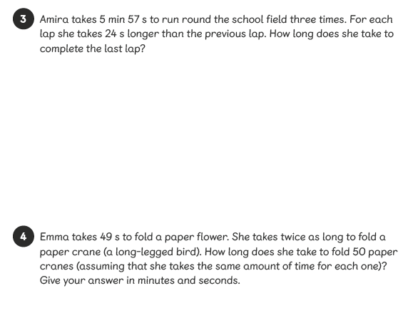
Activity 4
Activity 5

Theme Activities – Home Learning

Monday | Tuesday | Wednesday |  | Thursday | Friday
Plan out some healthy meals for the next few weeks. Some can be repeated each week. Work with mum and dad to see what you have at home and things you will need from the shop. Make a list. | If you can, go shopping with mum or dad with the shopping list.  Look for the best value for items and check the quality of any fresh products you buy. If not make sure they take it with them when they go shopping. | Spend time in the kitchen learning new cooking skills from your parents. Remember, when creating a meal, it must be balanced and include all the food groups. Carbohydrates, Protein, vitamins and minerals (fruit and veg), fats.  The best way to eat is to have a balanced diet. To combine foods from all the groups but small amounts of fat and sugar.  Make sure you take photos of what you are doing in the kitchen and take photos of your creations in the kitchen.
Easier:  Do as many of the above activities as you can. If you are finding some of the activities challenging, try these as they are a little easier:  - Make a list of the things you eat throughout the week.  - Split the list into three:  - HEALTHY, UNHEALTHY, BOTH |  |  | Challenge:  If you feel you need a further challenge, try these:  - Create some comment cards for your family to tell you what they thought about the food.  - Use the 2 stars and a wish idea. 2 things they liked 1 thing that could be improved.
Other Activities
Draw a plan of your bedroom. Label it with all the main features. Door, window, bed etc | Draw a new plan to rearrange you room if you can.  It helps to change our surroundings and can be exciting to feel like in a new place even though it’s your normal room | Make a den.  If you don’t know what this is then ask your parents.  Every should make a den at some point in their life.  Couch/sofa cushions can help, a spare sheet, poles/broom etc. | Movie night with the family. Vote for a film to watch. Get some healthy snacks popcorn (not toffee) fruit (nature’s sweets)  At the end everyone to do 2 star and 1 wish
Key skills to continue practicing weekly:
- Timetables, Handwriting, Reading of own books, PE/Exercise.
If you are able to access the internet, try these useful websites:

If you or your child has any further queries regarding their learning projects, please contact admin@hardwick.derby.sch.uk, clearly stating your child’s name and class teacher, and the staff will be in touch to support you and your child.

Thank you and stay safe.

