Year 2 Home Learning Projects
Week 1 Summer Term
Hope you are all well and taking this time to do lots of reading and having fun. A few projects to keep you busy learning for the next week. There are extra challenges and some alternative tasks if you are finding them a bit hard.
English
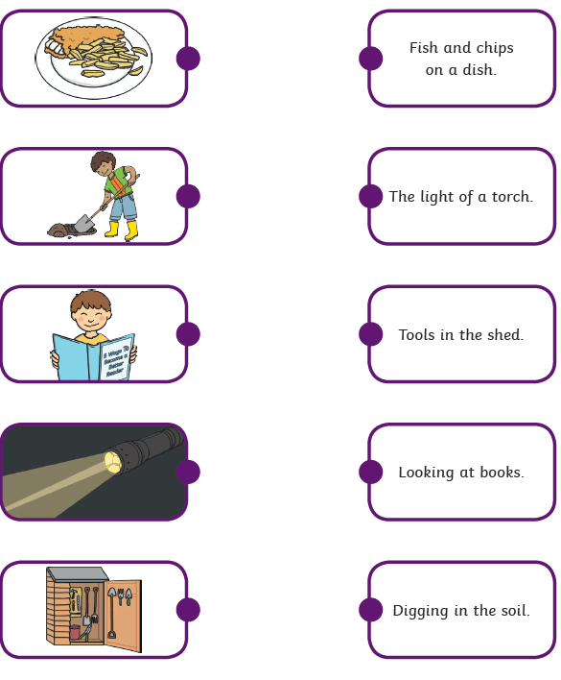
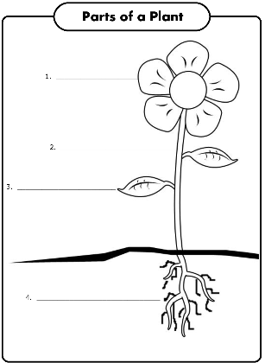
Can you label this picture ?
Maths
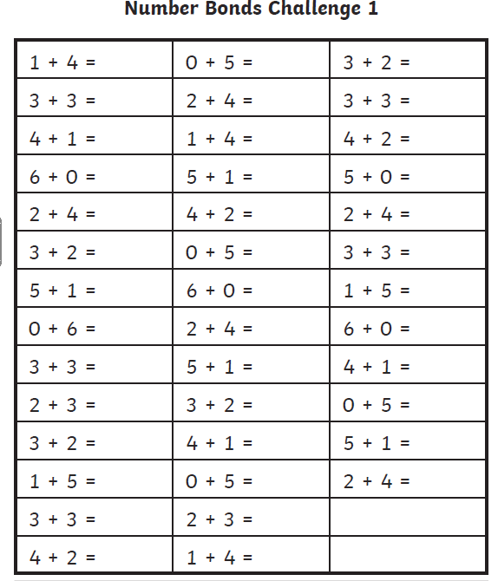
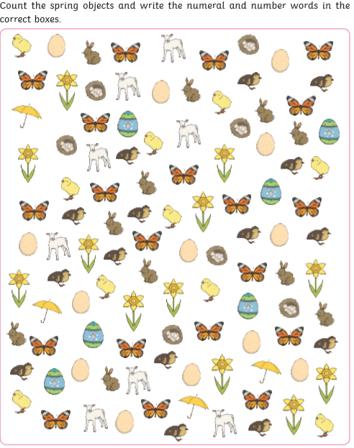
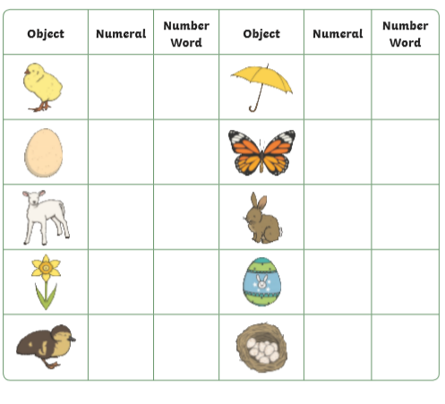

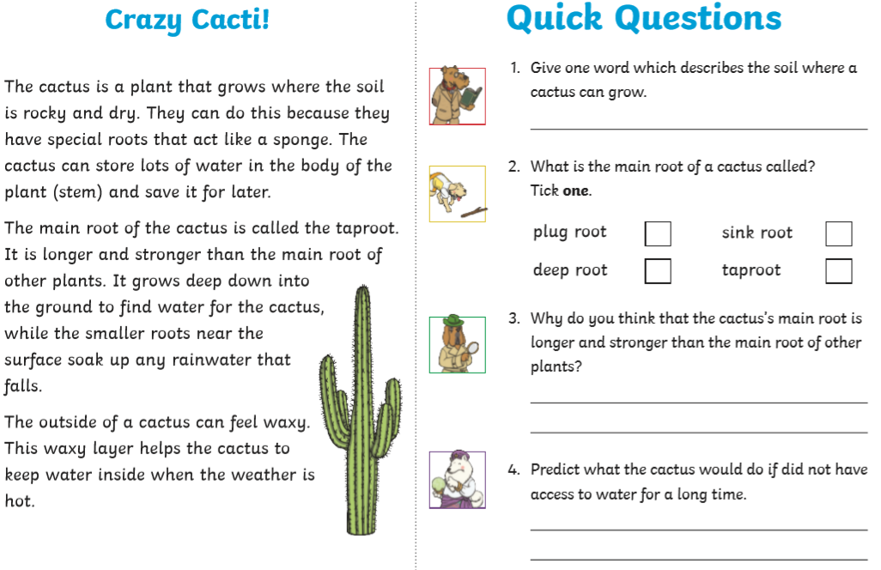
More Home Learning to follow later in the week.

