Year 4 Home Learning
Week Commencing: 18th May 2020
Year 4 teachers: Mrs Haslam, Mrs Tatla, Mrs Jogela and Miss Annable
Year 4 TAs: Miss Perry and Mrs Smith
Message from staff: Hi Year 4, we hope that you are all well and keeping safe. Even though we are not teaching you, we are thinking about you and working very hard to provide fun activities for you to complete at home. We are also preparing lots of exciting projects for when we return to school. If you struggle with any of the work, please remember to ask for help when we make our weekly phone call. We hope you are taking some time out of the day to get fresh air and spend time with your family.

Your Home Learning this Week:
Every day (Monday to Friday), make sure you choose a *reading, *writing, *spelling/handwriting, *maths and *theme learning activity. There are also further activities to choose from should you wish to.

Reading and writing resource “The River” by Valerie Bloom
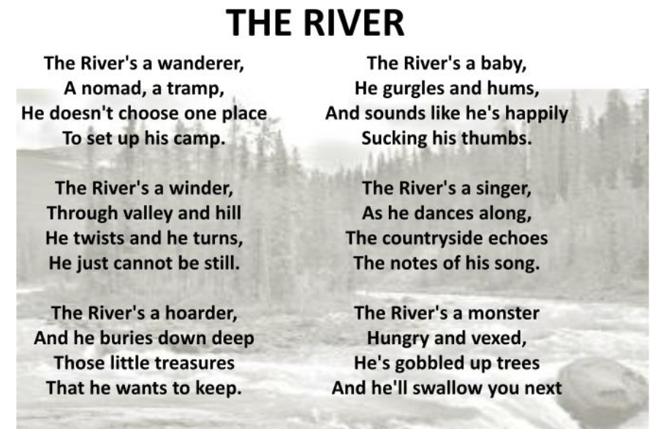
Reading Home Learning
Monday | Tuesday | Wednesday |  | Thursday | Friday
Monica the Monitor  Read ‘The River’ by Valerie Bloom. Using reading skills to help you understand as you go through it. Highlight any words you do not understand and find the meaning of them. | Colin and Carmen the Connectors  Read last week’s poem: “The Sound Collector” and read this week’s poem, “The River”.  Can you compare the two poems?  Do they have any similarities or differences?  Discuss with an adult. | an you label them?  Read “The River” poem and answer questions below.  1) What is the river compared to in Stanza 3? How is it described?  2) Name two actions performed by the river in Stanza 5.  3) What does the river hide in Stanza 3?  4) What is the mood of the River in Stanza 4 and 5?  5)Why do you think the poet wrote this line ‘He just cannot be still’ in Stanza 2?  Can you label them? |  | Rhyme is often used in poetry.  - Can you identify where it is used in the poem?  - Do you know any other poems that use rhyme?  - Does rhyme affect the way you read it?  - Do you notice any repetition in the structure of the poem?  - Can you identify any other poetic techniques? | Oracy – Performance of “The River”  Practise reading “The River” poem aloud to an audience (your family), expressing words clearly and using appropriate intonation.  Add sounds and actions to interest the audience.
Easier:  Do as many of the above activities as you can. If you are finding some of the activities challenging, try these as they are a little easier:  - Listen to an adult read the poem.  - Make a list of all the rhyming words.  - Highlight all the rhyming words. |  |  | Challenge:  If you feel you need a further challenge, try these:  - Describe how the poet uses personification and metaphors in the poem.
Writing Home Learning – Poetry - The River– Write your own sound poem
Monday | Tuesday | Wednesday | Thursday |  | Friday
Create a text map for the poem “The River” by Valerie Bloom. You could text map the whole poem or choose your favourite part. | Use your text map to help you learn the poem “The River”. Once you have memorised it, try performing it (with actions) to a family member. Use your text map to help you. | Write down as many verbs that match the the following themes:  A child- (E.g. hiding, crying)  A snake- (E.g. sliding, hissing)  An explorer- (E.g. discovering, searching)  You could think of other ways to describe the river too. | Use the guide below to write your own River poem. Can you see where I have added my own ideas?  The River’s a snake.  Sliding and hissing,  She looks for a path,  Not knowing which one to take. |  | Complete your poem reading aloud as you work to check for fluency and meaning.  Proofread to check for errors in spelling, grammar, vocabulary and punctuation.
Easier:  Do as many of the above activities as you can. If you are finding some of the activities challenging, try these as they are a little easier:  - Ask an adult to read the poem out aloud to you and work together with an adult to create a text map of one stanza. You choose which one.  - Use the template below to create the opening stanza for your poem.  The River’s a_______________. (child, snake, explorer)  ________________and______________, (moaning, groaning, hissing, sliding, searching, exploring)  She (or He) looks for__________,  and____________________________________.  Add in your own words or choose from the words above. |  |  |  | Challenge:  If you feel you need a further challenge, try these:  Have a go at creating your own poem. It could be about a river, the sea, a mountain, the sun etc.  Choose which poetic techniques you wish to use.
Spelling/Handwriting Home Learning
Monday | Tuesday | Wednesday |  | Thursday | Friday
Monday  Choose the next 10 spellings on your list that you struggle with or use the spellings below:  accident consider group accidentally continue guard actual decide guide actually  Spelling Pyramids. | Tuesday  Race how many times you can write each word in 1 minute with a family member. | Wednesday  Write a sentence for each spelling.  Try using different sentence types:  Simple- I was in a car accident.  Compound-I was in a car accident but I wasn’t hurt.  Complex-Although I was in a car accident, I wasn’t hurt. |  | Thursday  Choose a paragraph from your favourite book and write it out using the school handwriting style. Ensure you join letters correctly. | Friday  Spelling quiz!  Ask a family member to test you on your spellings.  You could also test yourself on the Top Marks website:  http://www.ictgames.com/mobilePage/lcwc/index.html
Easier: Year 1 and 2 Key Words (Statutory Words)  Do as many of the above activities as you can using the spellings below.  because  climb  children  clothes beautiful  great  every everybody  hour break |  |  | Challenge:  If you feel you need a further challenge, try these:  - List these words in alphabetical order:  attached accommodate ancient appreciate according achieve aggressive apparent accompany amateur  - Use the words above to practise your handwriting.  - Write a sentence for each of the words above
Maths Home Learning
Monday | Tuesday | Wednesday | Thursday |  | Friday
Practise your times tables and division facts. Once you know them test your understanding by getting someone to ask you them and see how many you can answer correctly in 1 minute. Then do the same with the division facts. | Activity 1 (lesson 12 p23 and 24)  Follow the Let’s Learn, In Focus and have a go at the Guided Practice. Then complete Worksheet 12. | Activity 2 (Lesson 14 p27)  Follow the Let’s Learn, In Focus and have a go at the Guided Practice. Then complete Worksheet 14. | Addition:  Write down the following numbers: 0,1,2,3,4,5,6,7,8,9  Cut up your numbers and use them to generate two numbers to add together:  4567+1234=  9876+345=  Aim to complete at least 5 addition questions. |  | Subtraction:  Write down the following numbers: 0,1,2,3,4,5,6,7,8,9  Cut up your numbers and use them to generate two numbers to subtract:  4567-2381=  9876+3452=  Aim to complete at least 5 subtraction questions.
Easier:  Do as many of the above activities as you can. If you are finding some of the activities challenging, try these as they are a little easier:  - Number Patterns: Add on 2 starting from 1,6 and 12  1, ___________, ___________, ____________,____________,________  6, _____,_________,__________,__________,__________,___________  12,_________,__________,____________,__________,____________  - Measuring length: Estimate the length of 5 objects in your house. Then use a ruler to measure them to the nearest cm.  - Adding:1) 27+15= 2) 26+36= 3)57+23= 4) 18+45=  - Subtracting: 1) 57-48= 2)64-37= 3) 72-48= 4) 100-46= |  |  |  | Challenge:  If you feel you need a further challenge, try these:  - Learn addition and subtraction facts for your 13, 14 and 15 times tables.  - Write down all of the factors for 24  - If a 4 sided shape has a perimeter of 36, what could the length and width measure?  List all the possibilities.
Activity 1 Lesson 12 Work through the In Focus, Let’s Learn and have a go at the guided practice. Then complete worksheet 12 on p23 and p24.
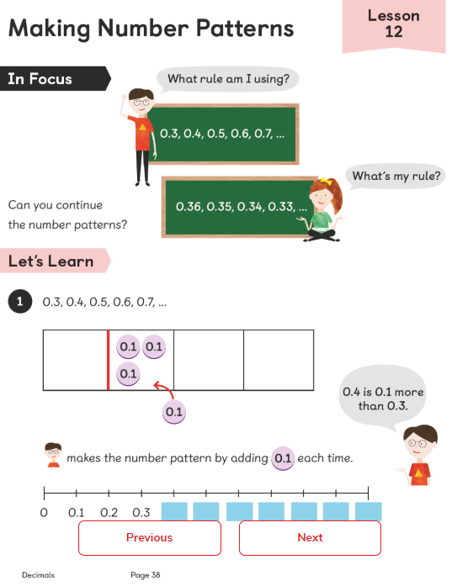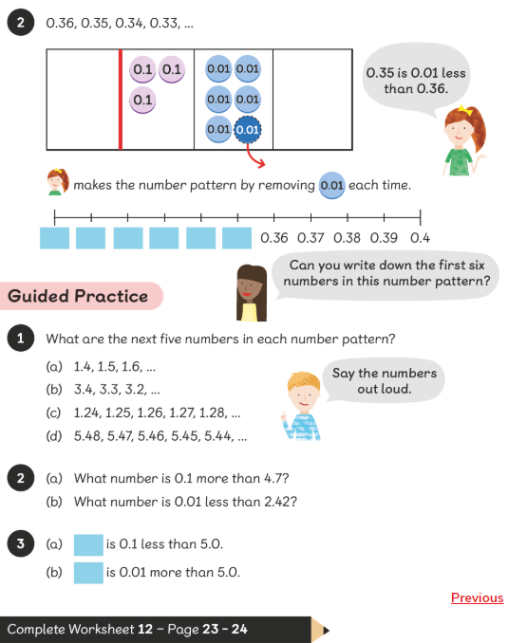

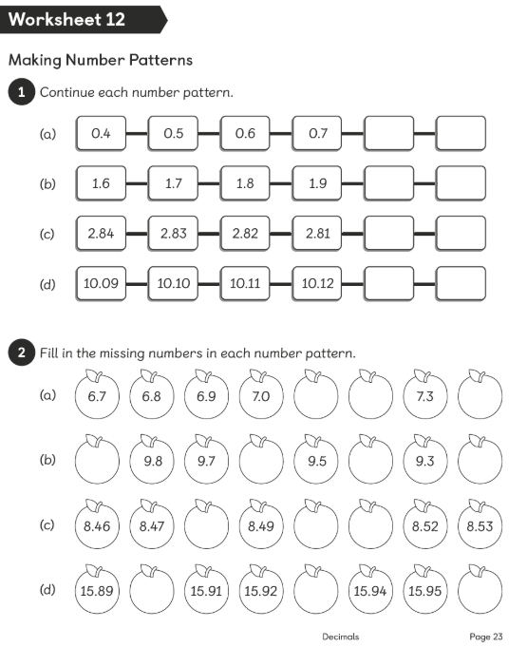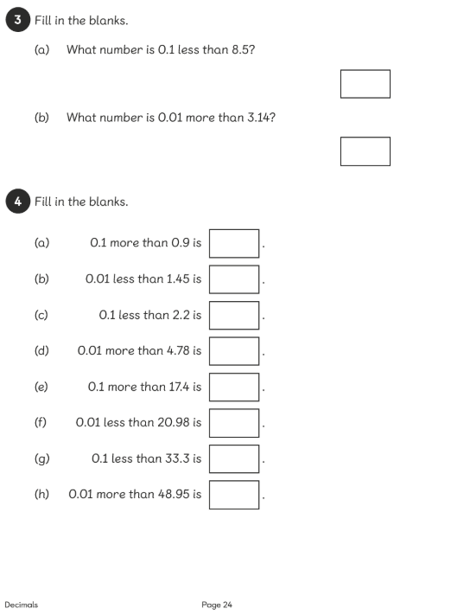

Activity 2 Lesson 14 Work through the In Focus, Let’s Learn and have a go at the guided practice. Then complete worksheet 14 on p27.

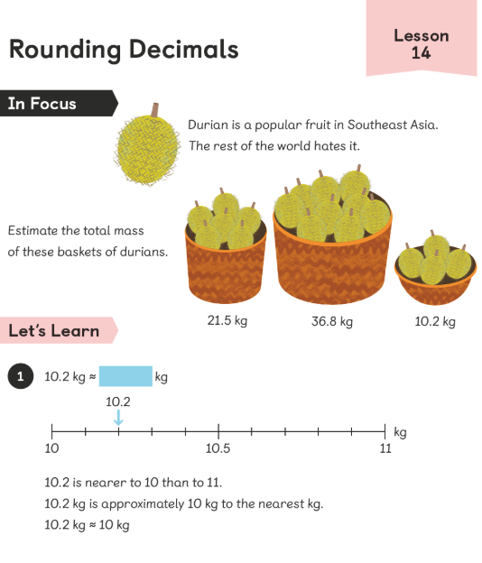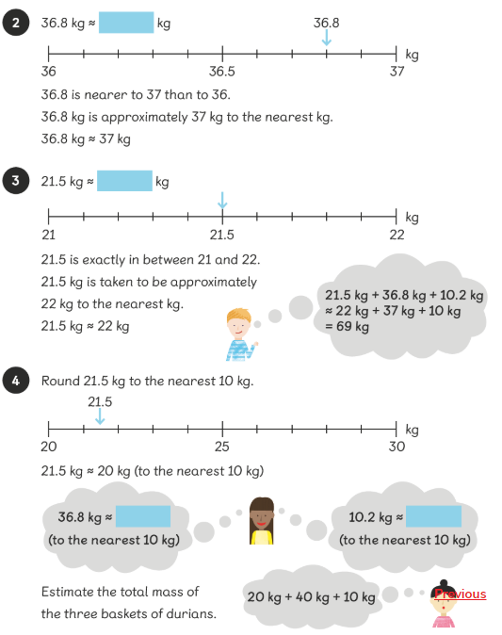
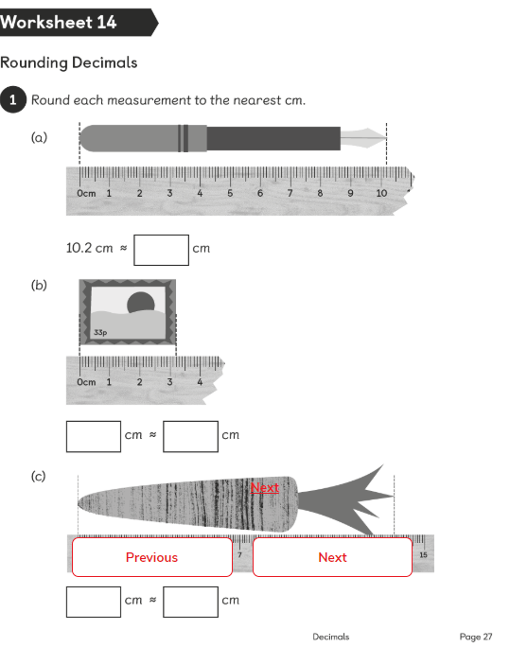
Theme Home Learning – Out theme this term is Playlist
Monday | Tuesday | Wednesday |  | Thursday | Friday
PE-Challenge Yourself  - How many jumping jacks can you do in one minute? | Science Revision  Here are some facts about:  Use this information to create a poster. | RE-Create a prayer or wish to help people stay positive during lockdown. |  | Science-How far can sound travel? | PE-Challenge Yourself  Can you beat your time from Monday? (Number of jumping jacks in one minute)
Easier:  Do as many of the above activities as you can. If you are finding some of the activities challenging, try these as they are a little easier:  - Have a discussion with an adult about the loudest sound you have ever heard inside the house and outside the house.  - Learn the chorus to one of your favourite songs.  - Create a “washing your hands” song. Perform to your family. |  |  | Challenge:  If you feel you need a further challenge, try these:  PE-How many press ups can you do in one minute?

Other Activities
Start your day with Joe Wicks’ YouTube workout for kids live every morning at 9.00.  https://www.youtube.com/results?search_query=joe+wicks | You have 3 minutes to make as many words as you can from the letters below?  e d s t a f I u r w h n | Can you design a Science board game. The questions could be on any of the topics that we have covered so far. | Extra Handwriting Practice  Spend 10 minutes practising your handwriting. | BBC Bitesize daily lessons for Year 4  (See timetable of which lessons are taught each day)  https://www.bbc.co.uk/bitesize/dailylessons
Key skills to continue practising weekly:
- Times tables (including division facts)
- Reading (This can be anything! Reading your favourite book again, reading magazines, sub-titles on the TV etc.)
- Watch Newsround everyday so you are keeping up-to-date with what is going on in the world.
If you are able to access the internet, try these useful websites:
- Reading: There is an online book of short stories written during lockdown by 100 authors, including Michael Morpurgo.
https://issuu.com/bloomsburypublishing/docs/thebookofhopes_interactivepdf/4?ff
- Timestable.co.uk
- Topmarks.co.uk
If you or your child has any further queries regarding their learning projects, please contact admin@hardwick.derby.sch.uk, clearly stating your child’s name and class teacher, and the staff will be in touch to support you and your child.
Thank you and stay safe.

