Year 1 Home Learning
Week Commencing: 6th July 2020
Year 1 teachers: Mrs Desai, Mrs Dumbuya Year 1 TAs: Mrs Scott, Miss Taj
Message from staff:
Hello everyone, how are you all? We hope that you’re all well at home and keeping safe. It has been lovely speaking to some of you this week.

Mrs Desai is still working at home and planning lots of fun activities for you to complete at home. Mrs Dumbuya, Miss Taj and Mrs Scott are now back at school working hard and teaching some of the children. We are all well and miss you all lots.

If you are still at home then please carry on doing your homework – you’re doing an amazing job! We will speak to you soon.

Your Home Learning this Week:
Every day (Monday to Friday), make sure you choose a *reading, *writing, *spelling/handwriting, *maths and *theme learning activity. There are also further activities to choose from should you wish to.
Reading Home Learning
Monday | Tuesday | Wednesday |  | Thursday | Friday
Read the text called New clothes for Alex. What do you think is happening? Who is your favourite character? How many different characters are there in the text? Do you like this text? Explain why? Tell someone at home. | Read the text called  New clothes for Alex. Are there any words you don’t understand? Can you find the meaning of these words? | Answer these questions  - Who are the characters in this story?  - What did Mum do that surprised Alex?  - Did they ﬁnd clothes that Alex liked? How do you know?  - Why did Alex want to go back home?  - Why was Alex giving his mother his very ﬁerce monster stare? |  | Have a go at designing your own t-shirt. What do you like about it? Write a few sentences explaining this. | Design your own jeans. What do you like about it? Write a few sentences explaining this.
Easier:  Do as many of the above activities as you can. If you are finding some of the activities challenging, try these as they are a little easier:  Wind the bobbin up  H  Wind the bobbin up  Wind the bobbin up  Pull, pull, clap, clap, clap  Wind it back again  Wind it back again  Pull, pull, clap, clap, clap  Point to the ceiling  Point to the floor  Point to the window  Point to the door  Clap your hands together, one, two, three  Put your hands upon your knee  - Learn the nursery rhyme Wind the bobbin up.  - Can you act this nursery rhyme out? Have a go  - Draw a picture of a bobbin and write down some simple sentences describing it. |  |  | Challenge:  If you feel you need a further challenge, try these:  Read the text called  Please see separate sheet at the end of the pack for your reading challenge

Writing Home Learning
Monday | Tuesday | Wednesday |  | Thursday | Friday
Invent a brand new mode of transport and describe how it works. What special features does it have? | If flowers could talk what would they say. Write a few sentences describing this. | Design the perfect superhero. Write a few sentences describing it.  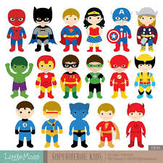 |  | If your shoes could talk, what would they say to you? Write a few sentences. | Invent a new fish and write a few sentences describing it.  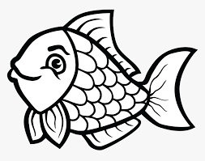
Easier:  Do as many of the above activities as you can. If you are finding some of the activities challenging, try these as they are a little easier:  - Learn the nursery rhyme wind the bobbin up. Use actions to help you.  - Draw a picture of flower and write some simple sentences to describe it.  - Draw a picture of a fish and write some simple sentences to describe it. |  |  | Challenge:  If you feel you need a further challenge, try these:  - Write a poem about your superhero  - Write a poem about the fish  - Think of 8-10 adjectives you could use to describe your superhero.  - Think of 8 -10 adjectives you could use in your fish.

Spelling/Handwriting Home Learning
Monday | Tuesday | Wednesday |  | Thursday | Friday
Look at the spellings and learn them. Use each word and write a sentence.  blink  think  stink  drink  chink | Look at the spellings and learn them. Use each word and write a sentence.  helper  steeper  shorter  stronger  shelter | Look at the spellings and learn them. Use each word and write a sentence.  softer  smarter  starter  fluster  duster |  | Look at the spellings and learn them. Use each word and write a sentence.  flash  loft  blank  crust  clip | Look at the spellings and learn them. Use each word and write a sentence.  camp  much  roast  went  help
Easier:  Do as many of the above activities as you can. If you are finding some of the activities challenging, try these as they are a little easier:  Look at these words and learn them at home.  Circle the initials sounds and then choose five words and write some very simple sentences down. Don’t forget tom use capital letters and full stops.  Pot hot cot not dot got |  |  | Challenge:  If you feel you need a further challenge, try these:  Look at the words below and learn them. Write a sentence for each word.  Singing kicking jumping starting lifting  Shifting laughing  - You could also create a poster and stick it somewhere – this will help you learn more words
Maths Home Learning
Monday | Tuesday | Wednesday |  | Thursday | Friday
Double these numbers  6  14  18  21  25  28 | Half these numbers  12  18  22  26  32  48 | Add these numbers  22 + 8 =  16 + 5 =  12 + 9 =  32 + 8 =  38 + 12 =  42 + 8 = |  | Subtract these numbers  22 – 6 =  18 – 5 =  14 – 6 =  37 – 6 =  39 – 12 =  44 – 10 = | Find the quarter of the following numbers  12  24  20  42  48  66
Easier  Do as many of the above activities as you can. If you are finding some of the activities challenging, try these as they are a little easier:  Find one more  11 16 18 20 22 28  Find one less  12 16 18 22 32 37 |  |  | Challenge:  If you feel you need a further challenge, try these  PLEASE SEE SEPARATE SHEET – MAKE A SUPERHERO

Theme Home Learning
Monday | Tuesday | Wednesday |  | Thursday | Friday
Design and make a robot. Use materials at home to make it.  Write down a few sentences describing your robot. | Make a list of foods that are healthy and foods that are unhealthy. Write a few sentences explaining why these foods are healthy and unhealthy. | Draw a picture of something outside. Write 5 or more sentences about it. |  | Choose a flower out of your garden, learn everything you can about that flower. | Make price tags for several objects in your room. Make some play money and use it to buy the things in your “play store.”
Easier:  Do as many of the above activities as you can. If you are finding some of the activities challenging, try these as they are a little easier:  - Design and make a robot. Use materials at home to make it  - Draw pictures of healthy and unhealthy foods. Tell someone at home why you think these foods are healthy and unhealthy.  - Draw a picture of something outside. Write some simple sentences describing it. |  |  | Challenge:  If you feel you need a further challenge, try these:  - Write a story or a poem about your robot.  - Write a report about your chosen flower.  - Do a little presentation explaining to your family which foods are heathy and which foods are unhealthy.
Other Activities
Find objects around your home that begin with the sound SH. Draw a picture of each of them or have someone help you write them down. (sheets, shoe, etc.) | Help mum and dad cook something yummy to eat. | Tidy your bedroom. | Go outside and find 3 different kinds of leaves. How are they alike and different? Try to find out what types of leaves they are. | Read three times a week.

Key skills to continue practising weekly:
- Try learning the time at home. What time do you wake up? Have lunch? Dinner? Sleep?
- Use your purple books and keep learning the words in there
- Learn the months in a year
- Times table rock stars – lots of activities on there

If you are able to access the internet, try these useful websites:
https://www.youtube.com/channel/UCP_FbjYUP_UtldV2K_-niWw
https://www.nytimes.com/2016/09/22/learning/40-intriguing-photos-to-make-students-think.html
https://www.derbycountycommunitytrust.com/programmes/schools/resources/

If you or your child has any further queries regarding their learning projects, please contact admin@hardwick.derby.sch.uk, clearly stating your child’s name and class teacher, and the staff will be in touch to support you and your child.
Thank you and stay safe.

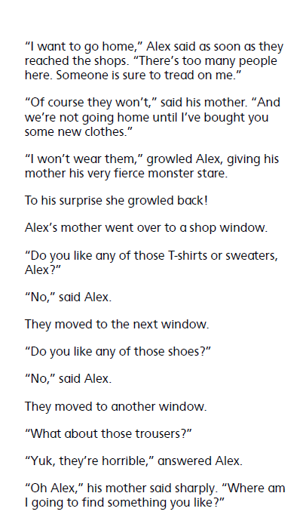
READING

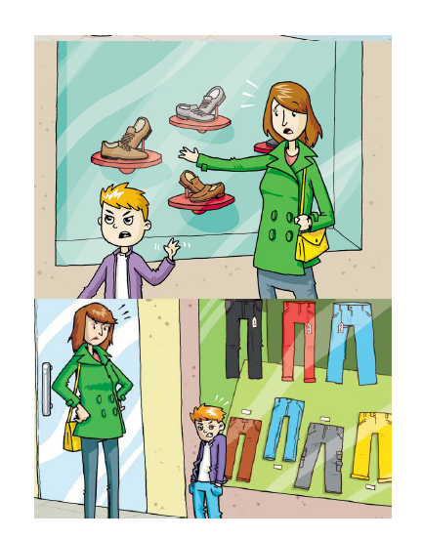
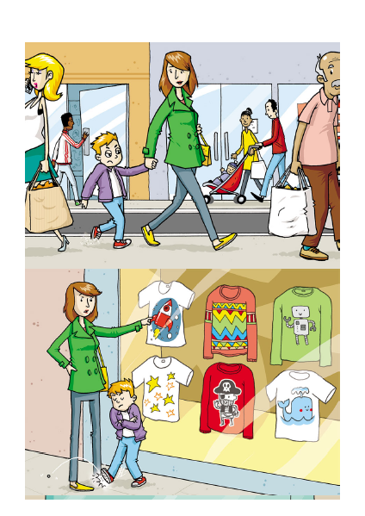

READING CHALLENGE
The Sweet Shop
This extract is taken from Roald Dahl’s autobiography: “BOY. Tales of Childhood”.
The sweet-shop in Llandaff in the year 1923 was the very centre of our lives. Without it, there would have been very little to live for. But it had one terrible drawback, this sweet-shop. The woman who owned it was a horror. We hated her and we had good reason for doing so.
Her name was Mrs Pratchett. She was a small skinny old hag with a moustache on her upper lip and a mouth as sour as a green gooseberry. She never smiled. She never welcomed us when we went in, and they only times she spoke were when she said things like, “I’m watchin’ you so keep yer thievin’ fingers off them chocolates!” Or “I don’t want you in ‘ere just to look around! Either you forks out or you gets out!”
But by far the most loathsome thing about Mrs Pratchett was the filth that clung around her. Her apron was grey and greasy. Her blouse had bits of breakfast all over it, toast-crumbs and tea stains and splotches of dried egg-yolk. It was her hands, however, that disturbed us most. They were disgusting. They were black with dirt and grime. They looked as though they had been putting lumps of coal on the fire all day long. And do not forget please that it was these very hands and fingers that she plunged into the sweet jars when we asked for a pennyworth of Treacle Toffee or Wine Gums or Nut Clusters or whatever. The mere sight of her grimy right hand, with its black fingernails, digging an ounce of Chocolate Fudge out of a jar would have caused a starving tramp to go running from the shop. But not us. Sweets were our life-blood. We would have put up with far worse than that to get them. So we simply stood and watched in sullen silence while this disgusting old woman stirred around inside the jars with her foul fingers.
The other thing we hated Mrs Pratchett for was her meaness. Unless you spent a whole sixpence in one go, she wouldn’t give you a bag. Instead you got your sweets twisted up in a small piece of newspaper which she tore off a pile of old Daily Mirrors lying on the counter.
So you can well understand that we had it in for Mrs Pratchett in a big way, but we didn’t quite know what to do about it. Many schemes were put forwards but none of them was any good. None of them, that is, until suddenly, one memorable afternoon, we found the dead mouse.
The Sweet Shop
- Where was the sweet-shop? (1 mark)
________________________________________________________________________
- Find and copy a group of words from the text which shows how important the sweet-shop was to Dahl and his friends. (1 mark)
________________________________________________________________________________________________________________________________________________
- What does Mrs Pratchett mean by “Either you forks out or you gets out!” (1 mark)
________________________________________________________________________________________________________________________________________________________________________________________________________________________
- Explain what Dahl means when he says sweets were the boys “life-blood”. (1 mark)
________________________________________________________________________
________________________________________________________________________
________________________________________________________________________
________________________________________________________________________

MATHS CHALLENGE
Make a Superhero!
You have 15p to spend to make your superhero.
You can’t afford everything so need to decide how to spend your money.

Powers
Strength – 5p
Speed – 3p
Making fire – 4p
Making ice – 3p
Flying – 5p

Clothes
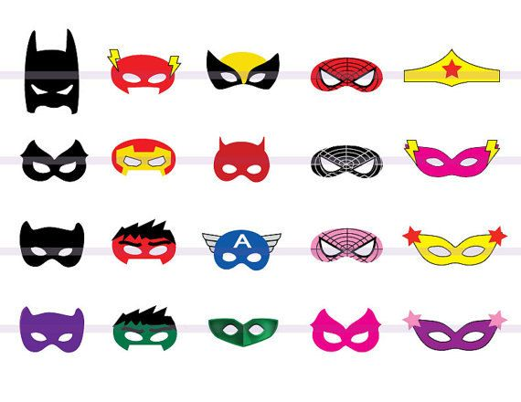 mask – 2p each
cape 3p

boots 3p

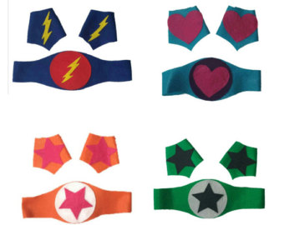 belt and cuffs 5p

