







Newsletter December 2017

****[](http://www.google.co.uk/imgres?q=santa&num=10&hl=en&safe=active&biw=1024&bih=571&tbm=isch&tbnid=LgDsy3YfzRF4xM:&imgrefurl=http://santababyrunning.blogspot.com/2011/12/santa-mown-down-by-train-shocker.html&docid=SSVksiyGPug--M&imgurl=http://1.bp.blogspot.com/-0ySi0u_vCh0/Tt5Zetjh4pI/AAAAAAAAByE/hU4jp1ejPTE/s1600/cartoon-santa.jpg&w=1042&h=918&ei=bsWbUJK3GqfV0QXSwYDQCw&zoom=1&iact=hc&vpx=693&vpy=122&dur=46&hovh=211&hovw=239&tx=126&ty=116&sig=116186279883587554604&page=1&tbnh=112&tbnw=108&start=0&ndsp=21&ved=1t:429,r:5,s:0,i:85)**Care for each other and our school**

**Always try our best**

**Remember our manners**

**Enjoy learning!**

Dear Parents/Guardians

It has been a very busy, successful term for our staff and pupils. In the midst of our teaching and learning, preparation for all our festivities, Christmas parties, Pantomimes, musical celebrations and community activities, we are mindful of the need to reflect on the true meaning of Christmas. As ever, our pupils and families have given generously to support our Winter Fair. I would like to thank you all - parents, pupils and friends - for your continued support, and to wish you and your loved ones a restful Christmas and a happy New Year.

I look forward to seeing you all again at our Parents’ Evenings in January, where we will once again be asking you for your thoughts and opinions about our school.

I would like to take this opportunity to say a big thank you to Mr. Beattie (Year 4) and Miss Sheldon (SENCO) who will be taking up new posts in January. We wish them all the best. Mrs. Smith will be joining Hardwick as SENCO from January.

[](http://www.google.co.uk/imgres?q=christmas+tree&hl=en&safe=active&biw=1024&bih=571&tbm=isch&tbnid=DtYdj21vYTEeBM:&imgrefurl=http://uncyclopedia.wikia.com/wiki/File:Christmas-tree.gif&docid=_-FzJ313Z4mXOM&imgurl=http://images4.wikia.nocookie.net/__cb20071214125022/uncyclopedia/images/4/41/Christmas-tree.gif&w=300&h=348&ei=ncWbUImsE-TY0QXI1oCwCQ&zoom=1&iact=hc&vpx=307&vpy=193&dur=562&hovh=242&hovw=208&tx=90&ty=160&sig=116186279883587554604&page=2&tbnh=126&tbnw=109&start=21&ndsp=28&ved=1t:429,r:9,s:21,i:165)

Mr. J Gallimore Mrs. R Sandhu

Executive Headteacher Head of School

**Dates for your diaries**

Monday 18th December INSET DAY – SCHOOL CLOSED

Tuesday 19th December INSET DAY – SCHOOL CLOSED

Wednesday 20th December – Tuesday 2nd January SCHOOL CLOSED FOR SCHOOL HOLIDAY

Wednesday 3rd January SCHOOL RE-OPENS

Friday 12th January INSET DAY

Tuesday 16th and Wednesday 17th January Parents Evening

Monday 15th January Deadline for FS2 School Place for September 2017

Wednesday 6th June – Friday 8th June Year 5/6 Kingswood Residential Trip

**Hardwick Primary Out and About**

**St Augustine’s Church**

On Wednesday 13th December, Year 4 children visited St Augustine’s Church on Upper Dale Road and had a wonderful time. During the visit children learned more about Christianity and the Christmas story.

**Choir**

The Hardwick Choir went to Intu Derby to take part in the Christmas Choir Competition 2017 and they made the school really proud.  They did not make it to the final but they sang amazingly! The parents who attended really enjoyed it too.

Some feedback from the judges included: “a well-developed performance with sound variation and some movement in the last song. I liked the varieties in the volume in the different songs and the choir watched the conductor all the way through so it was a real team effort.”  Well done to all of those who took part!

**Year 1 & 2 Trip to Intu Centre**

All the year 1 and 2 children had an amazing Christmas experience at Intu, Derby. The children had the opportunity to meet Santa and receive a present at the Festive Forest and enjoyed an hour’s play in the soft play area. A huge thank you to Eskimo Joe Events for providing us with discounted entry and asking Santa to come in especially for our children, providing great memories which our children will treasure forever!

We all had the opportunity to visit Build a Bear, who donated £25 to every class to make a bear. Thank you to all staff at Build a Bear who personalised our visit and made each child feel special.

A huge thank you to all of our parent volunteers, we all really appreciate all your support.

Samir 1CB “This was the best trip ever.”

Mohammad 1CB “I love my present from Santa.”

Aisha 1CM “We love our new class bear.”

Neman 1CM “I love the sparkly lights.”

David 2EC “This is the best!”

Mohammed Eesa 2EC “WOW!”

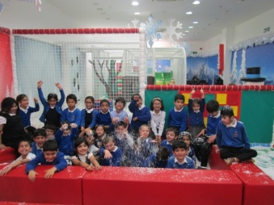Ahmad Hassan 2EH “The Winter Wonderland trip was awesome!” ☺

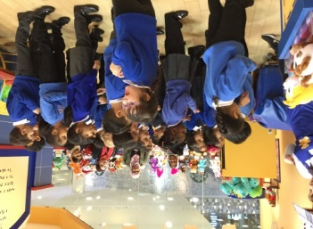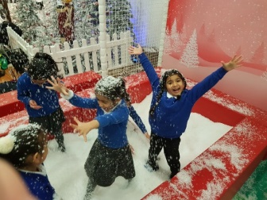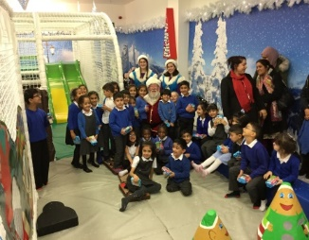

**Spoken English Competition 2017-18**

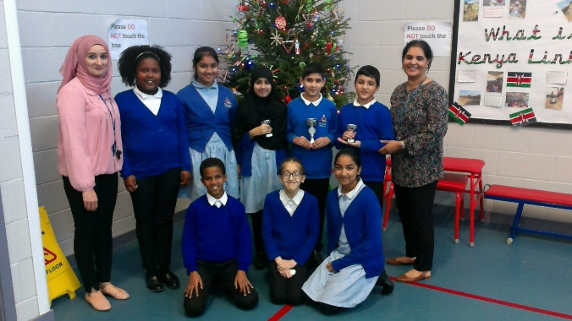On Friday 1st December, it was the second year of the annual Spoken English Competition for Year 6. Three children from each class were selected to compete in the final round. They had to present not only to the whole of Key Stage 2, but also to four judges; Mrs Sandhu, Mr Gallimore, Mr Sayers and Mrs Rolfs. Although some thought the event nerve-wracking, the children composed themselves well and did an amazing job! Well done to all those who participated in all rounds of the contest. The results of the competition are as follows:

Winner – Jabraan Khan (6PC)

Runner-up – Esha Hussain (6FN)

Runner-up Sanwal Zubair (6FN)

**Sporting Events**

This term groups of pupils represented Hardwick Primary School at two sporting events:

Friday 17th November a team of Year 5 & 6 pupils took part in a Benchball festival at the Tennis Centre. A thoroughly fun afternoon was had by all! They were particularly successful.

On Wednesday 22nd November some pupils took part in a Futsal Tournament at Arboretum School. They played really well, and we are very proud as they ended up winning the tournament. Well done boys!

**Black History Month**

We are very proud of the heritage of all of our children and we celebrated Black History month in school in November.

**Calling All Reading Volunteers**

We’d like to say a huge thank you to all the Reading Volunteers who currently come in to support our children with their reading. Mrs Bola is still looking to recruit more support. If you are interested in becoming a Reading Volunteer, please come and speak to her to find our more information.

**Christmas Pantomimes/Concerts**

**KS1 Carol Concert**

On Thursday 7th December our KS1 children preformed Carols to their parents.

A special thank you to ASDA Spondon and Sinfin for donating 132 Mince pies for our parents and guests to enjoy. Debra Jones from ASDA came in to deliver the mince pies and to say hello to the children and staff in KS1.

**Aladdin and Goldilocks**

On Monday 11th December we welcomed a theatrical company to perform ‘Aladdin’ to FS1 and KS1 children and on Thursday 14th December ‘Goldilocks’ to KS2 – all of the children thoroughly enjoyed watching the performances and we will hopefully see them again next year!

**Christmas Concert**

This year FS1/2 children performed their Christmas concert “A King is Born” to parents, staff, Governors and children on Tuesday 12th December. The children worked really hard and sang their hearts out! Thanks to everyone involved and the staff for all their hard work!

**Family Learning and Community**

**School Council**

The School Council met with Alexa Wigfield from ‘When You Wish Upon a Star’ Charity. They support families who have children with medical conditions and terminal illness. The school council will be supporting this charity through fundraising in school. The charity in return will be supporting the school with resources e.g. playground equipment, wet play equipment and prizes. More information to follow.

**School Meals Council**

We are looking for parent representatives to attend future meetings to discuss menu choices and school meals. If you would like to be a representative, please let the office know.

**Family Learning Classes and Sessions - All FREE**

**‘Healthy cooking with ASDA’**

Starting soon, Debra Jones from ASDA Spondon will be coming into school to deliver a free healthy cooking class to both parents and children in Family Learning. All ingredients will be provided free of charge. Date and time to be confirmed. Please see the School Office if you are interested.

**Level 1 & 2 Maths with Derby College**

Do you want to gain a Maths qualification? Most employers now ask for basic Maths and English qualifications. Come and learn Maths in a friendly and helpful environment while gaining a much needed qualification to help you support yourself and your children. **Every Monday afternoon**

**1-3pm,** starting back **Monday 8th January 2018.**

**ESOL**

Learning English with your child every Wednesday 1:10pm – 3:10pm. FREE ESOL English Exam at the end of the course. We have FREE crèche facilities for this class. All parents welcome. If you are interested, please just come along.

**Level 1&2 English with Derby College**

Do you want to gain an English qualification? Most employers now ask for basic Maths and English qualifications. Come and learn English in a friendly and helpful environment while gaining a much needed qualification to help you support yourself and your children. **Every Thursday morning 9.15-11.15am,** starting back **Thursday 11th January 2018.**

**Supporting Teaching and Learning- Level 2 Teaching Assistant Course**

Starting end of January 2018. You will need a two-day placement and the placement will need a student DBS and Childcare Disqualification check. If you would like more information, contact the school office.

**Rosehill Children’s Centre**

Staff from the Children’s Centre will be talking to parents at the beginning and end of certain days and at Parents’ Evening regarding services for under 5 year olds. For more information, please contact Tracey Mcginty on 01332 641315.

[](http://www.google.co.uk/imgres?q=children+in+need+2012&num=10&hl=en&safe=active&biw=1024&bih=541&tbm=isch&tbnid=T36sAGueS37CnM:&imgrefurl=http://www.whtimes.co.uk/news/hatfield_car_dealership_supports_children_in_need_1_1432290&docid=XXPEiAbSRHDaWM&imgurl=http://www.whtimes.co.uk/polopoly_fs/main_logo_cmyk_large_1_1432288!image/2336961388.jpg_gen/derivatives/landscape_630/2336961388.jpg&w=630&h=892&ei=e0GqUPPaFYuRhQfwioC4Cw&zoom=1&iact=hc&vpx=507&vpy=76&dur=2421&hovh=267&hovw=189&tx=115&ty=158&sig=116186279883587554604&page=2&tbnh=155&tbnw=109&start=8&ndsp=14&ved=1t:429,r:11,s:8,i:144)**Children In Need**

Friday 17th November was Children in Need Day. We raised a wonderful £602. Congratulations and well done everybody!

**Winter Fair**

The children had lots of fun at the Winter Fair held in school on Friday 1st December. We have raised £1110. The majority of money raised will help buy canopy shades for the KS2 and Foundation Playgrounds. £10 will go to each class for party prizes (In total £200).

A special thank you to The Parent Committee, parents, staff and pupils who volunteered to help on the day and who baked and donated items. Thank you for your continued support in helping to raise these funds.

A special thank you to: Sharif and Sons, Cakebox, K&B First Choice, Medina Pharmacy, Krishna’s, Rosehill Pharmacy, The Pizza Company, Serenity, Beauty Box, Allenton Kebab, Pappas of Belper, Oxygen FREEJUMPING, Slice of India, Poundshop Plus, S O’Brien Heating Services, and Miss H Taj, for all their donations and continued support. Thanks also to Sharmas’s for providing the samosas, without their contribution the fair would not have been so succesful.

The Raffle First prize was won by Tayiba Begum in 4MH.

**Parent’s Evening**

During Parent’s Evening on Tuesday 16th and Wednesday 17th January 2018, staff will be helping parents to complete an online Parents Survey. The following people wil also be promoting their services to parents on both evenings: Derby College, Livewell, Derby Community Parent Programme, Rosehill Children’s Services and Scholastic Book’

**Scholastic Book Fair- Everything Half price**

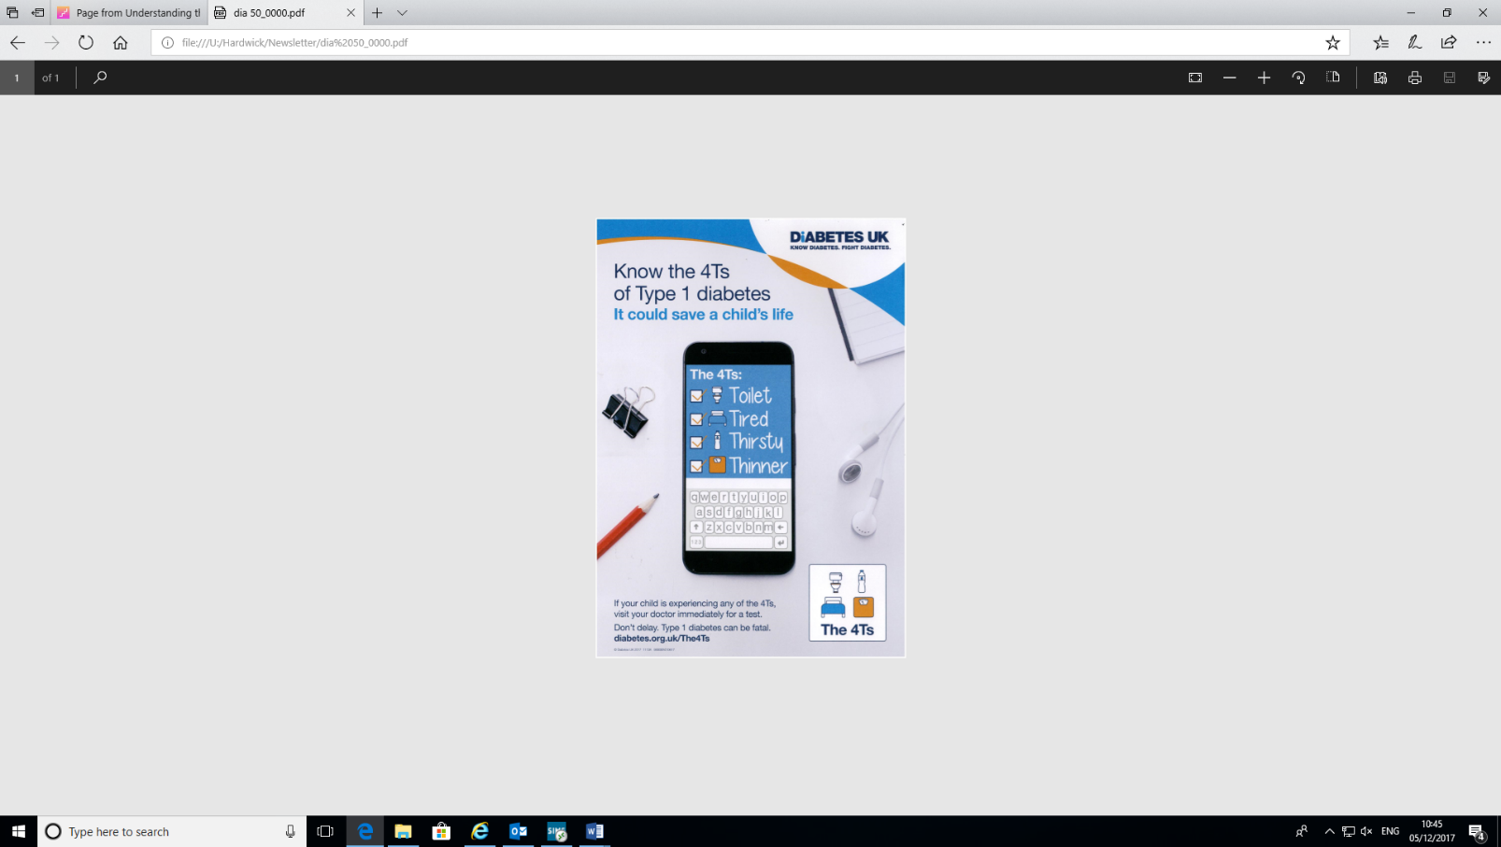We will be holding a Scholastic Book Fair in school on **Tuesday 16th and Wednesday 17th January** 2018 (during Parents’ Evening) between the hours of 3.30 – 6.00 pm in the School Hall. The Book Fair will also be held on **Thursday 18th January** in Studio 1 between the hours of 3.20 – 3.45 pm. A raffle ticket will be issued for each book that you purchase; there will be two winners each receiving £12.50 worth of books to choose from the Book Fair. Please support the Book Fair to make it as successful as in previous years.

**Diabetes Awareness**

November was ‘National Diabetes Month’ and November 14th was ‘World Diabetes Day’.

If you suspect your child is exhibiting any symptoms of Type 1 diabetes, mentioned on the poster, immediately consult a doctor.

Type 2 diabetes is increasingly being found in children and teenagers, and this is linked to an increase in childhood obesity and a lack of [exercise](https://www.webmd.boots.com/fitness-exercise/default.htm). Children from minority ethnic groups especially South Asian are at a greater risk of developing type 2 diabetes. This can be prevented if changes to lifestyles are made.

**Notices and Reminders**

**Deadline for FS2 Applications**

If your child was born between 1st September 2013 and 31st August 2014, he or she is due to start school in September 2018.  Derby City Council must receive your application by 15th January 2018.  Late applications received after this deadline will not be considered until all other on time applications have been determined.

You can make an online application at [www.derby.gov.uk/primapps](http://www.derby.gov.uk/primapps). If you want to make a telephone application, please call 01332 642728 or 642730.

**Nursery Places available at Hardwick for September 2018**

We currently have Nursery places available for September. If you have a child who will be turning 3 years of age before 31st August 2018 and you would like a place starting in September 2018 then please contact Mrs Keen in the school office.

**Bad Weather**

C:\Documents and Settings\nkeen\Local Settings\Temporary Internet Files\Content.IE5\2QD6VEJR\MC900331453[1].wmfHardwick Primary School will remain **OPEN** unless you receive a text message (by 8.00 am) to say otherwise. In the unlikely event we do have to close the school, a message will be sent out via Radio Derby, Capital FM and Gem106 and via a school text message which will be sent by 8.00 am.

Can you please ensure you send your child(ren) to school every day with a warm coat, hat and gloves, even if they come to school by car. Your children will be outside wherever possible at break and lunchtimes. In bad weather conditions please ensure your child has appropriate footwear in school such as wellies, trainers or boots. **We also ask that you write clearly your child’s name in all of their clothes and shoes.**

**Lost property**

There is quite a lot of lost property left uncollected in school. If you think you have any items in lost property, please come and have a look and collect them by Friday 15th December, otherwise they will be given to charity.

**Attendance**

**We would like to remind parents about the importance of being in school on time and children collected promptly at the end of the school day.**

**School Opening times: 8.45am to 3:15pm**

**The School gates open at 8.45 a.m. Children need to be in their class by 8.55 a.m. to begin their lessons promptly.**

Children who arrive late are greatly disadvantaged because they miss starting the day with their class and the beginning of lessons. This means that they are often unsettled and confused about tasks. Their teacher will not always be able to re explain work.

It is also very important that children establish good routines and habits in preparation for the rest of their lives. Punctuality is a life skill that they need to develop whilst they are young.

We are required to monitor children’s punctuality and attendance. On-going lateness (after the class register has been taken) is classified as an unauthorised absence.

We understand that there may be rare occasions when you are unavoidably late due to unforeseen circumstances. On these occasions please make sure that you contact the school office to inform us when you will arrive.

Children must be collected from their classes at 3.15p.m. promptly.

**High levels of unauthorised absences or poor punctuality can result in a referral to the Educational Welfare Service or other agencies which have a duty to investigate further and could result in legal action being taken against you.**

**Please keep in mind that Breakfast Club is available to children from 8.00 am.**

**Absence Procedures**

Just a reminder of procedures if your child is absent from school. Could you please contact school before 9.30am on the day of absence. There are currently two ways you can do this. You can ring the school office on 01332 272249 or by email to [admin@hardwick.derby.sch.uk](mailto:admin@hardwick.derby.sch.uk) Please provide the reason for absence, the child’s name, class and your name. As a safeguarding procedure, if we don’t hear anything, we will contact you to confirm the absence.

**Appointments**

Please arrange any GP or Dentist appointments for your child for after school. If you have to make any appointment during school time, an appointment card/letter will be required by the school office to enable us to authorise the absence. Without this, it will be an Unauthorised Absence. Please ensure you do not need to collect your child over the Lunchtime period, as it is difficult for us to locate your child for you at this time.

**Our school website**

Our website address is <http://www.hardwickprimaryschoolderby.co.uk> where you will find out many things that are happening in school and our term times.

Please download the eSchools App to your phone / iPad to keep in touch with your child’s attendance, notice of events, letters home etc. Please ask the office for your user name and password if this has been mislaid.

To download the eSchools App from the school website click on “parents” and then “parent forms and links” and then navigate to the “eSchools App User Guide”. If you require support, please see the School Office.

Finally, we look forward to seeing the children back in school on

**Wednesday 3rd January 2017 at 8.45am**

**Hardwick Primary School**

Dover Street, Derby, DE23 6QP

Telephone: 01332 272249 Fax: 01332 773638

E-mail: [admin@hardwick.derby.sch.uk](mailto:admin@hardwick.derby.sch.uk)

Website: <http://www.hardwickprimaryschoolderby.co.uk>

Executive Headteacher: Mr J Gallimore

Head of School: Mrs R Sandhu

Assistant Headteachers: Mrs A Awaan and Mrs G Freeman

School Business Leader: Mrs M Richardson

