Nursery Home Learning
Week Commencing: 8th June 2020
Teachers: Mrs Bletcher
TAs: Mrs White

Message from staff:

Hello! We hope you have had a lovely week enjoying the sunshine. It was definitely ice lolly and ice cream weather! We are so pleased to hear that lots of you have been enjoying our Nursery home learning, and have been so busy. As ever, we are so proud of all of you and miss you all SO much. We love talking to you and your families when we ring, and hearing what you all have been up to. We can’t believe we are in our last term at Nursery, and so many of you will be going to Reception in September. You are SO big! As always, all the love in the world for our wonderful Nursery children. Big hugs, Mrs Bletcher and Mrs White x
If you have any queries over home learning please don’t hesitate to get in touch via admin@hardwick.derby.sch.uk and we will get back to you quickly!

Your Home Learning this Week:
Every day (Monday to Friday), make sure you choose a *physical, *communication, *reading/phonics, *writing and *maths learning activity. There are also further activities to choose from should you wish to.
Physical Home Learning
Monday | Tuesday | Wednesday |  | Thursday | Friday
If your grown up boils some potatoes and allows them to cool, have go at mashing them with a fork or spoon.  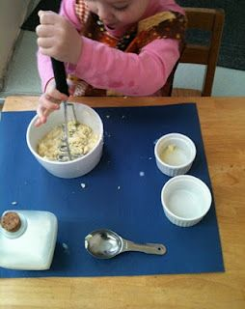 | Using a fork, explore mashing soft fruits such as strawberries or banana to make a dip. You could sweeten the dip by adding honey or mixing in yoghurt.  Try a piece of fruit you haven’t eaten before! | Develop your fine motor skills by using a knife and fork by yourself to eat your dinner this week! |  | Develop your fine motor skills by fastening the buttons on your cardigan, or zip on your hoody, by yourself. | Develop your fine motor skills by dressing yourself in the morning and putting your pyjamas on at night.
Easier:  Do as many of the above activities as you can. If you are finding some of the activities challenging, try these as they are a little easier:  - Practise your toileting by not wearing a nappy and using the toilet with a grown-up.  - Explore making marks with your fingers in playdough.  - Try taking your socks off by yourself and putting them back on again.  - Try taking your jumper off by yourself. |  |  | Challenge:  If you feel you need a further challenge, try these:  - Try juicing oranges and lemons by squeezing the fruits until the juice comes out.  - Use scissors to cut out a zigzag or spiral.  - Help your grown-up make food by chopping and mixing ingredients.  - Make a sandwich independently for lunch, using a knife to spread filling and cut the bread.
Communication Home Learning
Monday | Tuesday | Wednesday |  | Thursday | Friday
If you have the internet, develop your listening skills by following the link to our new quality text ‘Naughty Bus’  https://www.youtube.com/watch?v=sqQ1BAEj1oE  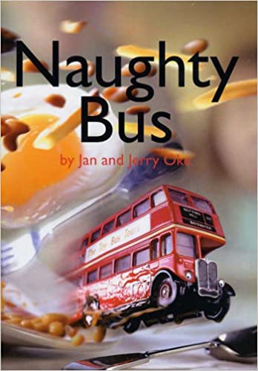 | Tell a grown up what you can see on the front cover.  What do you think will happen in the story? Why? | Why do you think the bus in our story is called the ‘Naughty Bus?’  Example: He’s called the Naughty Bus because he likes doing cheeky things! |  | Why do you think the Naughty bus drives through the beans?  Example: The Naughty Bus drives through the beans because he wants to get to the other side of the table! | How do you think the naughty bus feels when he falls in the water? Why do you think this?  Example: The Naughty Bus feels sad when he falls in the water because he can’t swim.
Easier:  Do as many of the above activities as you can. If you are finding some of the activities challenging, try these as they are a little easier:  - What sound does a snake make? Sssssssss  - Can you find a picture of a toy you have at home in the story? Use your words to say what you can see.  - What colour is the Naughty Bus? Example: The Naughty Bus is red |  |  | Challenge:  If you feel you need a further challenge, try these:  - How does the Naughty Bus feel when he can’t find his girl? Why?  - How do the toys feel when the Naughty Bus drives straight past them? Why?
Reading/Phonics Home Learning
Monday | Tuesday | Wednesday |  | Thursday | Friday
Can you think of a word that starts with the sounds:  -S (Examples: Snake)  -A (Example: Apple)  -T (Example: Tiger)  -P (Example: Penny)  -I (Example: Igloo)  -N (Example: Nugget)  If you have the internet, see link below to pronounce each phoneme (unit of sound) correctly)  Remember, alliteration is when words start with the same sound. | Practise making the following letter sounds in the mirror. What shape does your mouth make? What does your tongue do?  -S  -A  -T  -P  -I  -N  -C  -M  -R  -B  -F  -L  -K  -SH  -Z | Listening carefully to your grown up, have a go at sounding out the following CVC words we looked at last week:  a-t (at)  s-a-t (sat)  c-a-t (cat)  m-a-t (mat)  r-a-t (rat)  b-a-t (bat)  i-t (it)  s-i-t (sit)  i-p (ip)  t-i-p (tip)  sh-i-p (ship) |  | Listening carefully to your grown up, have a go at sounding out the following CVC words:  a-p (ap)  s-a-p (sap)  t-a-p (tap)  p-a-p (pap)  n-a-p (nap)  Listen carefully to the words you are blending. Do they rhyme? How do you know? | Listening carefully to your grown up, have a go at sounding out the following CVC words:  m-a-p (map)  c-a-p (cap)  b-a-p (bap)  c-l-a-p (clap)  r-a-p (rap)  Listen carefully to the words you are blending. Do they rhyme? How do you know?
Easier:  Do as many of the above activities as you can. If you are finding some of the activities challenging, try these as they are a little easier:  - Go into your garden and listen to the sounds. What can you hear? Can you draw what you heard?  - Explore making sounds with your body (Example: Clapping, stomping, tapping)  - Develop your listening skills by joining in with the Makaton actions for ‘The Wheels on the Bus’ (Youtube Makaton Singing Hands The Wheels on the Bus)  - Explore using a spoon to make different sounds around the house. Example: Tapping a spoon on the table. |  |  | Challenge:  If you feel you need a further challenge, try these:  - Play ‘I Spy’ with your grown up or sibling, identifying sounds independently.  - Have a go at matching a sound to its corresponding letter in the alphabet.  - Have a go at writing the letters of any words you have sounded out. (Example: c-a-t to cat)  - Can you find any objects in your home that start with the sounds s, a, t, p, i, n? Can you write their names down?

Writing Home Learning
Monday | Tuesday | Wednesday |  | Thursday | Friday
Practise writing the first letter in your name. | Retell the story of ‘The Naughty Bus’ by drawing your own story map. Below is an example of a previous story map.  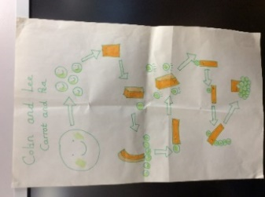 | Practise writing your full name by yourself.  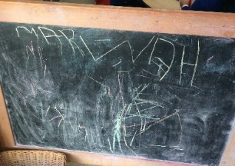 |  | Draw or paint the Naughty Bus, and any passengers on board.  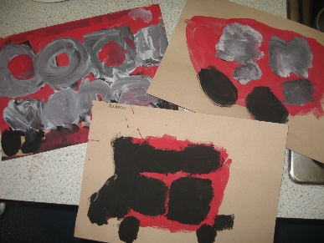 | Draw or paint where you think the Naughty Bus will travel to next.
Easier:  Do as many of the above activities as you can. If you are finding some of the activities challenging, try these as they are a little easier:  - Explore drawing circles and lines when shown by a familiar adult.  - Explore drawing circles and lines in the air with your finger.  - Explore drawing zigzags, spirals, and crosses in the air with your finger.  - Practise forming zigzags, crosses, spirals and circles when shown by a familiar adult. |  |  | Challenge:  If you feel you need a further challenge, try these:  - Can you identify the initial sound and write the initial grapheme of bus? (b)  - Can you sound out b-u-s and write each grapheme down? (bus)
Maths Home Learning
Monday | Tuesday | Wednesday |  | Thursday | Friday
Google the link ‘Where’s the monkey?’ to the following video on prepositions. Do you know where the monkey is? | Where is teddy?  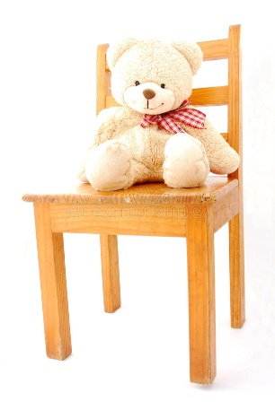  Model: Teddy is sitting on the chair. | Where is monkey?  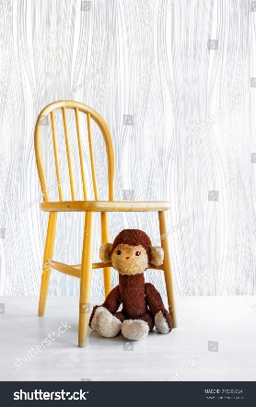  Model: Monkey is under the chair. |  | Where is teddy?  Model: Teddy is in the box. | How many?  Remember to count the holes of Numicon!
Easier:  Do as many of the above activities as you can. If you are finding some of the activities challenging, try these as they are a little easier:  - Have a go at representing 0, 1, 2, 3 and 4 on your fingers.  - Sing ‘1 potato, 2 potato, 3 potato, 4, joining in with actions and vocalisations.  - Count 0-10 as rockets. |  |  | Challenge:  If you feel you need a further challenge, try these:  - Have a go at drawing arrows. Tell a grown-up which direction they are facing.  - Using a teddy from your home, can you place him on a chair, under a chair, next to the chair, and behind a chair.
Other Activities
Sing one of your favourite Nursery Rhymes every day.  Examples include:  -Wind the bobbin up  -Miss Polly had a Dolly  -Two little Dickey birds  -5 little Peas | Ask your grown-up to put on your favourite songs to dance to and join in with. | Draw a picture of what you have done at home every day. | Develop your fine motor skills by helping your grown- up make breakfast, lunch, and dinner. | Think about what your favourite thing to do at Nursery is. Draw a picture of it, tell your grown up, and then email us so we can make sure we do it when we get back!

Key skills to continue practising weekly:
- Children should be practising being independent with their toileting at home.
- Children should be starting to be more independent in dressing/removing clothes themselves. Examples include: Taking their jumper off when hot, putting on shoes on, and starting to do zips and buttons
- Encouraging children to use at least four words in their sentences (Example: ‘I ate toast for breakfast’. This can be supported through modelling.

If you are able to access the internet, try these useful websites:
- Alphablocks: Alphablocks is excellent for blending CVC words!
- Letters and Sounds overview: This is what we follow in Phonics!
- Singing Hands: Singing hands are fantastic at providing Makaton actions for familiar Nursery Rhymes!

If you or your child has any further queries regarding their learning projects, please contact admin@hardwick.derby.sch.uk, clearly stating your child’s name and class teacher, and the staff will be in touch to support you and your child.

Thank you and stay safe.

