Year 6 Home Learning
Week Commencing: 29th June 2020
Year 6 teachers: Mrs Haider, Miss Qayoom, Mr Nowak
Year 6 TAs: Mrs Yar-Khan
Message from staff: We hope you are all well and enjoying the lovely sunny weather.
Once we have finalised the date and time for the leavers picnic we will inform you.

TALK Derby DAY – 1st July 2020
TALK Derby DAY is a celebration of speech, language and communication – the skills children and we all need to succeed in life.
We’ve adapted our plans to reflect the changing nature of the lockdown and are still encouraging people across the city to hold activities which encourage conversations – face-to-face or online, at home, work or elsewhere.

Use the discussion starters PMI Oracy activty
below to help you.
Consider and discuss the PMI (Plus, Minus, Interesting) points of the lockdown for you and your family.
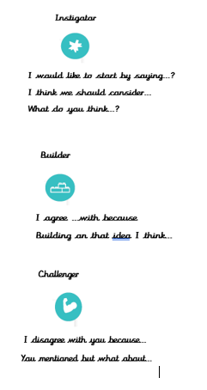
Minus
Interesting
Positive
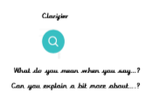
Reading Home Learning
Monday | Tuesday | Wednesday |  | Thursday | Friday
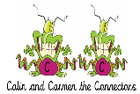  You will be reading a text about how weeds get everywhere. Make connections with what you already know about weeds. Are there any interesting facts you know? Have you heard anything about this from your friends/family on the television or elsewhere (e.g. newspapers)? Ask the people you live with if they know anything.  How are weeds different to other plants? | Read the text ‘How weeds get everywhere.’ Use the reading skills to help you understand as you go through it. Highlight any words you do not understand and find the meaning of them. | Summarise what you have read in the text. Remember, a summary covers the very important parts of the text (VIP). Which parts in the text do you think are important? |  | Now try answering these questions:  See the differentiated sheets (Easier, year 6 and challenge).  Explain how seeds disperse themselves. | After reading the text, think of any questions you may have. Is there anything you were left wondering that was not answered? Write these questions down. Reread the text again and this time, try to answer the questions you have. Can you answer them? If not, try to research the answers or, save the questions for when we come back to school so you can research at school.
Easier:  Do as many of the above activities as you can. If you are finding some of the activities challenging, try these as they are a little easier:  - Read the text using the reading skills to help you understand as you go through it.  - Highlight any words you do not understand and find the meaning of them.  - What type of text is this and how do you know? What do you notice about how it is set out? Have you seen anything like this before?  - Can you think of any other ways in which seeds can disperse themselves? |  |  | Challenge:  If you feel you need a further challenge, try these:  - Test yourself! Name the different ways seeds can be dispersed.  - What is the purpose of the article?  - Who is the article written for? How did you decide on your answer?  - Why do you think the writer included the ‘Fact File’ section?  Go back to the text. Ask an adult to test you to see if you can explain the meaning of the new words you have learnt.  - Use the new words by writing sentences of your own.
Reading Easier
Reading Year 6
Reading Challenge
Writing Home Learning
Monday | Tuesday | Wednesday |  | Thursday | Friday
Talk: Learning activity 1  What key landmarks can you see in the image? Ask people in your house to help if you are struggling. Can you and your family name them all? | Take a look at the image again and complete learning activity 2 task B. | Read through the words in learning activity 3. Can you find the meaning of these words? |  | Read over the teaching tips in learning activity 4. Choose the tasks you want to complete. | Create an informative travel leaflet/ brochure about one of the places from the image. Use the ideas in learning activity 5 to help you.
Easier:  Do as many of the above activities as you can. If you are finding some of the activities challenging, try these as they are a little easier:  - Complete learning activity 2 task A.  - Read through the words in learning activity 3, choose 3 words and write down what they mean.  - Make up sentences using these words.  - Learn how to spell these words. |  |  | Challenge:  If you feel you need a further challenge, try these:  - Complete learning activity 2 task C.  - Make up sentences using these words.

Learning activity 1

Learning activity 2
Have a go at discussing and answering these questions about the image.
Task A:
1.What do you think the image represents?
2. What do the landmarks represent?
Task B:
3. If the image were used as an advert, what might it be advertising?
4. The image has a key message in it. Explain what you think the message might be?
5. Use three adjectives to describe the image.
6. Why do you think different modes of transport are used in the image?
7. Are there any landmarks missing from the image that you think should be included?
Task C:
8. The weather in the image is varied. Why do you think this is? Explain your reasoning.
9. What feelings might the picture make you feel? Give three.
10. Where else might you have seen images of these landmarks?

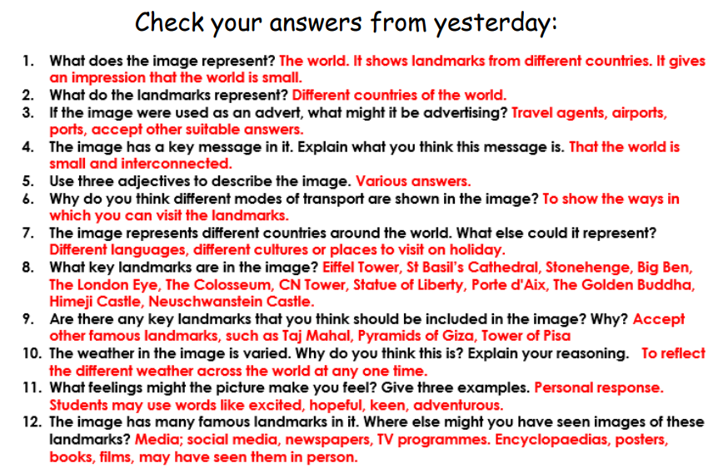

Learning activity 3
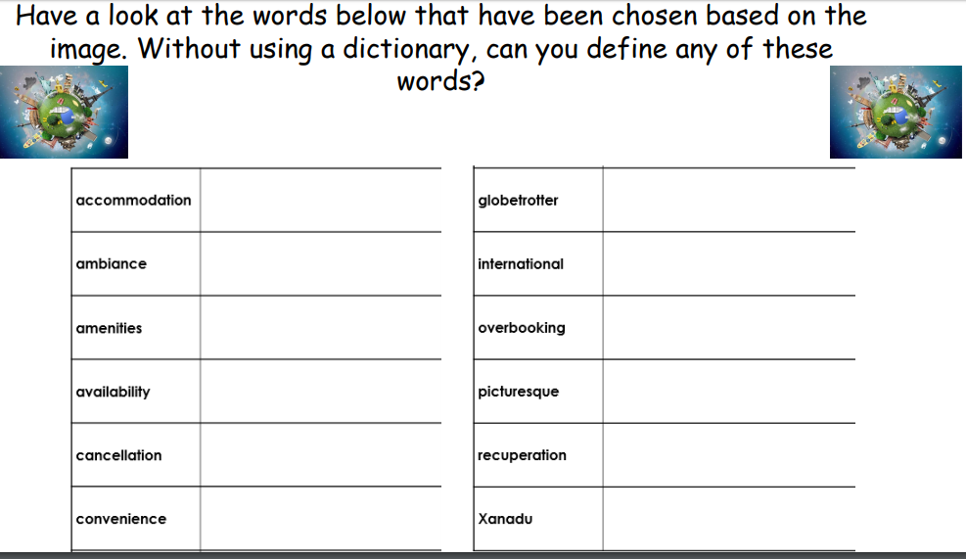

Learning activity 4: Teaching tip
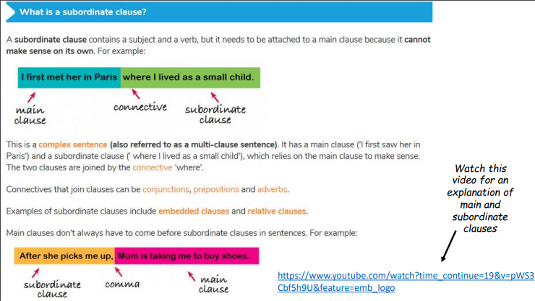
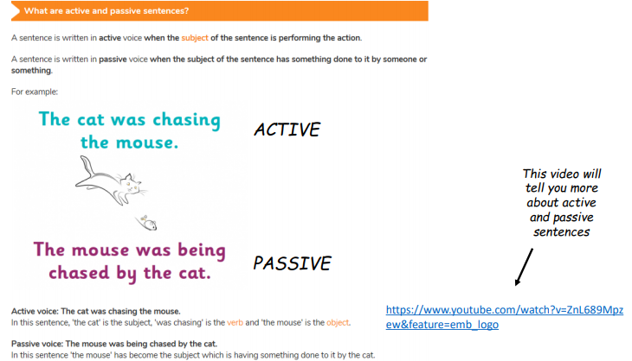
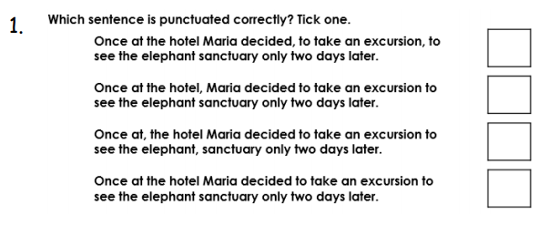
Learning activity task A: Task B
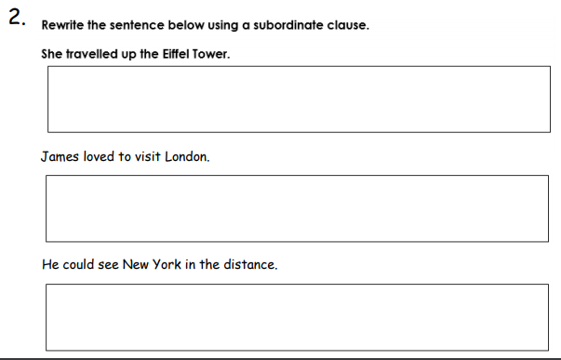
Task C: Task D:
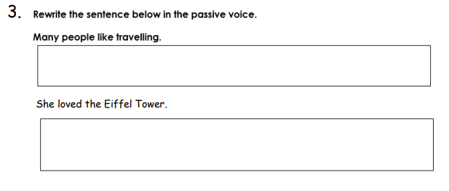
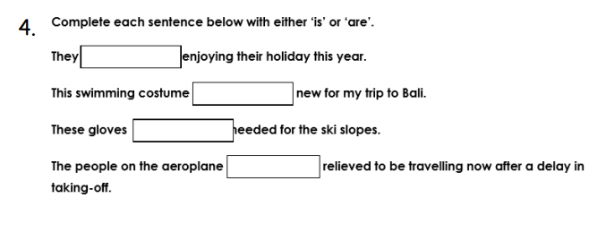

Learning activity 5

Example:
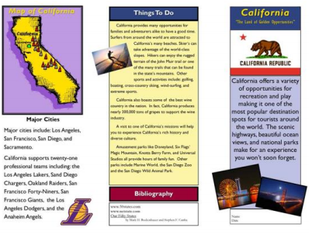
Spelling/Handwriting Home Learning Keep revising the same words this half term.
Monday | Tuesday | Wednesday |  | Thursday | Friday
suspicious  artificial  confidential  commercial  innocence  independent  recommend  significance  appearance  ferocious | Abstract nouns  disappointment  determination  enthusiasm  graciousness  apprehension  consideration  opportunity  speculation  enhancement  disturbance | Hyphens can be used to  join a prefix to a root  word. Words beginning  with the prefix co- can be  written with or without  prefixes.  co-ordinate, re-enter  co-operate, co-own  de-ice, co-author  re-examine, re-educate  re-form, co-pilot |  | Morphology - Provides  opportunity to find links  from previously taught  spelling/structure of  words and parts of words  (Stems, roots, prefixes, suffixes etc.)  Opportunity, parliament  Programme, privilege  Explanation, disastrous  Exaggerate, frequently  Necessary, appreciate | ASSESSMENT  Ask someone in your family to test you. 10 random words.
Easier:  Do as many of the above activities as you can. If you are finding some of the activities challenging, try these as they are a little easier:  - Use a dictionary to make sure you understand each word  - Try the following words:  chef, chalet, machine, brochure, chute, parachute  Moustache, quiche, chauffeur, chandelier |  |  | Challenge:  If you feel you need a further challenge, try these:  - Write a story and try to include as many words from your spelling list as possible.  - Write a poem using some of the words above  - Learn the words with double consonants:  accommodate, accommodation, aggressive,  embarrass, apparatus, success, successfully,  willingness, worthlessness, happiness

Maths Home Learning
Monday | Tuesday | Wednesday |  | Thursday | Friday
Revise addition and subtraction including decimals.  Using the digit cards you made, make up 10 sums for each operation and work out the answer ask an adult to check. | Revise multiplication including decimals.  Using the digit cards you made, make up 10 sums work out the answer ask an adult to check. | Revise division strategies and complete learning activity 3 task A. |  | Choose a challenge from learning activity 4 and complete. Discuss and share answers with your family. | Choose a challenge from learning activity 4 and complete. Discuss and share answers with your family.
Easier:  Do as many of the above activities as you can. If you are finding some of the activities challenging, try these as they are a little easier:  - Use digit cards to make up 3 and 4 digit numbers. Make 10 addition and 10 subtraction sums, work out the answer ask an adult to check.  - Use digit cards to make up x sums with 2 and 1 digit numbers. Example 23 x 7.make up 10 sums ask an adult to check.  - Complete learning activity 3 Task C |  |  | Challenge:  If you feel you need a further challenge, try these:  - Complete learning activity 1  - Complete learning activity 2  - Complete learning activity 3 task B

Learning activity 1 Learning activity 2
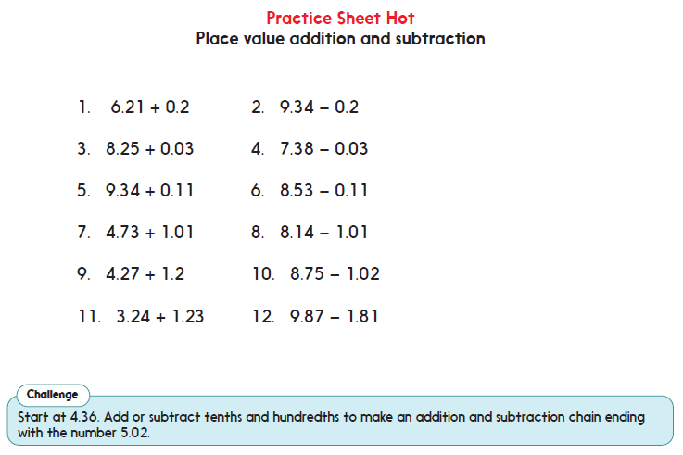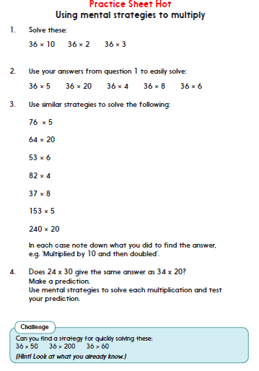

Learning activity 3 task A: Task B:
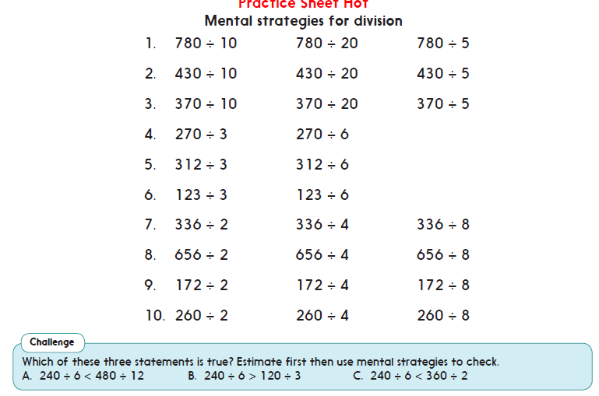
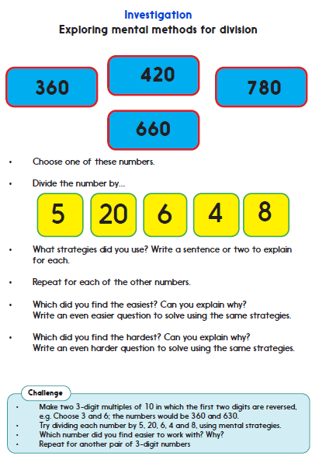
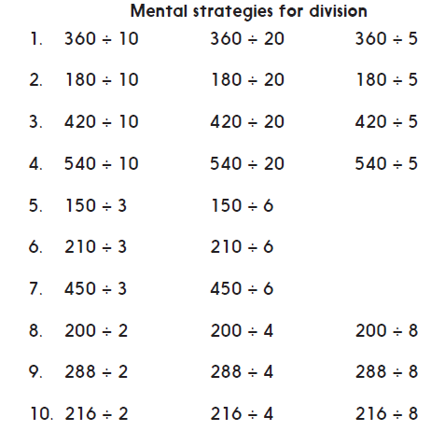
Task C: Learning activity 4 challenges

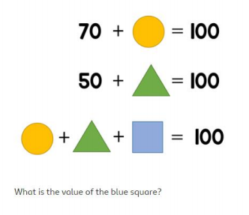

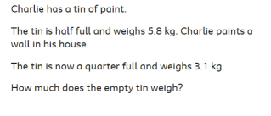

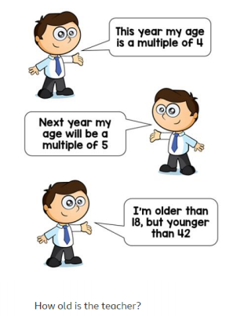
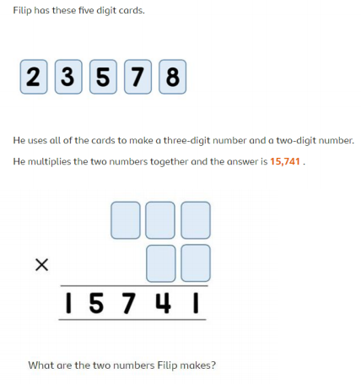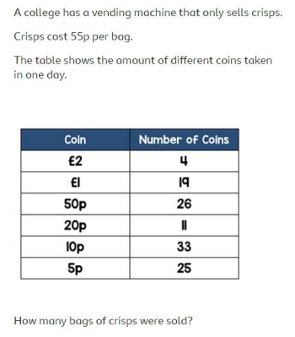

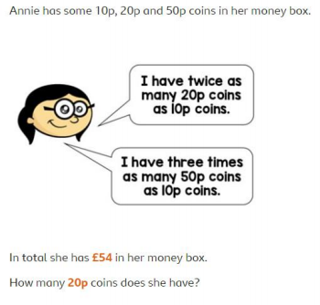
Theme Home Learning
Monday | Tuesday | Wednesday | Thursday | Friday
Science  From last week’s experiment (tomato plant and sunflower seeds planted), record what happened (growth).  Make a drawing of what you see each day for both of the plants.  TALK: discuss what has happened so far.  During Lockdown, a lot of people have started to grow their own food (fruit and vegetables). Why do you think this might be? Write a detailed paragraph using a range of sentence types.  Design a poster to encourage other adults to grow their own food. | RE  TALK  Retell the Buddhist story in your own words. You may wish to write some key words on a piece of paper to help you retell the events in order. Think back to the story of how the Prince because the Buddha. EXT: how many Buddhist symbols can you think of? Describe them.  Choose another story from either your own religion or from any other religion. Retell the story to your family.  Explain in your own words why you think it is important to retell religious stories. Write a detailed paragraph. | PSHCE  TALK  Goals/ambitions  Talk to your parents/careers about what you would like to be when you grow up. Explain why you wish to choose that particular job.  Make a poster on the qualities you need for the profession you have chosen.  List the skills required for the job (present this using bullet points).  Tick the skills you think you have already. Which skills do you feel that you need to work on?  Finally, research what qualifications are required in order for you to get onto this profession. | PSHCE  - Would you rather?  Complete any 3 activity. Choose any. Write a detailed explanation for each.  Ask an adult to complete the same activity through TALK. Is there anything that surprises you about what they have said? | PE  See PE sheet  Start from Easier (throwing and catching skills).  Complete Year 6 PE section.  Discuss with your parents the types of games they played when they went to Primary school. Make a list and compare this to your own.  Discuss: Have games changed much over the years?
Easier:  Do as many of the above activities as you can. If you are finding some of the activities challenging, try these as they are a little easier:  - Science  - RE choose a religious story your parents know well to support you in retelling.  - PSHCE choose any two activities. Ask an adult to help you think of a reason if you are stuck.  - PE Complete all throwing and catching skills with an adult. |  |  | Challenge:  If you feel you need a further challenge, try these:  - Science  - RE Compare the two stories: What is similar about both stories? What is different about both stories?  Draw a Venn diagram and complete this based on the two stories you have told.  - PSHCE give detailed answers using paragraph and a range of punctuation.  - PE Design your own 10 minutes warm up activities.

PSHCE Choose any 3 activities to complete
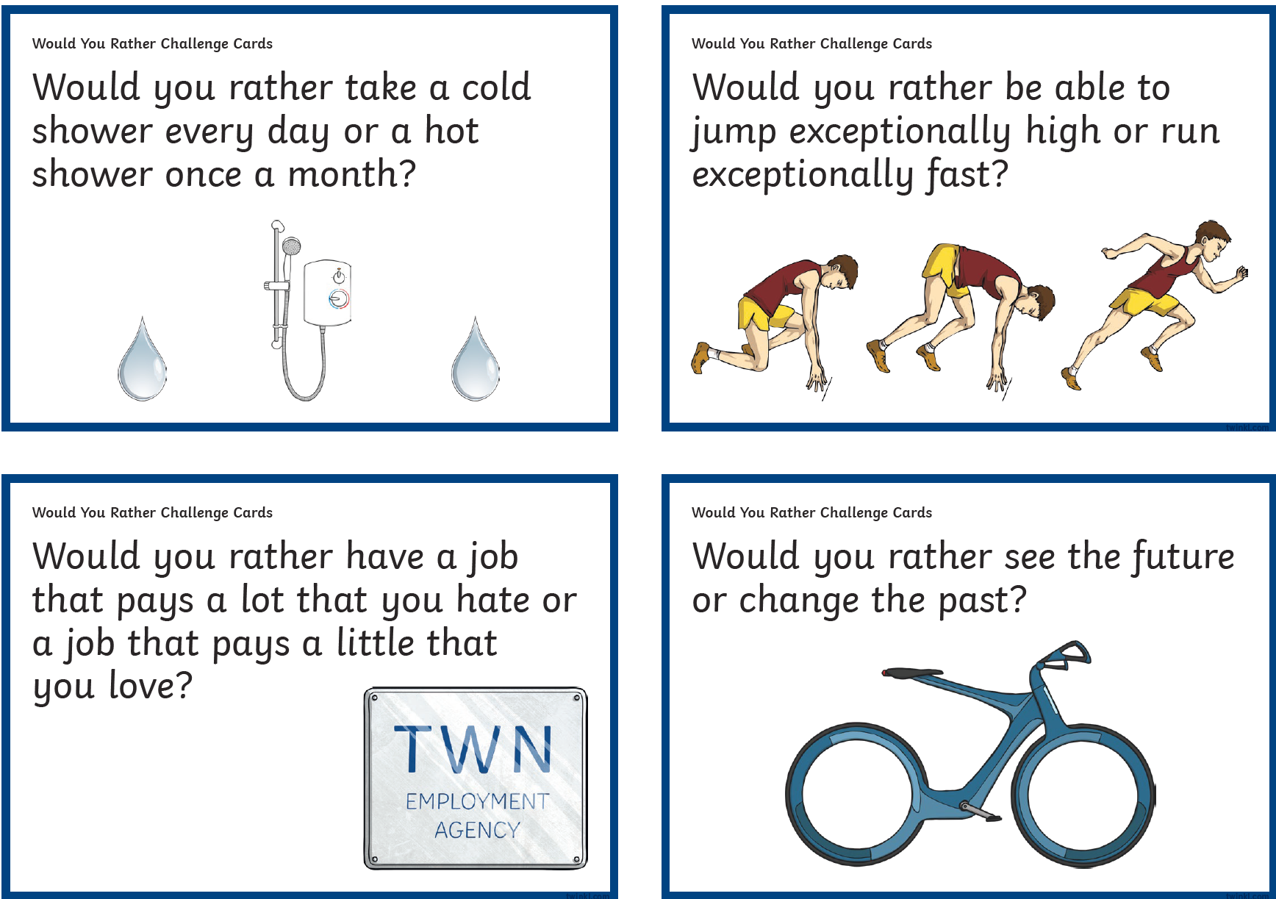
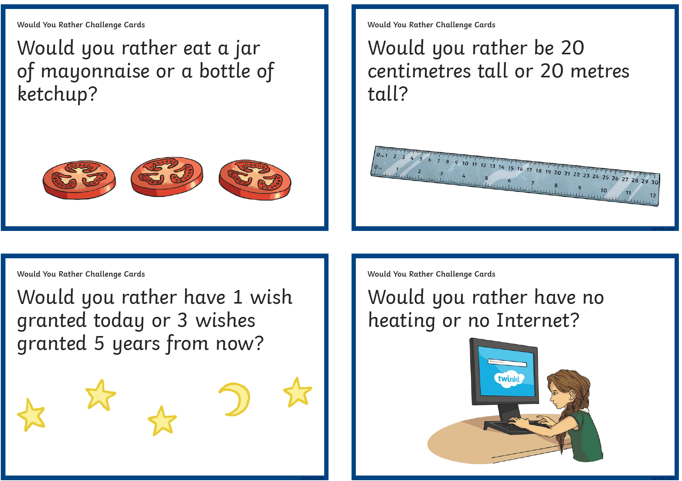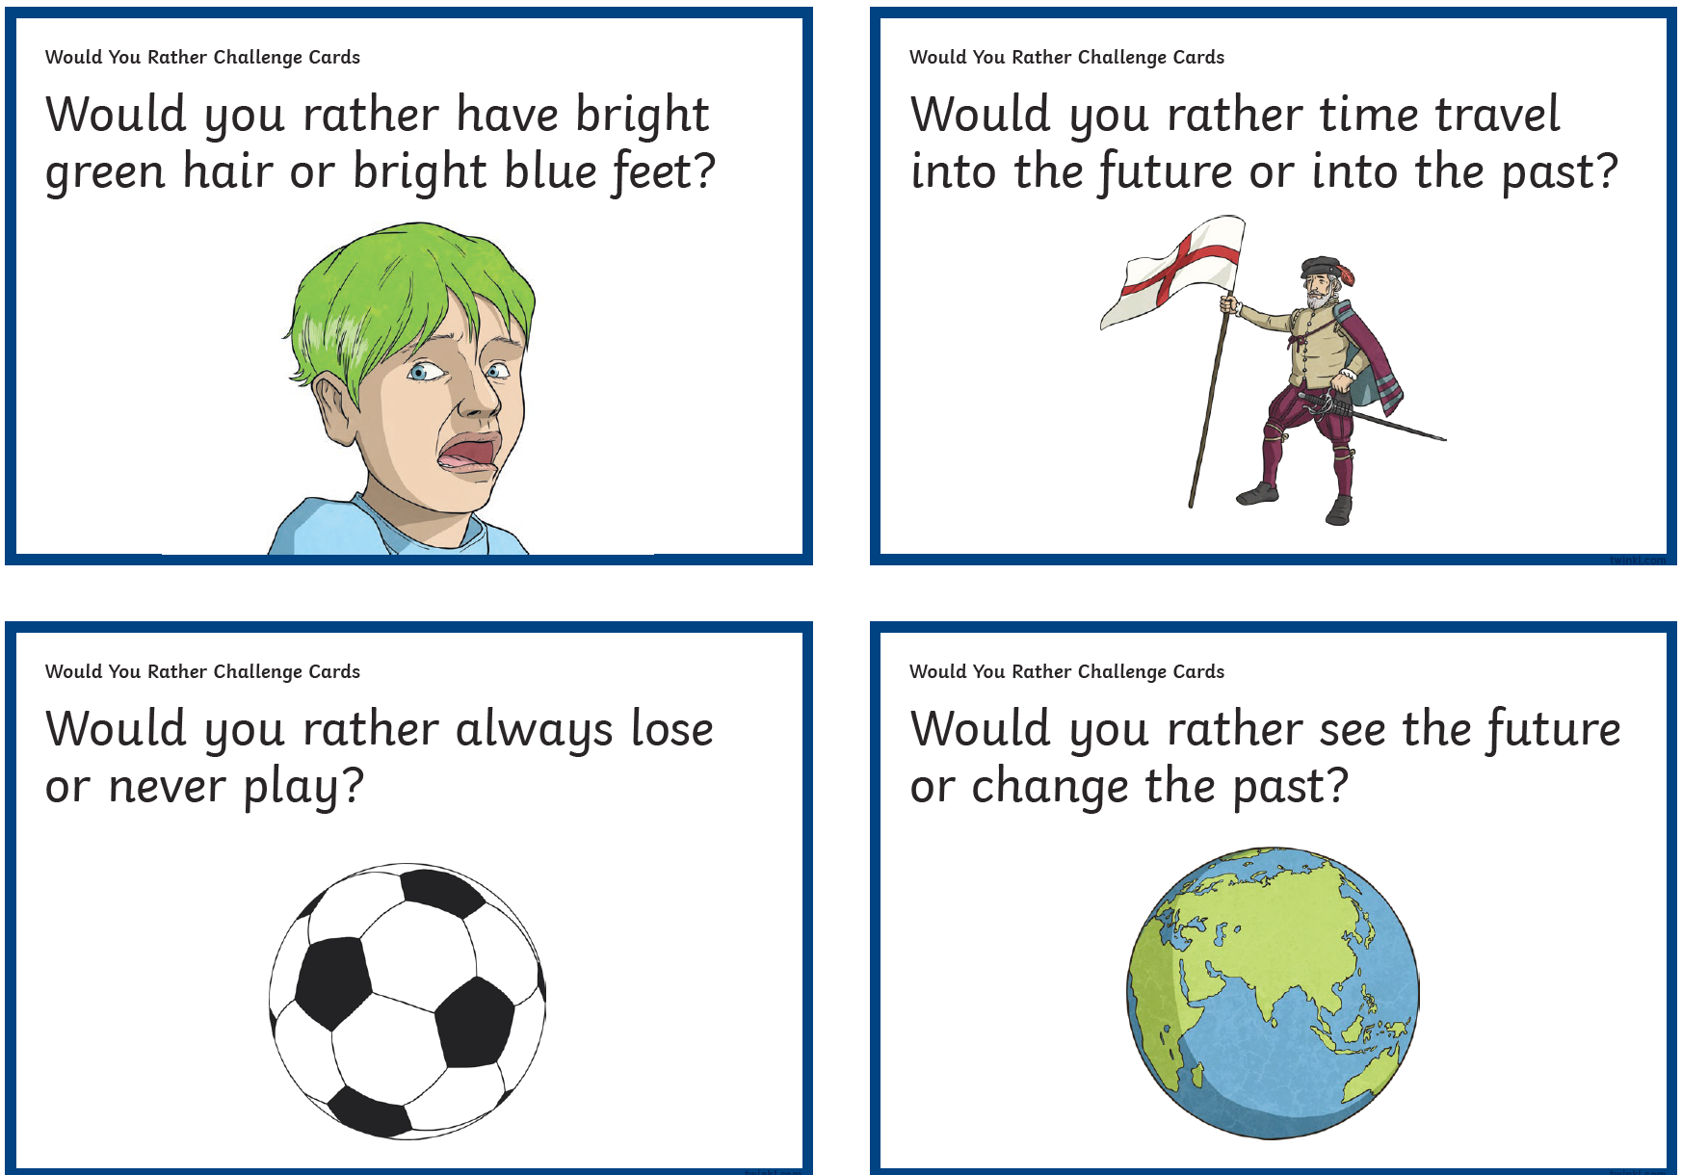
PE Easier
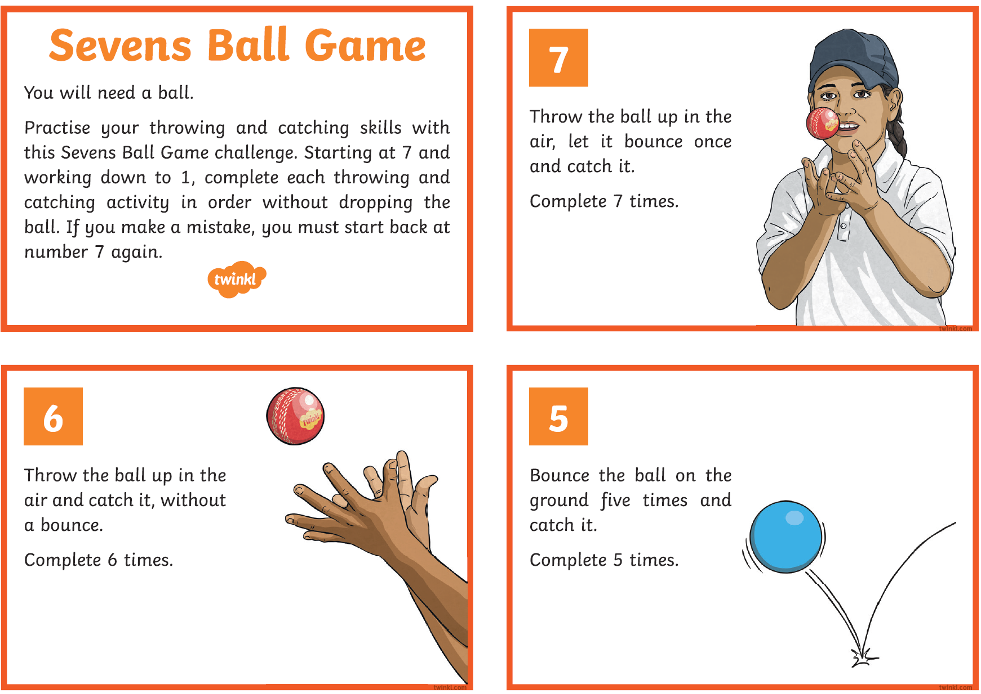
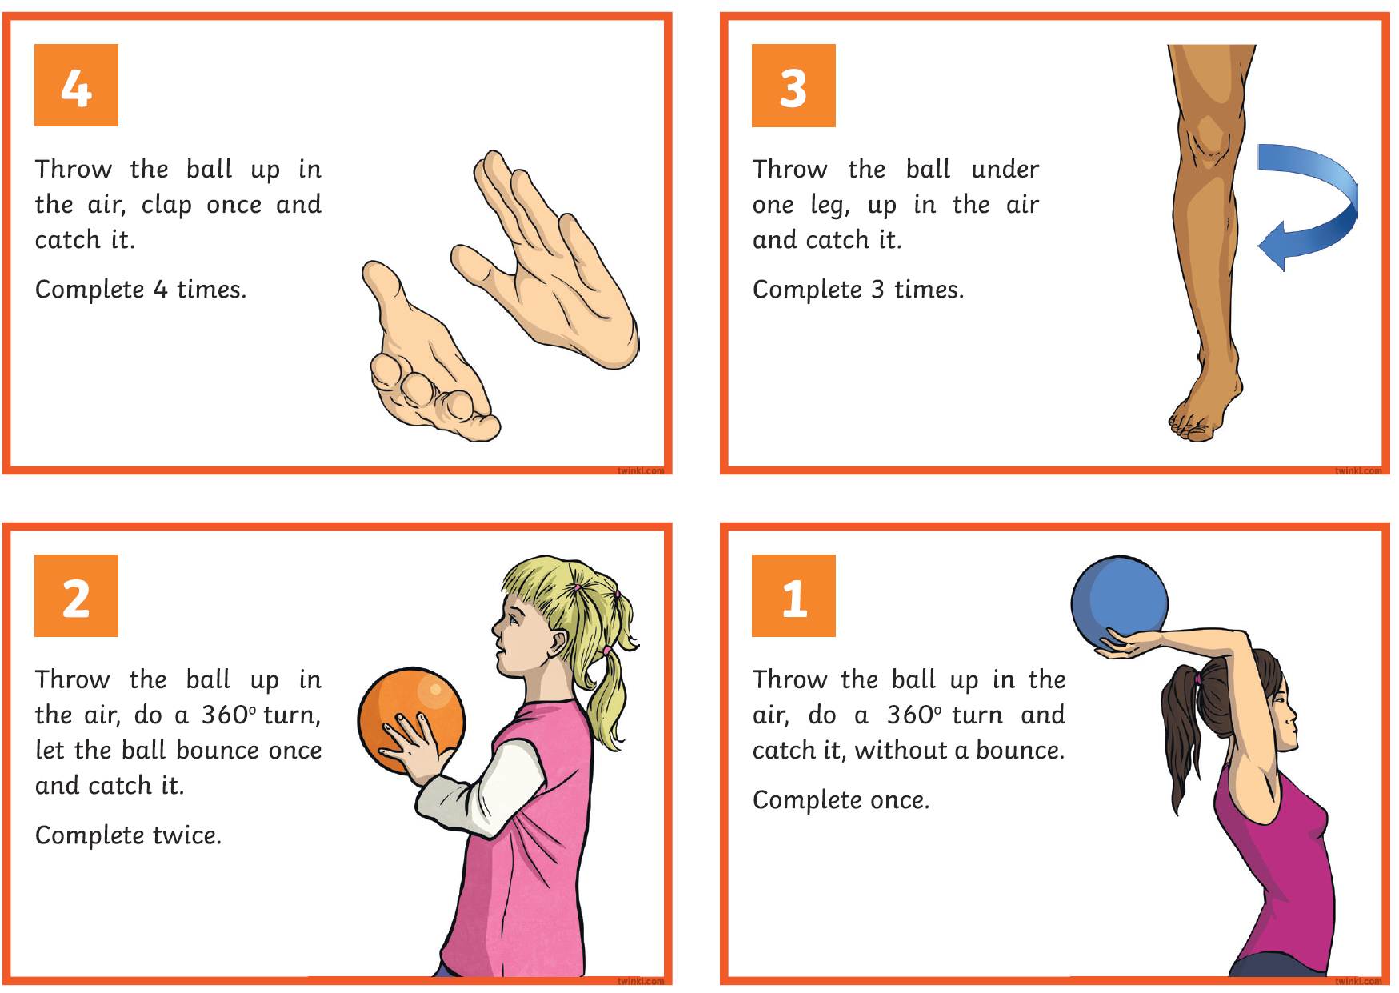

PE Year 6
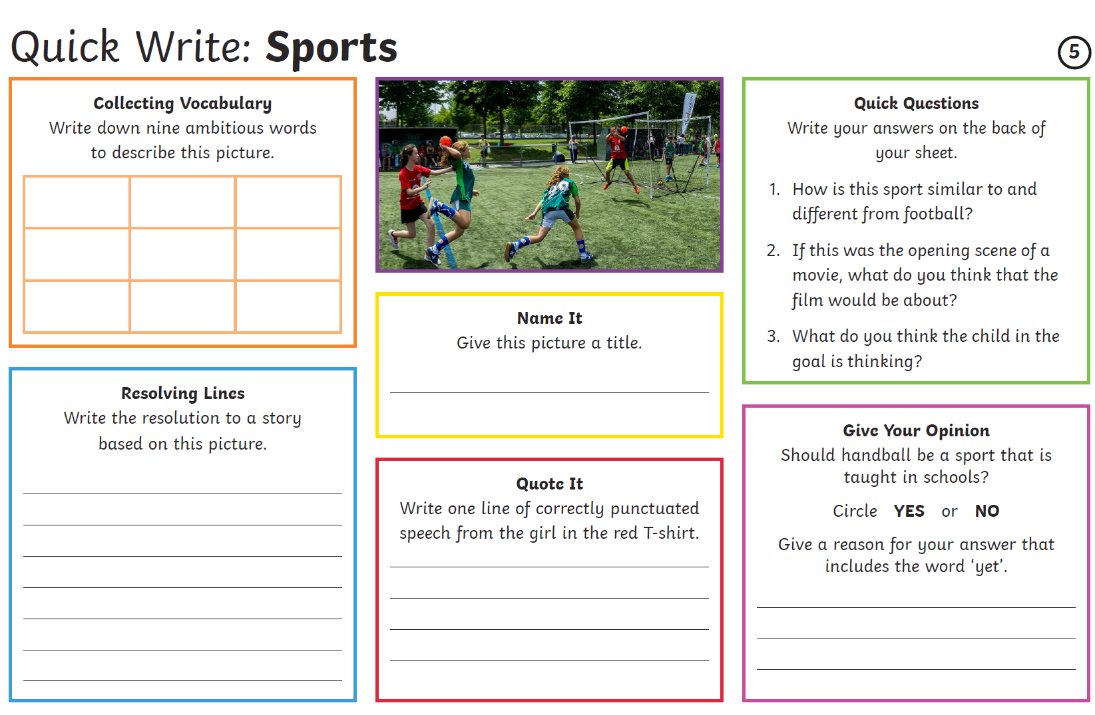
Other Activities
Times tables  Build up speed. Time yourself how long it takes you to answer 0 to 12 x tables in mixed order (work with an adult). | Get active.  With an adult, think of at least two different exercises which you can do at home e.g. in the garden. You must exercise for at least half an hour a day. | Use Purple Mash and play online learning games.  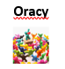 | Watch the news and choose any 3 stories to summarise. | Mindfulness  Try out some of the activities attached to help you relax.  How many different mindful techniques can you think of?  Which is your favourite?

Key skills to continue practicing weekly:
-spellings
-grammar (go through revision booklets)
-speed reading
-speed writing (count the number of words you can write in one minute)
-neat and joined up handwriting
-timetables (build up speed)

If you or your child has any further queries regarding their learning projects, please contact admin@hardwick.derby.sch.uk, clearly stating your child’s name and class teacher, and the staff will be in touch to support you and your child.

Thank you and stay safe.

