English | Maths | Science
Read for at least 30 minutes a day  Write a poem about the Blitz (include some words from our Year 5/6 spelling list)  Write a diary entry in role as an evacuee (William)  Watch the remaining part of Goodnight Mister Tom on YouTube and write a short description of Tom Oakley https://www.youtube.com/watch?v=eYJBkfKtCvM  Learn Year 5/6 spellings. These can be found at the back of your SPaG revision booklets.  Use your SPaG revision book and revise prefixes and suffixes p.54-59. Then create a poster with rules explaining how to use each prefix/suffix correctly.  If you are in 6HR, please use Purple Mash as new tasks are being added regularly. If you cannot remember your password, ask your parents to email Mr Nowak (g.nowak@hardwick.derby.sch.uk) | Focus on multiplication of whole numbers. Set yourself 10 sums ( see example) and answer using the column method. Ask an adult to check.  e.g: 4852 x 24  Focus on multiplication of decimal numbers. Set yourself 10 sums ( see example) and answer using the column method. Ask an adult to check.  e.g: 48.52 x 4  Use Mathematics revision guide read through pg 42. Make a poster showing how to work out the area of a parallelogram. Draw 6 parallelograms of different sizes ( see example) measure using a ruler, use the formula to work out the area.  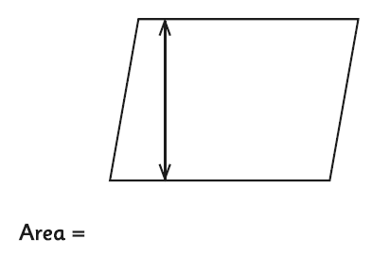  Learn x tables fact on TT Rockstars  Copy the table below and complete.  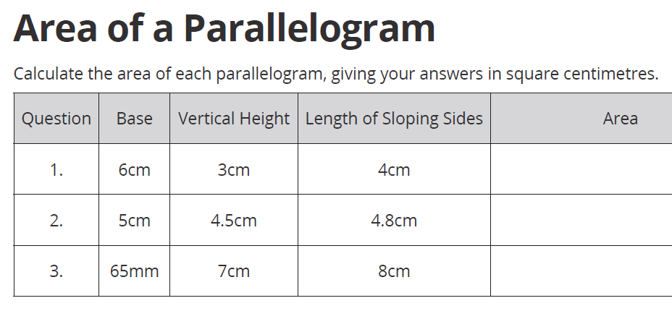  Look around you and identify as many shapes as you can in the environment.  Copy the table below and complete.  Shape picture Name of shape properties  Draw and cut out the shapes below and stick into the table and complete.  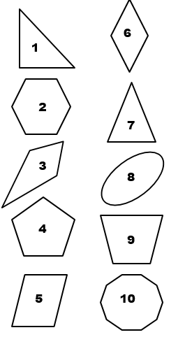 | - Draw a KWL grid on how animals are adapted to their environment. Choose any animal you wish and explain how their bodies are adapted to live in the habitat in which they are found.  K (what I know already) W (what I would like to find out) L (what I have learnt)  - Make two posters on the following animals, explaining how they are adapted to their environment:  camel, polar bear and a whale. See the links below to help you: https://www.bbc.co.uk/bitesize/topics/zvhhvcw/articles/zxg7y4j  - Choose an animal of your own and explain how it is adapted to the environment.  https://www.bbc.co.uk/bitesize/topics/zvhhvcw/resources/1  - Find the definitions of the following words: habitat, characteristics, streamline, adaptation, extinct and environment. Learn the definitions. (Use the online dictionary). Use each word and write your own sentences. Make sure you punctuate them correctly.  - Odd one out activity. Research the following animals (habitat and adaptation) and explain which animal is the odd one out (make sure you give a clear reason): camel, polar bear, whale and an eagle. Use Google to research.
Additional tasks:
- Watch Newsround and summarise each report (https://www.bbc.co.uk/newsround/news/watch_newsround).
- Watch BBC news and write an update on what is happening around the world, especially in the UK, about Coronavirus.
- Write a day to day diary on your feelings based on what you have seen on the news.
- Improve your timetable speed on TTRockstars.
- Each day children to do at least 1 thing to help a parent/guardian around the house e.g. cooking, cleaning, reading with a sibling.
- Each day children to do at least 1 thing they enjoy (other than electronics) e.g. draw a picture, paint, play a musical instrument, play a board game, build a sculpture using Lego.
- During the time children are off, they should learn a new skill e.g. how to cook a certain dish, how to sew, how to fix something.
- Children will have opportunity to feedback their new skills once school reopens.

