FS2 Home Learning
Week Commencing: 4th May 2020
FS2 teachers: Mrs Connelly-Haywood and Miss Ralph
FS2 TAs: Miss Hayat
Message from staff:
Miss Ralph: Hello, I am really looking forward to meeting you all when we return back to school. I hope you and your families are all well and you have been enjoying your time at home. I look forward to hearing about what you have been up to and getting to know you all. Take care, from Miss Ralph.
Mrs Connelly-Haywood – Hello everyone, I hope that you have had another good week at home. It has been another busy week for us. In my spare time this week, I have been doing lots of running and cooking. I cannot wait to hear about what you have been up to. Take care everyone!
Your Home Learning this Week:
Every day (Monday to Friday), make sure you choose a *physical, *communication, *reading/phonics, *writing and *maths learning activity. There are also further activities to choose from should you wish to.
Physical Home Learning
Practice your movements by moving like animals and insects e.g. fly like a butterfly, crawl like a caterpillar. Can you create your own movements for other minibeasts and insects? | With an adults supervision, use a knife to cut up pieces of fruit and make a yummy fruit salad | Continue to practice your scissor skills – cut out your own wings with different shapes to stick onto them. | Join in with a Cosmic Kids session. How many animal poses can you learn?  Follow the link at the end. | In the garden or an outside space, see how many times you can throw and catch a ball. Use different sized balls

Communication Home Learning
Listen to ‘The Very Hungry Caterpillar’ story. Discuss what happened in the story. If you have a copy of the book you could follow the story.  Follow the link at the end. | Can you remember the fruit in the story? Draw the pieces of fruit and retell the story using your pictures. The text map will also help you to remember the story. | Discuss your favourite fruit. What fruit do you not like and why?  I like ___ because ___.  I do not like ___ because ___. | Have a look at the minibeast PowerPoint, what minibeast can you see? Have you ever seen these minibeasts/insects in real life?  PowerPoint link at the end. | Can you describe different minibeasts that you may see outside?  It has ___ legs  It has wings/no wings  It is ___ (colour)

Reading/Phonics Home Learning
Focus on the phoneme ‘ck’  Read and write words.  sock pick pack sick tick dack gick gack  Which words are real? | Focus on the phoneme ‘e’  Read and write words.  get pet pen men neck peg | Focus on the phoneme ‘u’  Read and write words.  sun mug cup set mun dup sug  Which words are real? | Focus on the phoneme ‘r’  Read and write words.  rip ram rat rag rot | Focus on reading and writing these three key words in a sentence.  and the to

Writing Home Learning
Draw a picture of the fruit that the caterpillar ate each day. Can you find the initial sound of each piece of fruit?  apple – a  pear – p  plum – p  strawberry – s  orange – o  leaf - l | Can you segment to spell and blend to read these words that relate to the story:  ham, jam, sun, bug, egg | Draw a picture and write a sentence using the cvc words  It is ham.  It is jam.  It is the sun.  It is a bug.  It is an egg. | Can you draw a picture of 5 different bugs? What are they called? Write the initial sound for each bug.  Spider – s  Caterpillar – c  Butterfly – b  Fly – f | Talk about the days of the week and draw a picture of something you ate on that day.  Monday  Tuesday  Wednesday  Thursday  Friday  Saturday  Sunday

Maths Home Learning
Play the ladybird spot game. Make sure you count each of the spots carefully.  Link to game found at the end. | Can you name each of these shapes?  Triangle, square, rectangle, circle | Play a shape guessing game, talk about what each shape looks like.  It has ___ sides.  It has ___ corners.  It has ___ equal sides. | 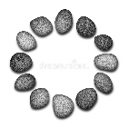  Collect lots of different items from around your house or outside (sticks, stones, leaves) and see if you can make a 2d shape. E.g. make a triangle out of sticks.  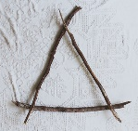 | What is a pattern? Can you create a pattern using 2 colours?

Other Activities
Make a caterpillar out of an egg box  Link to different ideas below | Find minibeats in the garden/outside and make a list of the minibeasts you find. | Sort minibeasts in different ways, e.g. how many legs they have, what colour they are. | Ask everyone in your house their favourite fruit record your findings in a graph or draw a picture to share what you found out. | Watch ‘Come outside – Butterflies’  Link at the end.

Key skills to continue practicing weekly:
Write your name.
Practice handwriting – try to form the letters on the line correctly.
Form numbers correctly.
Getting changed on your own.
Zip your coat up on your own.
Useful websites:
The Very Hungry Caterpillar - https://www.youtube.com/watch?v=75NQK-Sm1YY

Ladybird spot counting - https://www.topmarks.co.uk/learning-to-count/ladybird-spots

Guess the shape game - https://www.twinkl.co.uk/resource/through-the-binoculars-regular-2d-shapes-powerpoint-game-t-n-7347

Come outside Butterflies - https://www.youtube.com/watch?v=7l6nnv9ijBQ

What is the minibest power point - https://www.twinkl.co.uk/resource/t-t-10417-minibeast-what-can-you-see-powerpoint

Cosmic Kids Yoga - https://www.youtube.com/watch?v=xhWDiQRrC1Y

Egg box caterpillar - https://www.wikihow.com/Make-an-Egg-Carton-Caterpillar

If you or your child has any further queries regarding their learning projects, please contact admin@hardwick.derby.sch.uk, clearly stating your child’s name and class teacher, and the staff will be in touch to support you and your child.

Thank you and stay safe.

*Hungry Caterpillar Below:

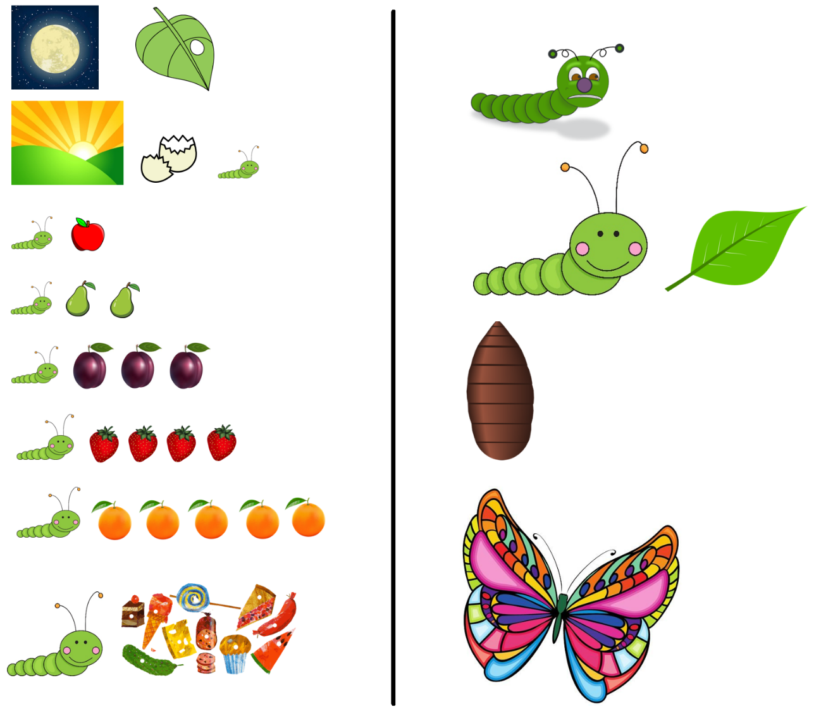
The Very Hungry Caterpillar

By Eric Carle

