Year 3 Home Learning
Week Commencing: 18th May 2020
Year 3 teachers: Mrs Priestland, Mrs Begg, Mrs Lumsden, Mr Rogers
Year 3 TAs: Miss Batool, Mrs Stringer
Message from staff:
We all hope you are safe, well and happy at home. We have really enjoyed talking to you all on the phone. Perhaps next time we talk you could think of something new or interesting you have been doing at home to tell us about.
We know that this time is really strange for you and your families. Many of you said you were missing school and some people were getting a bit bored and worried about things. To help you talk about what might be worrying you and how to make you feel better, Mrs Lumsden has given you lots of ideas to try in the other activities section of the home learning.
Hasn’t the weather been strange? One minute we are walking around in sandals and shorts and the next we are back in our winter coats and using umbrellas on our daily walk. Please remember to stay active – get into the garden and kick a football about, practise your skipping, see how many times you can round and round the garden, do 20 star jumps, balance a book on your head, anything to keep your bodies exercised. You could even make up a new game.
Your Home Learning this Week:
Every day (Monday to Friday), make sure you choose a *reading, *writing, *spelling/handwriting, *maths and *theme learning activity. There are also further activities to choose from should you wish to.

Reading Home Learning
Monday | Tuesday | Wednesday |  | Thursday | Friday
Read the Owl and the Pussycat. This is a narrative poem - it tells a story.  Pick out words that you do not understand. Find out what they mean and draw a picture to help you remember.  Monica the Monitor | Read the poem aloud with expression.  Draw a picture of what happened in each verse.  You will have three pictures telling the story.  Remember to add details – Vernon the Visualiser | Find the pairs of words which rhyme.  Add three more rhyming words to your list.  Check the spellings  Did you notice the parts of the verse which are repeated. |  | Write a list of characters in the poem. Draw each one and describe them.  You can find this poem animated on You Tube. Take a look! | This poem/story had two settings. Draw the two settings and describe them.  You can find another poem by Edward Lear on YouTube it is called The Jumblies
Easier:  Do as many of the above activities as you can. If you are finding some of the activities challenging, try these as they are a little easier:  - Using the text to help you, can you spot the mistake in each sentence and change it.  - The owl and the pussycat went to sea,  In a beautiful pea-blue boat.  - The owl looked up to the stars above,  And sang to his sweet piano.  - They took some jam and plenty of ham,  Wrapped in a ten pound note.  - Does the poem remind you of anything? Can you make any Colin and Carmen connections? Make a list of different links you can make. These can be other poems, books, nursery rhymes, movies, tv shows or anything you can think of. |  |  | Challenge:  If you feel you need a further challenge, try these:  - In the text, some words are highlighted. These words are homophones! (words that sound the same but can be spelt different and mean something different. For example, pair and pear.)  Try to find the different homophones for each of the words highlighted in the text.

The Owl and the Pussycat by Edward Lear

The owl and the pussycat went to sea,
In a beautiful pea-green boat.
They took some honey and plenty of money,
Wrapped up in a five pound note.
The owl looked up to the stars above,
And sang to his sweet guitar.
“Oh lovely Pussy! Oh Pussy my love,
What a beautiful pussy you are, you are, you are,
What a beautiful pussy you are.”

Pussy said to the owl “You elegant fowl.
How charmingly sweet you sing.
Oh let us be married, too long have we tarried:
But what shall we do for a ring?”
They sailed away, for a year and a day,
To the land where the Bong – tree grows,
And there in a wood a piggy-wig stood,
With a ring on the end of his nose, his nose, his nose,
With a ring on the end of his nose.

“Dear Pig, are you willing to sell for one shilling your ring?”
Said the piggy, “I will!”
So they took it away and were married next day
By the turkey who lives on the hill.
They dined on mince and slices of quince,
Which they ate with a runcible spoon.
And hand in hand, on the edge of the sand,
They danced by the light of the moon, the moon, the moon,
They danced by the light of the moon.

Writing Home Learning
Monday | Tuesday | Wednesday |  | Thursday | Friday
Create a text map for the poem. Begin to learn this poem off by heart. Summarise the story with 5 sentences. Do not copy lines from the poem. | Practise saying your poem with the text map.  Maybe you could act the story out with your brother, sister or mum. | Practise saying the poem.  This is a nonsense poem. In other words, it does not make sense. Find five things which could not possibly be true |  | Imagine you are the owl or the pussycat.  Write an invitation asking a turtle to come to your wedding. You need to tell him what, where and when it will be happening. | Pretend you are the owl or the pussycat. Write a letter to your mum or dad telling them all about your journey and your wedding. Use your imagination to add details and feelings.  There some clues on how to write a letter on the next page.
Easier:  Do as many of the above activities as you can. If you are finding some of the activities challenging, try these as they are a little easier:  - Write a list of other animals which might have gone to the wedding  - Write about a wedding you have been to. Who was there, where was it, what did you wear, what did you eat? |  |  | Challenge:  If you feel you need a further challenge, try these:  - Use your imagination to write a story about what the Owl and the Pussy cat did after their wedding.  - Think of another nursery rhyme and write a letter pretending to be a character eg Pretend you are Jill telling your friend all about Jack falling down the hill.

This is what an invitation might look like. – You can add decorations and pictures. Remember capital letters for places, names and months. How to write a letter.
Shrek and Princess Fiona  invite Donkey  to join them at their wedding  on 1st June 2021  at 5 o’clock  at The Palace  A Land Faraway  There will be dancing and dinner to follow | The Castle (The address)  A Land Far Away  14.5.20 (The date)  Dear Mum (who is it to?)  You will never guess what happened to me…………………  Love from

Spelling/Handwriting Home Learning
Monday | Tuesday | Wednesday |  | Thursday | Friday
break – brake  eight – ate  weight – wait  great – grate  son - sun  Write the word and draw a picture for each of the homophones | break – brake  eight – ate  weight – wait  great – grate  son - sun  Put these words into interesting sentences | metal, bottle, medal, little, label, table, camel, rival, angel, example, ankle, squirrel, pebble, circle, vowel, moral, signal – Sort these  al le el |  | Unjumble the words le/al/el words  meacl, temal, bleat, klean, quirlers, nentul, totble, tiltle bebple, nergela  No put the words into sentences. | Look at the key words list from last week’s home learning.  Choose ten words to practise. Remember to underline the trick part in each word.
Easier:  Do as many of the above activities as you can. If you are finding some of the activities challenging, try these as they are a little easier:  - pipe, try, climb, tie, bright smile, cry, spy, high shine, kind, fine, slide, pie, night, shy – Sort these words into the graphemes  ie igh y i - e i  pie  - Put these words into sentences  - Think of 10 words which end with y – making the /ee/ phoneme eg mummy, baby |  |  | Challenge:  If you feel you need a further challenge, try this:  - A silly but also important challenge!  Can you write the whole alphabet, in order, joining up every letter with the correct joins?  abcdefghijklmnopqrstuvwxyz  Even the computer can’t do this challenge!  Remember your letters should all be the same size except for your ascenders and descenders. Bonus points if you can do it without your pencil leaving the paper from start to finish!

Maths Home Learning
Monday | Tuesday | Wednesday |  | Thursday | Friday
Division  24 ÷ 4 =  35 ÷ 5 =  18 ÷ 3 =  64 ÷ 8 =  Write some of your own | To find a fraction of a number you divide it by the numerator.  Eg ¼ of 20 = 5  20 ÷ 4 = 5  Write some of your own. | Even numbers are numbers which can be equally divided by two. They end in 0 2 4 6 8  Write 10 three digit even numbers |  | Halve these numbers using partitioning  48 62 88  80 64 28  eg 1/2of 26.  ½ of 6 =3 ½ of 20 =10 10 + 3 = 13 so ½ of 26 = 13 | Halve these numbers  74 92 71 56  38 58  ½ of 94 = ½ of 4=2  ½ of 90 = 45  45 + 2 = 47
Easier:  Do as many of the above activities as you can. If you are finding some of the activities challenging, try these as they are a little easier:  Next time your mum does the washing help your mum to sort the socks into pairs. Does every sock have a partner?  How many socks were there altogether? How many pairs.  How many socks do I have if there 10 pairs  6 pairs  4 pairs  I have 14 socks – How many pairs?  I have 18 socks – How many pairs?  I have 8 socks – How many pairs? |  |  | Challenge:  If you feel you need a further challenge, try these:  - Find 1/3 of 15, 21, 30, 18, 36  - Find 1/8 of 56, 64, 8, 24  - Find 1/5 of 45, 80, 25, 60  Equivalent fractions are equal to each other  ½= 2/4= 4/8.  See the work below for some work on this.

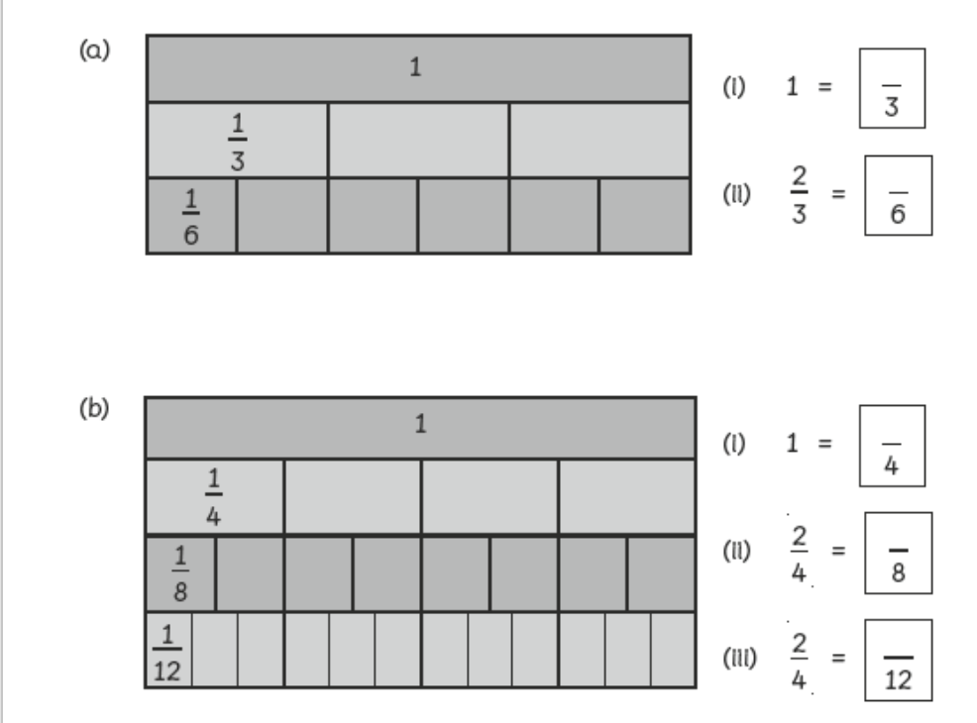
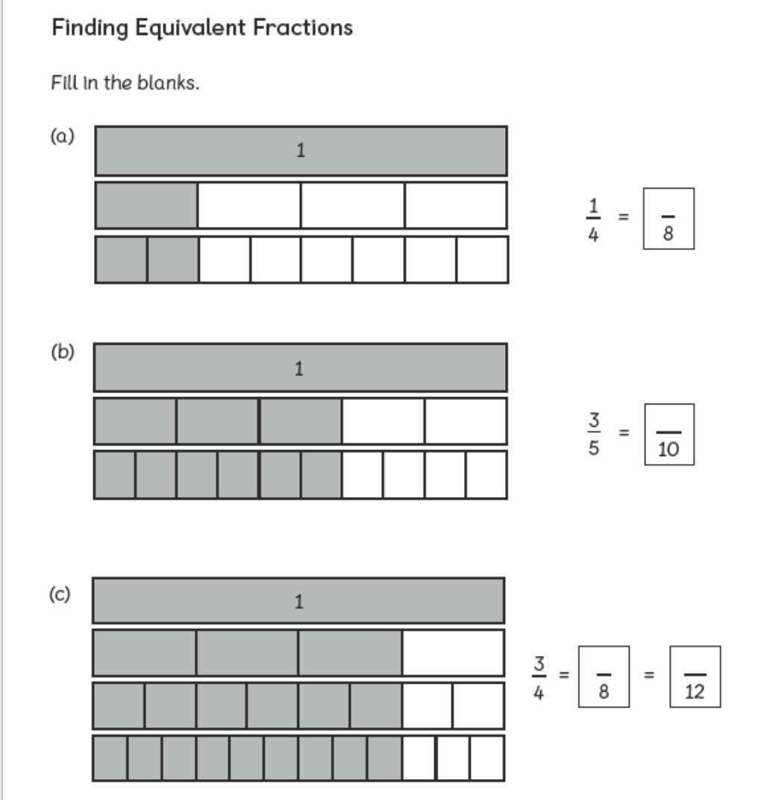

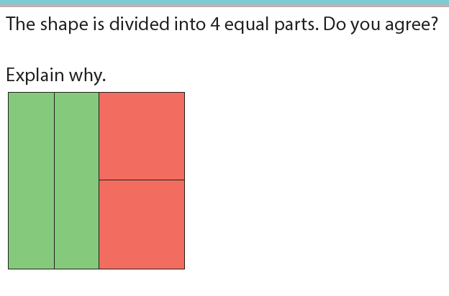
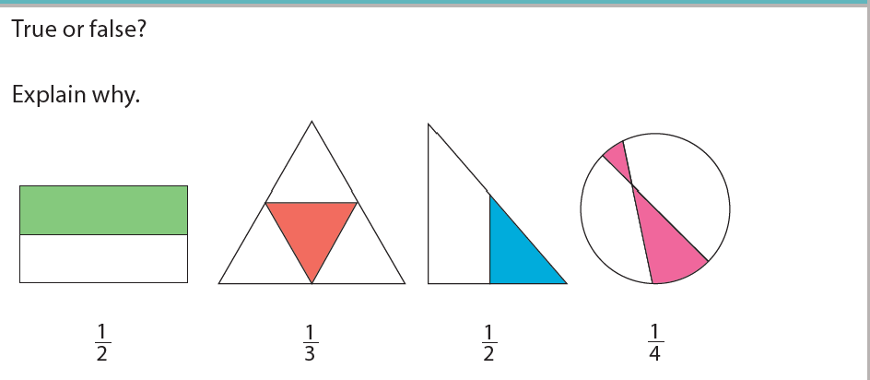

Theme Home Learning
Monday | Tuesday | Wednesday |  | Thursday | Friday
We know about the Ancient Greeks from artefacts they left behind. Look at the pictures on the Ancient Greek pots. What are the people doing? Use your imagination. | Can you draw an ancient greek pot or vase. Draw your own picture on it. Remember the people must be wearing ancient greek clothes. | Read the story of Daedalus and Icarus or ask mum to read it to you.  Draw four pictures to tell the story. |  | Read the story again.  Explain why Icarus fell to the ground. | Candles are made of wax. If you have one at home ask an adult to light it for you. What happens to the wax as the candle burns? What is the liquid made of? What happens when the melted wax cools?
Easier:  Do as many of the above activities as you can. If you are finding some of the activities challenging, try these as they are a little easier:  - With help from an adult, try to recreate some of the pictures on the pots and take a picture of you doing it.  - Draw a picture of Icarus falling from the sky and into the sea. |  |  | Challenge:  If you feel you need a further challenge, try these:  - If you have the resources, have a go at creating your own Ancient Greek pot. You could make it 2D or challenge yourself even more to make it 3D. You could even take some pictures of yourself doing different poses to add to your pot!  - From the story we learnt that the wax wings melted from the heat of the sun. Predict what you think might happen if;  - The wax wings were put in water  - The wax wings were put in the freezer

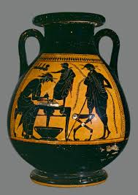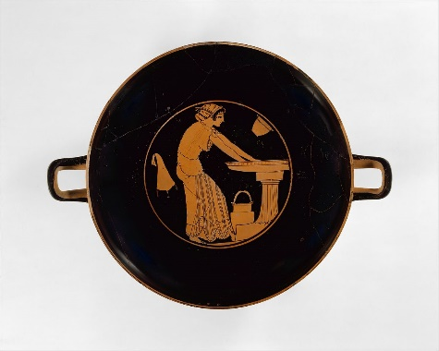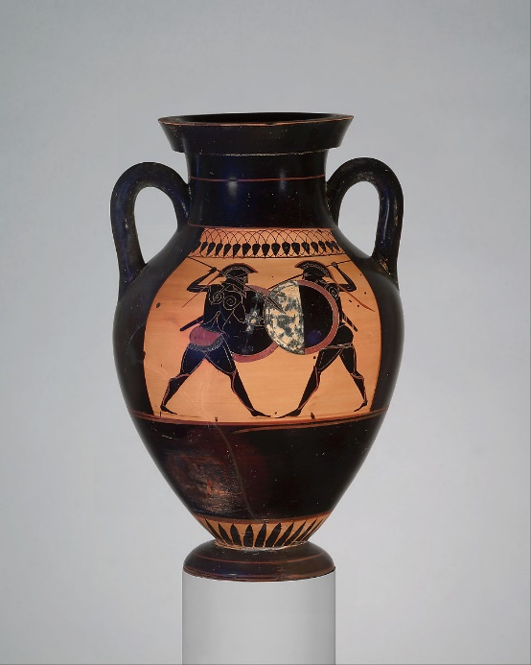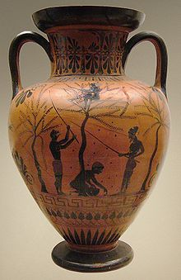
The Boy who Flew too High
Daedalus was a brilliant architect and inventor – in fact, he was so brilliant that King Minos of Crete did not want to let him go back to his home in Athens. Instead, he kept him as a prisoner. Daedalus lived with his son Icarus in a tower of the palace, and King Minos made him invent weapons of war that would make his army and navy even more powerful than they already were.
Although Daedalus and Icarus had every comfort they could ask for, the father longed to return home to Athens. His son hardly remembered his home city, but he too wanted to leave because he longed to run and play in the open, rather than live in a tower all day.
Daedalus looked out over the waves of the Mediterranean Sea, and he realised that even if they could manage to slip out of the tower and find a little boat, they wouldn’t be able to sail very far before they were spotted and caught by one of the ships of King Minos’ navy.
He thought for a long time about the best way to escape, and finally he came up with a plan, and this is what he did... He told King Minos that he needed feathers and wax for a new invention that he was working on. When these were brought to him, he took them up onto the roof of the tower. Here he arranged them into four lines, starting with the smallest feathers, and followed those with the longer ones so that they formed gentle curves. He then began to stick the feathers together with thread in the middle and wax at the base. While he was working, Icarus played with the wax, squashing it between his finger and thumb, and when the feathers blew away in the breeze he ran after them and caught them.
When Daedalus had finished, he showed Icarus his work. He had made the feathers into two pairs of wings. He fastened the larger pair to his arms, and began to flap them until his feet took off from the floor and he began to hover in mid air. Icarus laughed with delight and could not wait to try out the smaller pair of wings. Over the next few days, father and son both practised with them until little Icarus was almost as good at flying as his father was.
Then one morning Daedalus said to Icarus, "Now Son, we are ready to leave this island for good. We shall fly home to Athens. Although you are now quite good at flying, you must not forget that it can be very dangerous. Listen to my instructions and be sure to follow them to the letter. At all times follow me, for I will find the way home. Do not veer off on a different flight path, or you will soon be lost. Do not fly too low or your wings will fill with moisture from the waves, and if they will become too heavy you will sink down. Nor should you fly too high, or the sun will heat the wax and your wings will fall apart. Have you understood all that I have said?"
Little Icarus nodded to show his father that he had understood. Then Daedalus led his son up onto the battlements of the tower, and like a bird leading her fledglings from the nest for the first time, he jumped into mid air and flapped his wings, Icarus followed soon after.
If a fisherman or a shepherd had looked up just then, he would have seen two very unusual birds hovering above the waves. No doubt he would have thought that they had caught sight of two winged gods. Who could have believed that a mortal father and son had mastered the art of flight?
Over the seas they sailed, and at first Icarus felt frightened for he had never ventured very far in his practice flights, but soon he found that he was really good at flying. In fact, it was the most tremendous fun you could ever have. He began to swoop up and down with the sea gulls. Wow! It was amazing! His father turned round and called, "Icarus, take care!" and for a while after that Icarus obeyed his father, and flapped along behind him. But then his wings caught a warm air current, and he found that he could soar along and upwards almost without any effort. This was the life! He was floating ever so high above the waves and the ships down below were like tiny little specks.
His father called up to him, “Icarus, remember what I told you. Come down right now!” Icarus could not hear him however, and his father could not catch up with him.
Icarus was far too close to the sun, and soon the wax that held the feathers together began to melt. Gradually his wings began to lose their shape, and some of the feathers even began to fall off. Icarus flapped his arms frantically, but it was too late. He had lost the power of flight and down he plunged into the sea.

Other Activities This week we will investigate our worries and make a plan to help us handle them better.
Complete the sheet “Talking about worries” to find out what might be making you feel worried at this time. Share what you found with an adult. | Complete “how my body feels” to investigate whether you are feeling worried a lot of the time, or just every now and then. | Talk with an adult about times you feel worried and what others can say to help you through it sheet “Say this, Don’t say this” | Look through the large sheet of “coping skills ideas” these are things that might help distract you or calm you down if you’re feeling worried. Choose at least 5 you would like to try out this week. | Create a “when I feel worried action plan” This will give you a ‘cheat sheet’ ready to look at to help you regain control if you find yourself getting overwhelmed with worries. Remember, everybody worries, it is nothing to be ashamed of! ntrol.

Talking about worries.
Calm |  | A little worried | Quite worried | Very worried
Lately everyone has been feeling a little worried about what has been going on. Talking about your worries with someone close to you will help you begin to plan for how to handle them.
Rank these worries from 1-10 about how they make you feel.
 | Fights in my family (parents or siblings)
 | Watching the news/ seeing newspaper headlines.
 | Being outside the house (on a walk or shopping)
 | Being inside the house all day.
 | Sudden changes to plans.
 | Being away from friends or family.
 | Having too much time to think.
 | When members of the family go out to the shops.
 | Not knowing what will happen.
 | Hearing adults talking about the news.
 | Someone in the family behaving differently.
 | Trying to make other people happy.
 | Thinking about the future.
 | Being unprepared for something.
 | Being told off.
 | Being in tight spaces or being in wide open spaces.
 | Someone I know might get ill.
 | The thought of going back to school.
 | Talking about my feelings.
 | Loud noises or raised voices.
 | Emergency vehicle sirens.
 | (This is an empty space for anything else you have thought of.)

How my body feels when I am worried.
Knowing how your body feels when you are worried helps you to quickly realise that you are worried and begin to take steps to calm yourself. When you feel worried, which of these things happen to your body? Put a tick or a cross.
 | My heart beats fast. |  |  | I have a hard time talking to others.
 | I feel hot/warm. |  |  | I shake.
 | I feel afraid. |  |  | I have trouble sitting still.
 | My voice trembles. |  |  | I have trouble breathing.
 | I have trouble getting to sleep. |  |  | I feel ‘jumpy’ or on edge.
 | I have nightmares. |  |  | My chest feels tight.
 | I struggle to stay asleep. |  |  | I get a ‘lump’ in my throat.
 | I feel like I am going crazy. |  |  | I feel down
 | I feel like running away. |  |  | I avoid certain places or people.
 | I feel out of control or helpless. |  |  | I feel tired.
 | I feel like being left alone. |  |  | I have trouble relaxing.
 | I don’t want to be left alone. |  |  | I feel sick.
 | I feel hungry. |  |  | I can’t concentrate.
 | I don’t feel hungry at all. |  |  | I need to do something that takes all my focus (e.g. drawing, watching TV, running, video games)

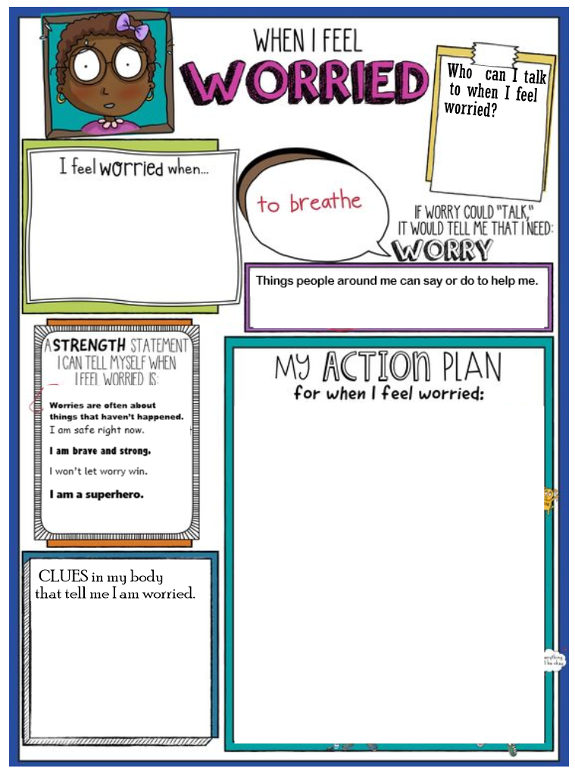
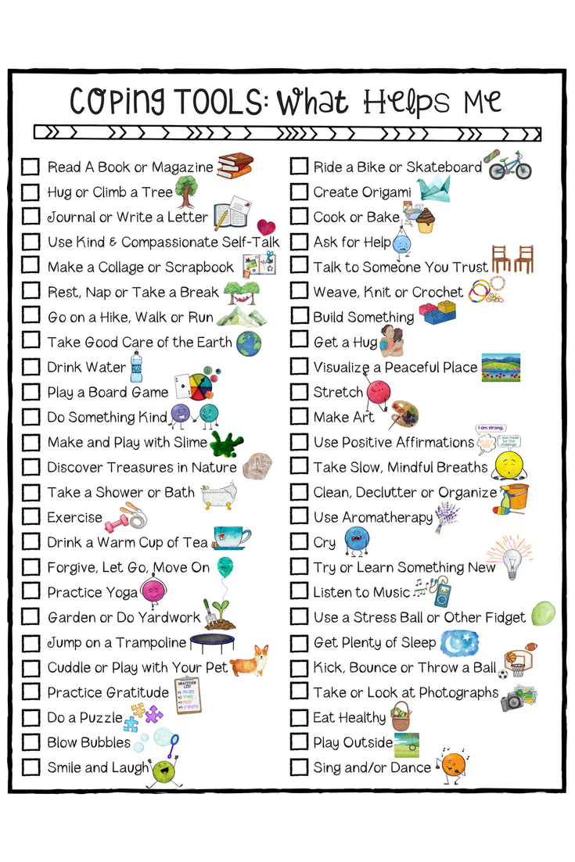
Key skills to continue practising weekly:
- Times tables – 2, 3, 4, 5, 8, 10. Also practise the division facts.
- Key word spelling – the lists were included in last week’s home learning
- Read and reread any books you have in the house. Read aloud with expression.

If you are able to access the internet, try these useful websites:
- https://nosycrow.com/blog/released-today-free-information-book-explaining-coronavirus-children-illustrated-gruffalo-illustrator-axel-scheffler This is a free digital book which explains all about the virus in a reassuring way
- BBCbitesize/daily lessons
- https://www.bbc.co.uk/bitesize/subjects/z39d7ty - keep up with your French buy learning new words and phrases.

If you or your child has any further queries regarding their learning projects, please contact admin@hardwick.derby.sch.uk, clearly stating your child’s name and class teacher, and the staff will be in touch to support you and your child.

Thank you and stay safe.

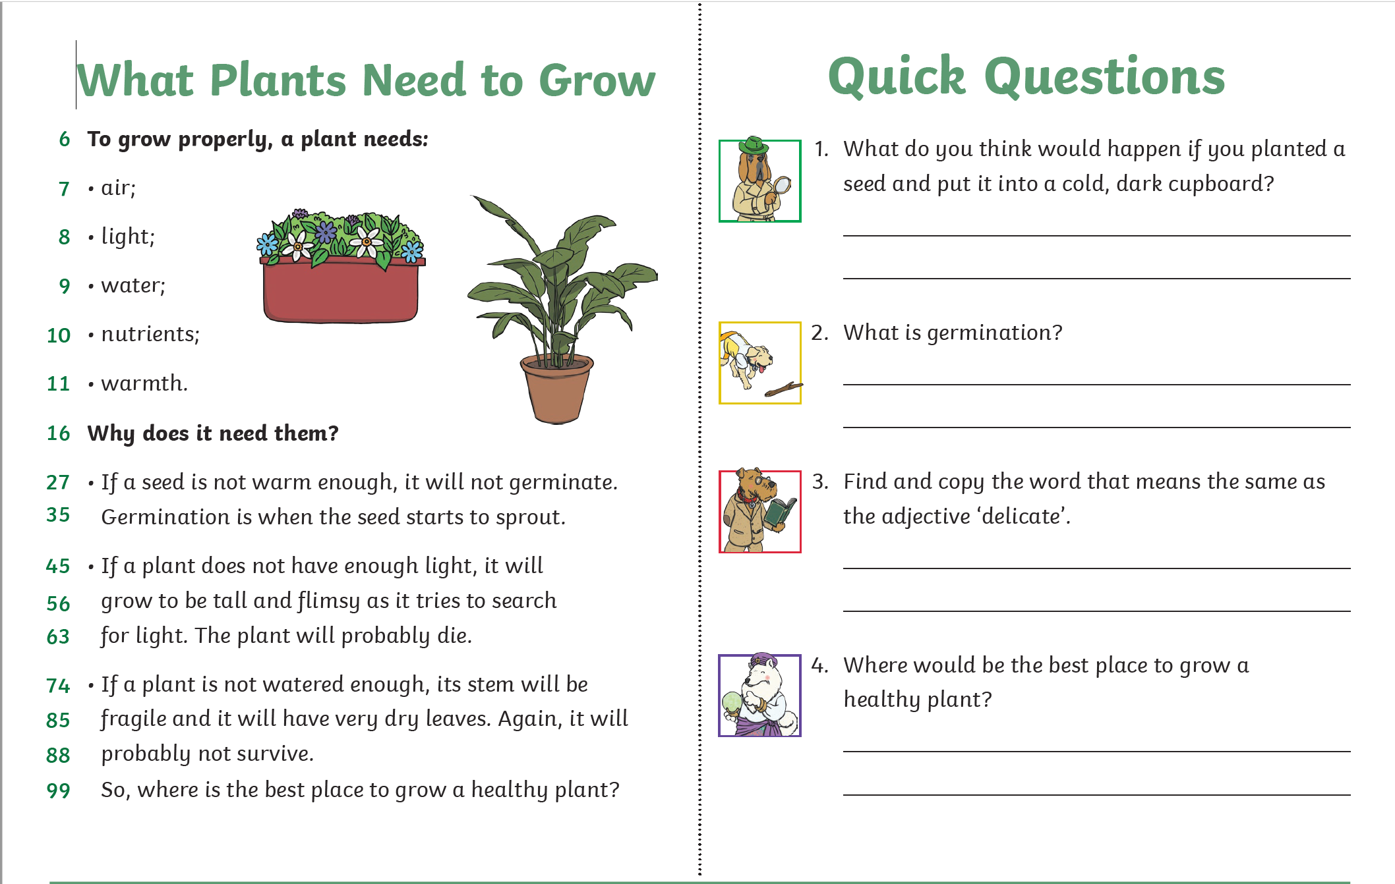

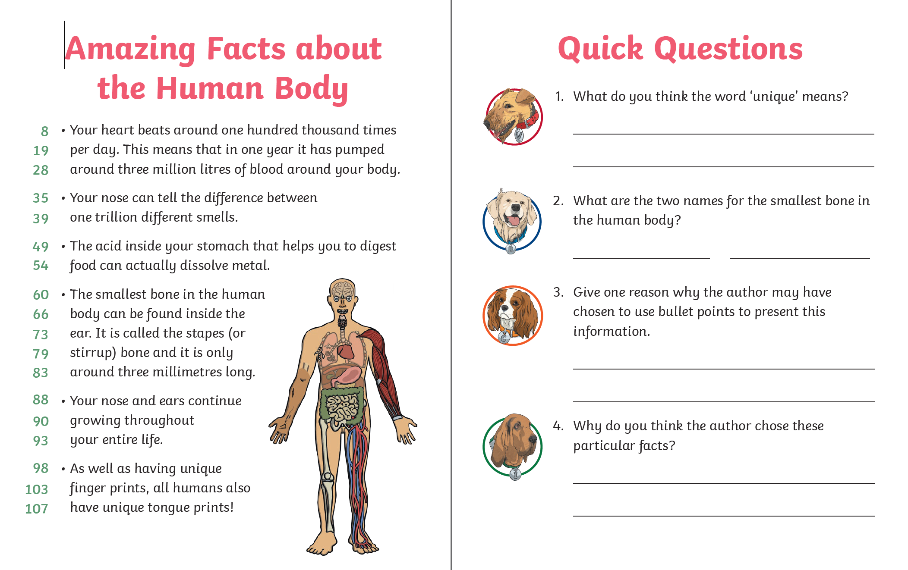

Would You Rather…
It is so important to talk and when we are at school, we have plenty of time to do so. However, that doesn’t mean you can’t talk even more when at home! So, to help you and give you an idea, here is an activity you can play with someone at home. For each box, make a choice; which would you rather? Remember, you can only choose one and explain why you would choose that. Don’t forget to have some fun with it!
ice – cream  or  chocolate | Bat-man  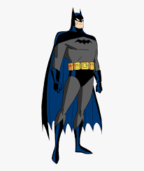  or  Wonder-woman  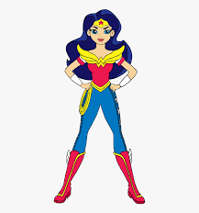 | snowball fight  or  water balloon fight  