Year 5 Home Learning
Week Commencing: 6th July 2020
Year 5 staff: (Mrs Nisa, Mr Caldwell and Mrs Hollingworth, Miss Gent, Mrs Begum)

Message from staff:
Hi Year 5,
I know we have said this each week but please try to do as much of the work as possible. We do not want your brains to go all mushy for when we do finally come back. It is incredibly important to keep our brains active.
Now, you will have received weekly phone calls from your teacher. As we have said, next week will be the last call from us (your current teachers) and you will be finding out who your new teacher is as well as getting a call form them the following week. This does not mean you stop working. Keep your Homework packs and continue to use them throughout the holidays. We will be setting new Homework each week until the end of term.
This week’s are all accessible for the whole year group. Try your best with all of it and push yourself to do the best work you can. Think about what we would say if we were to read your writing. Think about the questions we would ask you about your reading. Think about the tricks and tips we would remind you of in maths. Draw on your memory of the things you must ALWAYS REMEMBER TO DO in each subject.
Have fun and we will all speak to you at some point in the week.
Safe. Year 5 team.
Your Home Learning this Week:
Every day (Monday to Friday), make sure you choose a *reading, *writing, *spelling/handwriting, *maths and *theme learning activity. There are also further activities to choose from should you wish to.
Reading Home Learning
Monday | Tuesday | Wednesday | Thursday |  | Friday
You will be reading a text about a possibly haunted house. Read the text carefully and highlight or underline any word you do not understand.  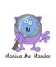 | Re-read the text and find the meaning of the words you do not understand from yesterday. | Using Stan Summariser, summarise the main information– do not forget to use your VIP’s (very important parts).  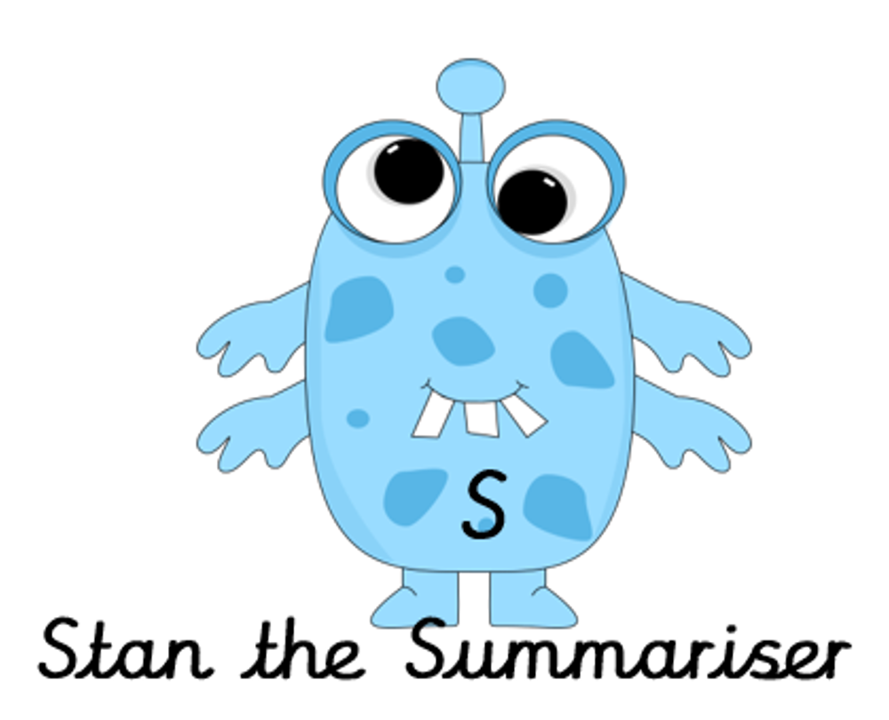 | Now try answering these questions:  - Who shouted ‘’Hello’’ to the girls as they walked Monty?  - Why did the girls cross the road?  - What two things made the girls feel better when they saw Mrs Walker?  - Why didn’t Freya believe her grandad?  - What two things did the girls notice about the house as they got closer that made it less scary? |  | After reading the text think of any questions you may have. Is there anything you were left wondering that was not answered? Write these questions down. Reread the text again and this time, try to answer the questions you have. Can you answer them? If not, try to research the answers
Easier:  Do as many of the above activities as you can. If you are finding some of the activities challenging, try these as they are a little easier:  - Read the easier version of the text.  - Highlight any words you do not understand and find out what they mean.  Try and answer these questions:  - What colour was Monty’s lead?  - Who waved at Jessica and Freya?  - Who told Freya that a witch lived in the house?  - What did Monty chase?  - What do you think will happen next in the story? |  |  |  | Challenge:  If you feel you need a further challenge, try these:  Answer the following questions:  - How do you now that the girls were nervous walking down the path?  - Why does Freya not trust what her Grandad says?  - How did the f=girls know that Monty needed a break?  - What is the moral of the story?
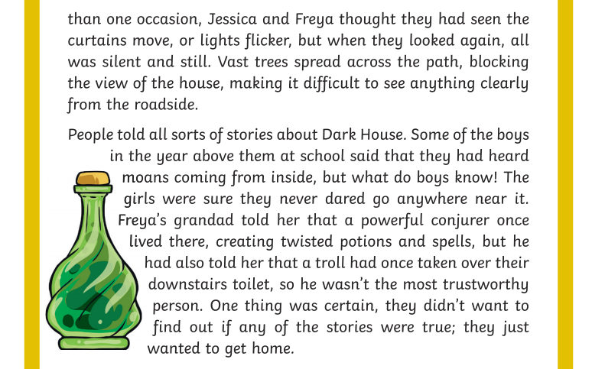
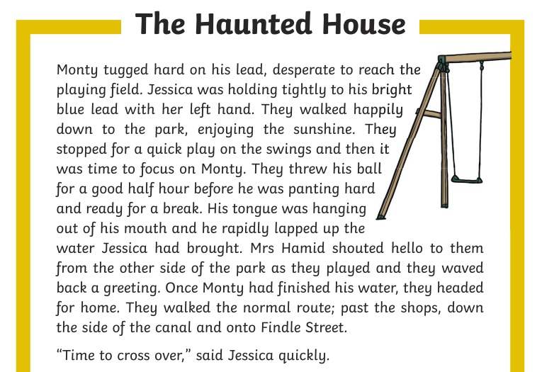
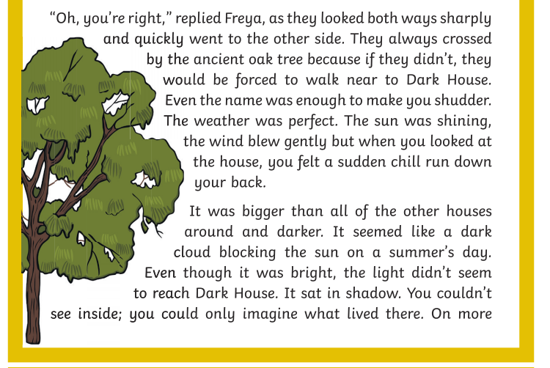

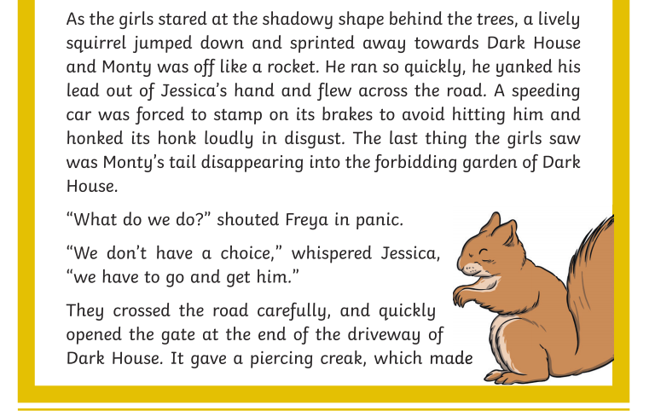

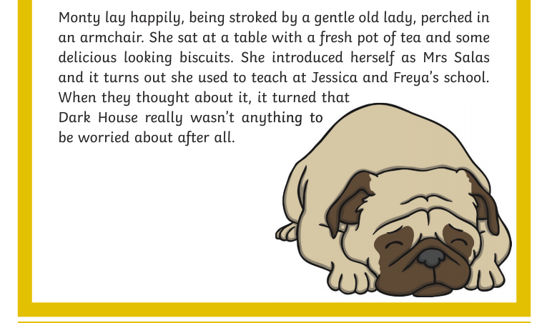
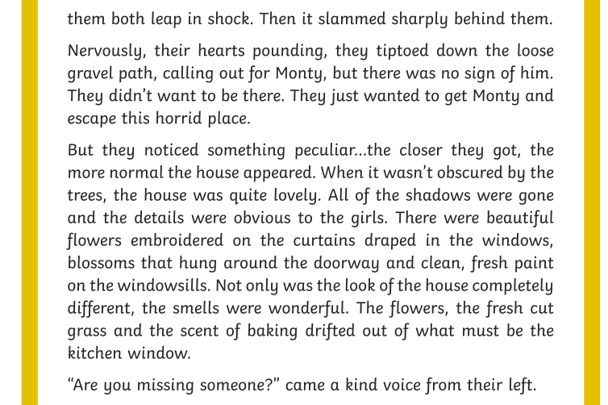

Easier text
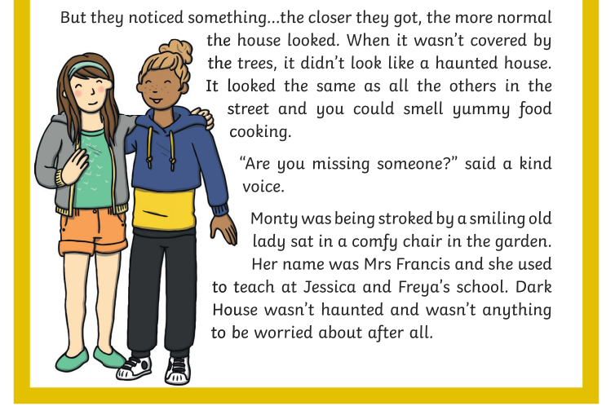
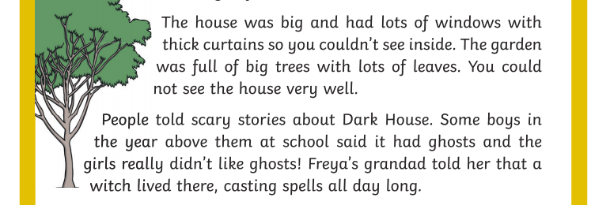
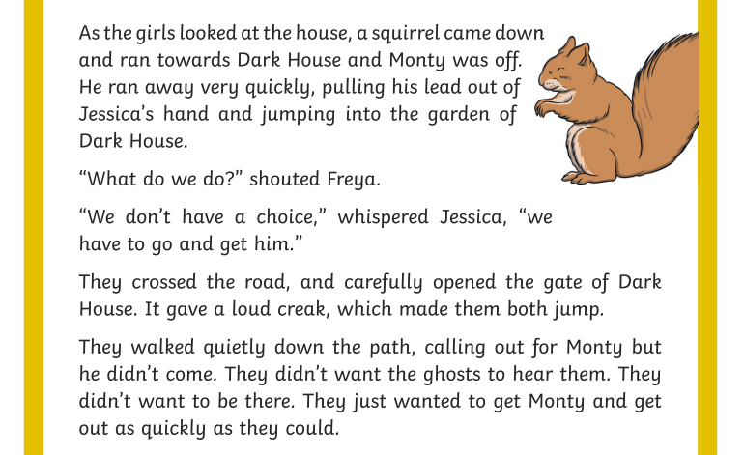
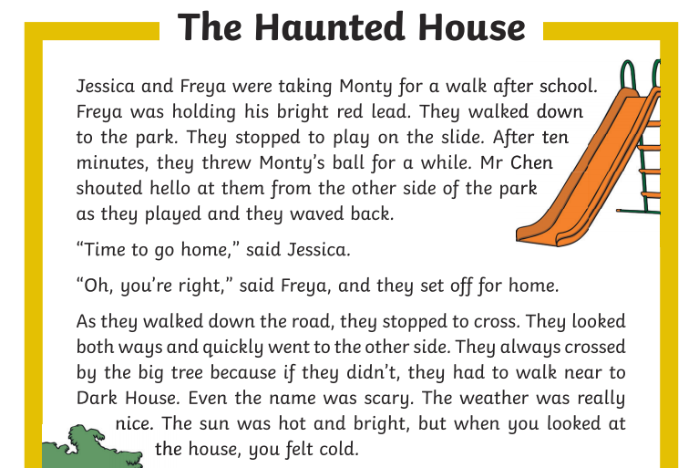

Writing Home Learning
Monday | Tuesday | Wednesday |  | Thursday | Friday
This week Mrs Nisa, Mr Caldwell and Mrs Hollingworth want you to have a go at writing a story with tension and atmosphere, it can be a haunting, a mystery or even an adventure!  The sheet below will help you with ideas. The setting has already been written. Have a go at re-writing the setting using the instructions on the story sheet below. | Mind map as many possible ideas as you can for what might happen next, think about who your characters will be, what will happen or go wrong, how they problem will be solved and how the story ends. | On a piece of paper create a comic strip to summarise the main parts of the story, setting, build up, dilemma, resolution, ending. Visualise each part of the story and draw a picture for each section to remind you of what happens, |  | You have already written your setting so continue to write your build up to the problem and then the problem itself. Make it exciting and remember to include plenty of detail for the reader. | Finish writing your story by adding the resolution and ending.  Have a go at reading it to someone at home and get their ideas and feedback. If it was meant to be funny, did they find it funny? If it was meant to be scary, did they find it scary?
Easier:  Do as many of the above activities as you can. If you are finding some of the activities challenging, try these as they are a little easier:  - Complete the activities above but use the easier story prompt sheet to get started.  - Remember to add exciting adjectives to describe your characters.  - Remember your full stops and capital letters.  - Read back each sentence after writing it to make sure it makes sense. |  |  | Challenge:  If you feel you need a further challenge, try these:  - Develop tension for the reader by inferring how the character is feeling rather than telling the reader.  - Add ellipses to create a cliff hanger at the end of a paragraph.  - Include brackets or dashes as parenthesis to add more detail for the reader.  - Choose time conjunctions to begin each paragraph to move the story on for the reader.
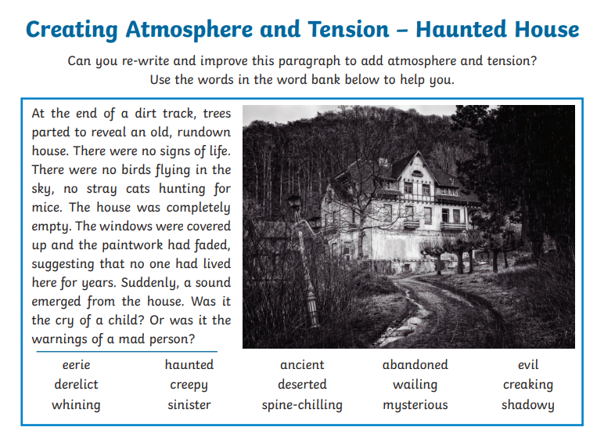

Easier
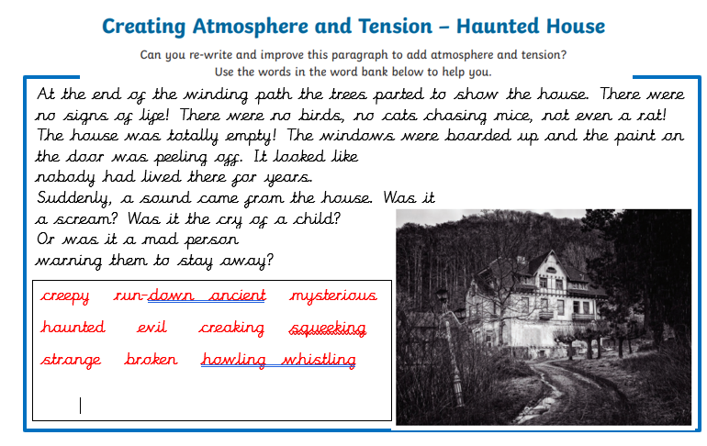
Spelling/Handwriting Home Learning
Monday | Tuesday | Wednesday |  | Thursday | Friday
Pick out some challenging words from a book you are reading or the new text chosen from the reading activities. Create your own spelling list to practice this week. | Practice your spellings. Using the cursive script for handwriting.  This time do some SPEED WRITING. Challenge your family members.  How many of each word can you write in ONE minute?  Mark each one to check you have spelt them correctly each time. | Copy out your reading text in your best joined up writing.  Do it again to see if you can make it even neater.  (remember- Not too small, not too big, letters in proportion to each other, CONSISTENCY. |  | Using the spellings you have chosen on Monday, practice your cursive handwriting.  Use different colours to create an image out of the words.  E.g. | Get your siblings or parents or anyone that can help, to test you on the spellings you have been revising.  Any you get wrong can go on a permanent list to practice another time.
Easier:  Do as many of the above activities as you can. If you are finding some of the activities challenging, try these as they are a little easier:  - Pick out words from any books you have, that are tricky for you and practice them. Get someone to test at the end of the week.  - Use the same words for handwriting practice.  - Play hangman with the words you have chosen. |  |  | Challenge:  If you feel you need a further challenge, try these:  - Continue with some of your old spelling lists (if you found them last week) practice the ones you struggled with the most.  - Find year 4 and 5 spellings lists online and pick out the ones you are most unsure about.  - Find the definitions of words you do not know.  - Play games like hangman. Or BIG challenge: INVENT your own game using the words.

Maths Home Learning YOU WILL NEED EXTRA PAPER TO DO YOUR WORKING OUT
COLUMN ADDITION – parental support may be required for children that struggle.
Monday | Tuesday | Wednesday |  | Thursday | Friday
Complete Activity 1  Subtraction with 2- and 3-digit numbers.  Easier: take a digit off if needed.  Challenge: Add all of the odd answers together. Then add all of the even answers together. Then take them away from each other. | Complete Activity 2  Subtraction with 3- and 4-digit numbers.  Easier: take off some digits if needed.  Challenge: Add all of the odd answers together. Then add all of the even answers together. Then take them away from each other. | Complete Activity 3  Subtraction 4-, 5- and 6-digit numbers.  Easier: Reduce the numbers before attempting subtraction. If you get to these ones. |  | Complete Activity 4  Subtraction in word problems.  Remember to pick out the relevant or important information. | Complete Activity 5  Subtraction in word problems. (cont.)
Easier:  Do as many of the above activities as you can.  Do as many of the sums as you can and if the numbers are too difficult, they can always be made a little bit smaller so you can practice your Written Subtraction methods.  Parents YOU can help reduce the number slightly.  REMEMBER:  - Big number always goes first.  - If you cannot take a big number of a little number you may need to EXCHANGE from the place value up. |  |  | Challenge:  If you feel you need a further challenge, try these:  - 45,674,893 - 7,332,887 - 11,893,079  - 56,784,224 - 345,921 - 4,599,403  - 763,933,470,987 - 98,234,802,488  Don’t forget to right them in the correct place value columns.
Activity 3 (WEDS)
- 63294 - 8934 =
- 75229 - 3472 =
- 22567 - 6829 =
- 90244 - 7746 =
- 89037 - 12995 =
- 567291 - 334592 =
- 477397 - 251643 =
- 783958 - 419467 =
- 578392 - 1940125 =
- 499456 - 265705 =
Challenge: (millions/7-digits)
- 3245692 – 983994 =
- 7385296 – 2791348 =
- 5832240 – 1994306 =
- 4098206 – 2890375 =

Activity 2 (TUES)
- 1324 - 547 =
- 2631 - 1558 =
- 3126 - 849 =
- 5834 - 2999 =
- 2189 - 986 =
- 5457 - 4199 =
- 8115 - 3884 =
- 3051 - 989 =
- 7833 - 5957 =
- 9786 - 2635 =
Challenge:
All odd added – all even added or the other way around =_______________________
Activity 1 (MON)
- 431 - 57 =
- 516 - 82 =
- 493 - 54 =
- 721 - 296 =
- 377 - 75 =
- 218 - 68 =
- 464 - 28 =
- 908 - 347 =
- 635 - 55 =
- 336 - 189 =
Challenge:
All odd added – all even added or the other way around =_______________________
Activity 5 (FRI) – Word Problems continued
- Mrs Begg has taught 57925 lessons and Mr Rogers has taught 9386. How many more lessons has Mrs Begg taught?
- If there 84790 schools in the UK and 27364 close down for refurbishments and new games rooms. How many schools are left open?
- Mr Caldwell has caught 367804 Pokemon. Mrs Hollingworth has caught 185993. How many more Pokemon has Mr Caldwell caught?
- Mrs Begum has 2674907 pairs of shoes. She gives 1026473 to charity and throws away a further 782658 pairs. How shoes does she have left?
- London has a population of 6743905 but 2904776 move out to different cities. Then 1784663 move back. How many people are now living in London?
Activity 4 (THURS) – Word problems
- Mr Caldwell walks 429km and Mrs Nisa walks 98km. How much further did Mr Caldwell walk?
- Mrs Hollingworth eats 294 strawberries and Miss Gent eats 567. How many more did Miss Gent eat?
- Mrs Begum managed to download 1823 songs on Monday and deleted 969 songs on Tuesday. How many songs did she have left?
- At a school fair there were 2260 visitors. The following year there were 492. How many more came to the fair the first year?
- Mr Caldwell has read The Hobbit 4197 times and Mr Nowak has read it 1664 times. What is the difference of how times have they read The Hobbit?

Theme activities Changed slightly from end of last weeks. Instead - WIND CHIMES
Monday | Tuesday | Wednesday |  | Thursday | Friday
This week we are building a wind Chime.  Something that hangs in your garden that looks nice and when it is windy will make some gentle sounds. | You will need to collect together some things that would help make a wind chime.  Begin by designing a simple wind chime and then think about what you can use to make each part. | Begin constructing your wind chime.  Remember it needs to hang and have several dangly parts to it so string, wool or thread will be essential. |  | Finish your wind chime and hang it in the garden. | If you have finished your wind chime then try making another one. What different things could you use this time?
Easier:  Do as many of the above activities as you can. If you are finding some of the activities challenging, try these as they are a little easier:  - This is a task anyone can do. Get it done.  - Use the pictures below to help with ideas. |  |  | Challenge:  If you feel you need a further challenge, try these:  - Have a look at some online and add some intricate ideas to your own.

Made for shops wooden Home made from cutlery and kitchen utensils. Beads and also sticks
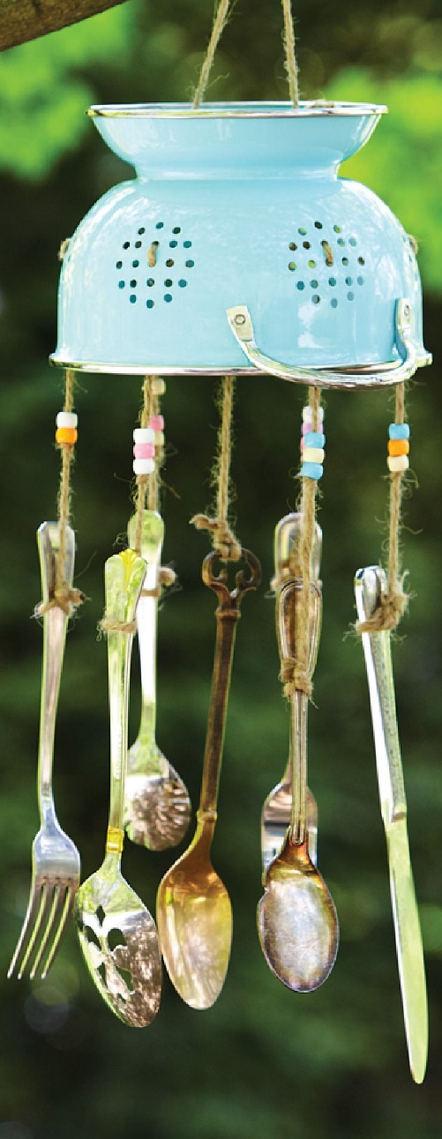
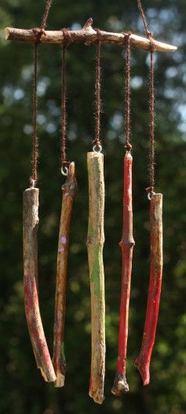
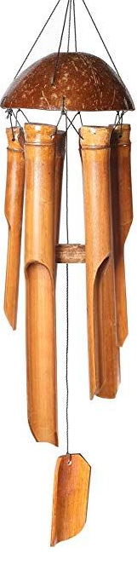
and metal

Key skills to continue practicing weekly:
- Timetables, Handwriting, Reading of own books, PE/Exercise.
- COLLECT AS MUCH STUFF AS POSSIBLE FOR NEXT WEEKS ENTERPRISE CHALLENGE. Scrap, rubbish craft stuff whatever we normally collect for building and creating things. NEXT WEEK we are definitely BUILDING A CREATURE!

If you or your child has any further queries regarding their learning projects, please contact admin@hardwick.derby.sch.uk, clearly stating your child’s name and class teacher, and the staff will be in touch to support you and your child.

Thank you and stay safe.

