Year 4 Home Learning
Week Commencing: 4th May 2020
Year 4 teachers: Mrs Haslam, Mrs Tatla, Mrs Jogela and Miss Annable
Year 4 TAs: Miss Perry and Mrs Smith
Message from staff: Hi Year 4, we hope that you are all well and keeping safe. Even though we are not teaching you, we are thinking about you and working very hard to provide fun activities for you to complete at home. We are also preparing lots of exciting projects for when we return to school. We hope you are taking some time out of the day to get fresh air and spend time with your family.
Your Home Learning this Week:
Every day (Monday to Friday), make sure you choose a *reading, *writing, *spelling/handwriting, *maths and *theme learning activity. There are also further activities to choose from should you wish to.
Reading Home Learning
Monday  Read Voices in the Park by Anthony Browne. Discuss with an adult what the book is about.  Write a summary of the book. | Tuesday  Look at the trees on Page 3 and Page 4, what do you notice? Why have they changed?  Look at Page 7, what do you notice? What do you think the imagery means?  Look at Page 15, what can you infer from the shadow over Charles? | Wednesday  What can we tell about the dad from: The way he is dressed? His body language? His speech? The way he speaks to Smudge?  Is there anything else in the pictures that give information about the dad character? | Thursday  Create a character profile for the four main characters.  Draw the outline of each character in the middle of a page and write interesting adjectives that describe their appearance (looks) on the inside and the character’s personality (actions) on the outside. | Friday  Write a detailed book review.  What is it about?  What was your favourite/least favourite part?  Describe the characters.  Would you recommend the book? Why?  How many stars would you rate it?

Writing Home Learning
Monday  Decide on an animal that you would like your non-chronological report to be about.  Research and take notes for the Introduction section. | Tuesday  Research and take notes for the Habitat section. | Wednesday  Research and take notes for the Diet section. | Thursday  Research and take notes for the Interesting Facts section. | Friday  Using your notes, write a detailed non-chronological report about the animal that you have chosen.  Also draw a detailed image of your animal. Use the non-chronological report features to help you.

Spelling/Handwriting Home Learning
Monday  Choose the next 10 spellings on the list that you struggle with.  Spelling Pyramids. | Tuesday  Race how many times you can write each word in 1 minute with a family member. | Wednesday  Rainbow write. | Thursday  Write a sentence neatly including each word. | Friday  Spelling quiz!  Ask a family member to test you on your spellings.  You could also test yourself on the Top Marks website:  http://www.ictgames.com/mobilePage/lcwc/index.html

Maths Home Learning
Monday  Log onto Times Tables Rock Stars.  Log how fast you completed the questions and how many you got correct, try to beat your score each time you play! | Tuesday  Emoji Code Breaking. Challenge yourself to complete all! | Wednesday  Create a maths chatterbox fortune teller like the example (see fortune teller guide). Come up with your own maths questions and play with a family member. | Thursday  Help your child to tell the time on a 24-hour clock.  Complete Let’s Learn and Guided Practice  The following link may be useful for parents:  https://www.busythings.co.uk/blog/teaching-children-how-to-tell-the-time-hints-and-tips/  If your child is struggling to tell the time, do not worry as we will pick this up as soon as we are back at school. You can re-visit lots of telling the time revision games on Top Marks instead. | Friday  Click on the following link and play the telling the time on a 24-hour clock games. https://mathsframe.co.uk/en/resources/resource/116/telling-the-time  Try to beat your timed score each time you play.  Time Maths Cards (you can choose how many you would like to complete).

Theme Home Learning - This half-term our theme topic is called, Playlist.
Monday  Click on the link below to listen to Le Nozze Di Figaro  https://www.youtube.com/watch?v=7YOD_gw1GiA  Write how you feel as you listen.  Make a list of instruments that you can hear.  Create a poster for the four types of orchestra instruments:  Brass  Percussion  Strings  Woodwinds | Tuesday  Listen to a range of dramatic film music. Have you heard it before? How does it make you feel? What do you imagine? What genre of film do you think it is from?  Below is a list of examples that you can choose from.  Harry Potter:  https://www.youtube.com/watch?v=Htaj3o3JD8I  E.T. The Extra-Terrestrial:  https://www.youtube.com/watch?v=2-qrMz-JAzo  Star Wars:  https://www.youtube.com/watch?v=_D0ZQPqeJkk&t=15s  James Bond:  https://www.youtube.com/watch?v=U9FzgsF2T-s  Chariots of Fire:  https://www.youtube.com/watch?v=CSav51fVlKU  The Magnificent Seven:  https://www.youtube.com/watch?v=8XDB7GMnbUQ  Jaws:  https://www.youtube.com/watch?v=lV8i-pSVMaQ  Darth Vader’s Imperial March: https://www.youtube.com/watch?v=-bzWSJG93P8 | Wednesday  Write your own song/rap that rhymes using the musical instrument that you previously made then perform your song to your family members. | Thursday  Wassily Kandinsky painted many pieces of Abstract Art.  Research and create a colourful mindmap all about Kandinsky.  Find at least 12 facts. | Friday  Listen to and watch the jazz music clip below and take your time to create a colourful Kandinsky inspired piece of Abstract Art.  https://www.youtube.com/watch?v=2DAsOeTB0wo

Other Activities
Start your day with Joe Wicks’ YouTube workout for kids live every morning at 9.00.  https://www.youtube.com/results?search_query=joe+wicks | Indoor Scavenger Hunt  Find something in your house that begins with every letter of the alphabet.  Find three things per letter. | Write your name using natural materials like the example below. | BOGGLE  How many words can you think of with these letters?  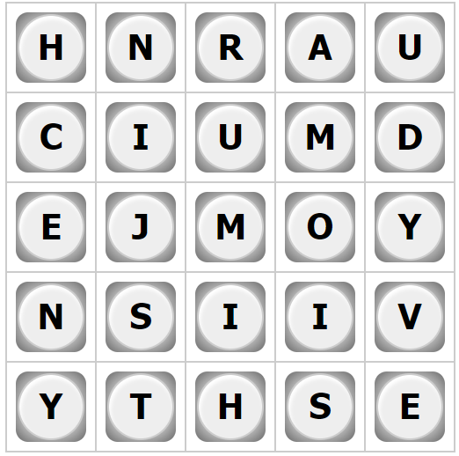 | BBC Bitesize daily lessons for Year 4  (See timetable of which lessons are taught each day)  https://www.bbc.co.uk/bitesize/dailylessons
Weekly Key Skills:
Times tables (including division facts)
Reading (This can be anything! Reading your favourite book again, reading magazines, sub-titles on the TV etc.)
Watch Newsround everyday so you are keeping up-to-date with what is going on in the world.
Every week, please expect a phone call from your child’s class teacher. It will be a quick, friendly chat to check how you are and whether you have any queries that we can help you with. We look forward to catching up with you all.
If you or your child has any further queries regarding their learning projects, please contact admin@hardwick.derby.sch.uk, clearly stating your child’s name and class teacher, and the staff will be in touch to support you and your child.

Thank you and stay safe.

