Year 5 Home Learning
Week Commencing: 1st June 2020
Year 5 teachers: (Mrs Nisa, Mr Caldwell and Mrs Hollingworth)
Year 5 TAs: Miss Gent and Mrs Begum
Message from staff: (Insert a message/update from staff. You could talk about what staff are doing, how you hope the children are doing etc…Something that will support the children in connecting with school/their teachers/TAs during this time.).

Your Home Learning this Week:
Every day (Monday to Friday), make sure you choose a *reading, *writing, *spelling/handwriting, *maths and *theme learning activity. There are also further activities to choose from should you wish to.

Reading Home Learning
Monday | Tuesday | Wednesday |  | Thursday | Friday
You will be reading a text about Eid al-fitr, which is a special event celebrated this weekend By Muslims. Read the text carefully and highlight or underline any word you do not understand. | Re-read the text and find the meaning of the words you do not understand from yesterday. | Using Stan Summariser, summarise the main information about Eid al-fitr – do not forget to use your VIP’s (very important parts).  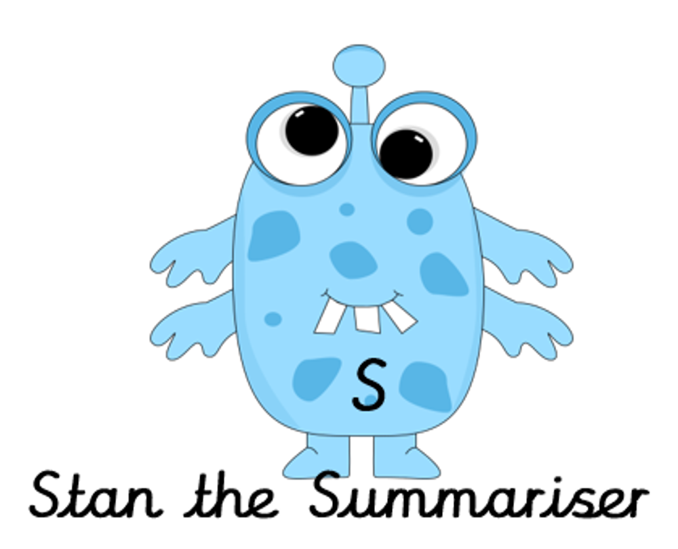 |  | Now try answering these questions:  - Explain in your own words what Ramadan is.  - Why must Muslims show self-restraint during Ramadan?  - What does Eid al-fitr mean? Why is it celebrated?  - Why is the crescent moon a symbol of Islamic faith?  - Can you think why Ramadan fasting is more difficult during the summer? | After reading the text on Eid al-fitr, think of any questions you may have. Is there anything you were left wondering that was not answered? Write these questions down. Reread the text again and this time, try to answer the questions you have. Can you answer them? If not, try to research the answers
Easier:  Do as many of the above activities as you can. If you are finding some of the activities challenging, try these as they are a little easier:  - Read the easier version of the text.  - Highlight any words you do not understand and find out what they mean.  - Try and answer these questions:  - What do Muslim people do during Ramadan?  - How many times a day to people pray during Ramadan?  - In the lunar calendar, which month is Ramadan? |  |  | Challenge:  If you feel you need a further challenge, try these:  - Answer the following questions:  - Can you think of and explain a situation when you have had to exercise self-restraint?  - Saum is just one of the five pillars of Islam; research the other four Islamic duties.  - Create your own fact sheet about Eid al-fitr to demonstrate your understanding.
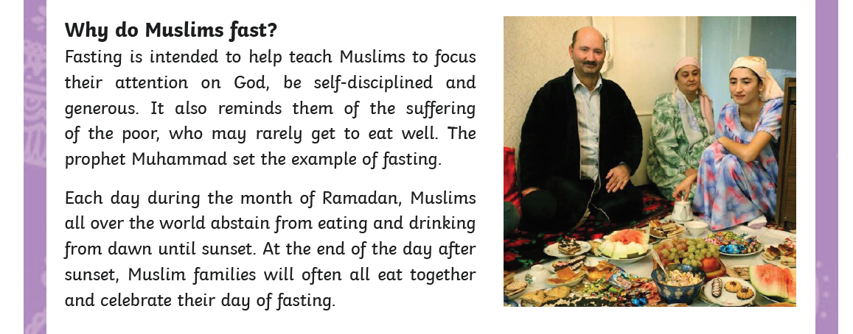
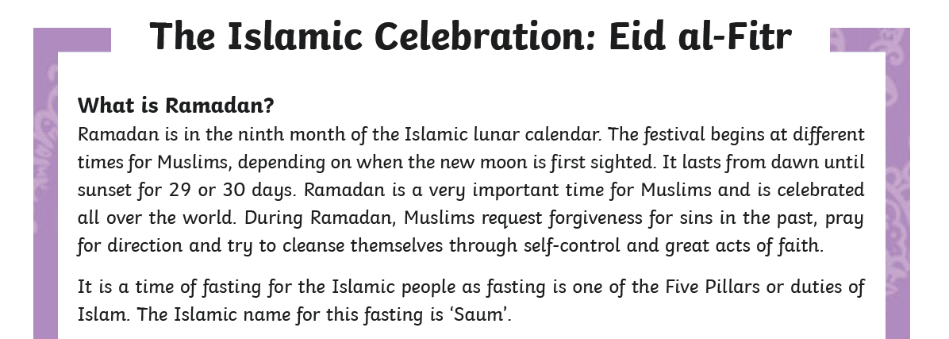

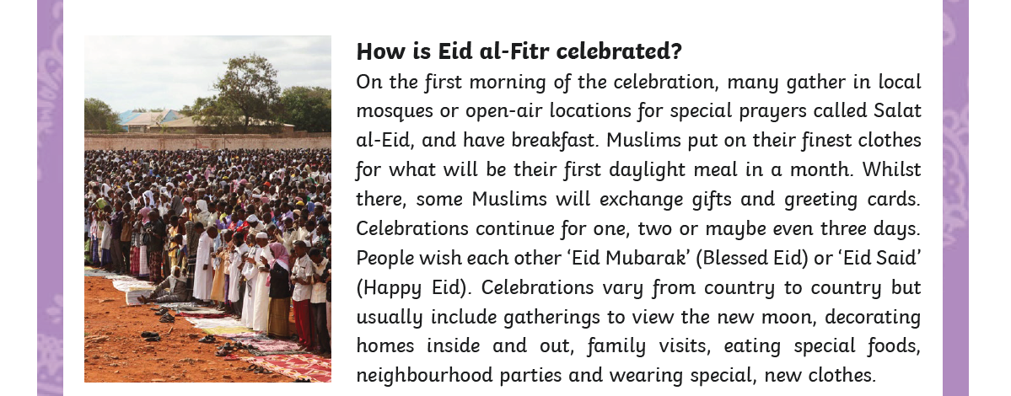
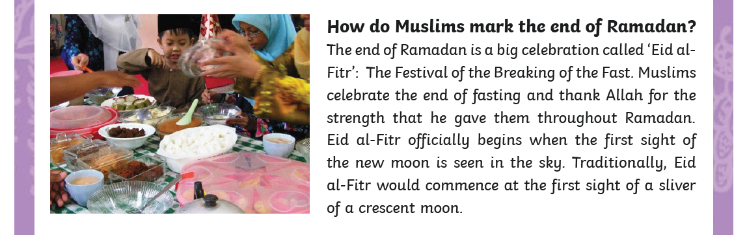

Easier version
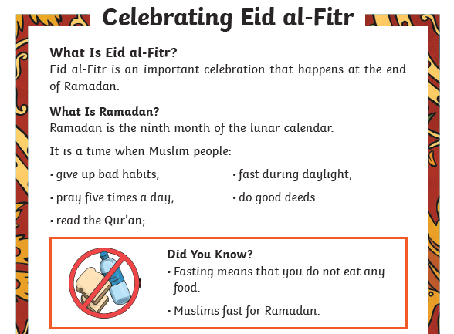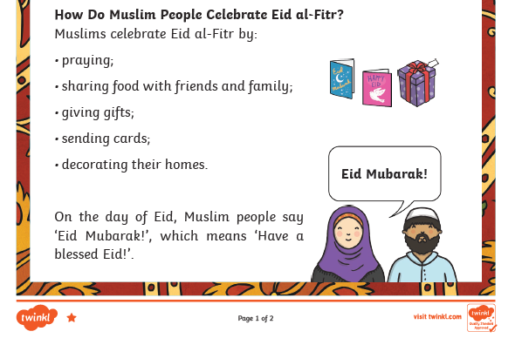

Writing Home Learning
Monday | Tuesday | Wednesday |  | Thursday | Friday
This week you can have a go at writing a story using your own ideas. On the next page is a story organiser that you can use to help you.  Today we want you to use the story organiser to decide on a setting, a main hero and villain and think about what problem the hero has to solve and how they will solve it. | Today we want you to draw a comic strip for you story. This will help you to visualise each of the 5 parts of it, remember to visualise the main parts of the setting, build up, dilemma, resolution and ending. | Today have a go at telling your story to an adult, brother or sister using your comic strip to remind you of the main events. Try to include as much detail as possible to interest your audience. This will help you to organise your ideas in your head ready for writing tomorrow. |  | It is time to have a go! Today, have a go at writing the setting and build up for your story – use your comic strip to help you. Try to include the following:  Fronted adverbial phrases.  A range of different sentence types.  Carefully chosen verbs and adjectives to create the setting. | Re – read your setting and build up from yesterday to remind yourself where you have go too with your story.  Today you need to write the problem, resolution and ending. Remember too add plenty of action and detail to describe the struggle between the hero and villain and include an exciting way to solve the problem.
Easier:  Do as many of the above activities as you can. If you are finding some of the activities challenging, try these as they are a little easier:  - Use the easier story organiser to plan your story.  - Focus on using good adjectives and verbs in your story.  - Re – read each sentence as you write to make sure it makes sense. |  |  | Challenge:  If you feel you need a further challenge, try these:  - Include parenthesis to add further detail to your story, this can be either a dash - or brackets ()  - Think about using conjunctions and fronted adverbial phrases to start each paragraph to link it back to the previous paragraph.  - Try and use a wider range of more adventurous vocabulary.

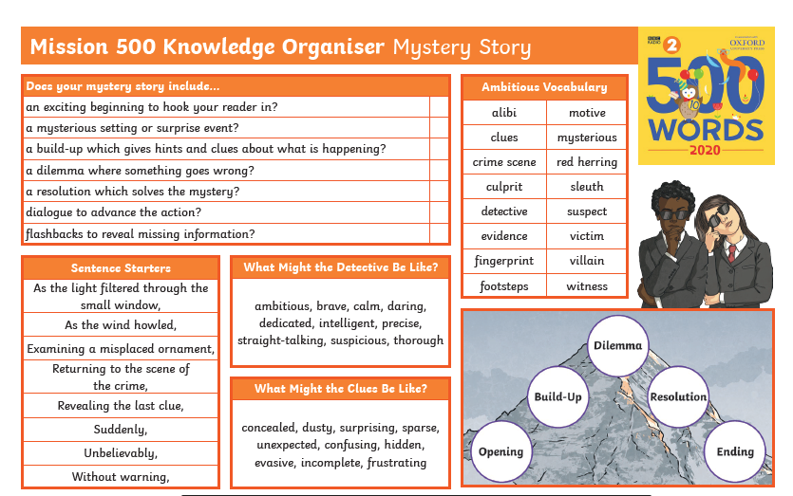
Easier story organiser
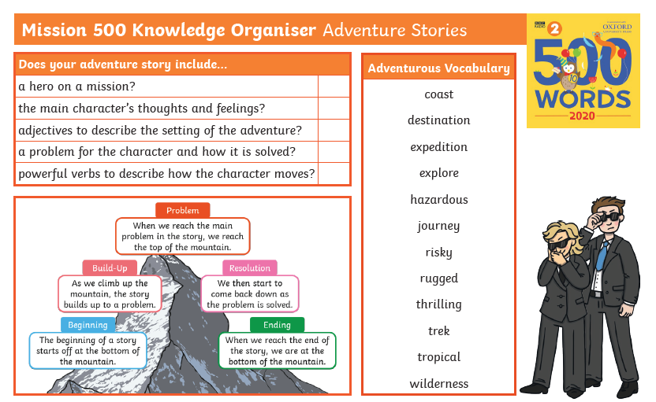

Spelling/Handwriting Home Learning
Monday | Tuesday | Wednesday |  | Thursday | Friday
Easier:  Do as many of the above activities as you can. If you are finding some of the activities challenging, try these as they are a little easier: |  |  | Challenge:  If you feel you need a further challenge, try these:

Maths Home Learning
Monday | Tuesday | Wednesday |  | Thursday | Friday
Area is the measure of how much space there is inside a shape. It is measured in square cm- cm2, square meters -m2 or square kilometres –Km2 | To find the area of a shape you can count the squares. Instead of counting the squares can you think of another way to calculate the area. | Write definition of area and perimeter in your own words and how do you calculate each of them? |  | Use the squared paper and investigate by drawing regular or irregular shapes with an area of 12 cm2.  What is the perimeter of each shape? | What is the link between the area of a shape ad its perimeter?
Easier:  Do as many of the above activities as you can. If you are finding some of the activities challenging, try these as they are a little easier:  - Draw the missing lines on the shapes in activity 1 and 2 to help find the area |  |  | Challenge:  If you feel you need a further challenge, try these:  We can use symbols and letters in maths e.g. A=l x b this means that area of a rectangle can be found by multiplying the length of both sides, l and b.  Explain the following:  - A=lxl (A is the area of a square)  - P=2(l+b), (p is the perimeter of a rectangle
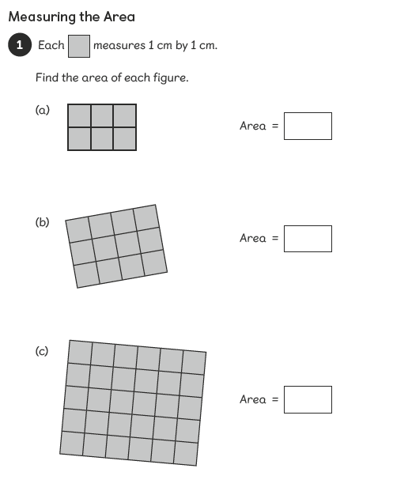
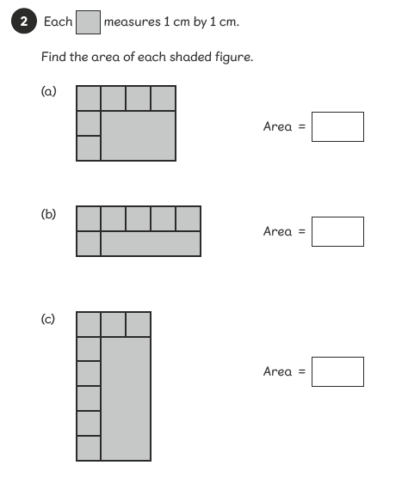
Activity 1
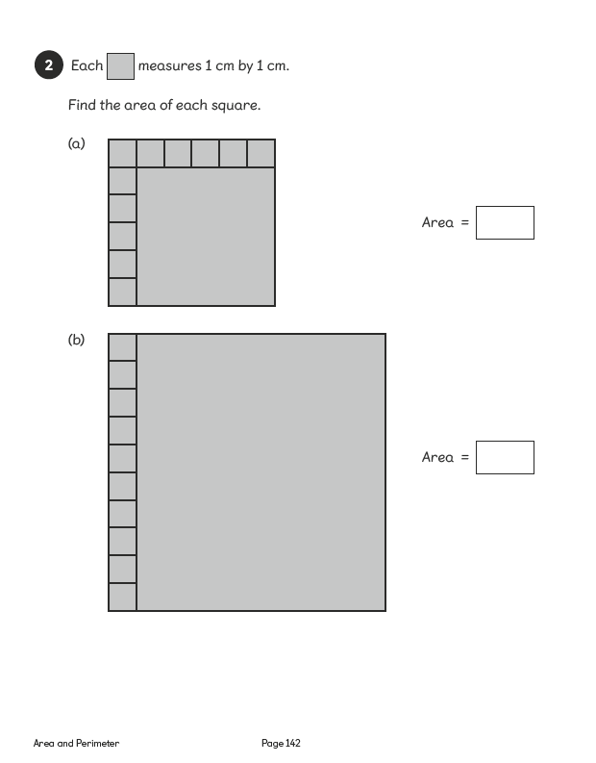
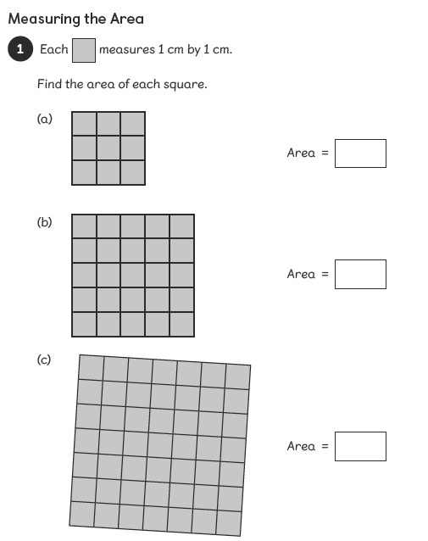
Activity 2
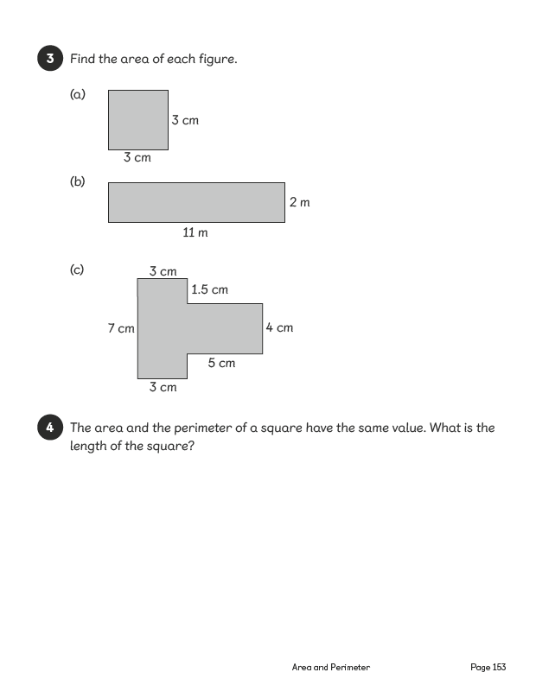
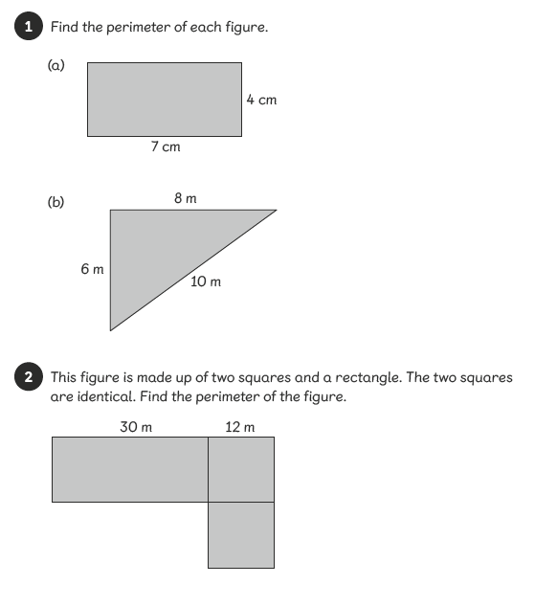
Activity 3
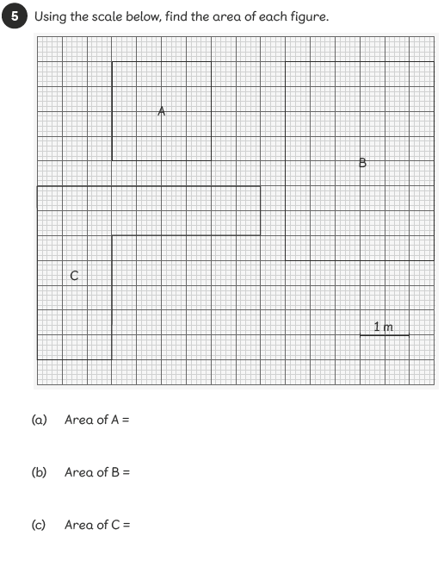
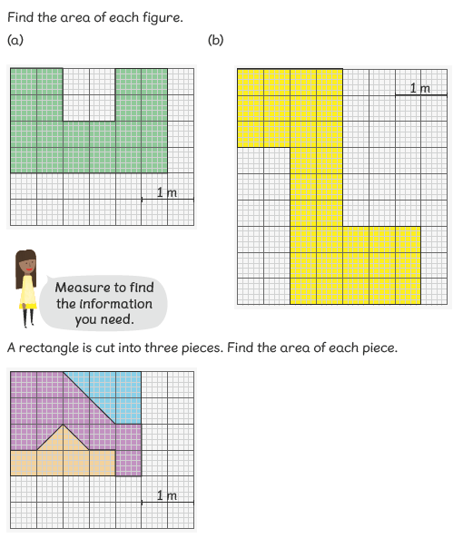
Activity 4
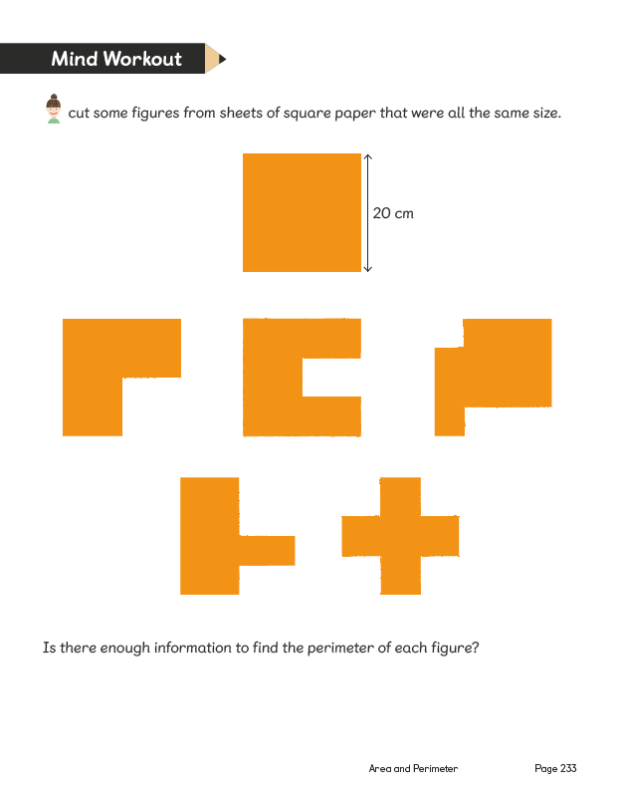
Aaaa Activity 5
Theme Home Learning
Monday | Tuesday | Wednesday |  | Thursday | Friday
Easier:  Do as many of the above activities as you can. If you are finding some of the activities challenging, try these as they are a little easier: |  |  | Challenge:  If you feel you need a further challenge, try these:

Other Activities

Key skills to continue practicing weekly:

If you are able to access the internet, try these useful websites:

If you or your child has any further queries regarding their learning projects, please contact admin@hardwick.derby.sch.uk, clearly stating your child’s name and class teacher, and the staff will be in touch to support you and your child.

Thank you and stay safe.

