Theme
Middle Group
WALT write a biography for a year 6 child to read.

See a good example of a Biography

Information about Charles Darwin
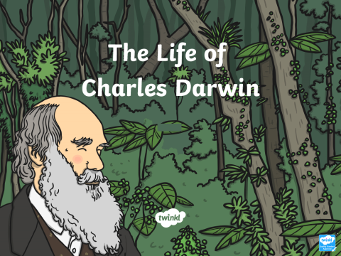
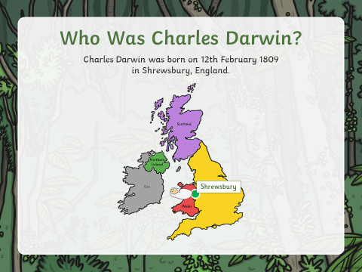
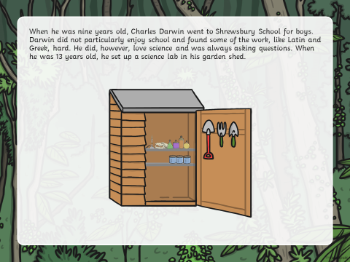

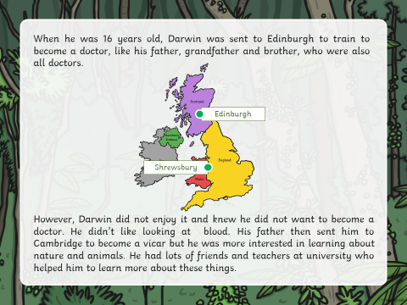
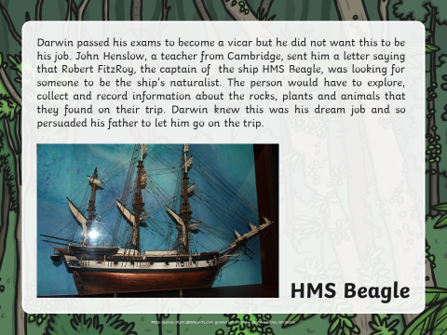
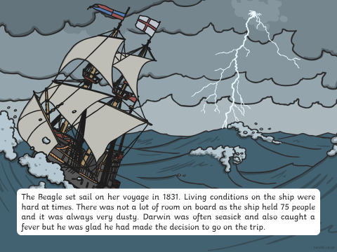

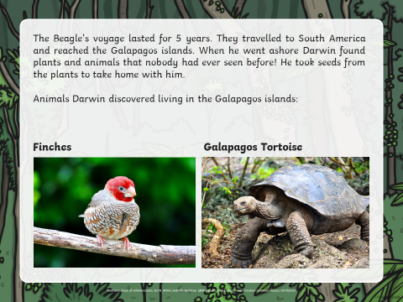
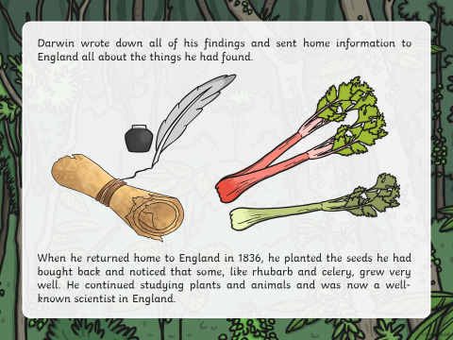
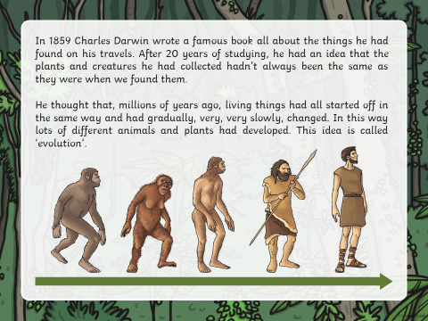

Evolution and Adaptation
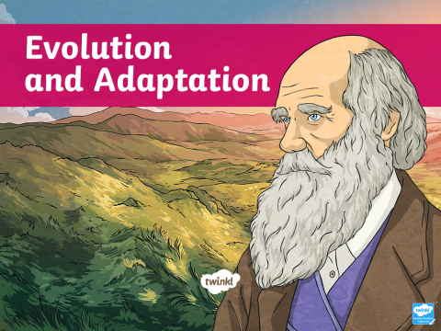 | 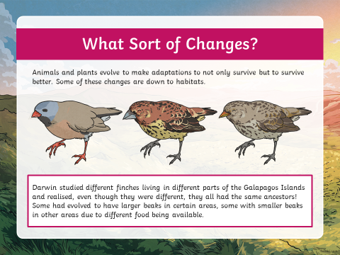
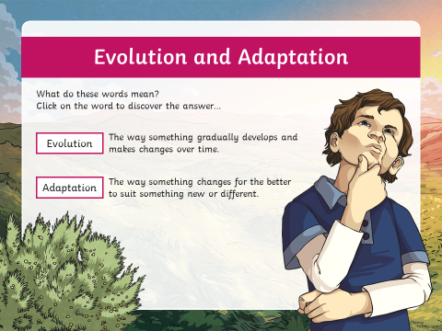 | 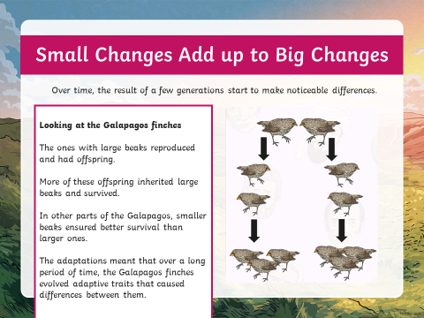
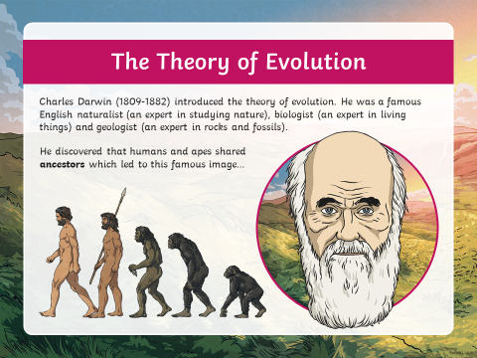 | 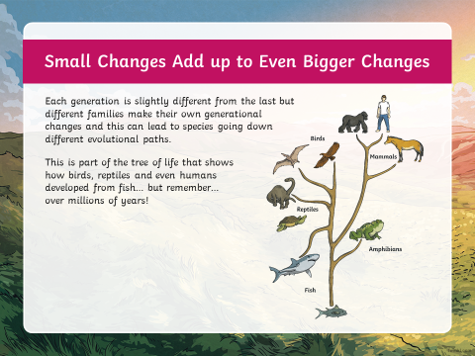
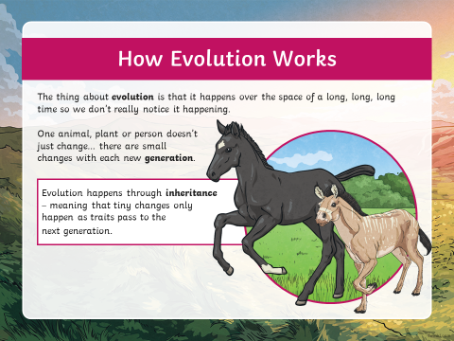

Learn the definitions below
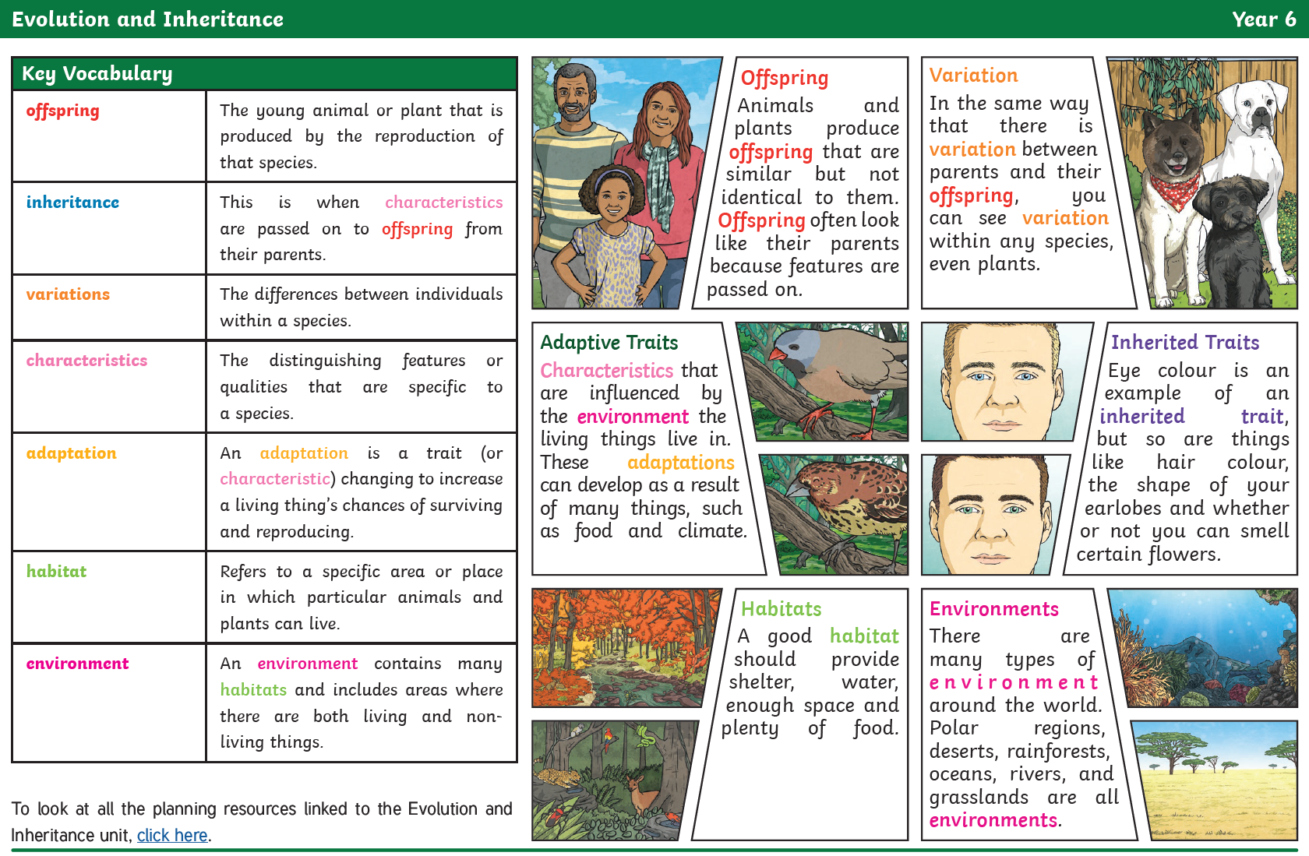
Learn the features of Biography so that you know what to include when you write your own.
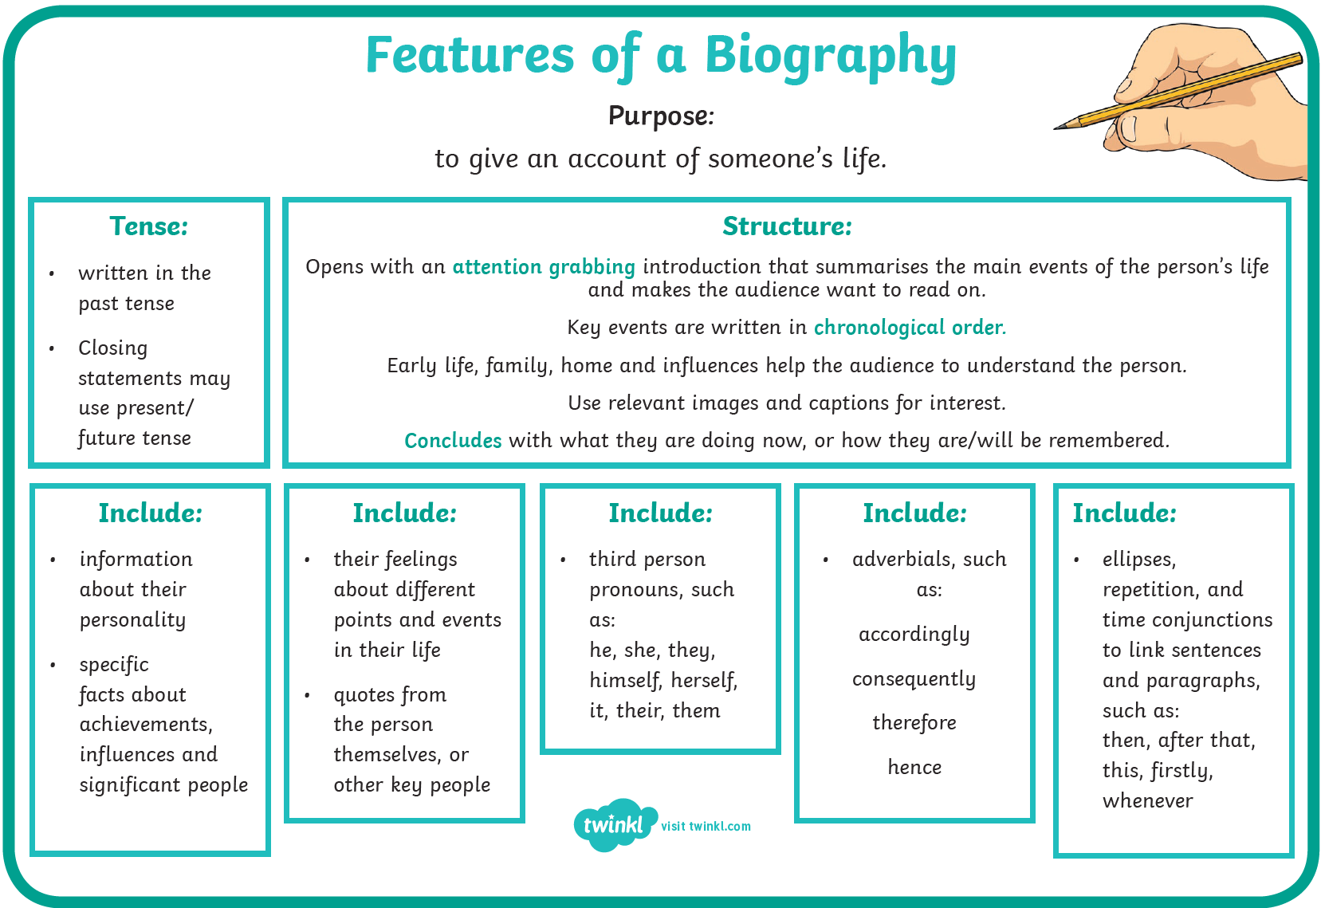

Task
Write an introduction based on who Charles Darwin was. Make sure you include his date of birth.
Write a separate paragraph and include what inspired him with his work which he contributed to Science. Include his family life.
Tips:
-don’t forget to include key dates
-use paragraphs
-record main events
- don’t forget to include pictures which explain the paragraphs you have written.

Then, write further paragraphs which include dates and further work by Charles Darwin.
Edit your biography by using a dictionary/support from an adult at home.
Remember, use the checklist for a biography.

When you write a biography, check you are including the following features listed below in the checklist.

Odd one out
The image below shows models of four mammals:
- Rhinoceros
- Whale
- Elephant
- Hippopotamus
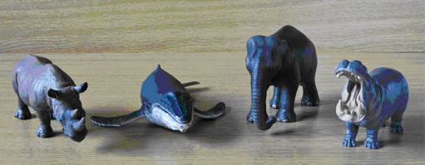
Figure 1
Which of these four do you think is the ‘odd one out’? Why?

Create a fact file booklet on animal adaptation. Base the booklet on the animals of your choice. Choose up to 10 different animals.

Poster
Create a poster based on Charles Darwin discoveries/his contribution to science and the dates.

