Phonics and Key Words

Key Words

Practise reading these key words:

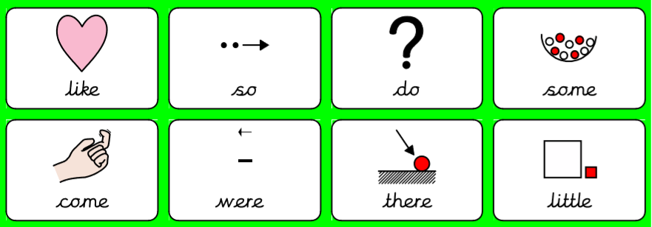
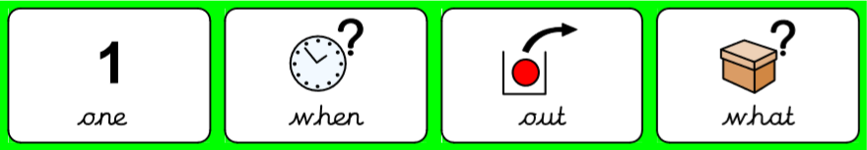

Practise writing these key words. The first two you can look to make sure you are spelling it right. Next, give it a go without looking. Lastly, check is you spelled it right!

Key word | Practise 1  (copy into space) | Practise 2  (copy again) | Practise 3  (fold and hide) | Can spell word  (check and correct)
like
so
do
some
come

Key word | Practise 1  (copy into space) | Practise 2  (copy again) | Practise 3  (fold and hide) | Can spell word  (check and correct)
were
there
little
one
when

Key word | Practise 1  (copy into space) | Practise 2  (copy again) | Practise 3  (fold and hide) | Can spell word  (check and correct)
out
what

Phonics:

Review - read the following sentences and words. Underline the GPCs ai ee igh oa.

She can wait in the rain.
I seem to get big feet.
I got up to put the light off.
We can get the right coat.
Copy the sentences below:
_________________________________________________________________________________________________________________________________________________________________________________________________________________________________________________________________________________________________________________________________________________________________
Read and write the following words. First segment the words e.g. cat – c – a – t. Then, try and read the words without segmenting them!

Focus GPCs = ‘oo oo ar or’

long oo | short oo | ar | or
too  zoo  boot  hoof  zoom  cool  food  root  mool  rooftop | look  foot  cook  good  book  took  wood  wool  hoon  hood | bar  car  bark  card  cart  hard  jar  park  market  farmyard | for  fork  cord  cork  sort  born  worn  fort  torn  cornet
Give it a go reading the following questions. Remember to try and not segment the key words in RED.

Can you put a cat in the zoo?

Will we cook jam?
Can we play in the park?
Can you play a cornet?

Which sentence do you think goes with which picture?
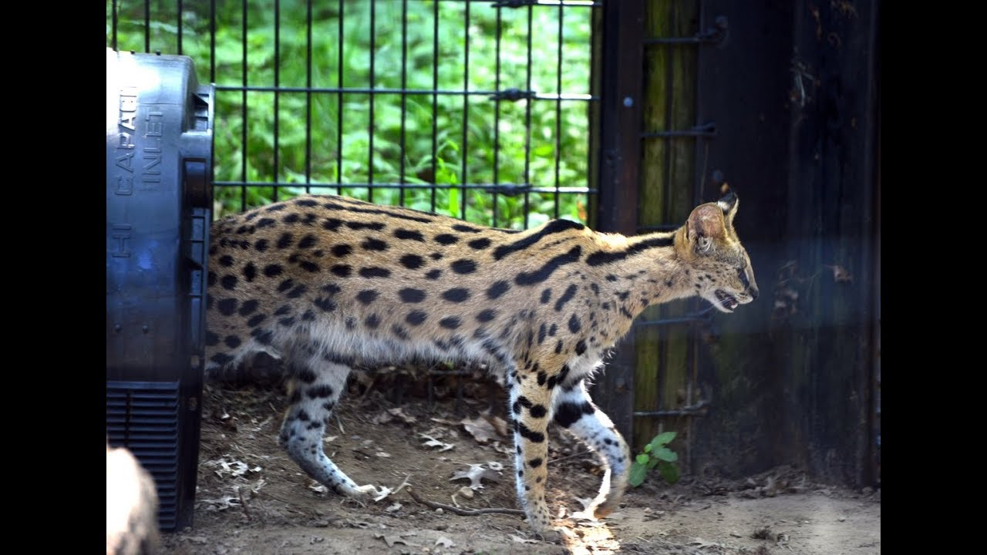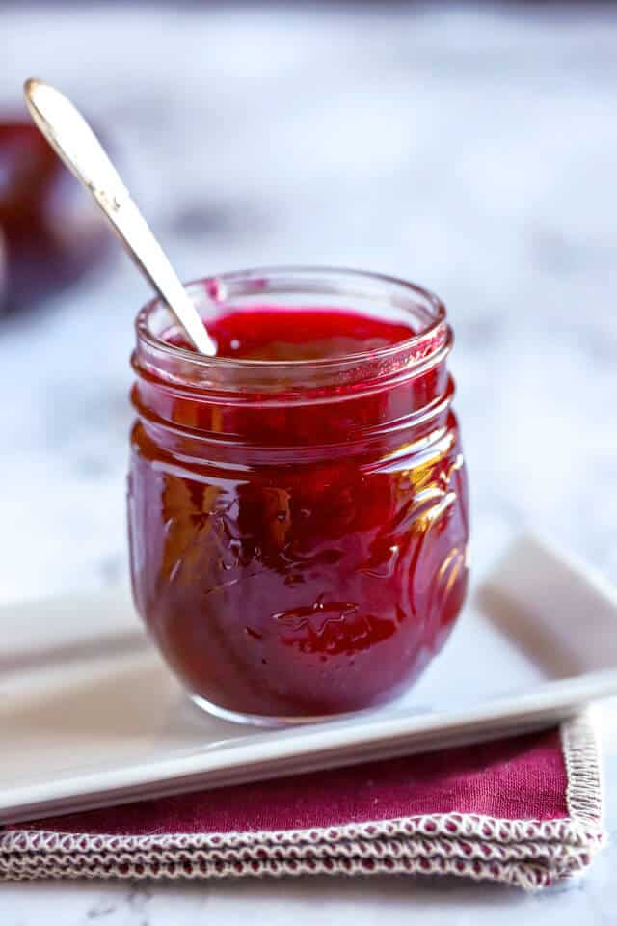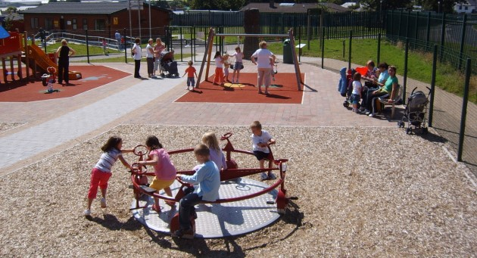

Handwriting:

Keep practising your handwriting – remember to write on the line! You can practise on any paper! If your paper does not have line – draw some!
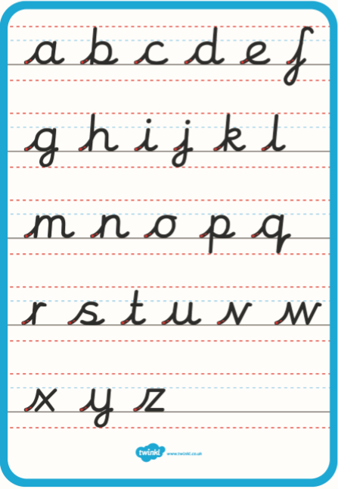
Practise your handwriting with the following words:

rooftop
book
farmyard
cornet
Everyday English:

Look at the following picture. What can you see? What are they doing? See if you can get someone to read you the questions.

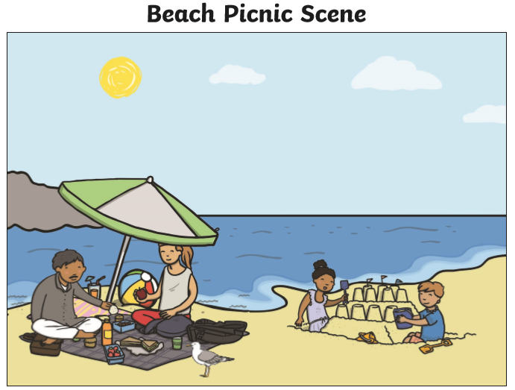
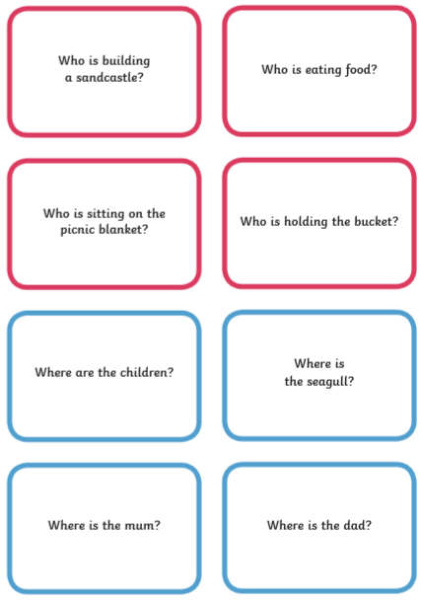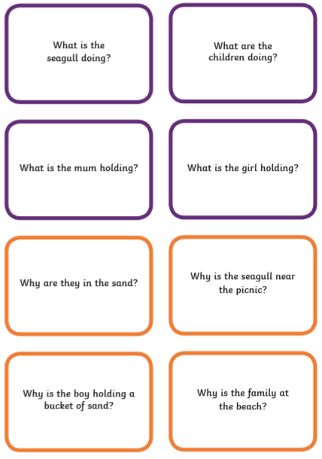

Try and use the following words:

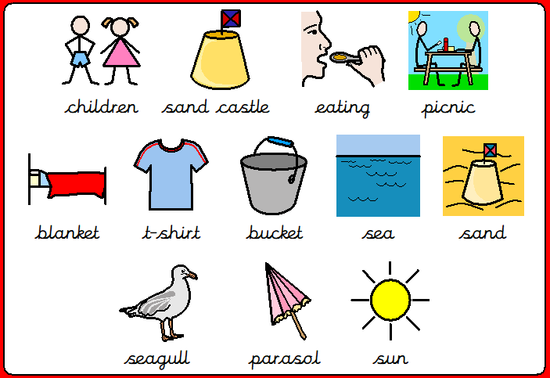

Classroom words labelling. Look at the words and label the picture.
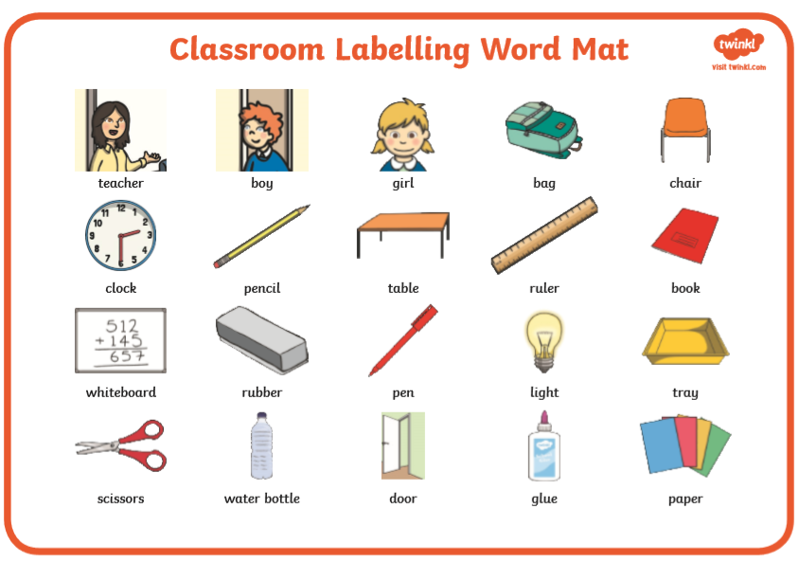
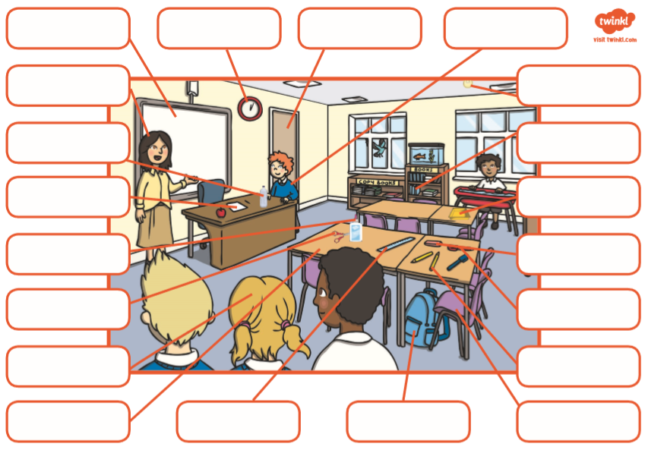
Talk!

Discussion of the week!
Look at the following question and discuss it with someone. Tell them WHY!
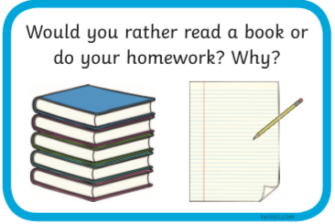

Useful websites:

Have a look at the following websites

- https://www.bbc.co.uk/cbeebies/shows/alphablocks - great phonics videos!
- https://www.bbc.co.uk/cbeebies/shows/numberblocks - great number videos!
- https://www.phonicsplay.co.uk/# - free to sign up!
- https://www.youtube.com/channel/UCP_FbjYUP_UtldV2K_-niWw - start from reception and work your way through!


I hope you enjoy the work and have a great week!

