Year 2 Home Learning
Week Commencing: 22nd June 2020
Year 2 teachers: Mrs Nicholson and Mrs Tomordy
Year 2 TAs: Mrs Rowland and Ms Shaista
Message from staff: Hello everyone. It was lovely to speak to many of you and/or your parents last week. We are all still busily getting some learning ready for you, both for now and for when we see you again in school!
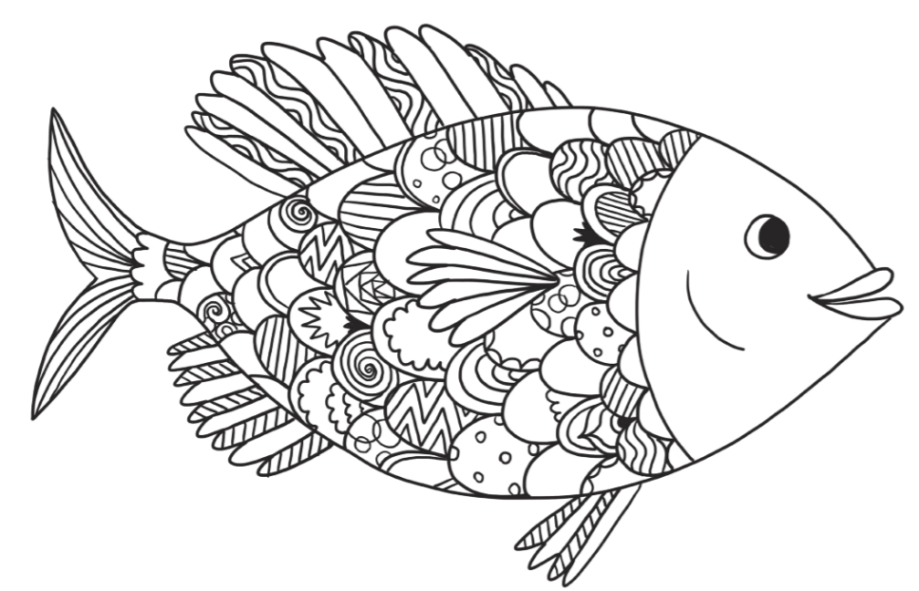

Your Home Learning this Week:
Every day (Monday to Friday), make sure you choose a *reading, *writing, *spelling/handwriting, *maths and *theme learning activity. There are also further activities to choose from should you wish to.
Reading Home Learning
Task 1  You will be reading some instructions on how to grow a beanstalk. Make connections with what you already know about instructions. When do you need instructions? What features do you see in a set of instructions? Can you find a set of instructions at home?  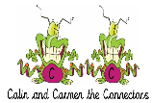 | Task 2  Read ‘How to grow a beanstalk’, using reading skills to help you understand as you go through it. Highlight any words you do not understand and find the meaning of them.  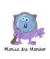 | Task 3  Summarise what you have read in the text. A summary covers the very important parts of the text (VIP). Which parts in the text do you think are important?  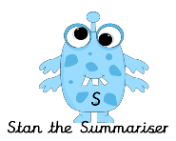 |  | Task 4  Now try answering these questions:  - Why was Jack’s mother upset?  - What is another word for hole?  - Where will the beanstalk grow?  - How should you care for the beanstalk?  - What could you fetch if you climbed the beanstalk?  - What is another word for nearby? | Task 5  After reading the text on ‘How to grow a beanstalk’, think of any questions you may have. Is there anything you were left wondering that was not answered? Write these questions down. Reread the text again and this time, try to answer the questions you have. Can you answer them?  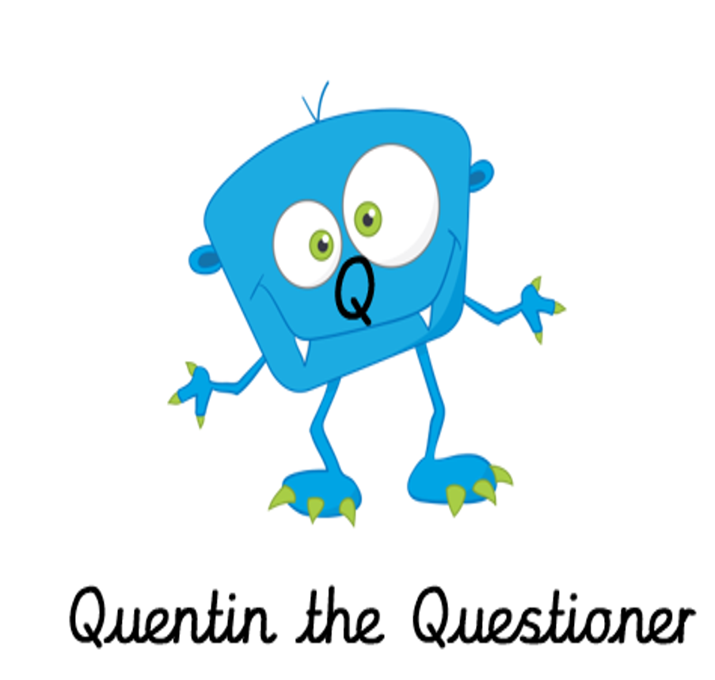
Easier:  Do as many of the above activities as you can. If you are finding some of the activities challenging, try these as they are a little easier:  Read the text ‘Men on the moon’ and answer the questions:  Men went to the moon in ______________________________________  They got into a __________________________. It took off.  The rocket went into _______________________________________________.  Then it went into _________________________________ around the moon.  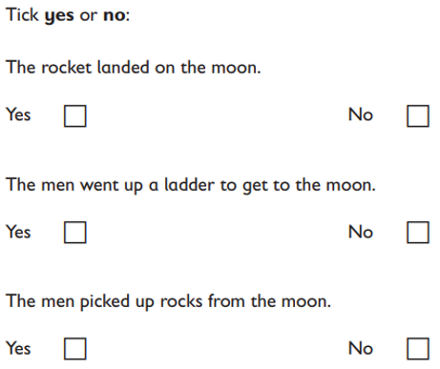  The landing craft went back to the _________________________________.  What did the rocket splash down into? _________________________. |  |  | Challenge:  If you feel you need a further challenge, try these:  - Find all the verbs in this letter from Jack.  - Write the verbs in the past tense – there are some tricky ones! E.g. reading becomes read.  Dear Children,  I understand you have been reading all about my adventures when I grew a beanstalk!  I wondered if you might like to grow your own beanstalk because beans are a fantastically nutritious snack and they can be served for breakfast, lunch and dinner! Sometimes, my mother even pours custard over them and we have them for pudding!  I have written the instructions for how to grow your own beanstalk. Of course, you could change them and grow other things as well or even change them to write instructions for doing something else.  Have fun!  Love from Jack  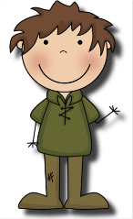
How to grow a beanstalk  Do you want to feed your family with healthy snacks every day? If so, follow these instructions to grow your very own beanstalk.  What you need:  Five magical beans, a garden, a cross mother and a large spade.  What to do:  - First, upset your mother by selling your only cow for five magical beans.  - Next, dig a deep pit.  - After that, ask your mother to throw the beans out of the window.  - Finally, go to bed.  When you wake up, there will be a beanstalk growing outside your window!  How to care for your beanstalk  A beanstalk is not easy to care for. If you don’t want your beanstalk to become a wild plant, you should follow these instructions carefully.  - Water your beanstalk every day.  - Talk to your beanstalk to make sure it isn’t unhappy.  - Trim the leaves to keep it looking pretty.  A final note of warning  Should you climb your beanstalk to collect hens or gold, keep an axe handy! |  |  | Men on the moon  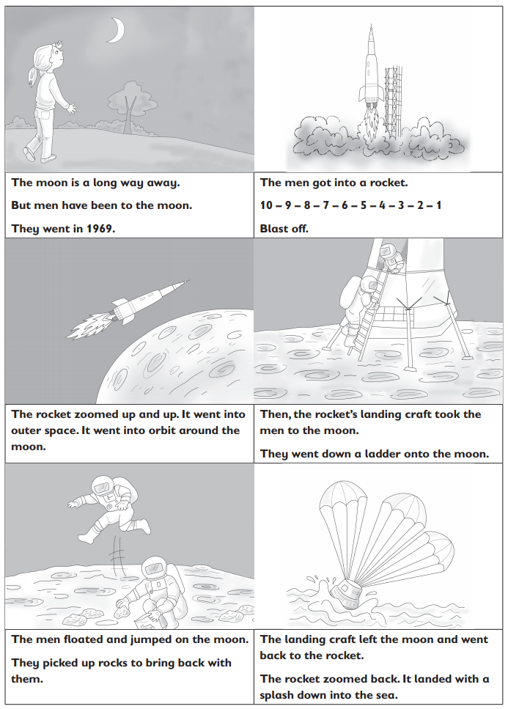
Writing Home Learning
Task 1  You are a vet! Imagine that this is your waiting room. Write about why all these animals have come to see you. Has the giraffe got a sore throat? What will you say to him? | Task 2  When you go home, you have to describe the animals to your friends. Use noun phrases to describe them.  E.g. The small, black and white dog was singing tunefully even though he had trapped his fluffy tail in a big door. | Task 3  Create a text map of the instructions ‘How to grow a beanstalk’. Draw pictures instead of words and try to recite the story using only your text map. |  | Task 4  Practise your text map. Be a detective and find the following in the text:  Headings  Lists  Commas in a list  Exclamation sentences  Conjunctions (if, when, but) | Task 5  Write a set of instructions to grow another plant – you could grow a sunflower that lets you visit the sun or a moonbeam plant that lets you visit the …
Easier:  Do as many of the above activities as you can. If you are finding some of the activities challenging, try these as they are a little easier:  - You and your friend visit the moon. What do you do? What do you see there? Try writing some sentences using your sounds.  - Add labels to the picture using your sounds:  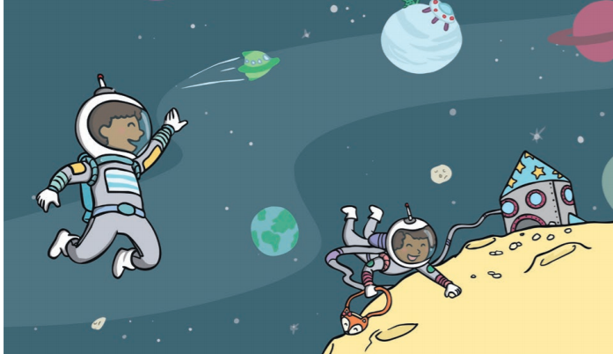 |  |  | Challenge:  If you feel you need a further challenge, try these:  Task 1  Write a letter to a friend to explain that you have written some instructions for growing a plant. Use Jack’s letter to help you.  Task 2  Draw a picture of your plant or a beanstalk when it is fully grown. Label it.

Spelling/Handwriting Home Learning
Monday | Tuesday | Wednesday | Thursday | Friday
This week we are focussing on the ‘au’ phoneme.  Can you ladder write each of these words? Make sure you use a capital letter for the 2 which are names of things.  Paul  August  haul  launch  haunted  automatic  autumn  daub  So remember ladder write is:  P  Pa  Pau  Paul | Using lined paper practise writing each of the words from yesterday 10 times. Be careful with the joins and make sure any ascenders (tall letters) are tall. Also, they should be sitting on the line. | Can you create a picture to help you remember what each word means? If you are not sure what a word means, then try using a dictionary to look it up. 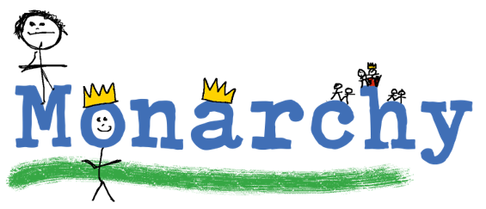 | Now you know what each word means can you put them into an amazing sentence? | A bit of fun for a Friday. Use the grid below and colour in the real words one colour and the nonsense words a different colour.
Easier:  Do as many of the above activities as you can. If you are finding some of the activities challenging, try these as they are a little easier:  - 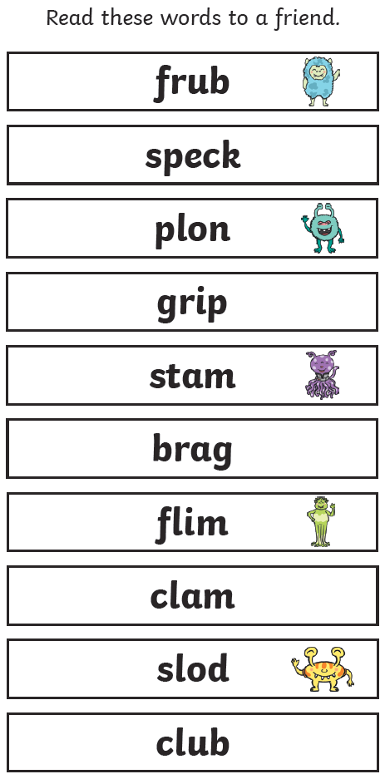  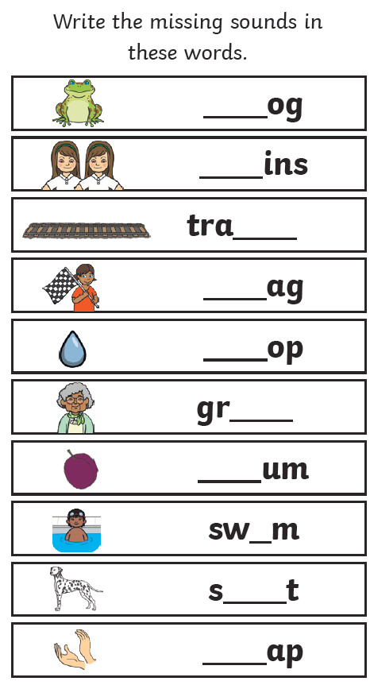 |  | Challenge:  If you feel you need a further challenge, try these:  - How did you do with spelling the common exception words last week? Have another go and see if you can get a better score this week.  - Can you change these singular words into plurals so that there is more than one of them?  cat, church, gate, fox, fly, sheep  - Remember we started looking at their, there and they’re last week. Tell someone what the difference between them is.  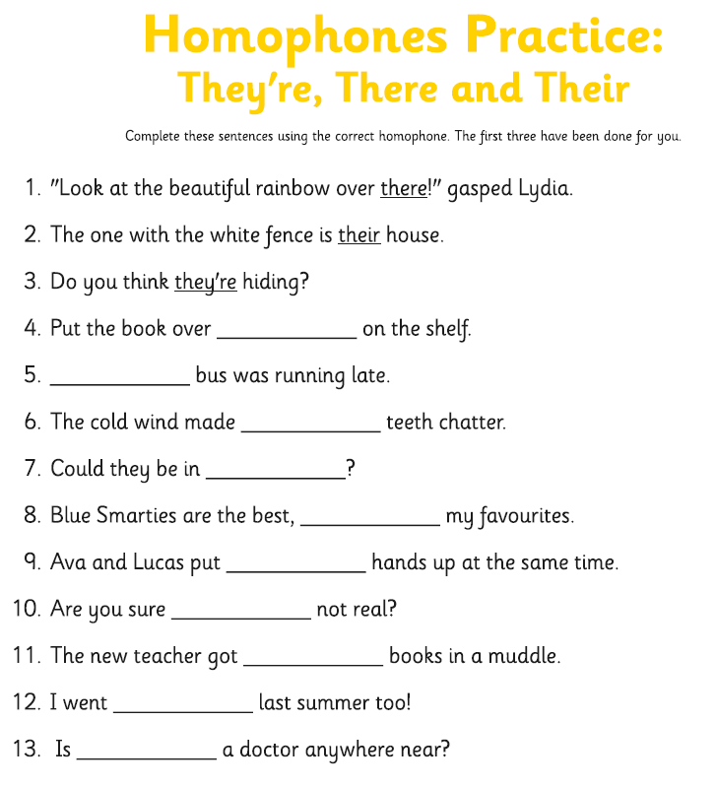  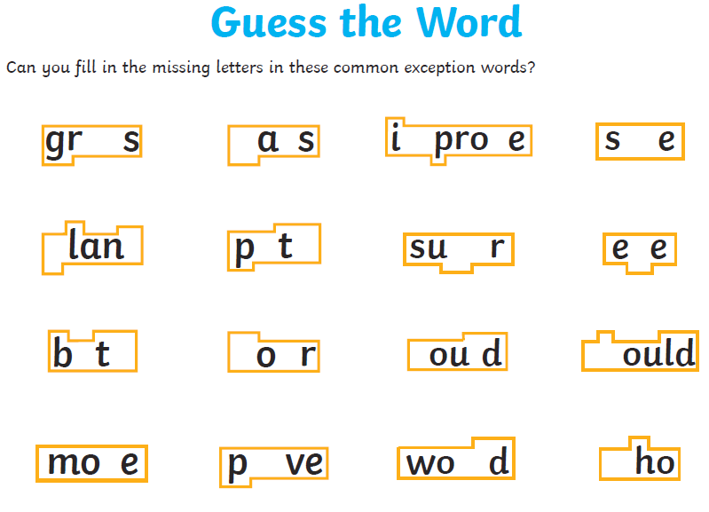
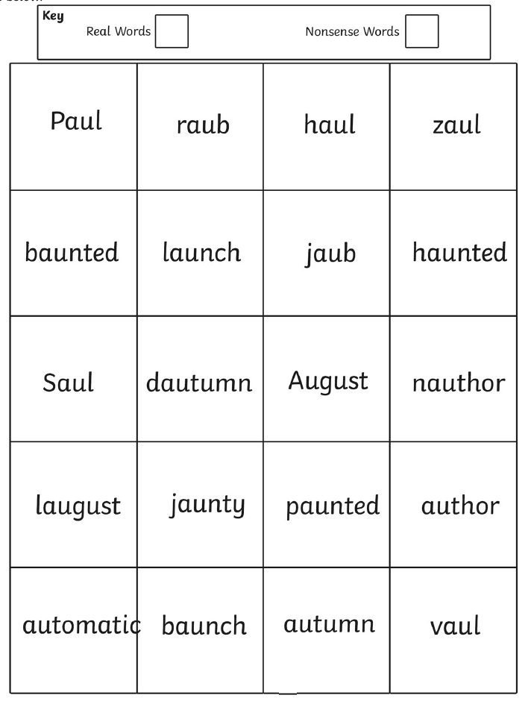
Maths Home Learning
Monday | Tuesday |  | Wednesday
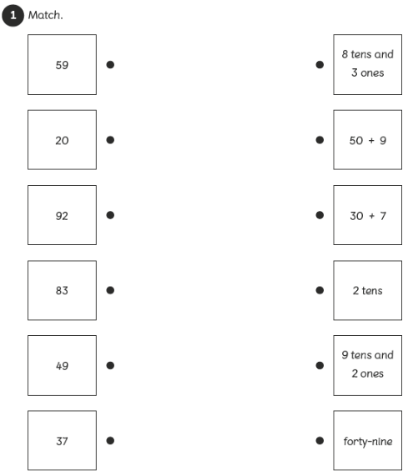 | 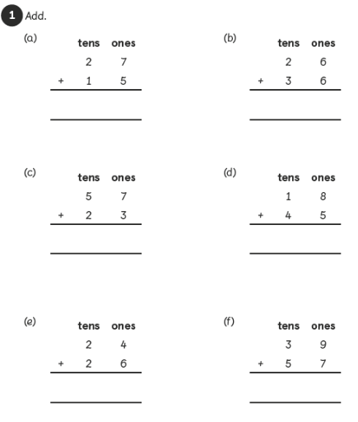 |  | 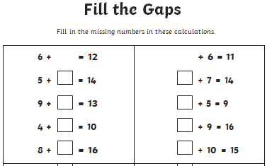
Thursday  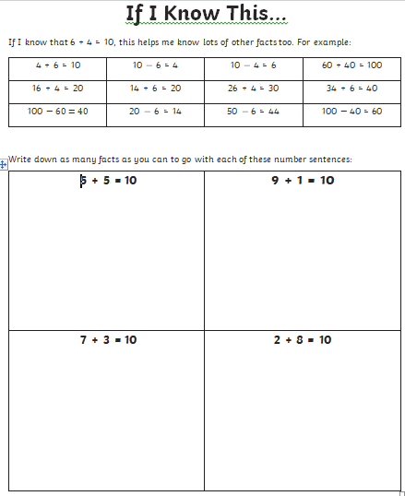 |  | Friday  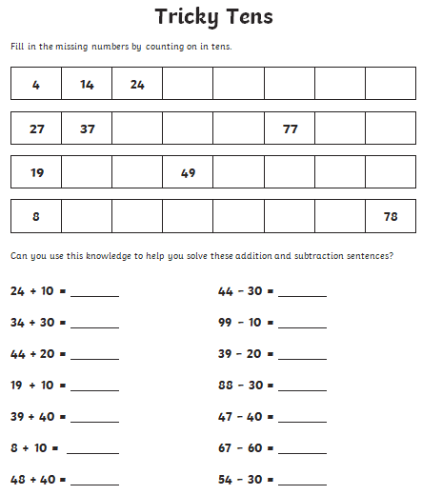

Easier:  Do as many of the above activities as you can. If you are finding some of the activities challenging, try these as they are a little easier:  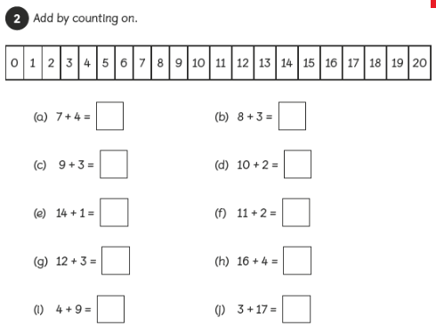  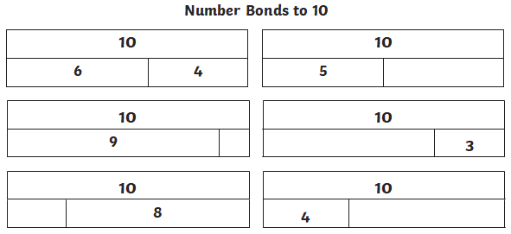 | Challenge:  If you feel you need a further challenge, try these:  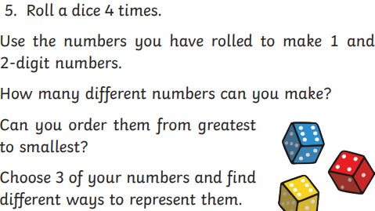  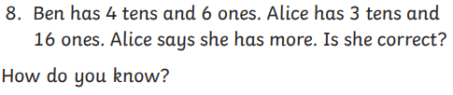

Theme Home Learning
Monday | Tuesday | Wednesday | Thursday |  | Friday
Science  Look at the life cycle of a bean plant.  Put the pictures and labels in the right order below. | Science  Draw a picture and write a sentence to show the four stages of a bean’s life cycle.  Here is the word bank to help you:  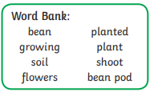 | Art  Create salt painting using watercolours.  Follow the instructions below and have fun! | Music  Sea shanties are work songs. They were used to coordinate people working together and also improve the efficiency of the job. Additionally, these songs helped workers to relieve the boredom of a tedious job.  The first 2 verses of the sea shanty are done for you, create a couple of verses below. |  | Science  Have a trip to your favourite outdoor place. Take the mini beasts hunt sheet and see how many mini beasts you can find.
Easier:  Do as many of the above activities as you can. If you are finding some of the activities challenging, try these as they are a little easier:  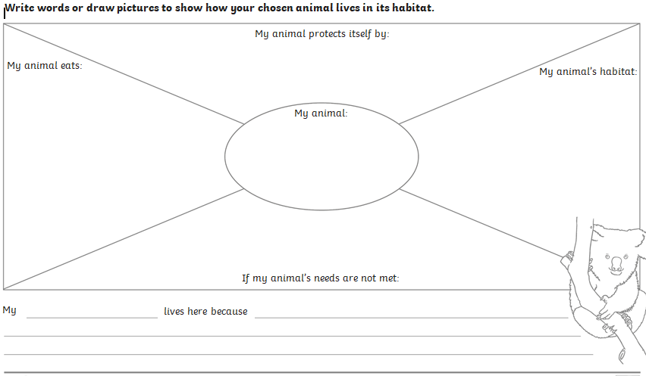 |  |  |  | Challenge:  If you feel you need a further challenge, try these:  - Name the habitats below:  - List all the animals in that live in these habitats.  - Describe weather condition in these places

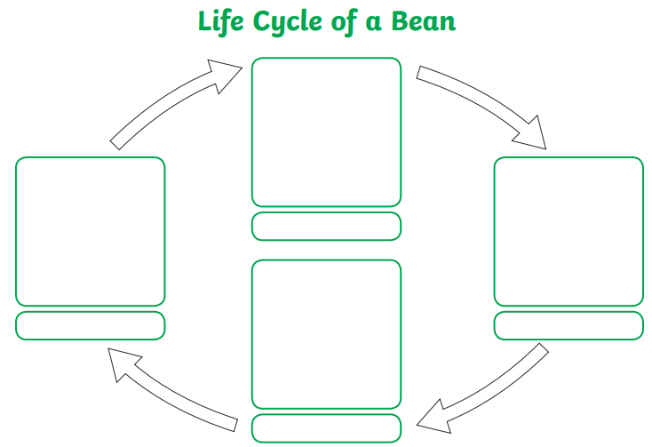
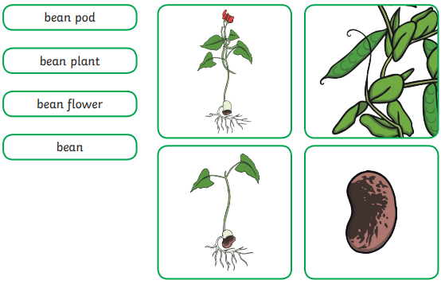
Science- Put the pictures and labels in the right order:

Salt Paintings
YOU WILL NEED:
- PVA school glue or craft glue
- Salt
- Food coloring or water colours (any color of choice)
- Water
- White card-stock or watercolor paper
- Template for your shapes
You may want to do this activity in two stages to allow the salt and glue to dry before adding watercolor.
STEP 1: Trace your template onto cardstock.
STEP 2: Add glue to outline your shapes.
STEP 3: Then add a good amount of salt onto the glue and carefully pour the excess salt off.
STEP 4: Let the glue and salt dry.
STEP 5: Mix a few tablespoons of water with your choice of food coloring to make your watercolor paint.
Salt Painting Tip: The more food coloring you use the darker your “paint” will appear.
STEP 6: Use a pipette to slowly drip the watercolor mixture onto the salt. Try not to drench the patterns but rather watch the salt soak up one droplet of color at a time.
Notice how the water is absorbed and slowly moves throughout the pattern. You can even add drops of different colors and sees what happens!
Leave your salt painting to dry overnight!

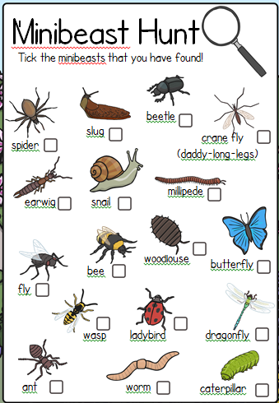
Sea Shanty
When I was one I sucked my thumb
The day I went to sea
I jumped aboard a pirate ship
And the captain said to me…
We’re going this way, that way
Forwards and backwards
Over the Irish Sea
That’s the life for me
When I was two I buckled my shoe
The day I went to sea
I jumped aboard a pirate ship
And the captain said to me…
We’re going this way, that way
Forwards and backwards
Over the Irish Sea
That’s the life for me
When I was three ………………

Other Activities
Art  Cut a rectangular hole in a piece of paper and use this as a viewfinder to draw a view of the garden or street. | PSHE  Lie with your back on the floor and place a soft toy  on your tummy.  Breathe in and out slowly and  deeply and try to concentrate  on the way your toy rises and  falls with your breathing. | PE  Create a simple gymnastic routine using a balance on one limb, two limbs and three limbs. Use different levels – high, low, etc. Practise it and show someone else how to do it. | Geography  Design a new flag for the UK. Think about all the different people that live here, many of which weren’t born here but it is now their home. How can we celebrate all our people in a new flag? | Science  Find an object in your house made from plastic, wood, metal, paper, stone. Explain to someone why this material is used for this purpose.

Key skills to continue practising weekly:
- Times Table Rock Stars – I have checked and not many of you are doing this and it is fun to do plus keeps your skills going. If you have forgotten your log on details, then just email the school.
- Oxford Owl – lots of books to read
- Telling the time throughout the day to the nearest 5 minutes
- Play shops and work out the change
- Common exception words both reading and spelling

If you are able to access the internet, try these useful websites:
- https://www.bbc.co.uk/bitesize/primary
- https://www.bbc.co.uk/bitesize/clips/z4tmhyc
- New lessons are uploaded every day for children to interact with
- https://scratch.mit.edu/
- A chance to have a go at computer programming and create your own games, all completely free.
- Plus remember to check the list of other useful websites which are under home learning on a separate sheet.
If you or your child has any further queries regarding their learning projects, please contact admin@hardwick.derby.sch.uk, clearly stating your child’s name and class teacher, and the staff will be in touch to support you and your child.
Thank you and stay safe.

