Nursery Home Learning
Week Commencing: 4th April 2020
Nursery Teacher: Mrs Bletcher
Nursery TA: Mrs White

Message from staff:

We hope you have had another lovely week at home! The weather has been so sunny, but it has been a bit rainy over the last few days! We hope you will be wearing your welly boots if you go outside to play. We are looking forward to speaking to you and your grown-ups on the telephone soon. We have missed chatting to you lots and can’t wait to hear what you have been up to. Remember we are so proud of all of you and love you all lots! Big big hugs, Mrs Bletcher and Mrs White x

Your Home Learning this Week:
Every day (Monday to Friday), make sure you choose a *physical, *communication, *reading/phonics, *writing and *maths learning activity. There are also further activities to choose from should you wish to.

Physical Home Learning
Develop your fine motor skills by using your hands to roll balls made out of playdough  (recipe at the end). | Develop your fine motor skills by using a knife and fork by yourself to eat your dinner this week! | Develop your fine motor skills by peeling your fruit by yourself - examples: oranges and bananas. | Develop your fine motor skills by dressing yourself in the morning, and putting your pyjamas on at night! | Develop your fine motor skills by joining in with the Makaton actions for ‘Old Macdonald had a Farm’  https://www.youtube.com/watch?v=yJvEwjK0lSQ

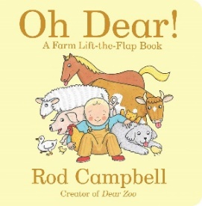
Communication Home Learning
Follow the link to listen to our new quality text ‘Oh Dear!’  https://www.youtube.com/watch?v=v0zLKTIjH0g | Ask your child to tell you about the front cover of our quality text below.  What can you see? | Who is your favourite animal in ‘Oh Dear?’ ‘Why?  Example: I like the pig because he is pink. | How does Buster feel when he can’t find any eggs? Why do you think this? | How does Buster feel when he finds the eggs? Why do you think this?

Reading/Phonics Home Learning
Can you think of two words that rhyme with:  -Tea  -Rat  -Frog  -Two  Remember, rhyming words are words that have the same sounding ending! | Can you make the following sounds in a mirror in your house?  -S  -A  -T  -P  -I  -N  What shape does your mouth make? What does your tongue do?  Can you make any other sounds in the mirror? | Can you think of two words that starts with the sounds:  -S (Examples: Snake)  -A (Example: Apple)  -T (Example: Tiger)  -P (Example: Penny)  -I (Example: Igloo)  -N (Example: Nugget)  See phonics link at the end to pronounce each phoneme (unit of sound) correctly.  Remember, alliteration is when words start with the same sound. | Play ‘I Spy’  Play ‘I Spy’ with your family at home.  Example: I spy with my little eye something beginning with the sound ‘t’.  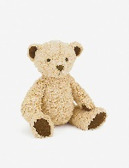 | Voice sounds  Make your voice go down a slide-Wheee!  Make your voice bounce like a ball-Boing Boing!  Hiss like a snake…sssss  Moo like a cow…Moooo

Writing Home Learning
Retell the story of ‘Oh Dear!’ by drawing your own story map. Below is an example of a previous story map.  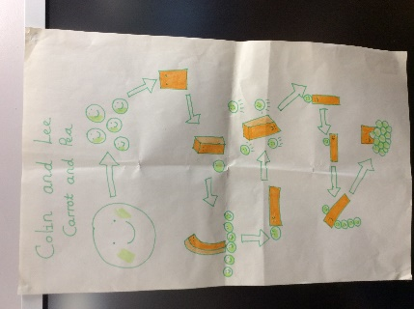 | Can you identify the initial sound and write the initial grapheme in any of your grown-ups names? Example: ‘D’ for Daddy. | Practise writing the first letter in your name. | Practise writing your whole name by yourself.  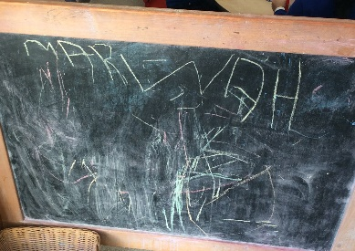 | Draw your favourite character from ‘Oh Dear!’  Can you identify the initial sound and write the initial grapheme of your favourite animal?  Example: ‘P’ for ‘Pig’

Maths Home Learning
Follow the link below to explore different objects that are heavy and light:  https://www.youtube.com/watch?v=SQmI21BB8mA  Who do you think is heavier? A mouse, or an elephant? Why?  What do you think is lighter? A feather, or a car? Why? | Who do you think is heavier, you or your grown up? Why? | Collect something that is heavy from your bedroom, and something that is light. | Have a go at writing 0-10 by yourself. | How many?  Remember to count the holes of Numicon!

Other Activities
Sing one of your favourite Nursery Rhymes every day.  Examples include:  -Wind the Bobbin Up  -Miss Polly had a Dolly  -Two Little Dickey Birds  -5 Little Peas  -Twinkle Twinkle Little Star | Ask your grown-up to put on your favourite songs to dance to. | Draw a picture of what you have done at home every day.  Write your name on it. | Develop your gross motor skills by helping your grown- up make dinner. Example: Rolling roti. | Think about what your favourite animal in the world is. Why? Draw a picture of your favourite animal.
Key skills to continue practicing weekly:
-Children should be practising being independent with their toileting at home.
-Encourage children to extend sentences using connectives (Example: ‘I ate toast for breakfast because I was hungry’). This can be supported through modelling.
-Children should be starting to be more independent in dressing/removing clothes themselves. Examples include: taking their jumper off when hot, putting on shoes on and starting to do zips and buttons.
-Children should be using knives and forks independently at meal times.

For Phonics: https://www.youtube.com/watch?v=Y0ZILFubEdI
https://www.youtube.com/watch?v=VxBEmaaSh1c

If you or your child has any further queries regarding their learning projects, please contact admin@hardwick.derby.sch.uk, clearly stating your child’s name and class teacher, and the staff will be in touch to support you and your child.

Thank you and stay safe.

*Playdough recipe below

Playdough Recipe

Ingredients:
2 cups plain flour
1 cup salt
4 teaspoons cream of tartar
2 cups water (with food colouring)
4 tablespoons cooking oil

- Mix all ingredients together in bowl.

- Stir on low heat until lump forms (around five minutes)

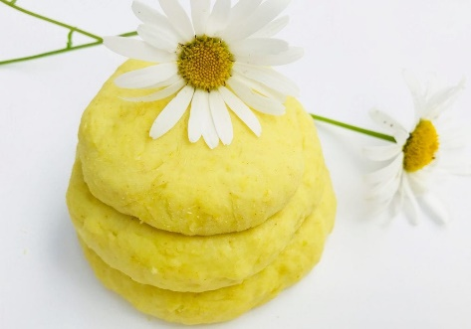
- Allow to cool in pan before transferring to pan.

