Year 4 Home Learning
Week Commencing: 29th June 2020
Year 4 teachers: Mrs Haslam, Mrs Tatla, Mrs Jogela and Miss Annable
Year 4 TAs: Miss Perry and Mrs Smith
Message from staff: Hi Year 4, we hope that you are all well and keeping safe. Even though we are not teaching you, we are thinking about you and working very hard to provide fun activities for you to complete at home. We have enjoyed teaching you over the phone. If you struggle with any of the work, please remember to ask for help when we make our weekly phone call. We hope you are taking some time out of the day to get fresh air and spend time with your family.

Your Home Learning this Week:
Every day (Monday to Friday), make sure you choose a *reading, *writing, *spelling/handwriting, *maths and *theme learning activity. There are also further activities to choose from should you wish to.

Reading Home Learning
Monday | Tuesday | Wednesday |  | Thursday | Friday
Monica the Monitor  Read Robots in Films and TV Programmes Using reading skills to help you understand as you go through it. Highlight any words you do not understand and find the meaning of them. | Colin and Carmen the Connectors  Text-to-self.  As you read the text, what are your thoughts?  Have you ever seen a robot? Where did you see it? (on TV, a film, book)  What was the robot’s job? | Quentin the questioner  Write 5 of your own questions to ask a family member. Use the text - Robots in Films and TV Programmes to help you. Ask them to read the text then answer your questions.  1)  2)  3)  4) |  | Monica the Monitor: Question Zap!  On your own, answer the questions on page 4. | Monica the Monitor: Crack it!  With an adult, go through the questions together, highlight where you found your answers in the text.
Easier:  Do as many of the above activities as you can. If you are finding some of the activities challenging, try these as they are a little easier:  - Listen to an adult read the text- Robots in Films and TV Programmes  - Discuss the meaning of words that you do not understand. |  |  | Challenge:  If you feel you need a further challenge, try these:  - Can you find out more about robots? Is it possible to have a toy that is like a robot? If so, what is the name of this toy robot? Write a report on this robot.

Reading Resource- Robots in Films and TV Programmes

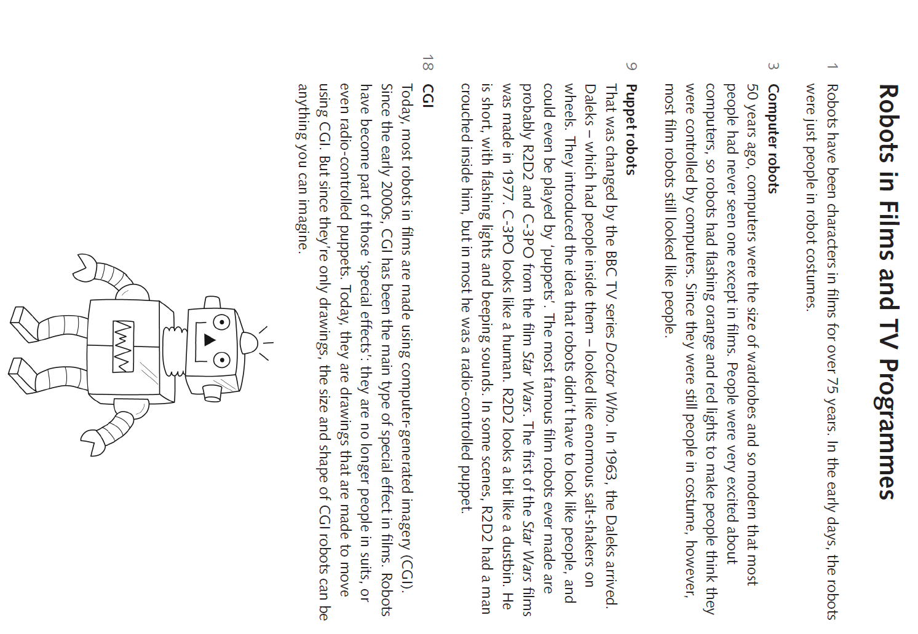
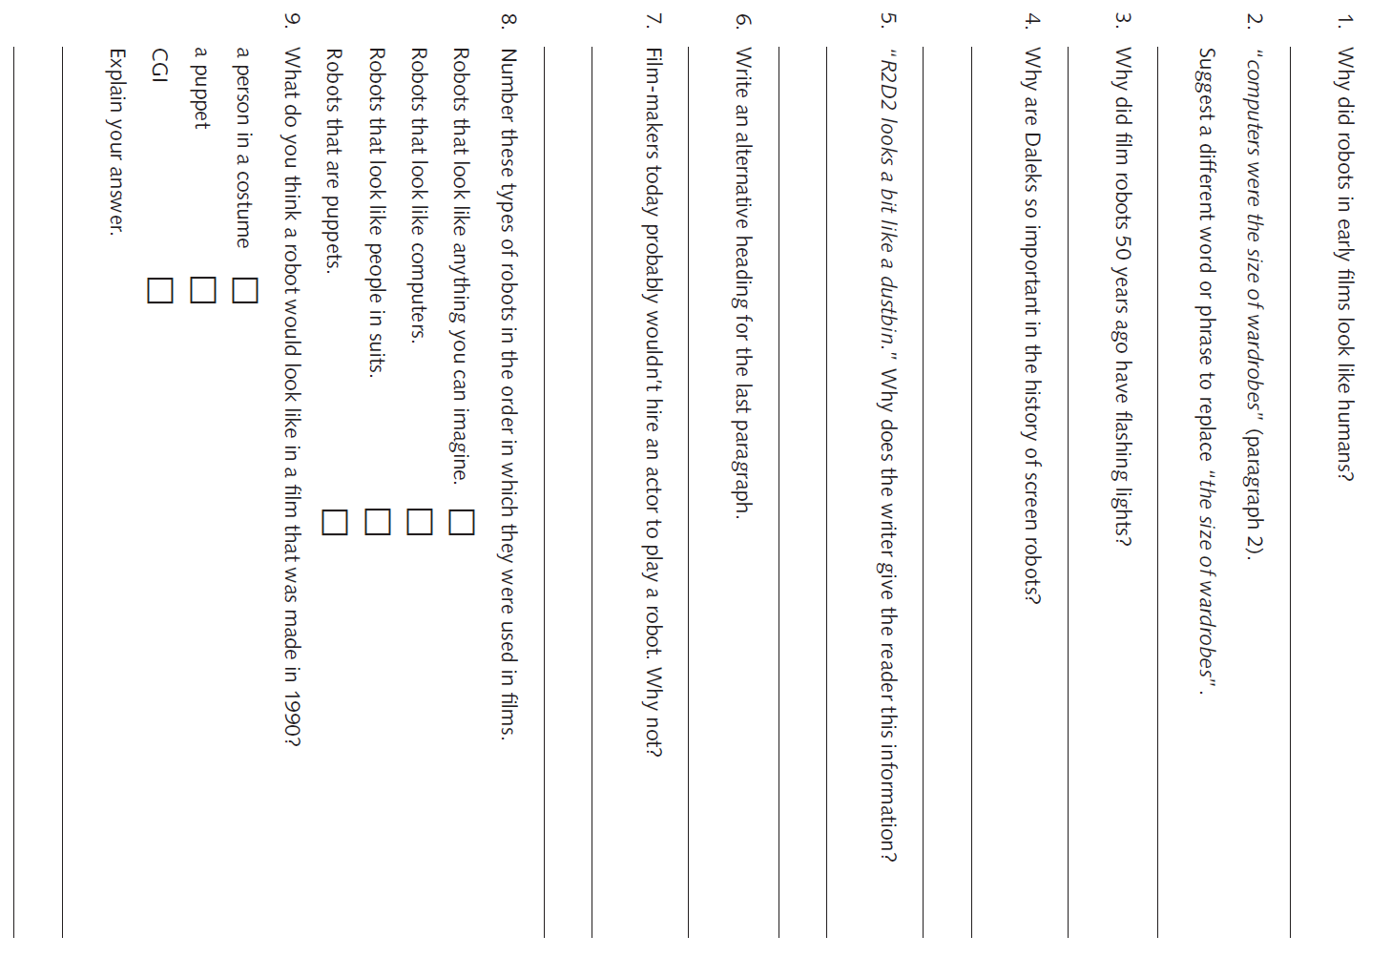
Writing Home Learning – Non Chronological Reports
Monday | Tuesday | Wednesday |  | Thursday | Friday
This week you will be learning about Non Chronological Reports. Today, read through the text about Humpback Whales. Are there any words that you don’t understand? Ask an adult to help you.  Task- Create a text map to represent the text in pictures. | Use your text map and the text about Humpback Whales to learn the text off by heart. It may take a couple of days to learn the text.  Task: When you have learned it as much as possible, try using your text map to help you read out the information to an audience (family members). |  |  | Features of a Non Chronological Report  Use the checklist for Non Chronological Reports and read through the Humpback Whale text. Fill in the checklist with examples from the Humpback Whale text. | Use coloured crayons to highlight the different features of the Non Chronological text- Humpback Whales.  Find and underline examples of the following features::  • Title  • Present tense  • Third Person- they, it  •Subheadings  •Technical Vocabulary  •Statistics – 80%,15m
Easier:  Do as many of the above activities as you can. If you are finding some of the activities challenging, try these as they are a little easier:  - Read through the easier text about Humpback Whales with an adult and ask them to explain any difficult words that you don’t understand.  - Ask an adult to help you read the checklist for Non Chronological Reports and find the features in your text. |  |  | Challenge:  If you feel you need a further challenge, try these:  Can you create an information leaflet using the Humpback Whale text or a poster to give information about the Humpback Whale?
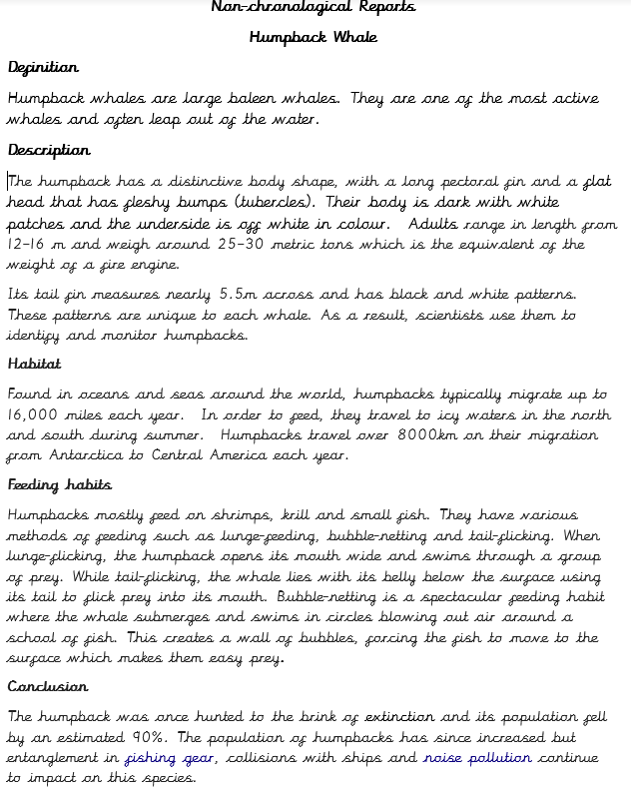
Easier text
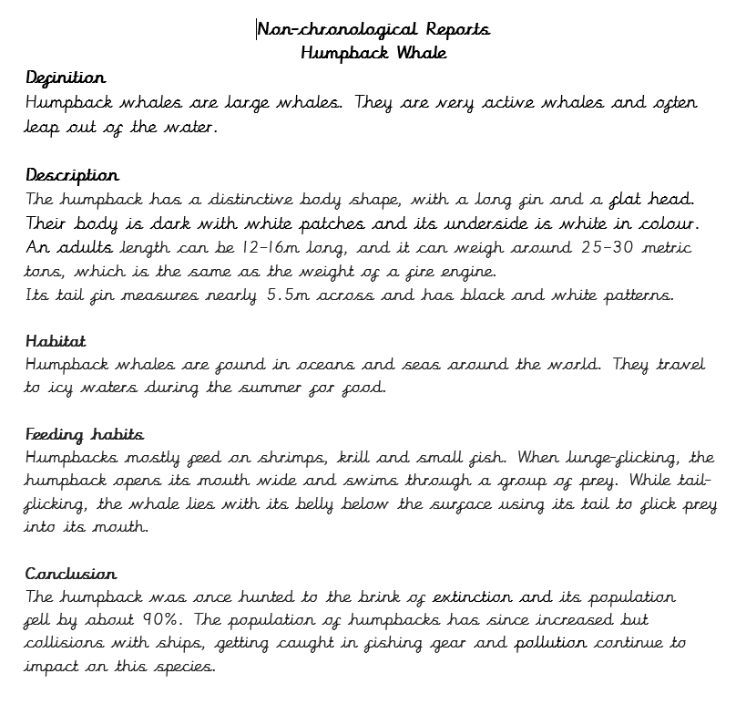

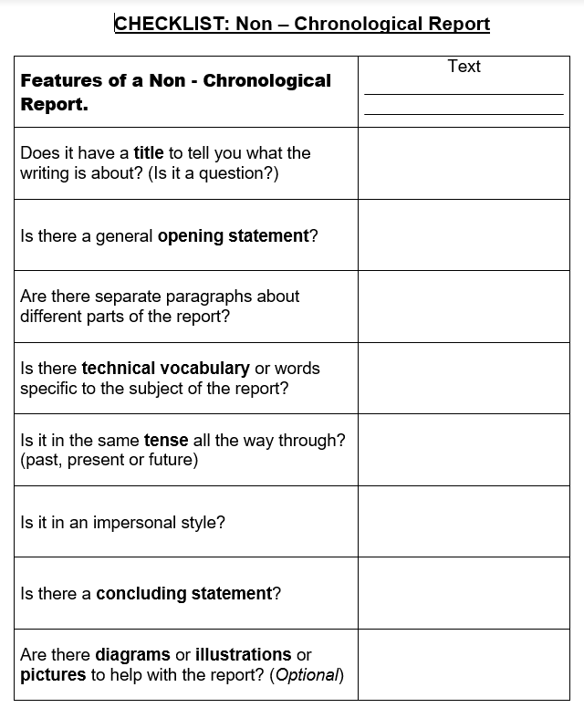

Spelling/Handwriting (Continued from last week as a revision so the same words are used again) Home Learning
Monday | Tuesday | Wednesday |  | Thursday | Friday
Monday  Choose the next 10 spellings on your list that you struggle with or use the spellings below:  appear early imagine  arrive earth increase  believe eight important  bicycle eighth interest  Spelling Pyramids. | Tuesday  Race how many times you can write each word in 1 minute with a family member. | Wednesday  Write a sentence for each spelling.  Try using different sentence types:  Simple- I was in a car accident.  Compound-I was in a car accident but I wasn’t hurt.  Complex-Although I was in a car accident, I wasn’t hurt. |  | Thursday  Choose a paragraph from your favourite book and write it out using the school handwriting style. Ensure you join letters correctly. | Friday  Spelling quiz!  Ask a family member to test you on your spellings.
Easier: Year 1 and 2 Key Words (Statutory Words)  Do as many of the above activities as you can using the spellings below.  door floor  poor because  find kind  mind behind  climb child  children wild  most only both |  |  | Challenge:  If you feel you need a further challenge, try these:  - List these words in alphabetical order:  - recommend relevant relevant restaurant rhyme rhythm sacrifice secretary shoulder signature  - Use the words above to practise your handwriting.  - Write a sentence for each of the words above.
Maths Home Learning
Monday | Tuesday | Wednesday | Thursday |  | Friday
Practise your times tables and division facts. Once you know them test your understanding by getting someone to ask you them and see how many you can answer correctly in 1 minute. Then do the same with the division facts. | Area of figures: Lesson 3  Have a go at the guided practice then complete the worksheet. | Area of figures:  Lesson 4  Have a go at the guided practice then complete the worksheet. | Multiplication: following numbers: 0,1,2,3,4,5,6,7,8,9  Cut up your numbers and use them to generate two numbers to multiply together:  4567x3=  9876x=  Aim to complete at least 5 addition questions. |  | Subtraction:  Write down the following numbers: 0,1,2,3,4,5,6,7,8,9  Cut up your numbers and use them to generate two numbers to subtract:  4567-2381=  9876-3452=  Aim to complete at least 5 subtraction questions.
Easier:  Do as many of the above activities as you can. If you are finding some of the activities challenging, try these as they are a little easier:  - Adding:1) 15x2= 2) 13x2= 3)12x4= 4) 21x4=  - Subtracting: 1) 66-49= 2)83-36= 3) 61-49= 4) 100-74=  - Ask an adult to give you some 3 digit addition sums, rather than doing the 4 digit ones above. |  |  |  | Challenge:  If you feel you need a further challenge, try these:  - Learn addition and subtraction facts for your 16, 17 and 18 times tables.  - Write down all of the factors for 54  - If a 4 sided shape has a perimeter of 54, what could the length and width measure?  List all the possibilities.

Lesson 3Work through the In Focus,Let’s Learn and have a go at the guided practice. Then complete worksheet 3.
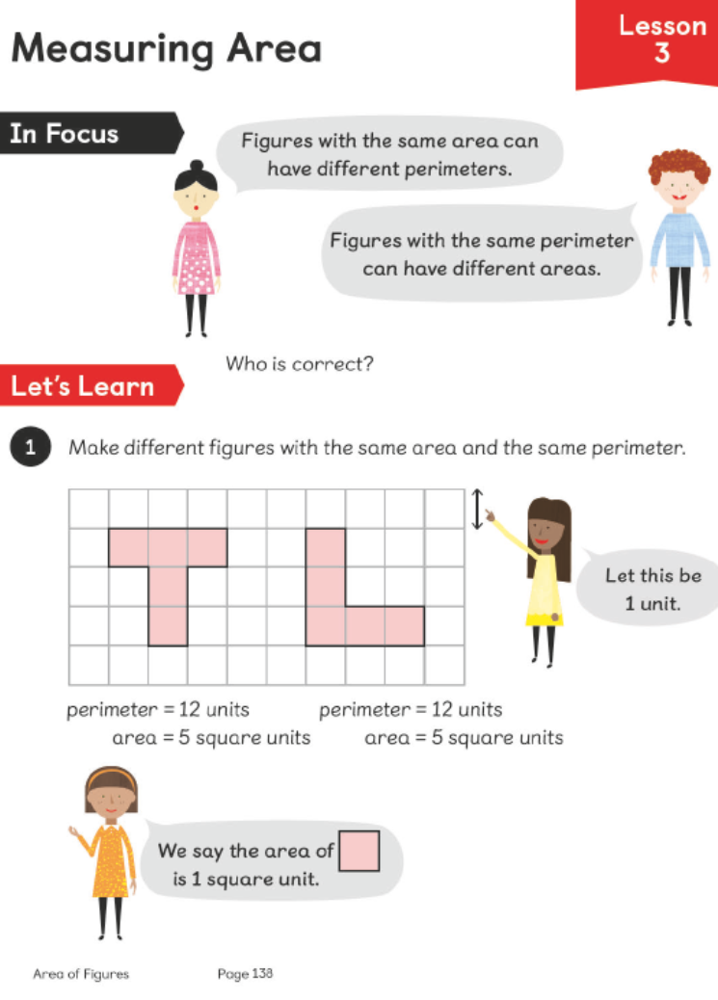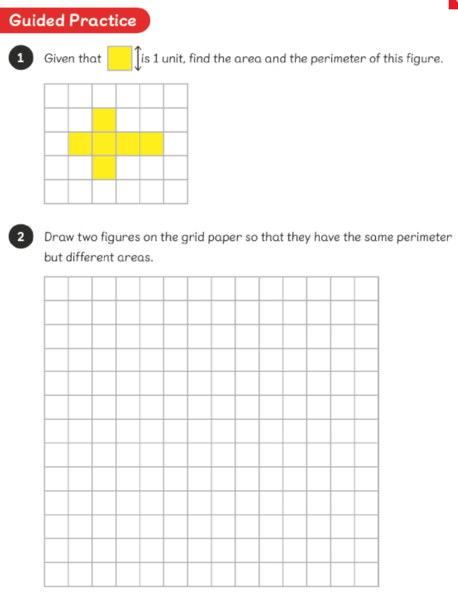
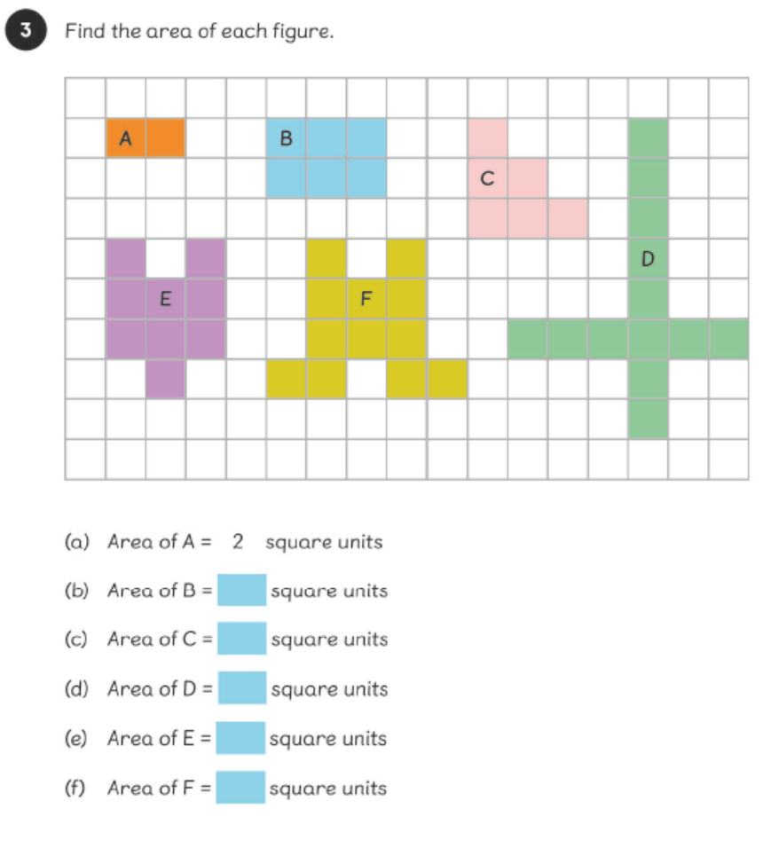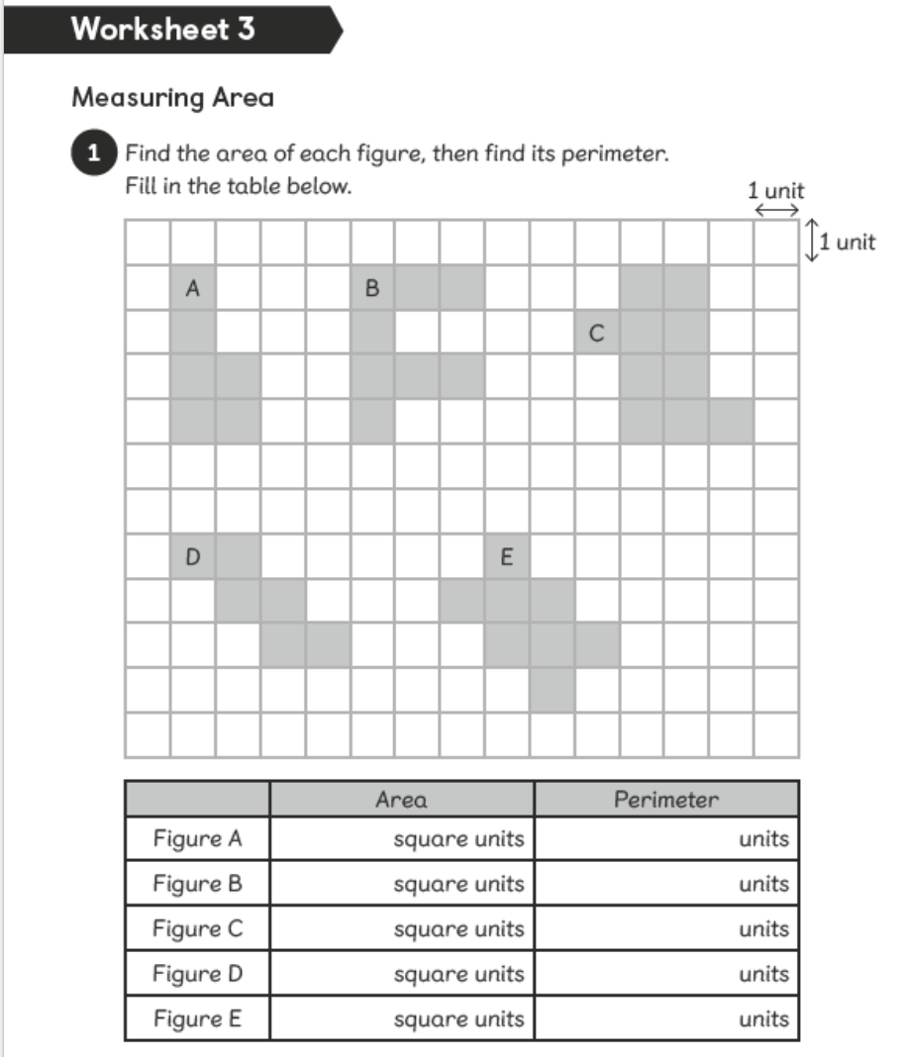

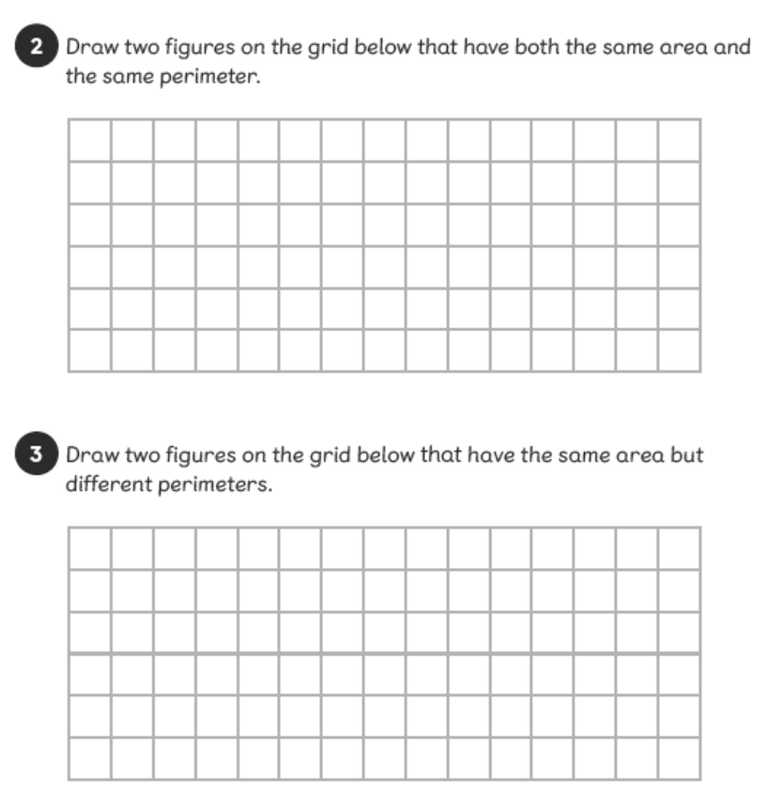
Lesson 4Work through the In Focus,Let’s Learn and have a go at the guided practice. Then complete worksheet 4.

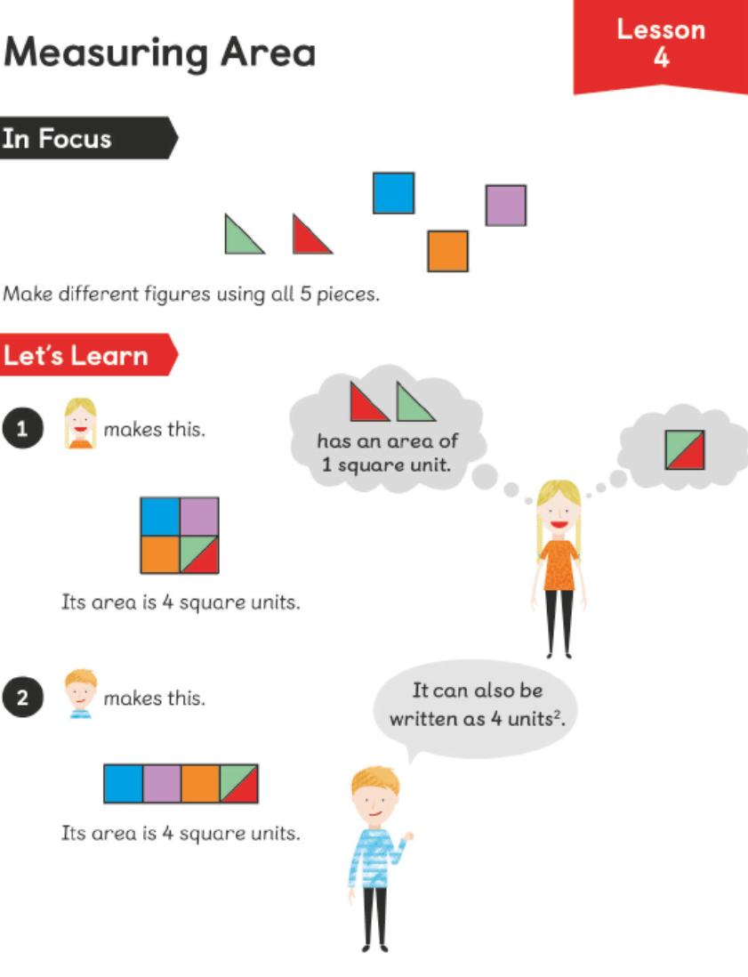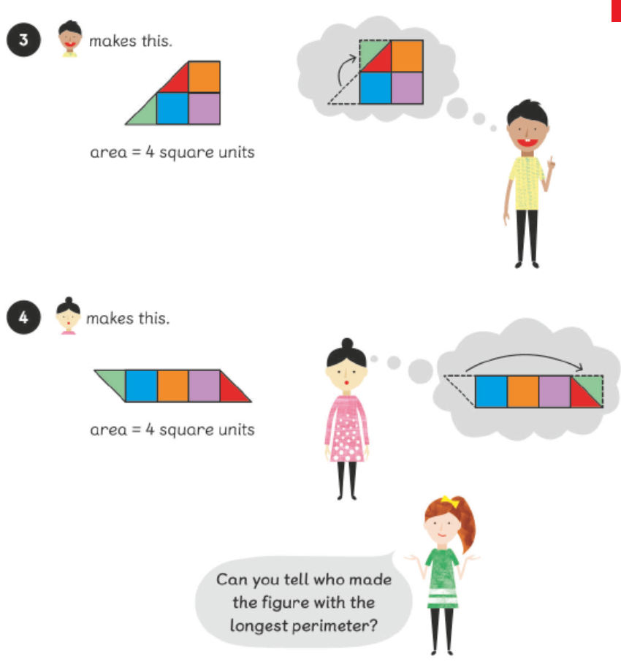
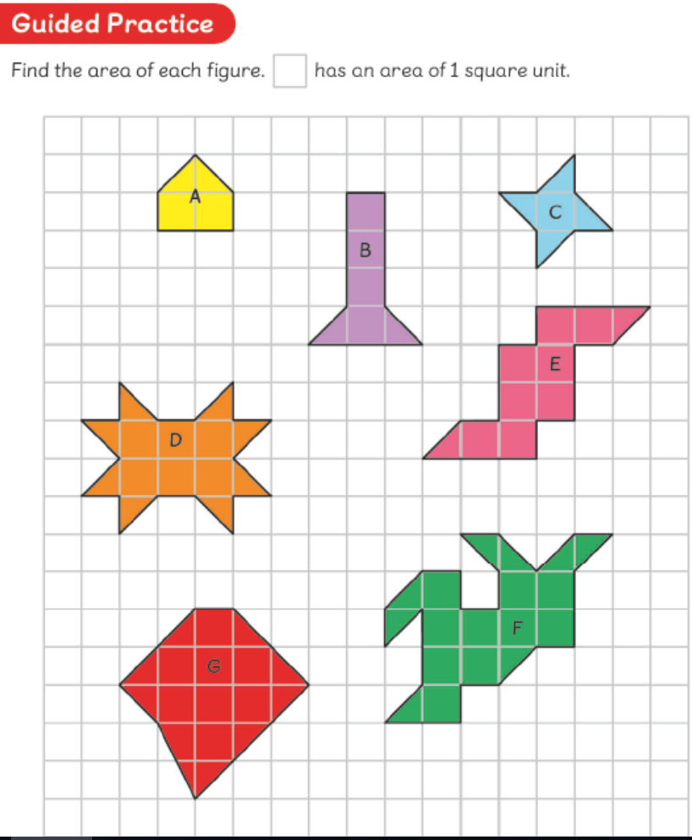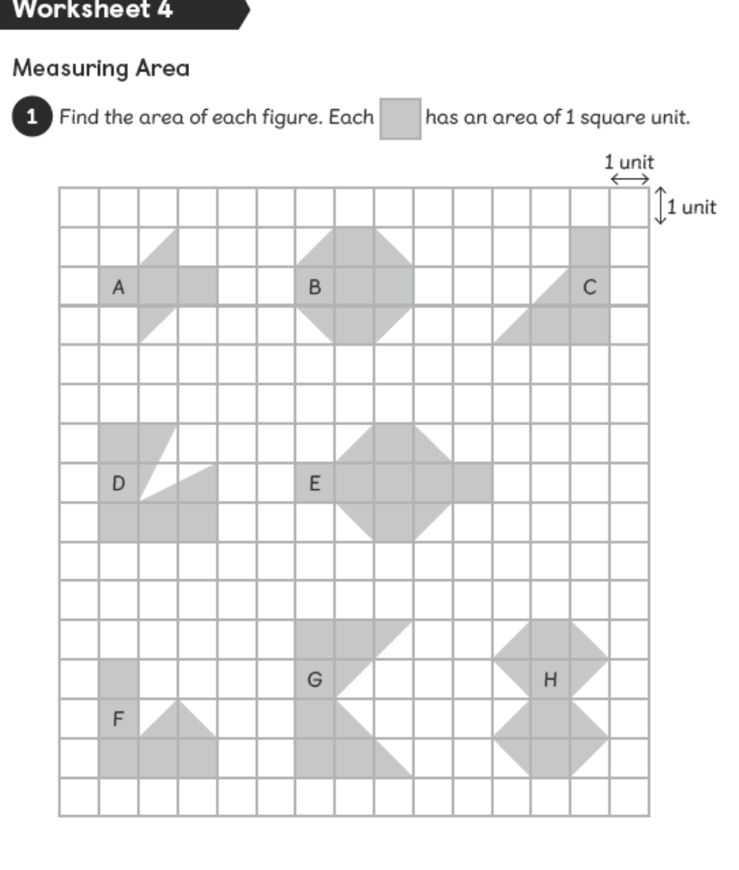

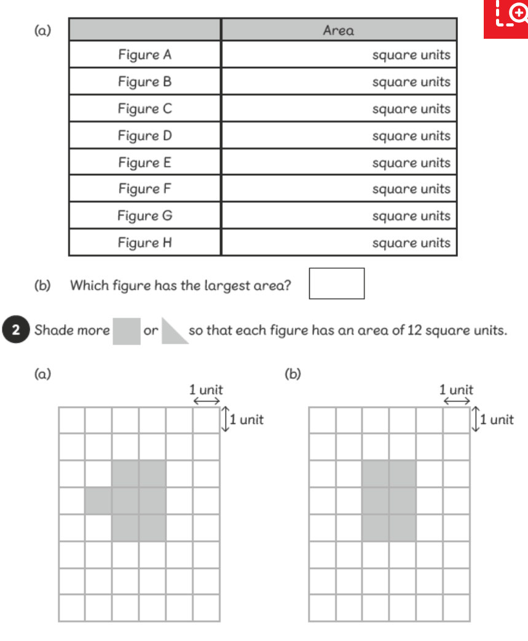

Theme Home Learning
Monday | Tuesday | Wednesday |  | Thursday | Friday
PE-Challenge Yourself  - How many jumping jacks can you do in one minute?  - Is your score increasing each week? | Science-Sound  Do you have a saucepan and a wooden or plastic spoon?  Investigation- What happens to sound when you bang an item softly? What happens to the sound when you hit the pan hard?  Write a paragraph and draw a diagram to explain your findings. | History-Vikings  This week History is all about where the Vikings came from and where they invaded and settled in the UK. Follow the instructions on the next page. |  | DT- This week, your Reading Text is all about robots again. Last week’s DT activity was designing a robot. This week, we would like to use your design to build a robot out of empty food and drink containers. | PE-Challenge Yourself  Can you beat your time from last week? (Number of jumping jacks in one minute)
Easier:  Do as many of the above activities as you can. If you are finding some of the activities challenging, try these as they are a little easier: |  |  | Challenge:  If you feel you need a further challenge, try these:  PE-How many press ups can you do in one minute?  French  Can you count to 20 in French?  Can you count to 100 in French?

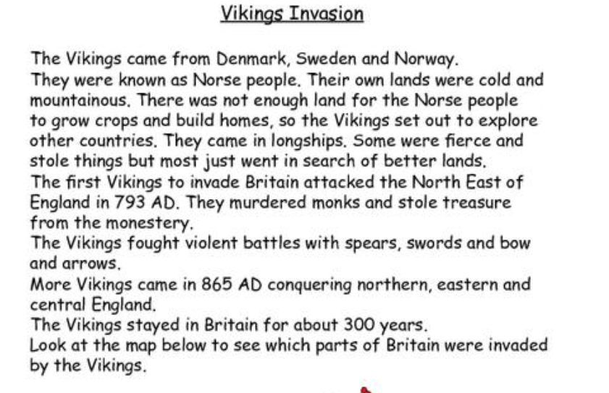
Use the map of Europe to colour in the countries where the Vikings came from. Also use the diagram on the next page to help you colour the parts in the UK where the Vikings invaded and settled.
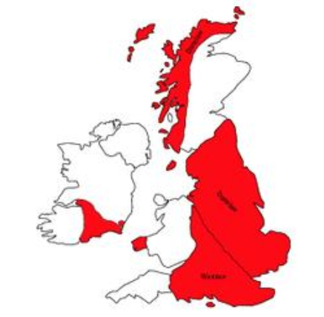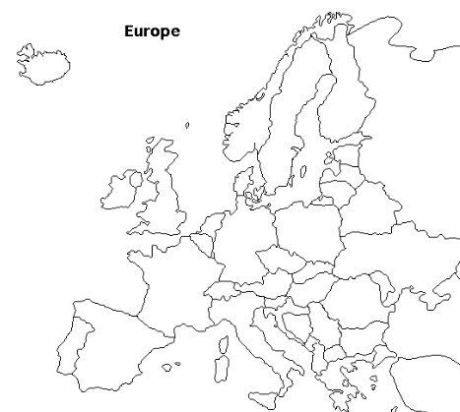

Colour code-
Red for where the Vikings invaded.
Green- for the home of the Vikings.
Other Activities
Start your day with Joe Wicks’ YouTube workout for kids live every morning at 9.00.  https://www.youtube.com/results?search_query=joe+wicks | You have 3 minutes to make as many words as you can from the letters below?  e d s t a f I u r w h n I og | Can you design a Maths board game. The questions could be on any of the topics that we have covered so far. | Extra Handwriting Practice  Spend 10 minutes practising your handwriting. | BBC Bitesize daily lessons for Year 4  (See timetable of which lessons are taught each day)  https://www.bbc.co.uk/bitesize/dailylessons
Key skills to continue practising weekly:
- Times tables (including division facts)
- Reading (This can be anything! Reading your favourite book again, reading magazines, sub-titles on the TV etc.)
- Watch Newsround everyday so you are keeping up-to-date with what is going on in the world.
If you are able to access the internet, try these useful websites:
- Reading: There is an online book of short stories written during lockdown by 100 authors, including Michael Morpurgo.
https://issuu.com/bloomsburypublishing/docs/thebookofhopes_interactivepdf/4?ff
- Timestable.co.uk
- Topmarks.co.uk
If you or your child has any further queries regarding their learning projects, please contact admin@hardwick.derby.sch.uk, clearly stating your child’s name and class teacher, and the staff will be in touch to support you and your child.
Thank you and stay safe.

