FS1 Home Learning
Week Commencing: 18th May 2020
Teachers: Mrs Bletcher
TAs: Mrs White
Message from staff:

Hello! It has been fantastic catching up with you and your lovely families over the last couple of weeks. We are so happy to hear you are all well and have been so busy at home. We are always so proud of all of you! If you have any queries over home learning please don’t hesitate to get in touch via admin@hardwick.derby.sch.uk and we will get back to you quickly!
The weather has been so beautiful over the long weekend. We hope you have been have lots of fun in the sunshine. I have been eating lots of ice lollies to cool down and reading in my garden. We miss you all so much and can’t wait to see you all again soon! All the love in the world for our Nursery children, Mrs Bletcher and Mrs White x

Your Home Learning this Week:
Every day (Monday to Friday), make sure you choose a *physical, *communication, *reading/phonics, *writing and *maths learning activity. There are also further activities to choose from should you wish to.

Physical Home Learning

Monday | Tuesday | Wednesday |  | Thursday | Friday
Using the recipe we provided two weeks ago, use cutters or your hands to roll the playdough and pat circles to make cookies. | Develop your fine motor skills by using your hands to roll long strings out of playdough. | Develop your fine motor skills by using a knife and fork by yourself to eat your dinner this week! |  | Develop your fine motor skills by cutting or peeling pieces of fruit to make a fruit salad for snack. Try a piece of fruit you haven’t eaten before! | Develop your fine motor skills by dressing yourself in the morning, and putting your pyjamas on at night.
Easier:  Do as many of the above activities as you can. If you are finding some of the activities challenging, try these as they are a little easier:  - Practise your toileting by not wearing a nappy, and starting toilet training.  - Explore making marks with your fingers in the playdough.  - Try taking your socks off by yourself, and putting them back on again. |  |  | Challenge:  If you feel you need a further challenge, try these:  - Try forming the letters of your name with playdough.  - Help your grown-up make a cake by chopping and mixing ingredients.  - Make a sandwich independently for lunch, using a knife to spread filling and cut the bread.

Communication Home Learning
Monday | Tuesday |  | Wednesday | Thursday | Friday
If you have access to the internet, develop your listening skills by following the link to our new quality text ‘The Lion who wanted to Love’  https://www.youtube.com/watch?v=o3hU_aR71M0  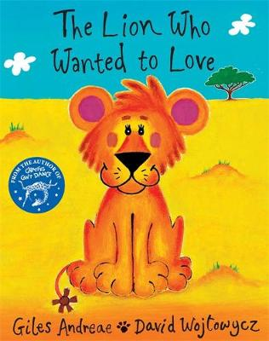 | Ask your child to tell you about the front cover of ‘The Lion who wanted to love’. What can you see? What do you think will happen in the story? |  | Explore the following vocabulary found in ‘The Lion who wanted to love:’  What do these words mean to you?  -Lion  -Love  -Jungle  -Zebra  -Antelope  -Leopard  -Hippos  -Vulture  -Wing  -Cheetah | Explore the following vocabulary found in ‘The Lion who wanted to love:’  What do these words mean to you?  -fierce  -hunt  -injured  -safety  -wounded  -panic  -rescue | How do you think Leo the lion cub is feeling on the front cover?  Why do you think this?  Model: I think Leo is feeling happy because he is smiling.
Easier:  Do as many of the above activities as you can. If you have listened to the story and are finding some of the activities challenging, try these as they are a little easier:  - What sound does a lion make? ROAR  - Who is your favourite animal in the story? Example: Leo Lion  - (Look at the last page) What is the lion cub called? Leo |  | Challenge:  If you have listened to the story, and feel you need a further challenge, try these:  - How is Leo different to other lions?  - How does Leo feel when his Mummy tells him to leave the lion pride?  - How do the baby antelopes feel when the cheetahs are chasing after them?

Reading/Phonics Home Learning
Monday | Tuesday | Wednesday |  | Thursday | Friday
Can you think of a word that starts with the sounds:  -S (Examples: Snake)  -A (Example: Apple)  -T (Example: Tiger)  -P (Example: Penny)  -I (Example: Igloo)  -N (Example: Nugget)  If you have access to the internet, see the link below to pronounce each phoneme (unit of sound) correctly. | Practise making the following letter sounds in the mirror. What shape does your mouth make? What does your tongue do?  -S  -A  -T  -P  -I  -N  -C  -M  -R  -B  -F  -L  -K | Listening carefully to your grown up. Have a go at sounding out the following CVC words we looked at last week:  a-t (at)  s-a-t (sat)  n-a-t (nat)  p-a-t (pat)  t-a-t (tat)  c-a-t (cat)  m-a-t (mat)  r-a-t (rat)  b-a-t (bat)  Do these words rhyme?  Remember, rhyming words have the same sounding ending. |  | Listening carefully to your grown up, have a go at sounding out the following CVC words:  i-t (it)  s-i-t (sit)  n-i-t (nit)  p-i-t (pit)  Do these words rhyme?  Remember, rhyming words have the same sounding ending. | Listening carefully to your grown up, have a go at sounding out the following CVC words:  b-i-t (bit)  k-i-t (kit)  f-i-t (fit)  m-i-t (mit)  l-i-t (lit)  Do these words rhyme?  Remember, rhyming words have the same sounding ending.
Easier:  Do as many of the above activities as you can. If you are finding some of the activities challenging, try these as they are a little easier:  - Go into your garden and listen to the sounds. What can you hear? Can you draw what you heard?  - Explore making sounds with your body (Example: Clapping, stomping, tapping) |  |  | Challenge:  If you feel you need a further challenge, try these:  - Play ‘I Spy’ with your grown up or sibling, identifying sounds independently.  - Have a go at matching a sound to its corresponding letter in the alphabet.  - Have a go at writing the letters of any words you have sounded out. (Example: c-a-t to cat)
Writing Home Learning
Monday | Tuesday | Wednesday |  | Thursday | Friday
Practise writing your whole name by yourself.  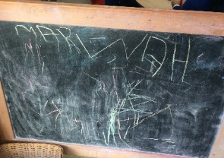 | Retell the story of ‘The Lion who wanted to Love’ by drawing your own story map. Below is an example of a previous story map.  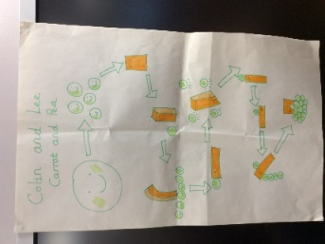 | Practise writing the first letter in your name. |  | Draw Leo from ‘The Lion who wanted to love’. | Draw your favourite animal from ‘The Lion who wanted to love’.
Easier:  Do as many of the above activities as you can. If you are finding some of the activities challenging, try these as they are a little easier:  - Explore drawing circles and lines when shown by a familiar adult.  - Explore drawing circles and lines in the air with your finger.  - Practise forming zigzags, crosses, spirals and circles when shown by a familiar adult. |  |  | Challenge:  If you feel you need a further challenge, try these:  - Can you identify the initial sound and write the initial grapheme of lion and Leo? (L)  - Can you identify the initial sound and write the initial grapheme of Zebra? (Z)  - Can you identify the initial sound and write the initial grapheme of a friend at Nursery? Example: ‘B’ for Ben.

Maths Home Learning
Monday | Tuesday | Wednesday |  | Thursday | Friday
Who do you think is heavier in ‘The lion who wanted to love’, Leo the baby lion or Mummy lion?  Why do you think this? | Who do you think is lighter in ‘The Lion who wanted to love,’ a baby bird or a giraffe?  Why do you think this? | When your grown up goes shopping what is the heaviest item in the bag? What is the lightest item?  Can you order the items from lightest to heaviest? |  | How many baby antelopes did Leo save?  Can you show the number on your fingers?  Can you write the number down? | How many?  Remember to count the holes of Numicon!
Easier:  Do as many of the above activities as you can. If you are finding some of the activities challenging, try these as they are a little easier:  - Have a go at representing 0, 1, 2 and 3 on your fingers.  - Sing ‘5 little peas’, joining in with actions and vocalisations.  - Count 0-10 as rockets. |  |  | Challenge:  If you feel you need a further challenge, try these:  - Order the lightest person in your house to the heaviest person in your house.  - Carefully pour two bowls of water so that they weigh the same. You may need your grown up to help you.  - Order three of your favourite toys from the lightest to the heaviest.

Other Activities
Sing one of your favourite Nursery Rhymes every day.  Examples include:  -Wind the bobbin up  -Miss Polly had a Dolly  -Two little Dickey birds  -5 little Peas | Ask your grown-up to put on your favourite songs to dance to and join in with. | Draw a picture of what you have done at home every day. | Develop your fine motor skills by helping your grown- up make breakfast, lunch, and dinner. | Think about what your favourite thing to do at Nursery is. Draw a picture of it, tell your grown up, and then email us so we can make sure we do it when we get back!

Key skills to continue practising weekly:
- Children should be practising being independent with their toileting at home.
- Children should be starting to be more independent in dressing/removing clothes themselves. Examples include: Taking their jumper off when hot, putting on shoes on, and starting to do zips and buttons
- Encouraging children to use at least four words in their sentences (Example: ‘I ate toast for breakfast’. This can be supported through modelling.

If you are able to access the internet, try these useful websites:
- Alphablocks: Alphablocks is excellent for blending CVC words!
- Letters and Sounds overview: This is what we follow in Phonics!
- Singing Hands: Singing hands are fantastic at providing Makaton actions for familiar Nursery Rhymes!

If you or your child has any further queries regarding their learning projects, please contact admin@hardwick.derby.sch.uk, clearly stating your child’s name and class teacher, and the staff will be in touch to support you and your child.

Thank you and stay safe.

