Year 6 Home Learning
Week Commencing: 11th May 2020
Year 6 teachers: Mrs Haider, Miss Qayoom, Mr Nowak
Year 6 TAs: Mrs Yar-Khan
Message from staff: It was lovely to catch up with you all and speak to you. It is great to know that everybody is doing well. Keep safe and don’t forget to complete an hour of physical activity daily.
You should all now have your Purple Mash logins. Go on to this and explore the different features. We will begin to set work on this soon.
Finally, if you are still having problems going on to the school website and unable to access the home learning, information will follow shortly about collecting print outs from school.

Your Home Learning this Week:
Every day (Monday to Friday), make sure you choose a *reading, *writing, *spelling/handwriting, *maths and *theme learning activity. There are also further activities to choose from should you wish to.

Reading Home Learning
 | Monday | Tuesday | Wednesday |  |  | Thursday | Friday
 | 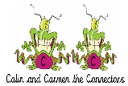  You will be reading a text about refugees. Make connections with what you already know about refugees. Are there any interesting facts you know? Have you heard anything about refuges on the television or elsewhere (e.g. newspapers)? Ask the people you live with if they know anything. | 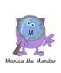  Read ‘Refugee Week’ text, using reading skills to help you understand as you go through it. Highlight any words you do not understand and find the meaning of them. | 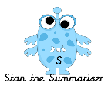  Summarise what you have read in the text. Remember, a summary covers the very important parts of the text (VIP). Which parts in the text do you think are important? |  |  | Now try answering these questions:  - See the differentiated sheets (Easier, year 6 and challenge). | 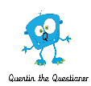  After reading the text on ‘Refugee Week’, think of any questions you may have. Is there anything you were left wondering that was not answered? Write these questions down. Reread the text again and this time, try to answer the questions you have. Can you answer them? If not, try to research the answers or, save the questions for when we come back to school so you can research at school.
 | Easier:  Do as many of the above activities as you can. If you are finding some of the activities challenging, try these as they are a little easier:  - Read the text ‘Refugee Week ’, using reading skills to help you understand as you go through it.  - Highlight any words you do not understand and find the meaning of them.  - What type of text is this and how do you know? What do you notice about how it is set out? Have you seen anything like this before?  - Can you think of as many reasons as possible why a family or a person might have to leave their country? How many different reasons can you think of? Ask an adult to help you. |  |  |  | Challenge:  If you feel you need a further challenge, try these:  - Test yourself! How many different countries can you name?  - What is the purpose of the article?  - Who is the article written for? How did you decide on your answer?  - Why do you think the writer included ‘Did you know’ sections?  Go back to the text. Ask an adult to test you to see if you can explain the meaning of the new words you have learnt.  - Use the new words by writing sentences of your own.
Reading Comprehension

Easier | Year 6

Reading Challenge

Writing Home Learning
Monday | Tuesday | Wednesday |  | Thursday | Friday
Read through Toast instructions 1 and 2. Complete learning activity 1 | Read through text in learning activity 2 and put it in order.  Can you add your own instructions to make these more concise? | Talk to your family about your favourite dishes. This could be your favourite sandwich or milkshake. Choose one and ask your family to talk you through the recipe and instructions for making this dish. Make notes. |  | Read through the checklist in activity 1 and write instructions for this dish. | Working with an adult, use the checklist to evaluate the instructions and improve your instructions. Have a go at following your instructions to make the dish. (You must get permission from your parents).
Easier:  Do as many of the above activities as you can. If you are finding some of the activities challenging, try these as they are a little easier:  - Read through Toast instructions 1 and complete activity 1  - Read through text in learning activity 2 and put it in order. |  |  | Challenge:  If you feel you need a further challenge, try these:  - Read through Toast instructions 1,2 and 3. Complete learning activity 1

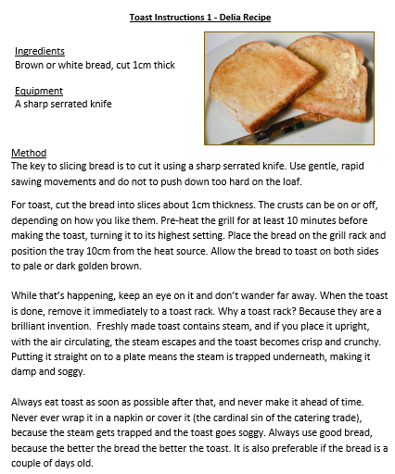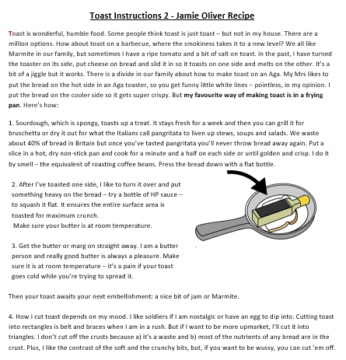

Learning activity 1

Complete this grid after reading the texts.
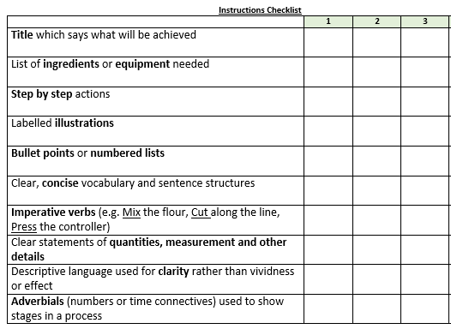

Learning activty 2

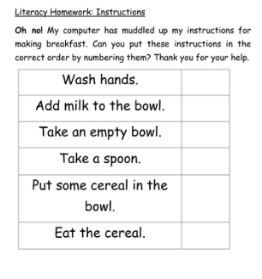

Spelling/Handwriting Home Learning
Monday | Tuesday | Wednesday |  | Thursday | Friday
Learn the following spellings.  Find the meaning of the words below  Ask an adult to test you on the spellings above. | Look at the word list for Monday and write your own sentences using these words.  Remember to punctuate your sentences correctly. | Learn the following spellings.  Find the meaning of the words below  Ask an adult to test you on the spellings above. |  | Look at the word list for Wednesday and write your own sentences using these words.  Remember to punctuate your sentences correctly. | Revisit spellings you have learnt over the last 3 weeks. Check that you can still remember them. Work with an adult to help you check the spellings.
Easier:  Do as many of the above activities as you can. If you are finding some of the activities challenging, try these as they are a little easier:  - Choose 10 spellings per day from the spelling list year 3 and 4 and learn them (see next page).  - Find the meaning of these words.  - Use the new words in your own sentences. |  |  | Challenge:  If you feel you need a further challenge, try these:  - Look at your CGP revision books and find the year 5/6 spellings. Revise them.  - Make sure you understand the meaning of the words you can spell.

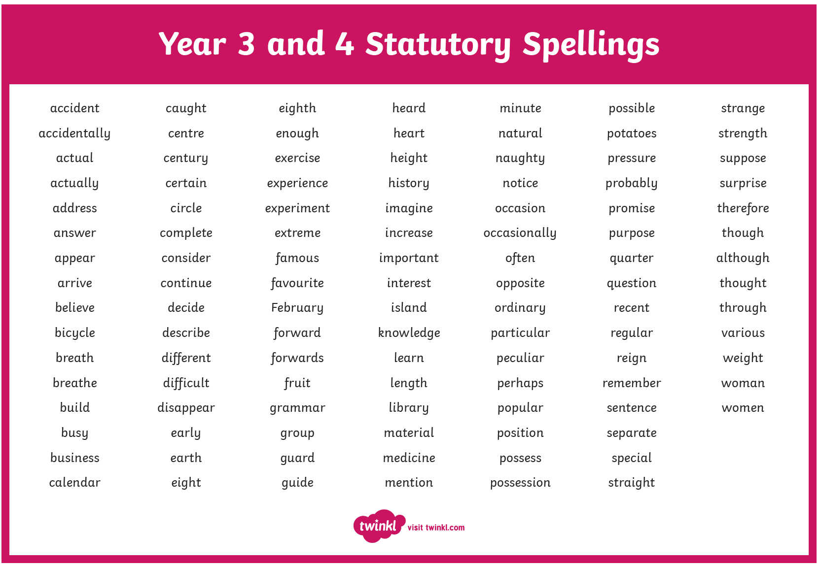
Easier Spelling list
Maths Home Learning
Monday | Tuesday | Wednesday |  | Thursday | Friday
Focus on + and – of whole numbers and decimals.  Write 10 sums for yourself, answer these and ask an adult to check. Use the methods you have been learning in class.  Example:  3456 + 78904 | Focus on x and ÷  of whole numbers and decimals.  Write 10 sums for yourself, answer these and ask an adult to check. Use the methods you have been learning in class.  Example:  5462 x 34 | Read through teaching tip and complete learning activity 1 |  | Read through teaching tip for activity 3 and complete learning activity 3 | Choose a challenge. Work through it with your family. The task are in order of difficulty.  Learning activity 4
Easier:  Do as many of the above activities as you can. If you are finding some of the activities challenging, try these as they are a little easier:  - X 1 digit by 2 digits. Make up 10 sums and answer using the method shown.  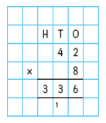  - Dividing 2 digits by. Make up 10 sums and answer using the methods you have been learning. Ext: Complete reasoning task.  - Dividing 3 digits by. . Make up 10 sums and answer using the methods you have been learning. Examples  - 844 ÷ 4 =  - 525 ÷ 5 =  Ext: Answer the problem below.  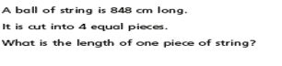  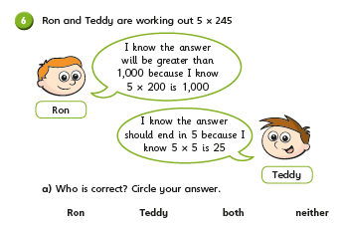 |  |  | Challenge:  If you feel you need a further challenge, try these:  Complete (Learning activity 2)

Teaching Tip for activity 1 and 2
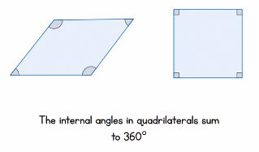
Activity 1 Activity 2
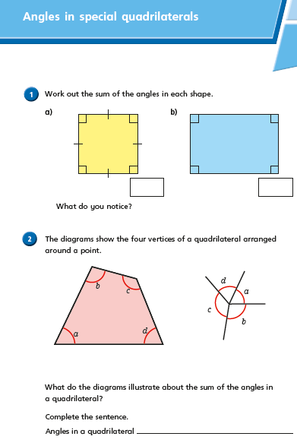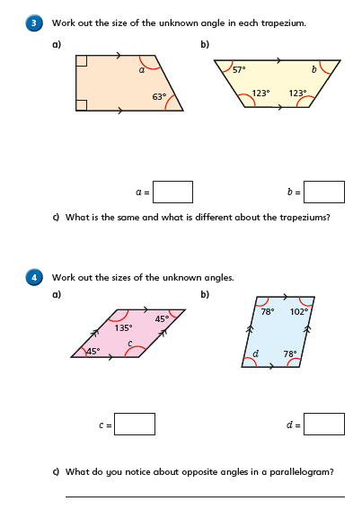

Teaching Tips for activity 3 :Angles in a regular polygon
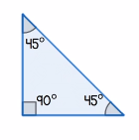
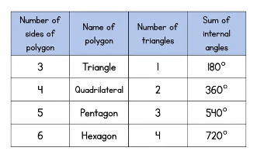
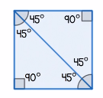
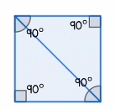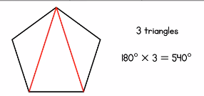
This shape (pentagon) contains 3 triangles so 3 x 180 = 540
so

Sum of a triangle is 180

This shape (square) contains 2 triangles so 2 x 180 = 360
so

Learning activity 3 Learning activity 4
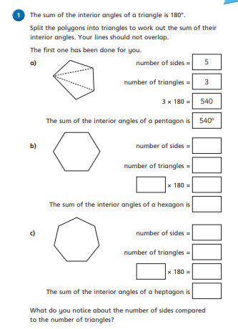
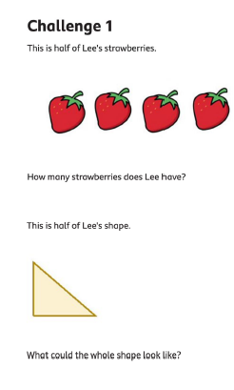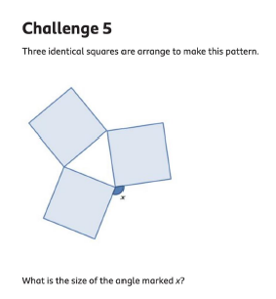

Theme Home Learning
Monday | Tuesday | Wednesday | Thursday |  | Friday
Science Inheritance  Look at the sheet  ‘My Family and me.’  Complete the first page. Work out the inherited features. | Science  Complete the sheet ‘Year 6 and challenge’ sheet.  Look carefully at the features you have inherited from your parents. Cut out some photographs and make a family tree. Annotate the features inherited. | PSHCE  Draw a Rainbow poster to support the NHS staff by sending the message to the public to stay home. Display the poster on your window. | RE  Buddhist symbols and meaning  Read the information sheets (Fact Sheet, Key beliefs, Enlightenment and Compare)  Complete the worksheet Year 6 and Challenge matching game sheet  Draw a Venn diagram and compare Buddhists beliefs with your own religious beliefs. |  | PE  Dance  See PE  Complete any 5 activities to complete with a family member
Easier:  Do as many of the above activities as you can. If you are finding some of the activities challenging, try these as they are a little easier:  - RE Complete the sheet Quiz (match the symbols to their meaning). Remember to cut out the pictures.  - PE Complete any 4 activities to complete with a family member. |  |  |  | Challenge:  If you feel you need a further challenge, try these:  - PE Dance  - Complete all 6 activities on the sheet with a family member.

Science Easier
The Inheritance Card Game

Cut out the pictures of the siblings. Shuffle the pictures and match them up according to eye colour, hair colour, skin colour and face shape.

Year 6 and Challenge

RE Buddhism
Learn the symbols and meanings below
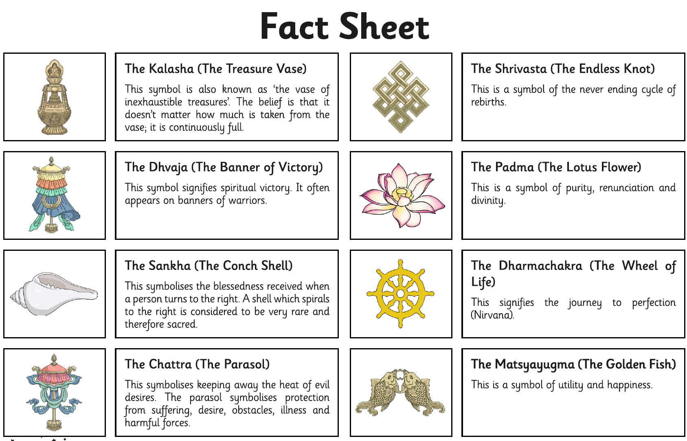

Easier
Year 6 & Challenge
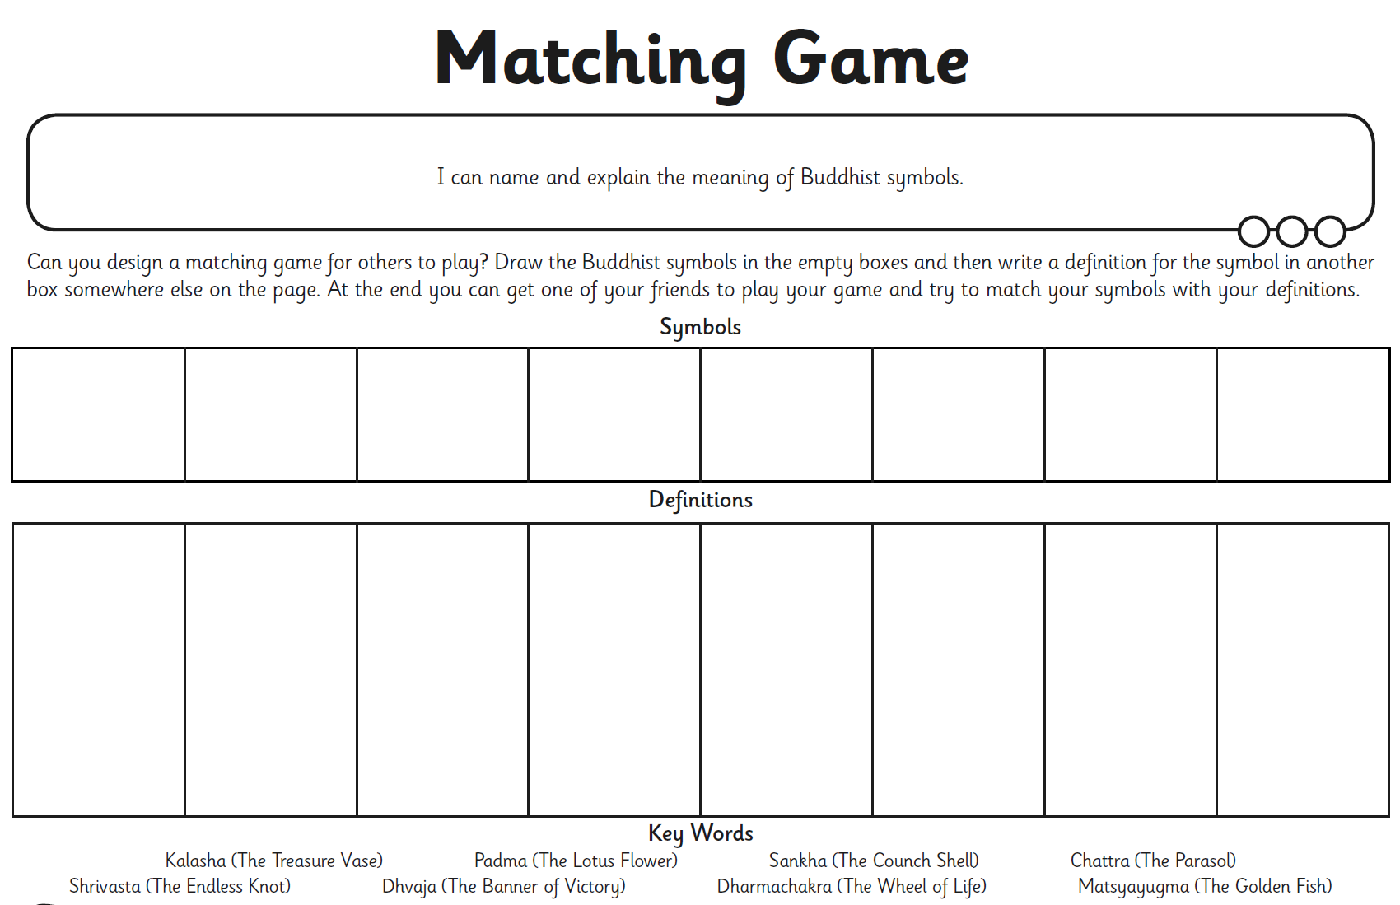

PE

Easier | Year 6 | Challenge
Choose any 4 activities to complete. | Choose any 5 activities to complete. | Complete all the activities above.

Other Activities
Times tables  Build up speed. Time yourself how long it takes you to answer 0 to 12 x tables in mixed order (work with an adult). | Write a book review about your favourite book. | Use Purple Mash and play online learning games. | Write a blurb for your favourite book. | How many different mindful techniques can you think of?  Which is your favourite?

Key skills to continue practising weekly:
-spellings
-grammar (go through revision booklets)
-speed reading
-speed writing (count the number of words you can write in one minute)
-neat and joined up handwriting
-timetables (build up speed)

If you or your child has any further queries regarding their learning projects, please contact admin@hardwick.derby.sch.uk, clearly stating your child’s name and class teacher, and the staff will be in touch to support you and your child.

Thank you and stay safe.

