Year 5 Home Learning
Week Commencing: 22nd June 2020
Year 5 teachers: (Mrs Nisa, Mr Caldwell and Mrs Hollingworth)
Year 5 TAs: Miss Gent and Mrs Begum
Message from staff:
Hi Year 5,
As we said last week, it is very important that you do as much of the Home Learning as you can. It does not all need to be completed but we don’t want your brains to go all mushy during this weird time.
Hopefully you are coping well and everyone in your families are looking after each other and you lot are helping at home as much as possible. We miss you all a lot and can’t wait to see you all again whenever that is.
We are all working hard in preparing lots of exciting activities for you to do at home. We would all like to teach you, explain things and answer any of your questions but this new way of learning at the moment. Please remind your families to collect your home learning every week, Monday, Tuesday and Wednesday from 10am until 2pm. You can also access it on the school website.
For now, stay safe and work hard. It is too easy to sit around and do nothing.
Speak to you and hopefully see you soon.
Year 5 Staff

Your Home Learning this Week:
Every day (Monday to Friday), make sure you choose a *reading, *writing, *spelling/handwriting, *maths and *theme learning activity. There are also further activities to choose from should you wish to.
Reading Home Learning
Monday | Tuesday | Wednesday |  | Thursday | Friday
You will be reading an extract from the text ‘Alice in Wonderland’. Which is a traditional story for children about a young girl who enters a magical world through a rabbit hole. Read the text carefully and highlight or underline any word you do not understand. | Re-read the text and find the meaning of the words you do not understand from yesterday.  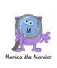 | Using Stan Summariser, summarise the main points, including what happens, when, where and who is involved – do not forget to use your VIP’s (very important parts).  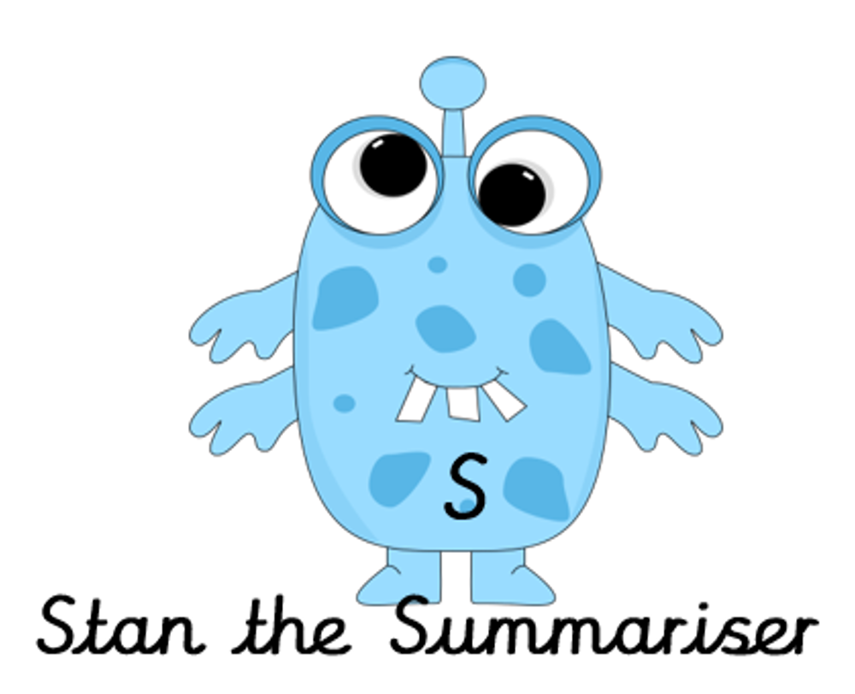 |  | Now try answering these questions:  1.Who is Alice thinking of sending a Christmas present too?  2.Why does Alice say, ‘You ought to be ashamed of yourself’?  3.Why does Alice decide she couldn’t have changed into Ava?  4.How do you think Alice is feeling at the end of the extract from the story? | After reading the text write a prediction for what might happen next.  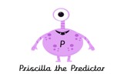
Easier:  Do as many of the above activities as you can. If you are finding some of the activities challenging, try these as they are a little easier:  - Read the easier version of the text.  - Highlight any words you do not understand and find out what they mean.  - Try and answer these questions:  - Who is Dinah?  - After finding out it is empty, what does Alice do with the jar of marmalade?  - What is running along the passage?  - Where does Alice think she will land? |  |  | Challenge:  If you feel you need a further challenge, try these:  - Answer the following questions:  - Why were the gloves and fan sodden?  - What does Alice mean when she says, ‘Reaching the heights I am now would be an impossibility’?  - Alice is stuck with nobody to help her. What would you suggest she does next to help herself try and get out of the situation?
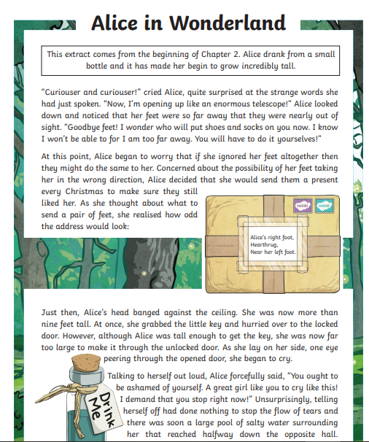
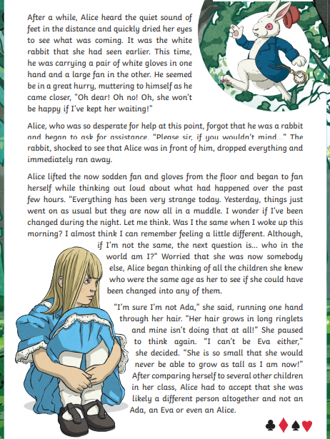
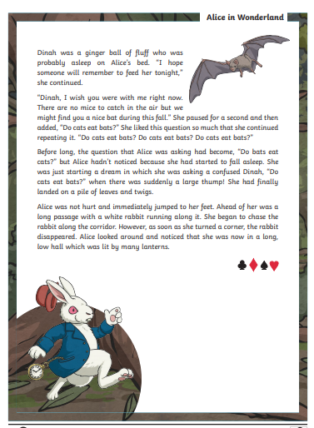
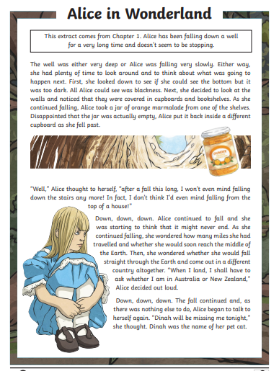
Easier version
Writing Home Learning
Monday | Tuesday | Wednesday |  | Thursday | Friday
This week you can have a go at writing the next part of the story for Alice in Wonderland. Re-read the extract above from you reading activity. Mind map 4 different events that might happen next to Alice – you will choose one to use for the next part of the story. | Today we want you to draw a comic strip for your next chapter of the story. Decide what will happen to Alice in the next chapter by choosing an idea from your mind map yesterday. | Today have a go at telling your story to an adult, brother or sister using your comic strip to remind you of the main events. Try to include as much detail as possible to interest your audience. This will help you to organise your ideas in your head ready for writing tomorrow. |  | It is time to have a go! Today, have a go at writing the next chapter of the story – use your comic strip to help you. Try to include the following:  Fronted adverbial phrases.  A range of different sentence types.  Carefully chosen verbs and adjectives to infer information about your characters. | Re – read your story from yesterday and highlight any words or phrases that you can edit and improve upon. Think about any extra detail or information you can add - then have a go at re-writing the chapter with your improvements. Then read both versions to an adult at home and see if they can notice the improvements you have made.
Easier:  Do as many of the above activities as you can. If you are finding some of the activities challenging, try these as they are a little easier:  - Use the easier text from your reading activity to plan your story.  - Focus on using good adjectives and verbs in your story.  - Re – read each sentence as you write to make sure it makes sense. |  |  | Challenge:  If you feel you need a further challenge, try these:  - Include parenthesis to add further detail to your story, this can be either a dash - or brackets ()  - Think about using conjunctions and fronted adverbial phrases to start each paragraph to link it back to the previous paragraph.  - Try and use a wider range of more adventurous vocabulary.  - Try and end the chapter with a cliff hanger that makes the reader want to read on.

Spelling/Handwriting Home Learning
Monday | Tuesday | Wednesday |  | Thursday | Friday
Pick out some challenging words from a book you are reading or the new text chosen from the reading activities. Create your own spelling list to practice this week. | Practice your spellings. Use one of the many techniques you have been taught.  -Different colour syllables.  -Say it the way you see it.  -Word pyramid.  -Look cover, write check. | Copy out your reading text in your best joined up writing.  Do it again to see if you can make it even neater.  (remember- Not too small, not too big, letters in proportion to each other, CONSISTENCY. |  | Using the spellings you have chosen on Monday, practice your cursive handwriting.  Get plenty of colours. Write each spelling as many times as possible in different shapes, Follow the lines and curves of the shape to fit as many words in as possible. | Get your siblings or parents or anyone that can help, to test you on the spellings you have been revising.  Any you get wrong can go on a permanent list to practice another time.
Easier:  Do as many of the above activities as you can. If you are finding some of the activities challenging, try these as they are a little easier:  - Pick out words from any books you have, that are tricky for you and practice them. Get someone to test at the end of the week.  - Use the same words for handwriting practice.  - Play hangman with the words you have chosen. |  |  | Challenge:  If you feel you need a further challenge, try these:  - Find year 4 and 5 spellings lists online and pick out the ones you are most unsure about.  - Find the definitions of words you do not know.  - Play games like hangman. Or BIG challenge: INVENT your own game using the words.
Maths Home Learning
Monday | Tuesday | Wednesday |  | Thursday | Friday
Capacity is the amount something can contain, e.g. there is 1 litre pf juice in a carton. We use millilitres and litres to measure capacity.  Remember:  1 litre=1000ml  ½ litre=500ml  ¼ litre =250ml  ¾ litre =750ml  1/10 litre =100ml  Medicine spoon =5ml | 1 ½ litres=? ml  4 litres= ? ml  3 ½ litres=? ml  2 1/4l=? ml  2000ml= ? litres  3250ml=? litres  2750 ml= litres  5500 ml= litres  4250 ml = litres | Not all the scales are the same.  When reading scales check what the numbers are going up in. What does line represent? |  | What calculation can you do the find the difference between two numbers?  How can you find the difference between 2 measurements? | Design a poster to explain capacity. Give examples in everyday life at home and school where you may use capacity. Don’t forget to ask your families about their experiences of capacity.
Easier:  Do as many of the above activities as you can. If you are finding some of the activities challenging, try these as they are a little easier:  Leon takes 5mls of medicine three times a day.  How much will she take in a day? _________  How much will she take in 4 days? __________  - Use a measuring jug and pour in 1 litre of water,using the same cup, how many cups can you fill. How many ml can the cup hold?  - If Malika drinks 2 litres of water in one day,  how much will she drink in one week? ___________  2 weeks_________ 3 weeks________ 5 weeks____________ |  |  | Challenge:  If you feel you need a further challenge, try these:  - Find some any empty containers around the house and estimate how much water they can hold. Fill them with water and then empty into a measuring jug. Find the difference between your estimate and the actual measurements.  - Estimate and measure the capacity of 5 different sized cups and glasses in your home.
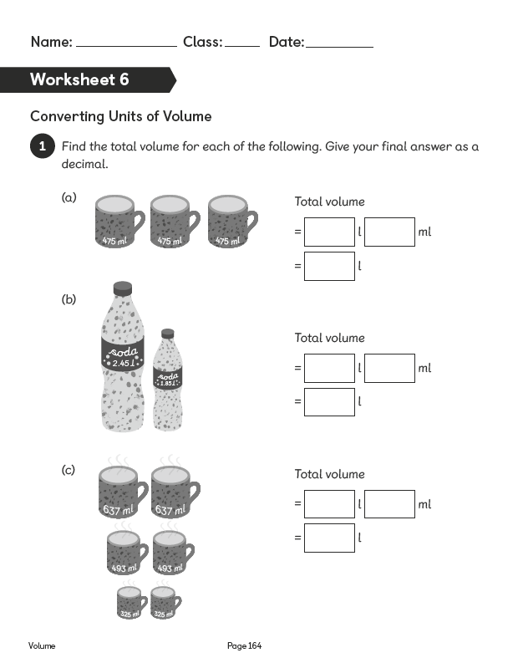
Activity 1 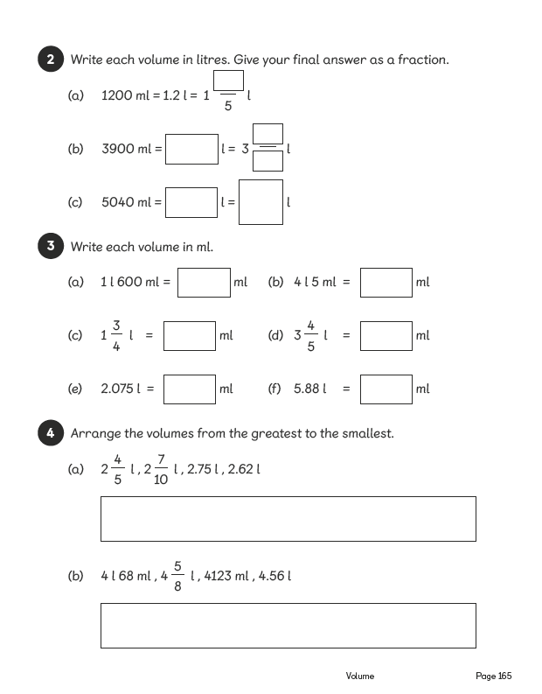

Activity 2 Reading scales accurately

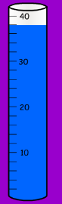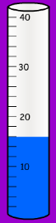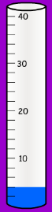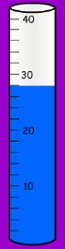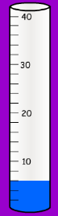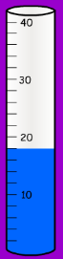
1)____ml 2)____ml 3)___ml 4)____ml 5)____ml 6)____ml 7)____ml 8)____ml 9)____ml 10)___ml

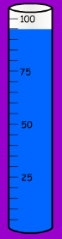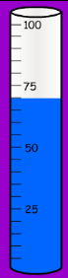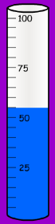
11)___ml 12)___ml 13)___ml 14)___ml 15)___ml 16)___ml 17)___ml 18)___ml 19)___ml 20)___ml

Activity 3 Reading scales accurately
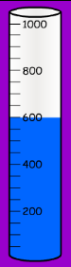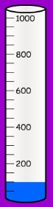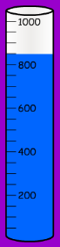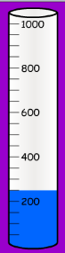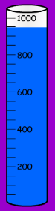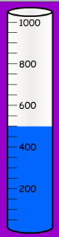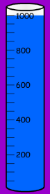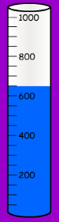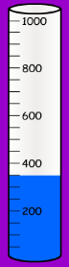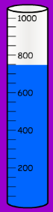
21)___ml 22)___ml 23)___ml 24)___ml 25)___ml 26)___ml 27)___ml 28)___ml 29)___ml 30)___ml

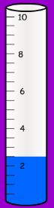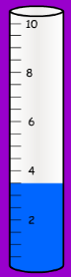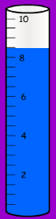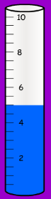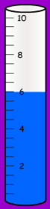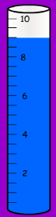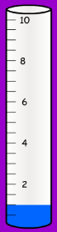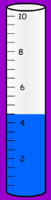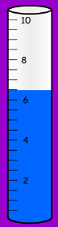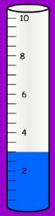
31)___ml 32)___ml 33)___ml 34)___ml 35)___ml 36)___ml 37)___ml 38)___ml 39)___ml 40)___ml

Activity 4 Find the difference between the two cylinders in each question
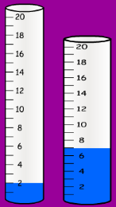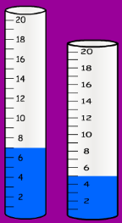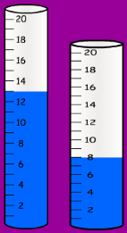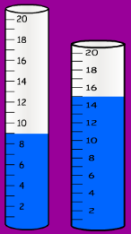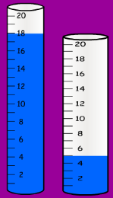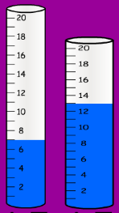
1)Difference =__ml 2)Difference =__ml 3)Difference =__ml 4)Difference =__ml 5) Difference =__ml 6) Difference =__ml

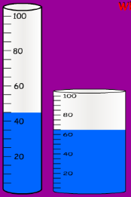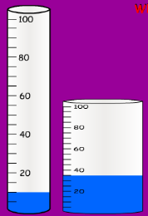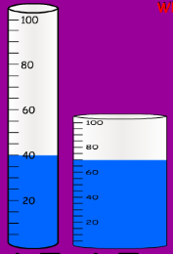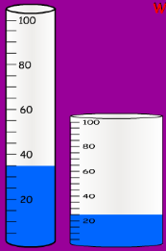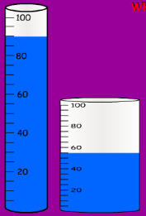
7) Difference =__ml 8) Difference =__ml 9) Difference =__ml 10) Difference =__ml 11) Difference =__ml

Explain the method you used to find the difference?

Activity 5 Find the difference between the two cylinders in each question

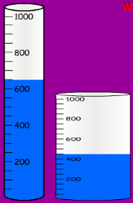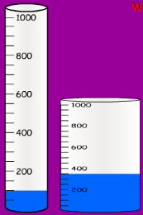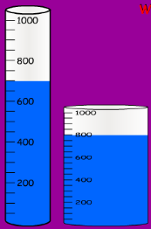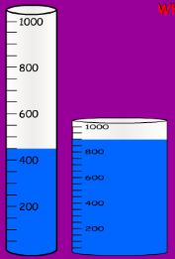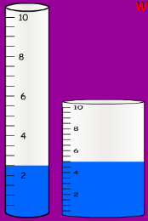
12) Difference =__ml 13) Difference =__ml 14) Difference =__ml 15) Difference =__ml 16) Difference =__ml

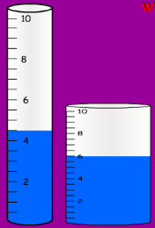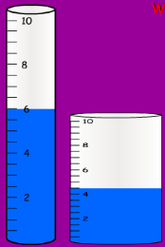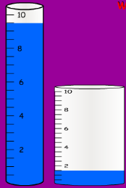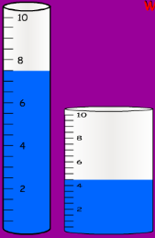
17 Difference =__ml 18) Difference =__ml 19) Difference =__ml 20) Difference =__ml
Explain the method you used to find the difference?

Can you think of another way?

Theme Home Learning
Monday/Tuesday | Wednesday |  | Thursday | Friday
At school, these next couple of weeks are usually enterprise weeks where we are tasked with building/creating something.  This week’s idea is to build something for the Garden. Choose either:  1. a bird feeder: A small table/stand or a hanging bird feeder.  2. a bird bath: To fill with water and birds can either drink or wash in it.  Use the first couple of days to design and collect the items you need to construct something. | Use today to finalise your plan making any changes you need. Also, plan how you are going to approach the construction.  (drawing diagrams will help if anyone is assisting in the project).  Begin construction. |  | Today will mostly be spent constructing the project. If you finish this part, then begin decorating. | Finish the decorating of you creation and ensure it is structurally sound. Strong enough to take the weight of a bird/water depending on what you have built.
Easier:  Do as many of the above activities as you can. If you are finding some of the activities challenging, try these as they are a little easier:  - Your task if the above is too difficult is to follow the same process of Design, Plan, Build, Decorate and Improve.  - But you will be building a model animal of your choice. The bigger the better 😊 |  | Challenge:  If you feel you need a further challenge, try these:  - This task may take longer than one week. This is ok. Take your time and do it properly.  - To challenge yourself try building one with a bird feeder/bird bath combination 2 in 1!

Other Activities
Have a YouTube Karaoke night with the family?  Doesn’t matter if you or your family members can’t sing. It is all about having fun. Just go for it and enjoy it. | Using some of your work or some of the things you have been getting up to, play games such as hangman. | If you have some squared paper, create a word-search for one of you siblings/family members or for a friend. | You could if you can and would like to: Watch the STARWARS saga, Lord of the Rings trilogy or the entire Marvel run through.

Key skills to continue practicing weekly:
- Timestables, Handwriting, Reading of own books, PE/Exercise.
- COLLECT AS MUCH STUFF AS POSSIBLE FOR NEXT WEEKS ENTERPRISE CHALLENGE. Scrap, rubbish craft stuff whatever we normally collect for building and creating things.
- NEXT WEEK IS BUILDING A BUG HOTEL

If you or your child has any further queries regarding their learning projects, please contact admin@hardwick.derby.sch.uk, clearly stating your child’s name and class teacher, and the staff will be in touch to support you and your child.

Thank you and stay safe.
Year 5 staff

