Nursery Home Learning
Week Commencing: 22nd June 2020
Teachers: Mrs Bletcher
TAs: Mrs White
Message from staff: Hello! We hope your reports arrived in the post safely this week. I absolutely loved writing all of them and feel so lucky to have had such wonderful children at Nursery this year. Well done! You have ALL made so much progress since September! We are really pleased that the weather has seemed much sunnier this week and hope that you have all been playing in your gardens at home! All the love in the world, Mrs Bletcher and Mrs White xx
If you have any queries over home learning please don’t hesitate to get in touch via admin@hardwick.derby.sch.uk and we will get back to you quickly!

Your Home Learning this Week:
Every day (Monday to Friday), make sure you choose a *physical, *communication, *reading/phonics, *writing and *maths learning activity. There are also further activities to choose from should you wish to.

Physical Home Learning
Monday | Tuesday | Wednesday |  | Thursday | Friday
Develop your fine motor skills by using a brush to scrub clean your favourite toy. | Develop your fine motor skills by using a soapy sponge to wash clean your favourite doll or toy in a tub of water.  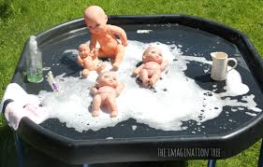 | Develop your fine motor skills by dressing your favourite doll or teddy independently. |  | Develop your fine motor skills by fastening the buttons on your cardigan, or zip on your hoody, by yourself. | Develop your fine motor skills by dressing yourself in the morning and putting your pyjamas on at night.
Easier:  Do as many of the above activities as you can. If you are finding some of the activities challenging, try these as they are a little easier:  - Practise your toileting by not wearing a nappy and using the toilet with a grown-up.  - Explore squeezing a soapy sponge with your hands to squeeze the water out.  - Try taking your socks off by yourself and putting them back on again.  - Try taking your jumper off by yourself. |  |  | Challenge:  If you feel you need a further challenge, try these:  - Try juicing oranges and lemons by squeezing the fruits until the juice comes out.  - Use scissors to cut out a zigzag or spiral.  - Use scissors to cut out a picture that you have drawn.  - Make a sandwich independently for lunch, using a knife to spread filling and cut the bread.

Communication Home Learning
Monday | Tuesday | Wednesday |  | Thursday | Friday
Tell a grown up what you can see on the front cover of our new quality text: Little Red Riding Hood. What do you think the story will be about? Why?  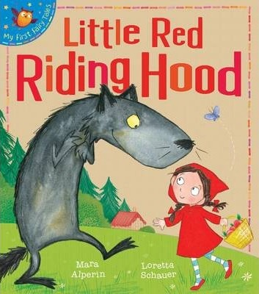 | Tell your grown up what you can see in the picture below. What do you think is happening? Why?  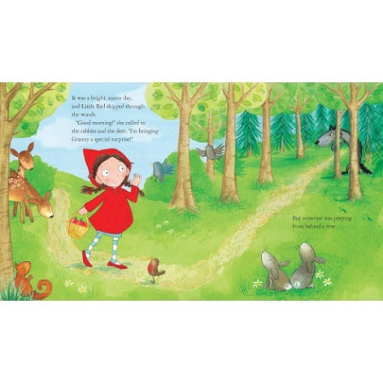 | Tell your grown up what you can see in the picture below. What do you think is happening? Why?  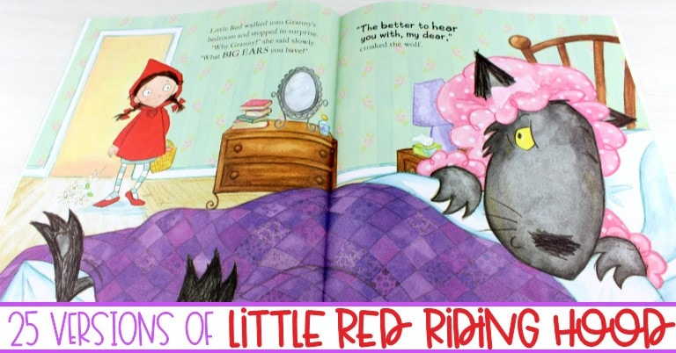 |  | Do you think the wolf is a naughty or nice character in Little Red Riding Hood?  Why do you think this?  Example: The wolf is naughty because he tries to eat Little Red Riding Hood and Grandma. | Would you like to be friends with Little Red Riding Hood? Why?  Example: I would like to be friends with Little Red Riding Hood because she is kind.
Easier:  Do as many of the above activities as you can. If you are finding some of the activities challenging, try these as they are a little easier:  - Can you find a picture of a toy you have at home in the story? Use your words to say what you can see.  - Can you sing ‘Hickory Dickory Dock’ by joining in with all the actions?  - What colour is Little Red Riding Hood’s cloak? Example: It is red. |  |  | Challenge:  If you feel you need a further challenge, try these:  - How does Little Red Riding Hood feel when she is sent to take fresh fruit to Grandma’s house?  - What does the wolf think when he sees Little Red Riding Hood in the woods?

Reading/Phonics Home Learning
Monday | Tuesday | Wednesday |  | Thursday | Friday
Can you think of a word that starts with the sounds:  -S (Examples: Snake)  -A (Example: Apple)  -T (Example: Tiger)  -P (Example: Penny)  -I (Example: Igloo)  -N (Example: Nugget)  See link below to pronounce each phoneme (unit of sound) correctly.  Remember, alliteration is when words start with the same sound. | Practise making the following letter sounds in the mirror. What shape does your mouth make? What does your tongue do?  -S  -A  -T  -P  -I  -N  -C  -M  -R  -B  -F  -L  -K  -SH  -Z | Listening carefully to your grown up, have a go at sounding out the following CVC words we looked at last week:  a-t (at)  s-a-t (sat)  c-a-t (cat)  m-a-t (mat)  r-a-t (rat)  b-a-t (bat)  i-t (it)  s-i-t (sit)  i-p (ip)  t-i-p (tip)  sh-i-p (ship)  a-p (ap)  s-a-p (sap)  m-a-p (map)  a-n (an)  p-a-n (pan)  m-a-n (man) |  | Listening carefully to your grown up, have a go at sounding out the following CVC words:  i-n (in)  p-i-n (pin)  t-i-n (tin)  n-i-n (nin)  s-i-n (sin)  Listen carefully to the words you are blending. Do they rhyme? How do you know? | Listening carefully to your grown up, have a go at sounding out the following CVC words:  b-i-n (bin)  sh-i-n (shin)  k-i-n (kin)  f-i-n (fin)  w-i-n (win)  Listen carefully to the words you are blending. Do they rhyme? How do you know?
Easier:  Do as many of the above activities as you can. If you are finding some of the activities challenging, try these as they are a little easier:  - Explore making sounds with your body (Example: Clapping, stomping, tapping)  - Develop your listening skills by joining in with the actions for ‘Old Macdonald had a farm’  - Fill a bottle with rice or pasta to make a musical shaker. Explore making quiet and loud sounds. |  |  | Challenge:  If you feel you need a further challenge, try these:  - Have a go at matching a sound to its corresponding letter in the alphabet.  - Have a go at writing the letters of any words you have sounded out. (Example: c-a-t to cat)  - Can you find any objects in your home that start with the sounds s, a, t, p, i, n? Can you write their names down, matching sounds to letters correctly?  - Have a go at breaking words down into individual phonemes (Example: Cat to c-a-t). Can your grown up guess what you are trying to say?

Writing Home Learning
Monday | Tuesday | Wednesday |  | Thursday | Friday
Practise writing the first letter in your name. | Draw your own story map on our quality text: Little Red Riding Hood. Below is an example of a previous story map.  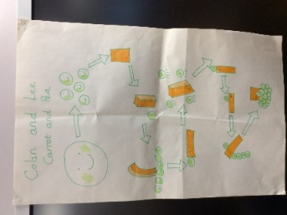 | Practise writing your full name by yourself. Can you write how old you are underneath?  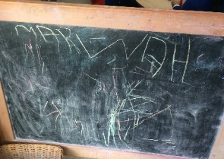 |  | Draw or paint a picture of Little Red Riding Hood. | Draw or paint a picture of the big bad wolf.
Easier:  Do as many of the above activities as you can. If you are finding some of the activities challenging, try these as they are a little easier:  - Explore drawing circles and lines when shown by a familiar adult.  - Explore drawing circles and lines in the air with your finger.  - Explore drawing zigzags, spirals, and crosses in the air with your finger.  - Practise forming zigzags, crosses, spirals and circles when shown by a familiar adult. |  |  | Challenge:  If you feel you need a further challenge, try these:  - Can you identify the initial sound and write the initial grapheme of Red Riding Hood? (R)  - Have a go at retelling the story of Little Red Riding Hood by writing the story down.
Maths Home Learning
Monday | Tuesday | Wednesday |  | Thursday | Friday
Find a teddy in your home.  Can you put teddy on the chair?  Can you put teddy under the chair? | Find a teddy in your home.  Can you put teddy next to the chair?  Can you put teddy behind the chair?  Can you put teddy in front of the chair? | Where is the wolf?  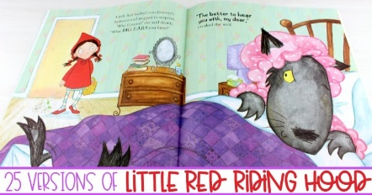  The wolf is in Grandma’s bed. |  | Where is the monkey?  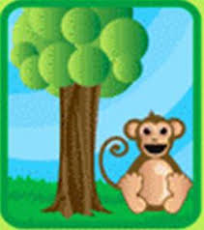  The monkey is next to the tree. | How many?  Remember to count the holes of Numicon!
Easier:  Do as many of the above activities as you can. If you are finding some of the activities challenging, try these as they are a little easier:  - Have a go at representing 0, 1, 2, 3, 4 and 5 on your fingers.  - Sing ‘1 potato, 2 potato, 3 potato, 4, joining in with actions.  - Count 0-10 as rockets.  - Have a go at counting four toys by yourself.  - Have a go at recognising the numerals 0 and 1 by yourself. |  |  | Challenge:  If you feel you need a further challenge, try these:  - Using a teddy from your home, can you instruct a friend at home to put teddy on, under, behind, next to, and in front of a chair?  - Draw a picture of Little Red Riding Hood next to a tall tree.
Other Activities
Sing one of your favourite Nursery Rhymes every day.  Examples include:  -Wind the bobbin up  -Miss Polly had a Dolly  -Two little Dickey birds  -5 little Peas | Ask your grown-up to put on your favourite songs to dance to and join in with. | Draw a picture of what you have done at home every day. | Develop your fine motor skills by helping your grown- up make breakfast, lunch, and dinner. | Think about what your favourite thing to do at Nursery is. Draw a picture of it, tell your grown up, and then email us so we can make sure we do it when we get back!

Key skills to continue practising weekly:
- Children should be practising being independent with their toileting at home.
- Children should be starting to be more independent in dressing/removing clothes themselves. Examples include: Taking their jumper off when hot, putting on shoes on, and starting to do zips and buttons
- Encouraging children to use at least four words in their sentences (Example: ‘I ate toast for breakfast’. This can be supported through modelling.

If you are able to access the internet, try these useful websites:
- Alphablocks: Alphablocks is excellent for blending CVC words!
- Letters and Sounds overview: This is what we follow in Phonics!
- Singing Hands: Singing hands are fantastic at providing Makaton actions for familiar Nursery Rhymes!
- Youtube ‘Little Red Riding Hood by Mara Alperin’ to watch a great animated version of our quality text.

If you or your child has any further queries regarding their learning projects, please contact admin@hardwick.derby.sch.uk, clearly stating your child’s name and class teacher, and the staff will be in touch to support you and your child.

Thank you and stay safe.

