Phonics and Key Words

Key Words

Practise reading these key words: Mixed phases 2,3,and 4
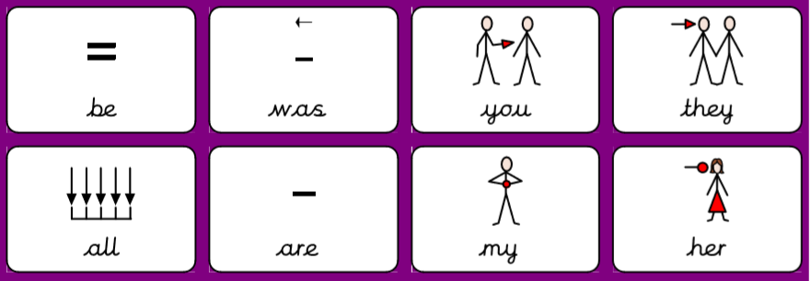
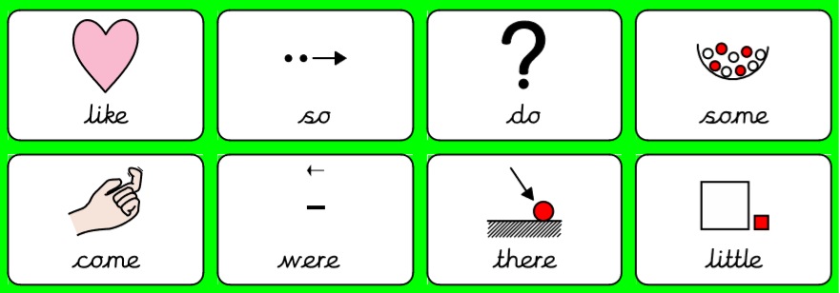
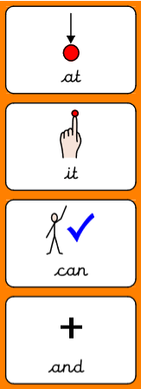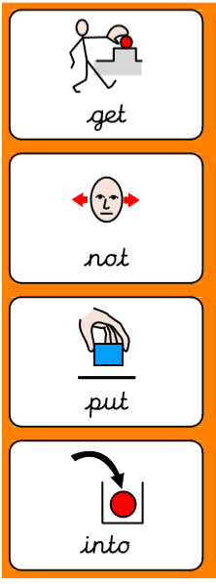

Practise writing these key words. The first two you can look to make sure you are spelling it right. Next, give it a go without looking. Lastly, check is you spelled it right!

Key word | Practise 1  (copy into space) | Practise 2  (copy again) | Practise 3  (fold and hide) | Can spell word  (check and correct)
and
her
like
into
it

Key word | Practise 1  (copy into space) | Practise 2  (copy again) | Practise 3  (fold and hide) | Can spell word  (check and correct)
get
not
put
my
there

Key word | Practise 1  (copy into space) | Practise 2  (copy again) | Practise 3  (fold and hide) | Can spell word  (check and correct)
they
you
can
at
do
there
come

Focus GPCs = ‘ear’ ‘air’ ‘er’

ear | air | er
ear | air | her
fear | fair | herb
hear | hair | perm
dear | pair | verb
near | lair | winter
gear | chair | banner
year | unfair | better
rear | flair | supper
clear | airship | letter
beard | hairbrush | summer

Read the sentences.

I brushed my hair after we had supper.
Winter and summer are in the year.
“Go near to the chair, dear.”
“I got the letter! It is good to hear from you.”

Phonics: phase 3 read and match the caption to the correct picture.
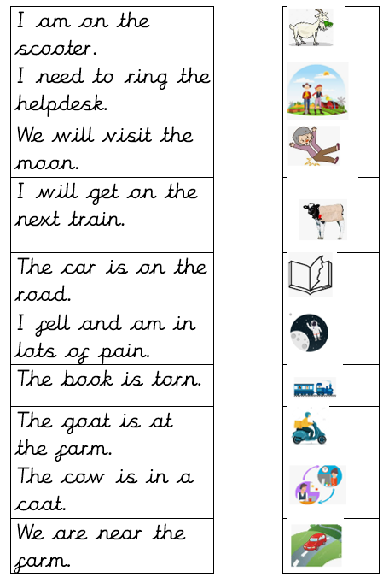
Phonics:phase2 read and circle the correct caption to match the picture.
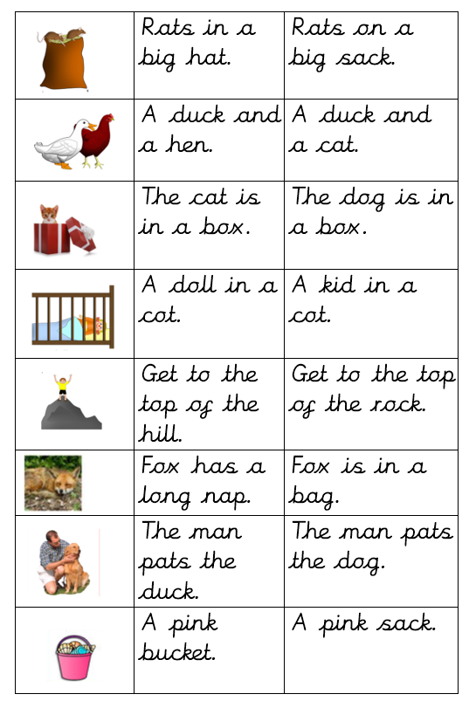
Handwriting:

Keep practising your handwriting – remember to write on the line! You can practise on any paper! If your paper does not have line – draw some!
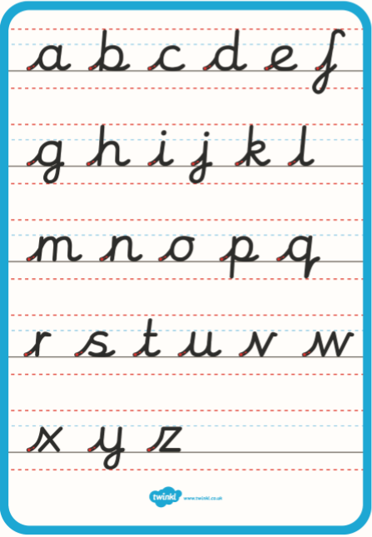

Practise your handwriting with the following words:

swoop
market
coach
snail
roads

Everyday English: Look at the 6 pictures for this story. Try to retell the story in your own words. 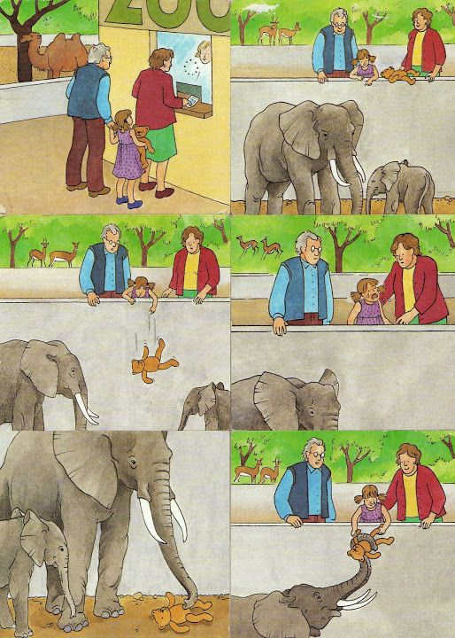
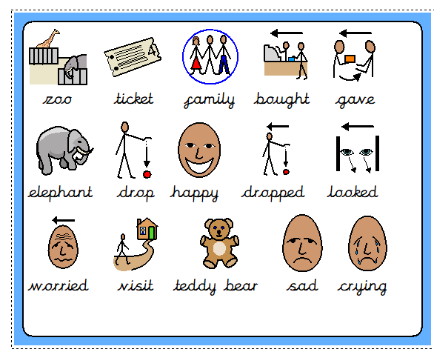
I-spy game!: Play I-spy with someone in your house.
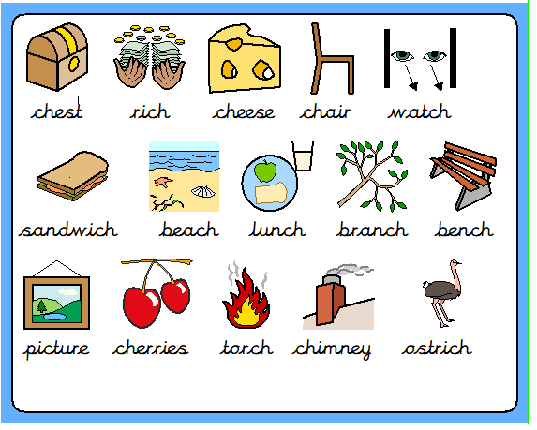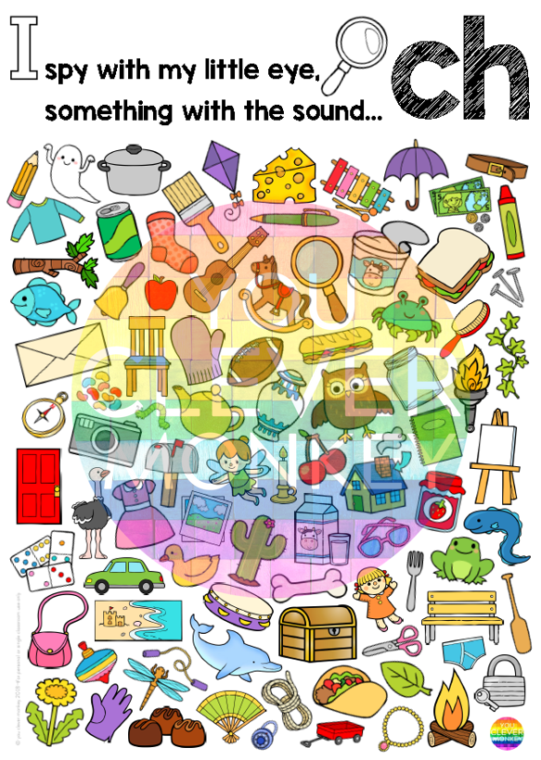

Body parts words labelling. Look at the words and label the picture.

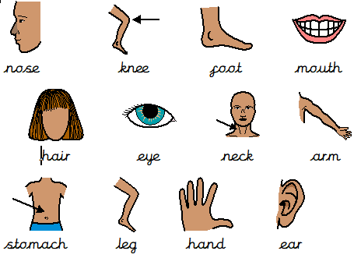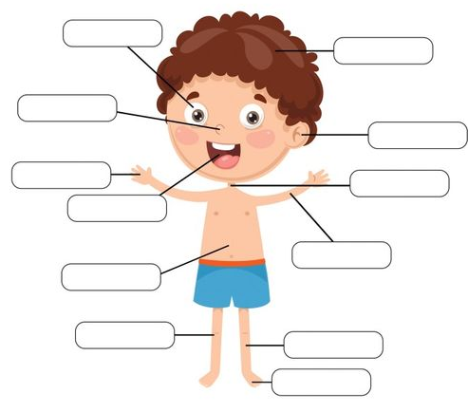

Talk! Discussion of the week!
Look at the following question and discuss it with someone. Tell them WHY!

Would you rather have
a pet puppy, or a pet kitten?
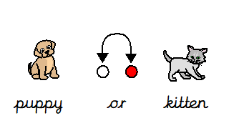

Useful websites:
Have a look at the following websites

- https://www.bbc.co.uk/cbeebies/shows/alphablocks - great phonics videos!
- https://www.bbc.co.uk/cbeebies/shows/numberblocks - great number videos!
- https://www.phonicsplay.co.uk/# - free to sign up!
- https://www.youtube.com/channel/UCP_FbjYUP_UtldV2K_-niWw - start from reception and work your way through!



I hope you enjoy the work and have a great week!

