EAL Home-learning Set 10

Phonics and Key Words

Key Words

Practise reading these key words:

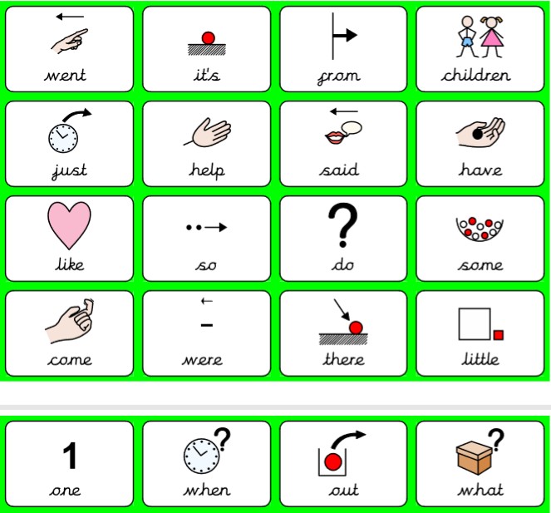

Practise writing as many of these key words as you can. You can use extra paper if you need too!

Key word | Practise 1  (copy into space) | Practise 2  (copy again) | Practise 3  (fold and hide) | Can spell word  (check and correct)
went
It’s
from
children
just
help
there
have
like
one

Try and use some of these keywords to talk about this picture.

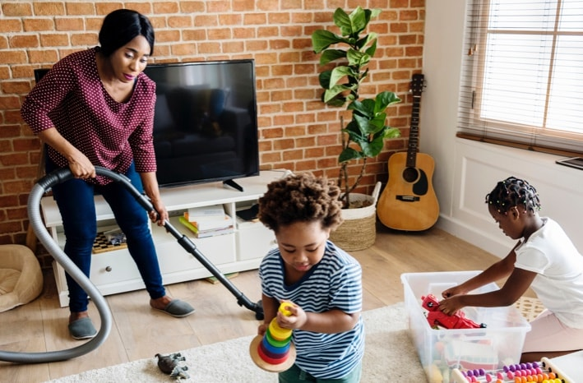

Phonics: Phase 3 review. Match the words to the pictures

fur
hurt
surf
cow
town
towel
coin
poison
tinfoil
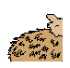


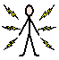


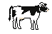
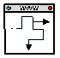


Read and write the following words. First segment the words e.g. cat – c – a – t. Then, try and read the words without segmenting them!

Focus GPCs =
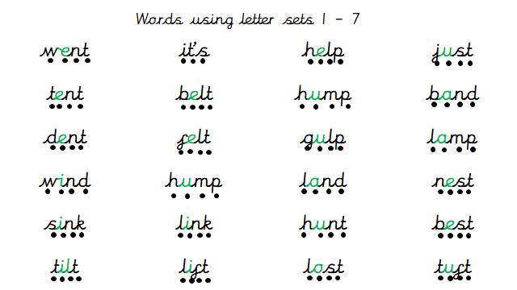

Give it a go reading the following sentences. Remember to try and not segment the key words in RED.

She said she went to camp.
He said they had a tent.
We will get a pond.
She will just be the best.
It cost me too much.

Handwriting:

Keep practising your handwriting – remember to write on the line!
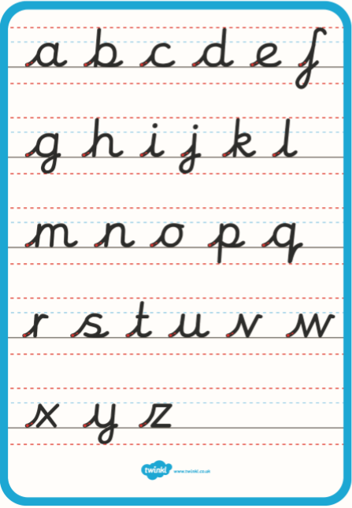

Copy the sentence below. The following sentence contains all the letters of the alphabet!
The quick brown fox jumps over the lazy dog
__________________________________________________________
_______________________________________________________
____________________________________________________
Everyday English:

Look at the following picture. What can you see? What are they doing? What sports do you like? What sports or things have/haven’t you played or done? Talk about it!
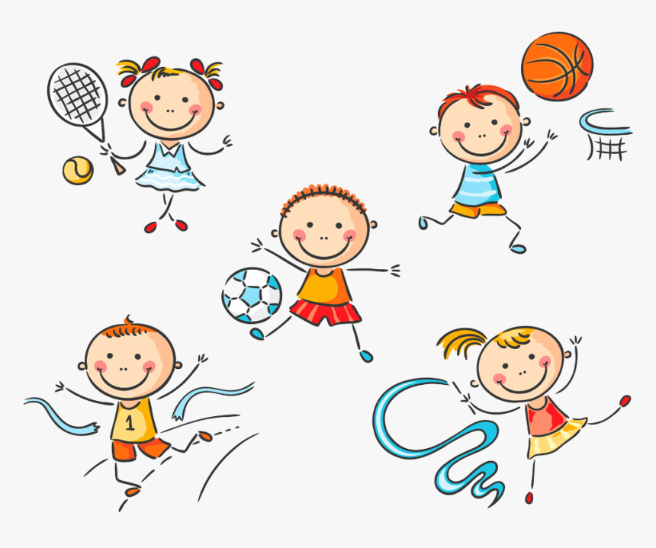

Try and use the following words:

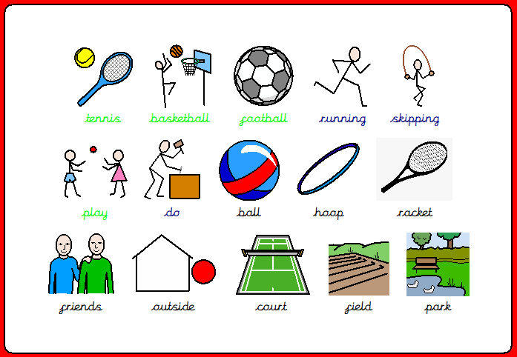

Talk!

Discussion of the week!
Look at the following question and discuss it with someone. Tell them WHY!
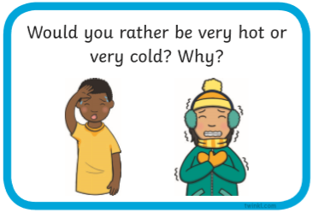

See if you can find some carboard – try and look at your recycling! You might also need a pair of siccors and some glue. Try and make a structure (like a house) with the cardboard. Look at the following two expamples! Try and write some intrsuctions of how you did it using the words First, Then, Next, After, Lastly!









