Year 3 Home Learning
Week Commencing: 22.6.20
Year 3 teachers: Mrs Begg, Mrs Lumsden, Mrs Priestland, Mr Rogers
Year 3 TAs: Miss Batool, Mrs Stringer
Message from staff:
As you may know, Mr Begg and Miss Batool are in school teaching the key-worker children. Mr Rogers and Mrs Priestland will be the ones telephoning you at home and working with Mrs Lumsden to create this home learning. You have all received an email with log-on details for Purple Mash, the school’s online learning platform. Mrs Lumsden will be setting work online so keep checking the ‘2dos’ for a list of activities that have been set.
We hope you are keeping well and staying safe. I know it is a strange time and we are all hoping that we will see each other soon and enjoy learning together again. Mrs Lumsden has put some more amazing activities this week about mindfulness and managing your emotions during this strange time. It is lovely to speak to you over the phone and hearing about what you have been up too.
Remember you do not have to do the easier and the harder. Do the activities to the best of your abilities.
Please take care of yourself and your family and see you soon.

Your Home Learning this Week:
Every day (Monday to Friday), make sure you choose a *reading, *writing, *spelling/handwriting, *maths and *theme learning activity. There are also further activities to choose from should you wish to.

Reading Home Learning
Monday | Tuesday | Wednesday |  | Thursday | Friday
Read the story of ants and the grasshopper.  Underline any words you do not understand. Is your word in the glossary? Read the story again. Then tell the story to someone else in your own words.  (Stan the summariser) | Read the story-  Draw four pictures to tell the story.  Write a sentence to go with each picture.  Remember to pick the VIPs - very important parts. | Read the description of a grasshopper. Try and draw the grasshopper in as much detail as possible using the information you have read.  (Vernon the visualiser) |  | Underline the words the ants and the grasshopper said. Speech marks go around the actual words a character says.  Change these into drawings with speech bubbles. | Draw a picture to go with each word in the glossary that helps explain its meaning.
Easier:  Do as many of the above activities as you can. If you are finding some of the activities challenging, try these as they are a little easier:  Ask someone at home to read the story to you  - If you have access to Youtube- search “silly symphonies, ants and grasshopper” to watch a version of this story.  - Act out the story using home-made puppets made of paper.  - What was wrong with the grasshopper? Why?  - Why didn’t the ants help him? |  |  | Challenge:  If you feel you need a further challenge, try these:  Why were the ants to mean to the grasshopper? Do you agree with them? Why?  Write sentences to explain why to agree or disagree. Try and give as many reasons as you can. Can you think of examples from your own life to ‘back up’ your opinion to show that they were right or wrong to do what they did?
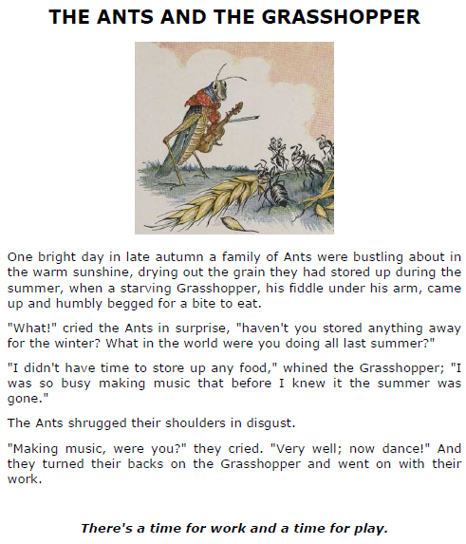
Description of a grasshopper.
Grasshoppers are insects so they have 6 legs. They are often coloured in a way that camouflages them in their local habitat, green ones in grassy fields. They have two long antennae that grow from the grasshoppers head. Grasshoppers have five eyes so they can see the front, side and even the back at the same time. Grasshoppers have two pairs of wings, one narrow and tough, the other wide and flexible, and long hind legs for jumping. They have strong mouth parts that tear at leaves and grasses.

Glossary
Begged- ask for something
Bustling- very busy
Camouflage- a disguise to hide or ‘blend in’ with what is near.
Disgust- a strong dislike
Fiddle- violin-like instrument
Flexible- bends easily without breaking.
Grain- seeds that are food. (like wheat)
Habitat- a place where something lives
Hind- behind or back
Shrugged- lift the shoulders
Starving- very hungry
Tough- strong
Whined- a moaning, complaining voice

Writing Home Learning
Monday | Tuesday | Wednesday |  | Thursday | Friday
Ants and grasshoppers are mini beasts. Can you write some clues to read to someone else to describe another mini-beast? Can they guess what you are writing about? (ideas- ladybird, snail, spider, woodlouse, millipede) | Pretend the ants asked questions for the grasshopper to answer. Write down what they might ask.  Now, pretend to be the grass hopper and write the answers to the questions giving as much detail as possible in your excuses! | The word ‘ant’ starts with a vowel, so you write ‘an’  not a.  Write some sentences about other things that start with vowels. Umbrella, eagle, owl, elephant, ox, ugly fish, angry witch, excited boy, interesting box, obnoxious dog |  | Write an acrostic poem about a mini-beast like this one about a ladybird.  L ovely  A ntenna  D ozing on grass  Y es it flies  B rilliant colours  I love them  R ed and spotty  D elightful | This story is very short and simple.  Can you write it out and improve it by adding in extra details? Use speech marks to write talking. Use adjectives to describe the characters and setting. Use adverbs to describe the action. Swap the verbs for more exciting word choices.
Easier:  Do as many of the above activities as you can. If you are finding some of the activities challenging, try these as they are a little easier:  - Draw a picture of an ant and a grass hopper, then label their body parts. Remember the line must touch the part of the picture you are naming.  - Write sentences about ants, grasshoppers and any other mini beasts to describe what they look like. Make sure you choose good adjectives to help describe them.  - Write about your favourite mini-beast and why it is your favourite. |  |  | Challenge:  If you feel you need a further challenge, try these:  - Imagine you are an ant, write down what kinds of things you have to do all day to get your food. Who is in your ant team? How far do you have to walk? How long to you work each day? What kinds of food do you collect? Does everyone work hard?  - Rewrite this story, but put it into a forest setting. What animals could be the hard workers? Which animal is the lazy one?
Spelling/Handwriting Home Learning
Monday | Tuesday | Wednesday | Thursday |  | Friday
‘ei’ ‘eigh’ ‘ey’ can all sound like a long /a/  Vein veil reign foreign weigh weight sleigh freight neighbour grey prey they obey survey  How many of these can you write in 1 minute? | Put the words from yesterday into sentences to show their meanings. | Draw pictures to help you remember the meaning of these homophones.  Bear bare  Whole hole  Flour flower  Wood would  Few phew  Allowed aloud  Flaw floor | Put the homophones from yesterday into sentences to show their meanings. |  | Do the proof reading sheet. There are spelling mistakes. Grammar mistakes and be sure to look out for missing punctuation!
Easier:  Do as many of the above activities as you can. If you are finding some of the activities challenging, try these as they are a little easier:  - Synonyms are words that mean the same, for example large and big. Write a list of words that mean ‘small’ ‘ugly’ ‘big’ and ‘said’ use your best handwriting!  - When there is a short vowel sound before a /k/ use ‘ck’ (neck sock chick luck sack, slick, crack pick clock)  - when it is a long vowel sound use just ‘k’ (soak, beak seek, break, week, creak, leek, cheek, cloak) or it might be a split diagraph vowel with just a ‘k’ (stoke spike rake trike) |  |  |  | Challenge:  If you feel you need a further challenge, try these:(Worksheet with parrot on)  Try to sort these noun words by type.  Abstract noun- an idea or personal quality (anger, love, freedom)  Collective noun – name of a group, (school of fish)  Proper noun- a name with a capital letter.  Concrete noun- an object that can be touched (car book TV)  Gerunds- a verb that is acting like a noun (“dancing is what I like to do” ‘dancing’ is a gerund as it is the name of the thing you like doing.
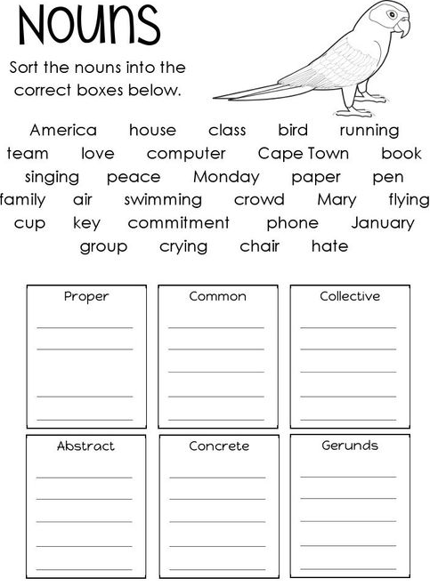
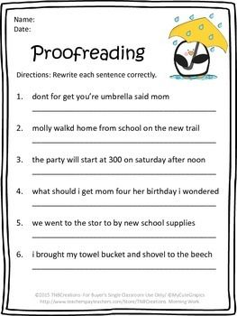

Maths Home Learning
Monday | Tuesday | Wednesday |  | Thursday | Friday
Complete the “explain” about the jug, bottles and cups.  Can you make up your own similar question to challenge someone at home? Check they got it right! | 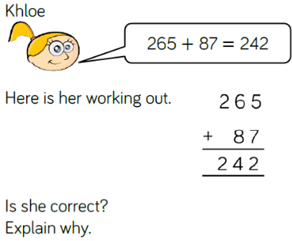  Write a guide to explain what to do when doing column addition. | Complete the question below about Sally and the function machine. Practise subtracting from three digit numbers.  548- 37=  274 – 130=  497-39=  604 – 70 =  205- 199 = |  | Do the ‘How many ways?” question below. What level can you get to? | Make a board game with maths questions on. Roll the dice then you need to solve the question to stay in that place. Play it with someone at home. Make it as hard or easy as you like.
Easier:  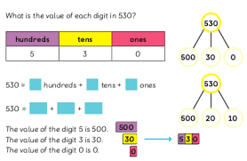  Do as many of the above activities as you can. If you are finding some of the activities challenging, try these as they are a little easier:  - Practise finding 1, 10 and 100 more and fewer than any 3 digit numbers.  - How the value of 3 digit numbers in many ways. |  |  | Challenge:  If you feel you need a further challenge, try these:  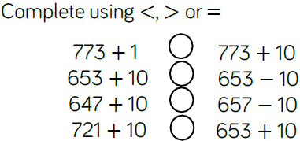  Compare each side…do you always have to calculate?
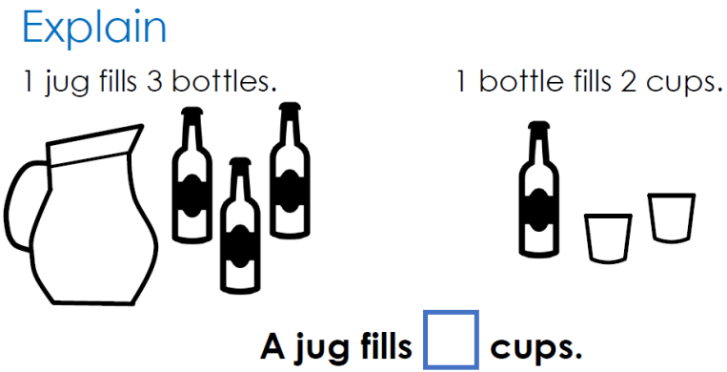
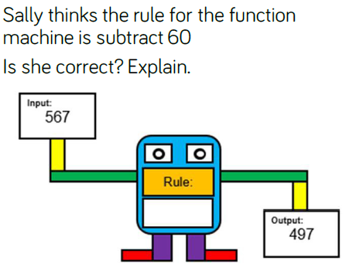
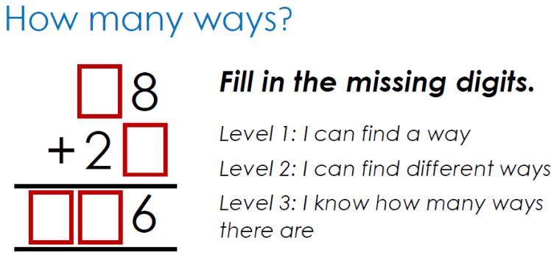

Theme Home Learning –
Monday | Tuesday | Wednesday | Thursday | Friday
Art: observational drawing.  Go outside and draw something from nature. It can be a plant, leaves, an insect, what ever you can find.  Try using to make areas darker by pressing harder with a pencil, and lighter by pressing gently.  Make sure you add lots of details.  Remember- Drawing is 95% looking closely, 5% drawing. | Philosophy :Would you rather:  - Go to the moon  - Go to the jungle  - Go to the Artic  Write and draw which one you would choose and why. Remember to give reasons for and against to explain.  Ask a member of your family the same question…..do they agree? Can you change their mind? Or perhaps, after listening to their ideas, you might change your mind! | Oracy:  Have a go at the page of tongue twisters.  Tongue twisters are phrases which are difficult to say without making mistakes. They are even harder if you try to say them quickly! (or if you are tired!)  Start with the easy ones, then see if you can work your way thought to the hardest ones at the bottom!  Good luck! | Philosophy :The BIG question.  “Do we, (as clever humans) have a responsibility to look after all animals?”  Some thought to consider….  - What about unwanted animals like fleas or spiders?  - Is it ok to keep animals in zoos?  - What about farms?  - Should everyone become a vegan?  Talk with someone at home and think of reasons for and against for this question. | Oracy: Talking is extremely important to practise. The better you can express yourself the better the changes of getting a good job when you are older!  Play the “Why?” game with an adult.  Can you give clear, ordered, thoughtful sentences to explain the answers to the questions?
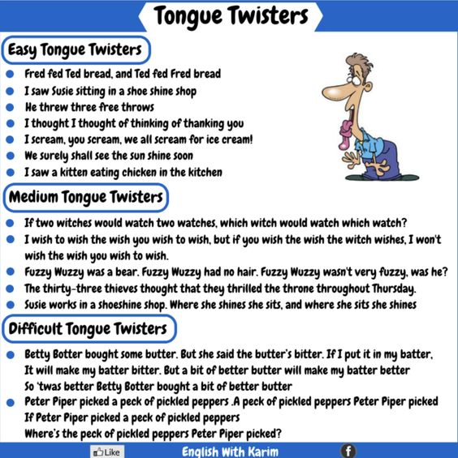

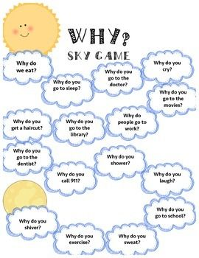

Other Activities This week we will look more closely at emotions.
Complete the sheet that teaches you all about 2 more types of automatic negative thoughts, how many examples can you think of?  Remember to do some mindful breathing at home. | Investigate what you think about emotions.  Can you sort them into the ‘correct’ and ‘incorrect’ sides?  Remember to do some mindful breathing at home. | Read and learn about emotions. Does anything surprise you in what you have learnt? Why?  Now draw pictures that describe how it feels to feel some of these unpleasant emotions. | See if you can find the ‘good’ in these unpleasant emotions.  Can you find a situation when it would actually be good to feel these emotions to ‘push’ you towards a positive action? | Learn how to deal with unpleasant emotions and why regular practise is needed.  Remember to do some mindful breathing at home.

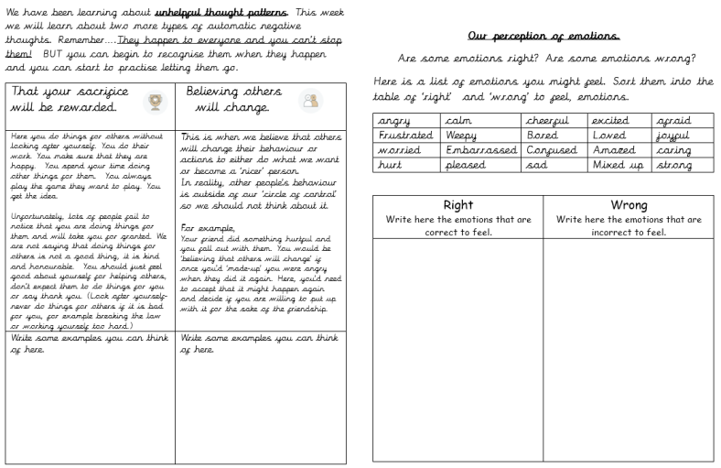

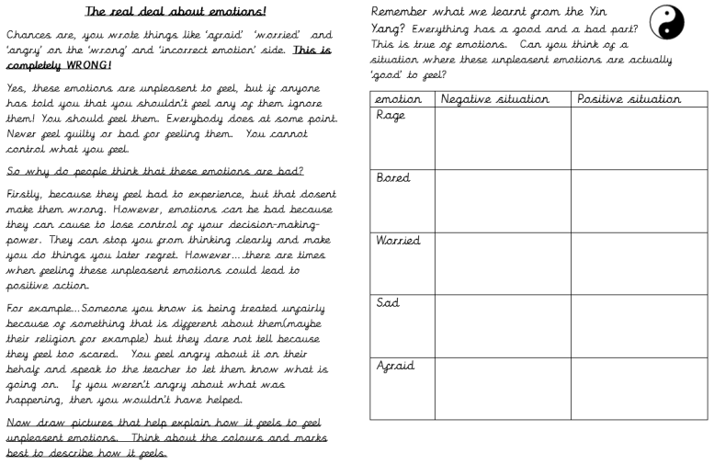

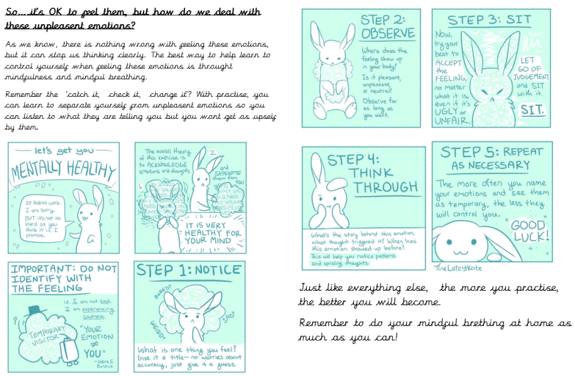

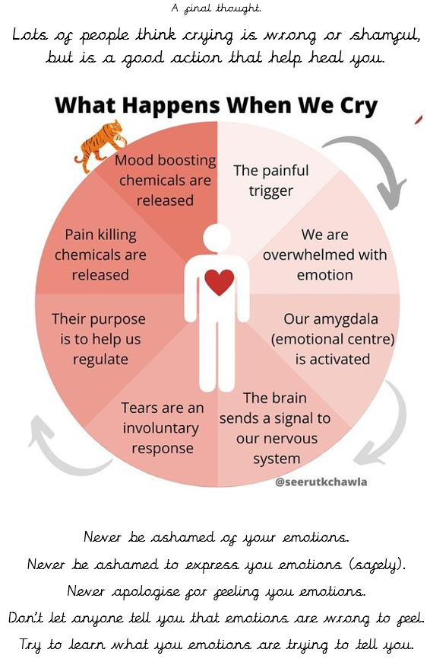

Key skills to continue practising weekly:
- 2, 3, 4, 5, 8, 10 times tables
- Quick addition and number facts 9+7 11 - 5
- Year One, two and three spelling sheets
- Reading any books, newspapers, cereal packets, websites you can find

If you are able to access the internet, try these useful websites:
- BBCbitesize/daily lessons
- https://www.youtube.com/user/CosmicKidsYoga- Cosmic Yoga is amazing. There are lots of yoga stories, mindfulness activities and active exercises for you to do.
- https://scratch.mit.edu/- we would be doing this if we were at school. Have an explore of Scratch and learn how to code. Make the cat move, speak and even dance. Create new characters, change the background and have some fun.

If you or your child has any further queries regarding their learning projects, please contact admin@hardwick.derby.sch.uk, clearly stating your child’s name and class teacher, and the staff will be in touch to support you and your child.

Thank you and stay safe.

