Year 3 Home Learning
Week Commencing: 1st June 2020
Year 3 teachers: Mrs Begg, Mrs Lumsden, Mrs Priestland, Mr Rogers
Year 3 TAs: Miss Batool, Mrs Stringer
Message from staff: Hello Year 3!
I hope you are well and keeping safe. It has been fantastic hearing from you all on the phone. We are especially pleased with the amount of effort you have been putting into doing your home learning.
As you have just had a week off from home learning because it was half term, the next time you speak to your teacher on the phone, we would love to hear about any exciting things you have been getting up to. Mr Rogers has been reading the new David Walliams book, SLIME! We would love to hear about any new books you have read recently.
A friendly reminder
As you will all now be aware, school is open to a small selection of students from certain year groups. This does NOT include our year group yet so please do not bring year 3 students into school until you are told otherwise. Furthermore, lockdown rules are beginning to change and we are now allowed out of our house a little bit more. Even though this is the case, it is still extremely important that we follow the social distancing rules. Remember to keep 2 metres away from anyone outside of your household at all times. It has also been noticed that children have been playing outside on the equipment in play areas in parks. Although it is great that children are getting outside for fresh air and exercise, please do not use the equipment as this is a dangerous way to spread the virus

Your Home Learning this Week:
Every day (Monday to Friday), make sure you choose a *reading, *writing, *spelling/handwriting, *maths and *theme learning activity. There are also further activities to choose from should you wish to.
Reading Home Learning
Monday | Tuesday | Wednesday |  | Thursday | Friday
Read the story or Arachne (Arracknee is how you say it)  Draw a line under the words you do not understand. Can you work out what they mean? Write out the new words from the bottom of the story and draw a picture to help you remember what they mean. | Answer the questions in sentences.  Who was Arachne?  What did she make?  Who was Athena?  Why was Athena cross with Arachne?  Why did they have a competition?  Who judged the competition?  Why was Arachne turned into a spider? | Using VIPS – Very Important Parts - tell the story of Arachne the weaver. You can use 5 pictures or 5 sentences (in your own words). |  | Have you ever boasted about anything? Do you know someone who has boasted? What did they boast about?  How does boasting make other people feel? Why do people boast?  Do you think Arachne go what she deserved? Why? | Pick out three interesting words or phrases the author used in the story. Why did she use those words? What effect did they have on the reader?
Easier:  Do as many of the above activities as you can. If you are finding some of the activities challenging, try these as they are a little easier:  - Ask an adult or big brother or sister to read the story to you  - You can also find this story on Youtube |  |  | Challenge:  If you feel you need a further challenge, try these:  - Change the ending to the story  - Act out the story with brother or sister

The story of Arachne, the weaver.
A long, long time ago, there lived a girl called Arachne. She had long black hair and light pale skin. She loved to spend her whole day spinning yarn under a tree, At night, she would weave yarn into different creations. Her work was so soft, bright and colourful that people would come from miles around to see it.
With all the praise and attention she was getting, Arachne began to boast.
“I am the best weaver the world has ever seen. Why, even Athena, the goddess of craft and wisdom cannot weave as well as I can!”
As she spoke, a beautiful woman appeared before her. It was Athena, herself! Athena was furious with Arachne and challenged her to a weaving competition. Arachne was certain that she would win. She agreed that if she lost she would never weave again.
On the day of the competition, Arachne wove a beautiful cloak. It was as soft as a cloud and as colourful as a rainbow. The crowds gasped at the beauty of her creation.
Next, it was Athena’s turn. She took gold from the sunlight, strands of blue from the bright sky and all the colours from the flowers that grew on the hillside. She created a picture of the world, which was so incredible that Zeus, the king of the gods, declared her the winner.
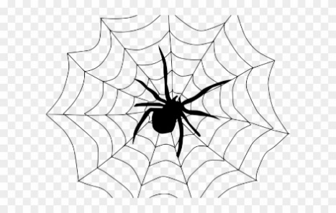
Arachne was broken hearted. How could she bear to live without her weaving? Athena felt sorry for her but she still needed to be taught a lesson. So, Athena turned her into a little black creature with many arms. This creature could spin all day long. Athena had created the first ever spider and to this day you can see the children of Arachne spinning webs all over the world!
New words – weaver – someone who makes fabric from thread
spinning – twisting to make silk, cotton, wool
yarn – thread or wool strands – little pieces
boast – show off create - make
craft – making things cloak – a coat without sleeves

Writing Home Learning
Monday | Tuesday | Wednesday |  | Thursday | Friday
Arachne was turned into a spider. Write six facts that you know about spiders.  Don’t forget capital letters, full stops and simple spelling. | Many people are scared of spiders. Why do you think that is? Write three reasons.  Sentences starters-  People are scared of spiders because….. | Use the text and your imagination to draw the wonderful scene that Athena created. Put in plenty of detail.  Use expanded noun phrases to describe your picture.  Eg She created a huge, golden sun. She wove dark, green, forests. |  | Describe the characters’ feelings in the story. Explain why they felt as they did.  Eg When Arachne did her weaving she felt --- because ----  When Athena heard her boasting she felt ----- because  Now write your own | Using possessive apostrophe  Arachne’s cloak was soft and colourful.  Write sentences explaining what people in your house are wearing.  My mum’s shoes are green. Abdul’s trousers are long.  Use the apostrophe
Easier:  Do as many of the above activities as you can. If you are finding some of the activities challenging, try these as they are a little easier:  - Write a list of things you are scared of. |  |  | Challenge:  If you feel you need a further challenge, try these:  - Imagine your brother or sister is scared of spiders explain to them why they should not be scared. Try to bring out the interesting facts about spiders.

Spelling/Handwriting Home Learning
Monday | Tuesday | Wednesday |  | Thursday | Friday
Adding suffix s to a word  When the word ends with a hissy sound like x, ch, sh, ss, z we had es rather than s  box – boxes  quiz – quizzes  Now try these words  wish, dish, fox, rich glass, miss, pass, church, watch, witch | When we add s to a word ending with consonant + y the y turns into an i and add es  fairy – fairies  story – stories  Now try these:  jelly, baby, cherry, lady, lorry, lolly, berry, dolly, pony | When we add s to a word ending in a vowel + y we just add s  key – keys  obey – obeys  Now try these:  monkey chimney, relay, tray, stay, play, pray, boy, toy |  | Add suffix s to these words using what you have learnt this week:  dish lady lorry tray toy watch match bed key pony  Put the words into sentences. | Some plurals do not end in s  Eg man – men  goose - geese  Write the plural for these words  woman  child  foot  tooth  sheep  mouse  deer
Easier:  Do as many of the above activities as you can. If you are finding some of the activities challenging, try these as they are a little easier:  - Add s to turn on into many  - One hen lots of hens One dog lots of dogs  - Follow the pattern boy, girl, table, cat, dog, ship |  |  | Challenge:  If you feel you need a further challenge, try these:  - We use suffix s for plurals but also as a verb ending eg I fight but she fights  - We agree but he disagrees.  - Do the same rules apply for adding s. Prove it by writing some resent tense verb for he and she.

Maths Home Learning
Monday | Tuesday | Wednesday |  | Thursday | Friday
Use the rhyme below to learn how many days in each month.  Which months have 31 days? Which months have 30 days? Why is February different? | Practise telling the time. You should be able to do minutes past and minutes to the hour, quarter past and quarter to. | Write a timetable of your day.  Make sure you write times of meals, getting up, bed time, school work, daily exercise. Eg  Half past 7 – Get up  10 to 8 – Breakfast  During Ramadan lots of your times will be different to normal. |  | How many seconds in a minute?  How many minutes in an hour?  How many minutes in a day?  How many days in a week?  How many wees in a month?  How many months in a year?  Learn these facts | Make sure you learn these time facts.  Keep telling the time throughout the day.  Write down the birthday date for everyone in your family.
Easier:  Do as many of the above activities as you can. If you are finding some of the activities challenging, try these as they are a little easier:  - Practise spelling the days of the week and months of the year  - Learn how to tell the time – o’clock, half past, quarter past and quarter to. |  |  | Challenge:  If you feel you need a further challenge, try these:  During Lockdown  - How long do you spend doing school work?  - How many hours do you sleep per night?  - How long does it take to have a shower?  - How long do you watch TV?  - How long does your daily exercise take?  - How long does it take to eat your meal?
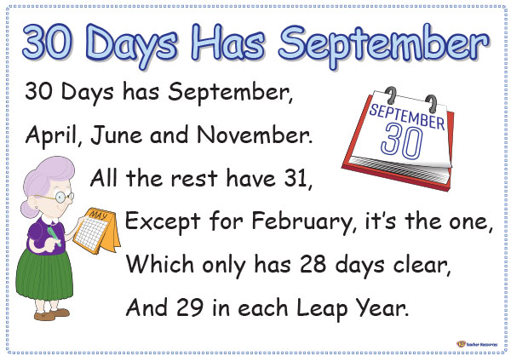
There are 365 days in a year.
There are 366 days in a Leap Year.
A Leap year happens every four years.

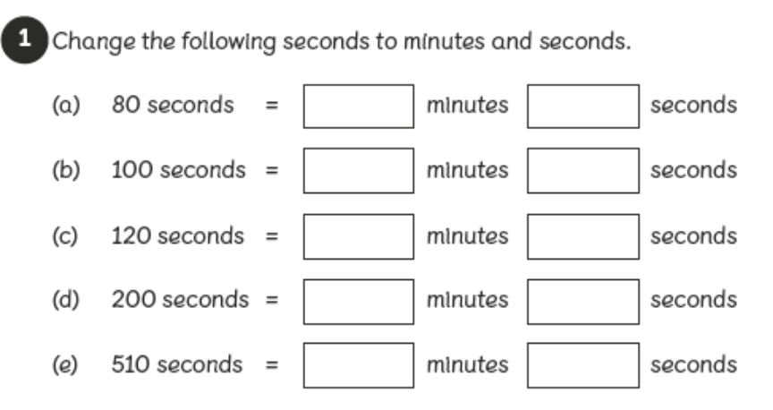
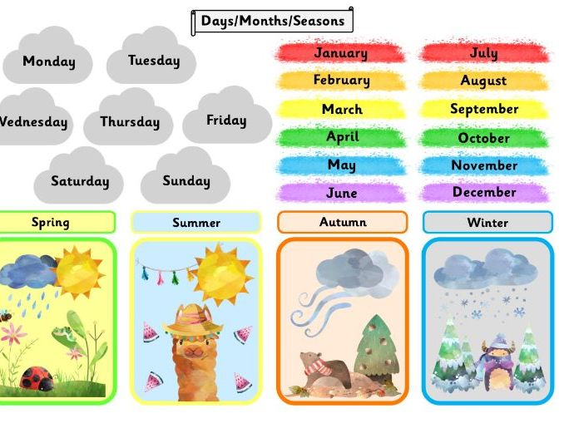

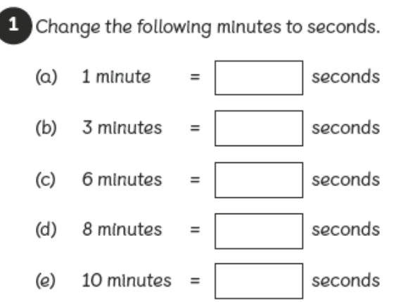

Theme Home Learning
Monday | Tuesday | Wednesday | Thursday | Friday
Read about Greek Temples. Think of four reasons why Greek people might go to the temple to ask the Gods for help.  Do you ever ask God/Allah for help? | Can you design a temple to one of the Gods.  Zeus – god of sky  Ares – god of war  Poseidon-god of sea  Hera – goddess of families Demeter – goddess of farming  Athena – goddess of wisdom and craft  Don’t forget to include a statue of your God. | Read – What happened to dead Greeks.  Why were Greeks buried with a coin? Draw a picture of the River Styx and the entrance to the Underworld. Don’t forget to draw Charon and the three headed guard dog. | Think of three deeds that might get you into the Elysian Fields. Think of three bad deeds which mean you would spend eternity in Tartarus. | To keep our bodies healthy we should get plenty of sleep. Seven year olds need about ten hours of sleep every night. When we are asleep our body repairs itself, our bodies grow, our brains sort out problems and store our memories. Make a poster explaining why we need a good night’s rest.

What were Greek temples like?
The Greeks built temples to their gods and goddesses. Some temples were small, while others were very grand and beautiful with amazing decorations.
Every city in Greece had a 'patron' god or goddess. People believed patron gods protected them from harm.
When people needed help from the gods, they went to the temple to pray. They might go if they were feeling sick, going on a journey or worried about the harvest on the farm.
To please the gods, people brought gifts of money, flowers, food and drink. They offered these gifts as sacrifices. Animals, like cattle, were sometimes killed as sacrifices. Then people feasted on the roasted meat.

What happened to dead Greeks?
The Greeks believed that the dead went to the Underworld. This was an underground kingdom ruled by the god Hades.
To reach the Underworld, dead souls had to cross the River Styx. A grumpy ferryman called Charon would take them across, but only if they paid him. So Greeks would place a coin in the mouth of a dead person at funerals, to make sure they could pay the fare.
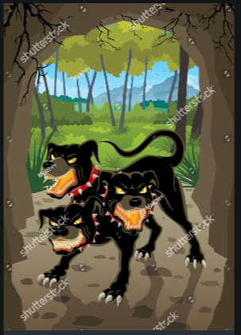
After crossing the River Styx, three judges decided where the dead person should spend eternity. If they’d been really good, they were sent to live happily forever in the Elysian Fields. If they had been ok, they were sent to the Asphodel Meadows. But if they had been really bad, they ended up in Tartarus. This was a really horrible pit where their soul was tortured for all eternity.

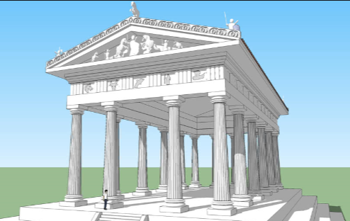
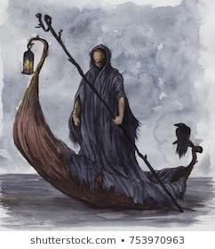

Other Activities This week we will investigate two types of automatic negative thoughts you might have.
Complete the sheet that teaches you all about 2 types of automatic negative thoughts, how many examples can you think of?  Remember to do some mindful breathing at home. | Complete “catch it, check it, change it”  Remember that all automatic negative thoughts are OK, but they can be examined to see if they are correct or not. If they are not correct, change it, then let the original thought ‘go.’ | Complete the “catch, check, change practise”  It doesn’t have to be about coming back to school. If you want it could be your first time going shopping or visiting family you haven’t seen for a long time. | Complete the “circle of control” to help you remember that some things are out of your control.  If you have a worry and it is out of your control- why worry?  If you have a worry that you are able to have control over- Why worry? You can take steps to change what is worrying you! | Write or draw your fortune-telling automatic thoughts.  As an added bonus this week: a just for fun house scavenger hunt!

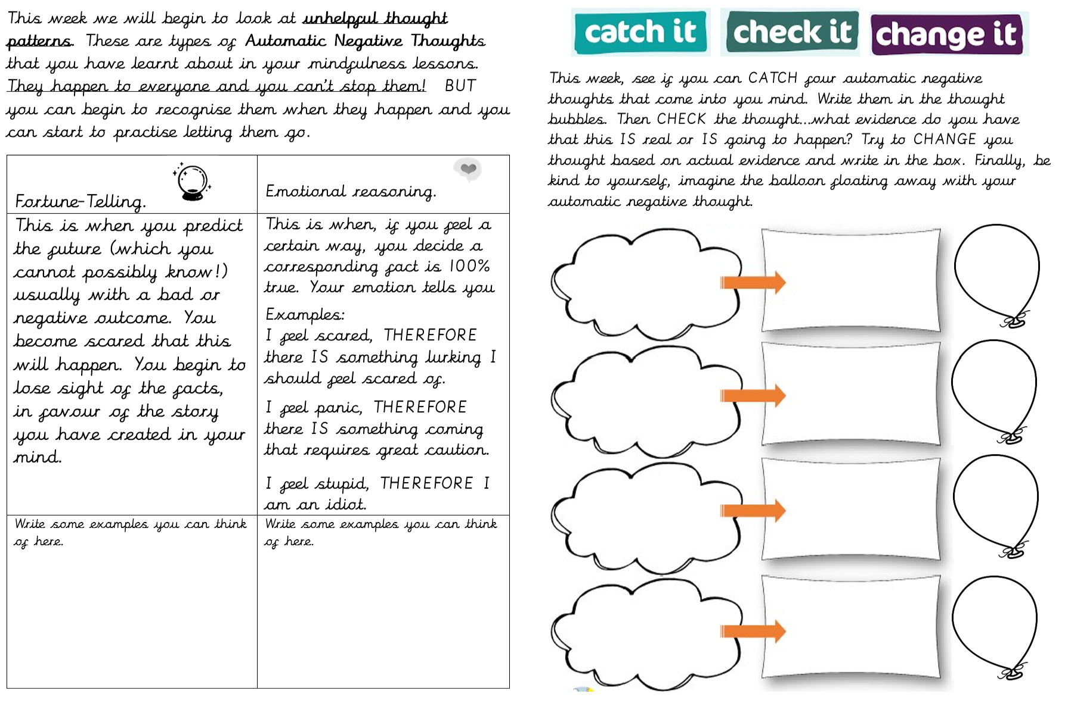

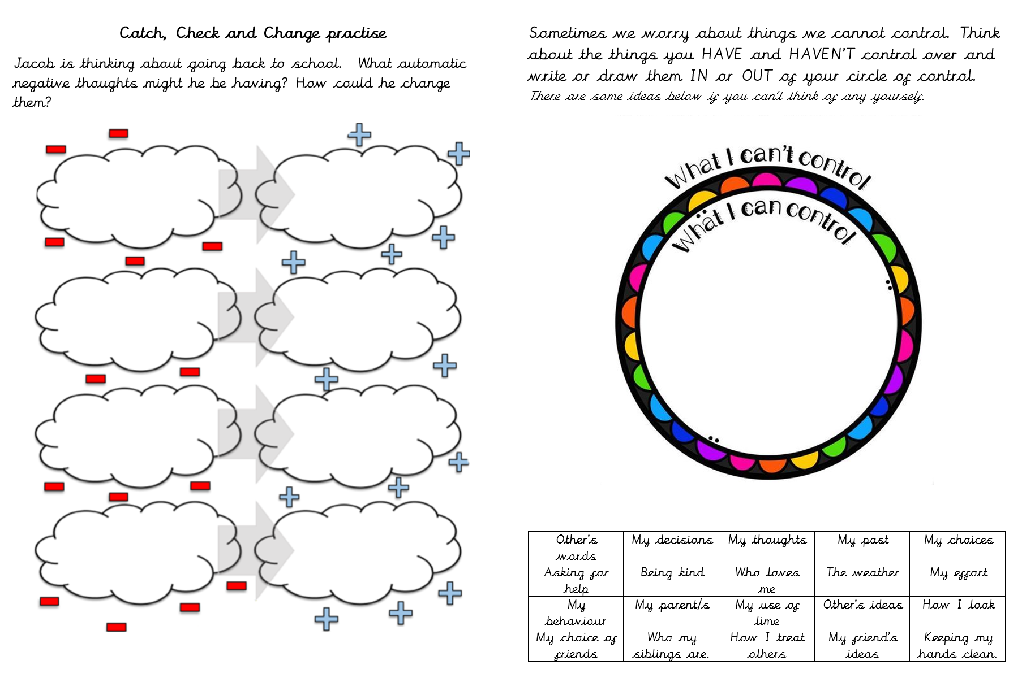

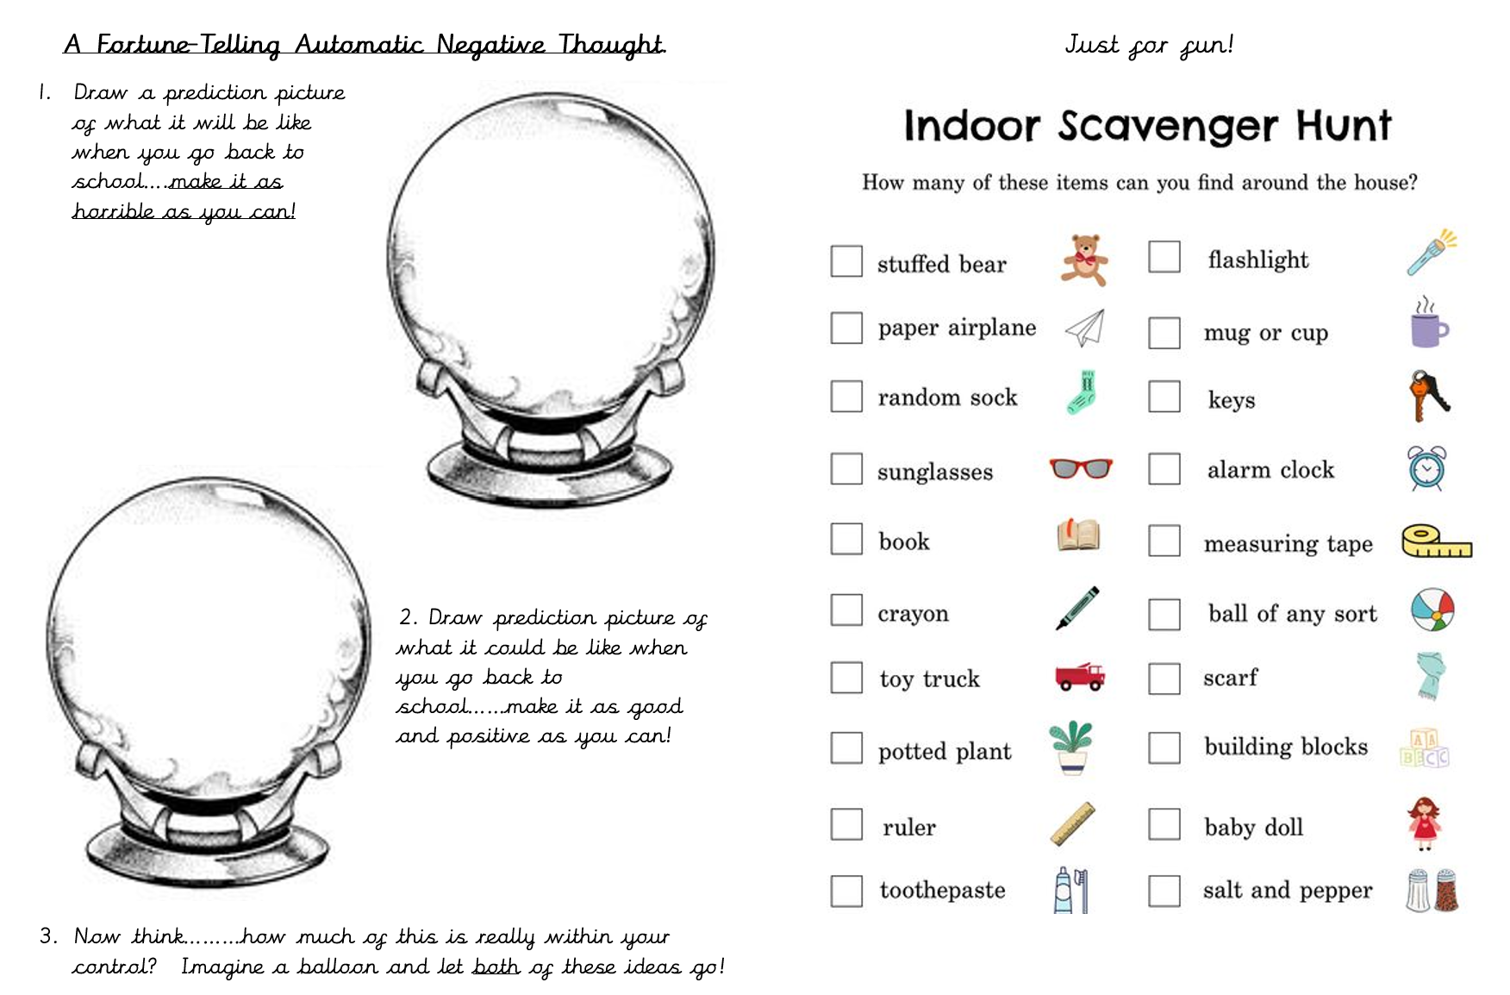

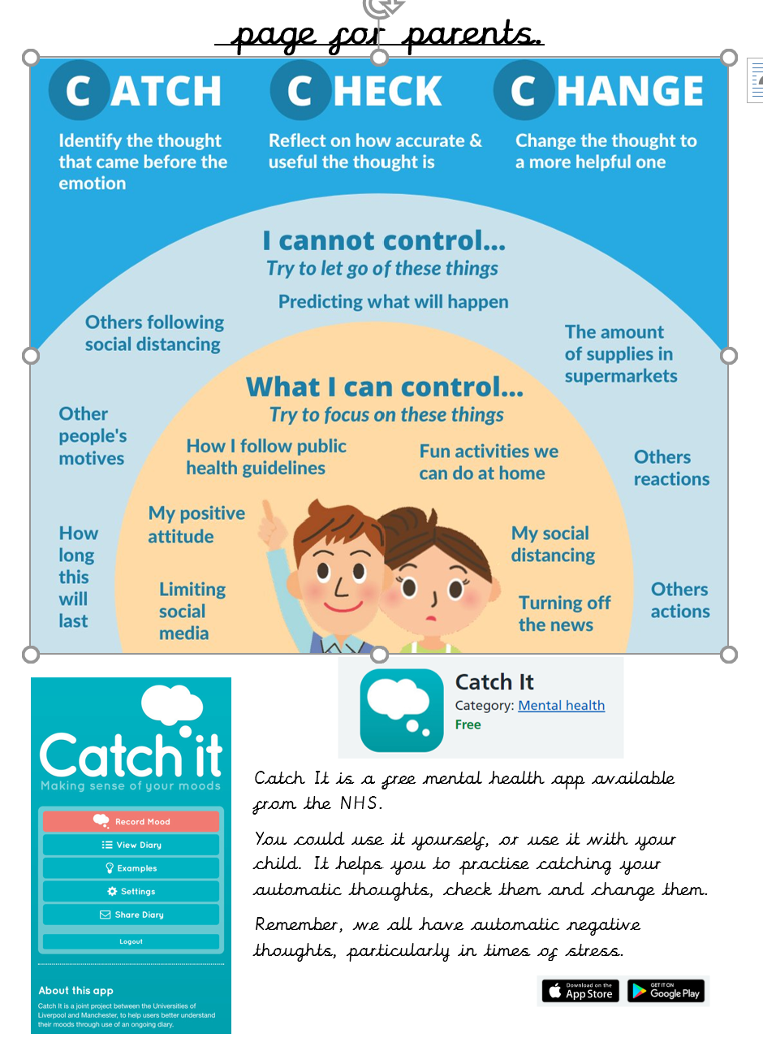

Key skills to continue practising weekly:
- Times tables and division facts
- Speedy number bonds to 20
- Year One, Two and Three spelling lists
- Reading aloud from any book or newspaper you have at home. You could find stories on the internet.

If you are able to access the internet, try these useful websites:
- Purple mash – using the log in Mrs Lumsden sent you. Lots of fun games and activities
- https://www.bbc.co.uk/bitesize/subjects/zwxhfg8- brush up on your music skills. Can you learn a new song to sing your teacher.
- https://www.youtube.com/user/GoNoodleGames- a fantastic YouTube channel which has lots of fun dance exercises for you to try.

If you or your child has any further queries regarding their learning projects, please contact admin@hardwick.derby.sch.uk, clearly stating your child’s name and class teacher, and the staff will be in touch to support you and your child.

Thank you and stay safe.

