Theme work for the week beginning 20th April
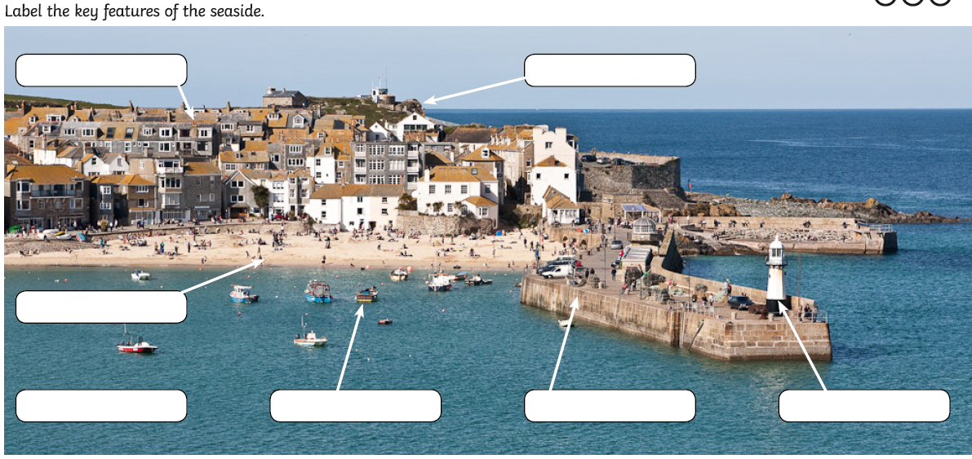
Geography

Then in geography we can sort features of the landscape into things that are physical (nature made) or human ( man made). Please label the next pictures and say whether they are physical or human features.

Looking at these two aerial photographs, can you tell which is at the seaside? Can you work out what some of the things are in both photographs?

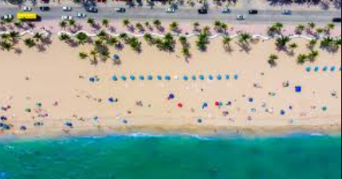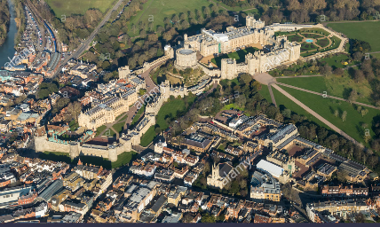

Computing
When you are creating a computer program you need to give clear instructions so that the computer knows what you need it to do. This is called an algorithm.
This link has a short video on what coding is from BBC bitesize.
https://www.bbc.co.uk/bitesize/clips/ztqxhyc
Also you can have a go at creating a program by going onto
https://scratch.mit.edu/
This is completely free and enables you to make a character move.

If you do not have access to a computer to do these then try writing a clear set of simple instructions for your mum or dad to follow. First have a go at writing some for them to get from the front door to your bedroom. Ensure they follow them carefully and if it goes wrong debug – that means look at which part is wrong and try again.

