FS2 Home Learning
Week Commencing: 29th June 2020
FS2 teachers: Mrs Connelly-Haywood and Miss Ralph
FS2 TAs: Miss Hayat

Message from staff: Hello everyone! We hope that you have been enjoying the sunshine. We have really enjoyed playing outside this week in school. We have paddled in water, planted sunflowers and created lots of beautiful pictures. Miss Hayat sang some songs with the children and we made our own musical instruments. We hope that you have been enjoying your time at home and we can’t wait to see you again. Take care everyone!

Your Home Learning this Week:
Every day (Monday to Friday), make sure you choose a *physical, *communication, *reading/phonics, *writing and *maths learning activity. There are also further activities to choose from should you wish to.

Physical Home Learning
Monday | Tuesday | Wednesday |  | Thursday | Friday
- Make a sandwich independently for a picnic lunch in the garden, using a knife to spread filling and cut the bread.  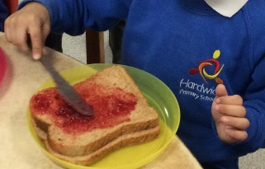 | Develop your fine motor skills (under the supervision of a grown up) by cutting and slicing different fruits to make a fruit salad.  Can you try a fruit that you haven’t eaten before?  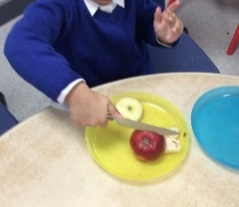 | Develop your fine motor skills by cutting citrus fruits into slices, and then squeezing the juice out with your hands into a cup.  How much juice can you squeeze out? |  | Develop your fine motor skills by threading small beads or pasta on to string to make a necklace.  How many pieces can you thread on to one string? | Develop your fine motor skills by helping your grown up wash their car with a soapy sponge. Can you make a circle? Can you go anti-clockwise?  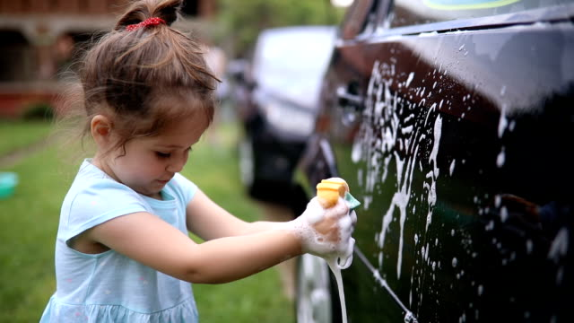
Easier:  Do as many of the above activities as you can. If you are finding some of the activities challenging, try these as they are a little easier:  - Practise holding a pencil and make lines and circles. – Try to write your name.  - Practise jumping from one spot to another. How far can you jump?  - Practise peeling a piece of fruit by yourself.  - Practise squeezing a soapy sponge so that bubbles come out. |  |  | Challenge:  If you feel you need a further challenge, try these:  - Independently, link strips of paper together in circles to make a paper chain.  - Under the supervision of a grown up, explore slicing a tougher fruit. For example: A pineapple, or a melon. Is it easier or harder to slice than a banana? Why?
Communication Home Learning
Monday | Tuesday | Wednesday |  | Thursday | Friday
See attached the story ‘Max’s Jungle Adventures’. Can you listen to the whole story carefully when your grown up reads it out to you? | Retell the story of ‘Max’s Jungle Adventure’ to someone in your house. Can you remember it all? | How does Max feel when he discovers the old wooden door in the middle of the wood? Why do you think this?  Example: Max feels excited because he wants to see what is on the other side. |  | How does Max feel when a tiger jumps out at him? Why do you think this?  Example: Max feels scared when he first sees the tiger because he thinks he might eat him! | How would you feel if you were invited to a birthday party in the jungle? Why?
Easier:  Do as many of the above activities as you can. If you are finding some of the activities challenging, try these as they are a little easier:  - Who did Max see when he went to the jungle? Example: Max saw a stripy tiger in the jungle.  - Using your words, talk to your grown up about a birthday party you have been to. |  |  | Challenge:  If you feel you need a further challenge, try these:  - Why do you think Max’s bandana had changed colour? How do you think Max felt when he realised his bandana had changed?  - How do you think Max would feel leaving his new friends in the jungle? Why?

Reading/Phonics Home Learning
Monday | Tuesday | Wednesday |  | Thursday | Friday
Focus on ‘ai’  Read and write words.  Wait, pain, bail, hail, sail, rain, bain  Which words are real? | Focus on ‘ee’  Read and write words.  See, feel, weep, feet, jeep, beep, neep  Can you think of and write down your own words? | Focus on ‘igh’  Read and write words. Play a game to see if you can write the words as quick as you can.  High, sigh, light, might, night, fight, tight  Can you think of your own words? |  | Focus on ‘oa’  Read and write words.  Coal, load, goat, loaf, road, roar, soar  Can you think of your own words? | Focus on recapping the key words  Was, my, you, her, they, all, are  Can you read them by sight?  Practice writing the key words.
Easier:  Do as many of the above activities as you can. If you are finding some of the activities challenging, try these as they are a little easier:  - Have a go at recapping the sounds below. Can play a game of bingo using these sounds.  - Find a person or object in your house that begins with the sound m. For example: Mummy or money.  s, a, t, p, i, n, m, d, g, o, c, k, ck, e, u, r, h, b, f, ff, l, ll, ss, j, v, w, x, y, z, qu, sh, ch, th, ng |  |  | Challenge:  If you feel you need a further challenge, try these:  - Recap the key words we have covered so far. Can you write them in a sentence?

Writing Home Learning
Monday | Tuesday | Wednesday |  | Thursday | Friday
Retell the story of Max’s Jungle Adventure by writing the story down. Have a go at using the tricky words ‘the, to, I, no, go’ in your story. | Design and make your own birthday card for the Tiger. Remember to include the words: ‘Dear’, ‘Happy Birthday’, and ‘Love from’. Have a go at sounding them out by yourself! | Draw or paint a picture of the old wooden door Max comes across in the story. Can you write a sentence about it using the tricky words ‘the’ and ‘to’?  Example: Max walked up to the old door. |  | Draw or paint a picture of the tiger Max visits in the story. Can you write a sentence about him using the tricky words ‘the’ and ‘I’?  Example: I like the stripy tiger. | Write a shopping list of items the Tiger will need for his birthday party. Have a go at sounding out words by yourself!  Examples include: chips, chicken, fish, rings.
Easier:  Do as many of the above activities as you can. If you are finding some of the activities challenging, try these as they are a little easier:  - Draw a picture of Max and label the picture with the CVC word ‘dog’ or ‘Max’. Can you sound out d-o-g or M-a-x by yourself to help you write it down?  - What are the initial sounds for these words: Max, tiger, monkey, Birthday, snake. Do any of the words start with the same phoneme? |  |  | Challenge:  If you feel you need a further challenge, try these:  - Can you make a map for Max of the jungle so he doesn’t get lost? Can you label each picture with a word using a describing word and read them back? Examples: ‘Tall tree’ and ‘stripy Tiger’.  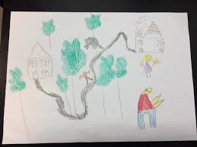

Maths Home Learning
Monday | Tuesday | Wednesday |  | Thursday | Friday
This week we are exploring money: Have you seen one of these before? Tell a grown up what you think it could be!  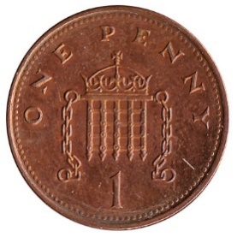  1 penny = 1p  Can you find any more pennies in your home? How much do you have all together now? Count how many you have! | With a sibling or grown up at home explore playing shops with money and objects to sell. You could ask a grown up in your house if you could borrow some change to play with.  Explore using the language:  Money  Penny  Pounds  Change  How much?  Bill  Receipt  Amount  Cost  Coin | How much do you have all together? Remember to look for the numbers on coins to work out the correct amount! Can you write it down correctly?  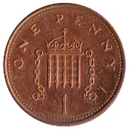  Can you find another coin that equals the same amount? |  | How much do you have all together? Remember to look for the numbers on coins to work out the correct amount! Can you write it down correctly? | How much do you have all together? Remember to look for the numbers on coins to work out the correct amount! Can you write it down correctly?  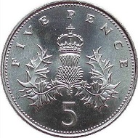
Easier:  Do as many of the above activities as you can. If you are finding some of the activities challenging, try these as they are a little easier:  - Play a game with your grown up: Close your eyes and count how many times they are clapping/stomping/tapping.  - Count five objects independently. Can you write the number five down? |  |  | Challenge:  If you feel you need a further challenge, try these:  - Explore how many pennies are in a pound. Can you write the amount down?  - How does it look different to the other coins we have explored this week?  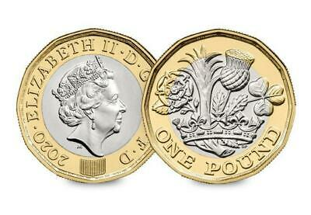

Other Activities
Make a potion in the garden out of flowers and water. | Give your favourite toys/dolls a bath outside by washing them with soapy water and a sponge. | Scrub an outside door at home using a sponge and soapy water. | Help the grown-ups in your house make dinner every day by helping to wash, peel, and mix ingredients. | Draw a picture of what your favourite thing to do at home has been that day.

Key skills to continue practising weekly:
- Write your name.
- Practise handwriting – try to form the letters on the line correctly.
- Form numbers correctly.
- Getting changed on your own.
- Zip your coat up on your own.
- Match the capital letters with the lowercase letters e.g. A a B b
- Number bonds to 10.
If you are able to access the internet, try these useful websites:

- Change for life indoor activities: https://www.nhs.uk/change4life/activities/indoor-activities
- Cosmic Kids - https://www.youtube.com/watch?v=tWSgNEs4IPg
- Playdough - https://www.bbcgoodfood.com/howto/guide/playdough-recipe
- Number Blocks – doubling: https://www.youtube.com/watch?v=Bot83VxMLqM
- Paper fan instructions - https://www.wikihow.com/Make-Paper-Fans
- https://www.talk4writing.com/wp-content/uploads/2020/06/R-Maxs-Jungle.pdf
If you or your child has any further queries regarding their learning projects, please contact admin@hardwick.derby.sch.uk, clearly stating your child’s name and class teacher, and the staff will be in touch to support you and your child.

Thank you and stay safe.

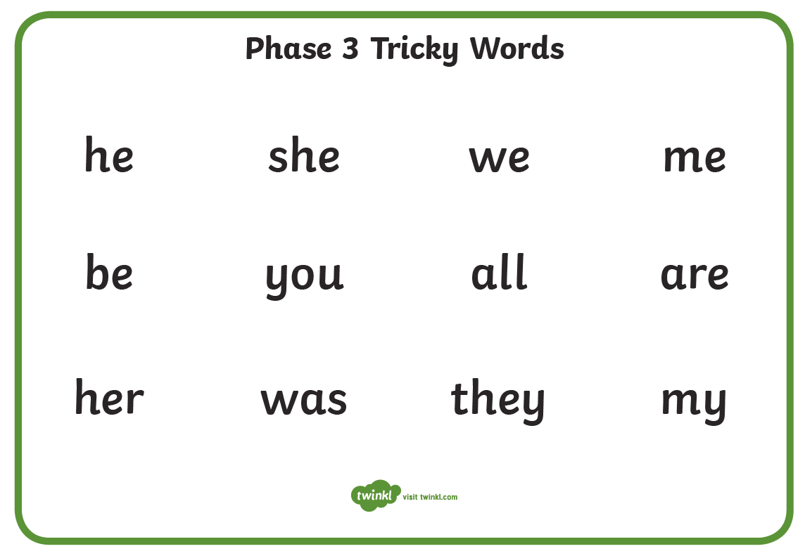

Max’s Jungle Adventure
Late one cold, wet afternoon, when the sky was covered with grey clouds, Max went for a walk through a forest. As he walked, he left a trail of muddy paw prints. At the end of the path, he discovered an old wooden door covered in green leaves. He nudged it gently with his nose and, very slowly, it began to creak open. Max stepped through. To his amazement, he found himself in the middle of a bright, sunny jungle. Max looked up. Above him, he saw tall trees stretching into the blue sky like gigantic pencils. Below on the ground, he saw strange round flowers with shiny leaves and red spotted petals like a ladybird. Around him orange butterflies and red parrots fluttered and flew. Everywhere Max looked he could see so many colours. It was like being wrapped in a rainbow!

As you listen to my story, think about - where I go, - who I meet - and what I see. And you could add in the sound effects!

Max listened. He heard monkeys chattering as they swung through the trees, parrots screeching from high in the branches and snakes hissing as they slid through the grass. “It’s very noisy in the jungle!” thought Max.
Roar! Suddenly, a tiger roared so loudly that Max jumped behind a tree and hid. Fortunately, the tiger was a friendly tiger. “Welcome to our jungle!” said Tiger. “It’s my birthday and we’re having a party. Would you like to join us?” asked Tiger.
“That sounds like fun. Yes please!” barked Max.
So Max, Tiger and all the jungle animals played music, sang songs and danced until the stars began to twinkle in the night sky. At last, it was time for Max to go. He thanked his new friends and said goodbye. Then he stepped through the old wooden door and followed his muddy paw prints all the way home.
Max was just getting into his bed when he noticed something very strange. His bandana was no longer blue! It had changed colour! Now it was orange with black stripes - just like the pattern on the tiger’s fur! Max smiled happily, curled up in his cosy bed and fell asleep dreaming of his new friends and his next adventure.

