**Year 2 Home Learning**

**Week Commencing: 1st June 2020**

Year 2 teachers: Mrs Nicholson and Mrs Tomordy

Year 2 TAs: Mrs Rowland and Ms Shaista

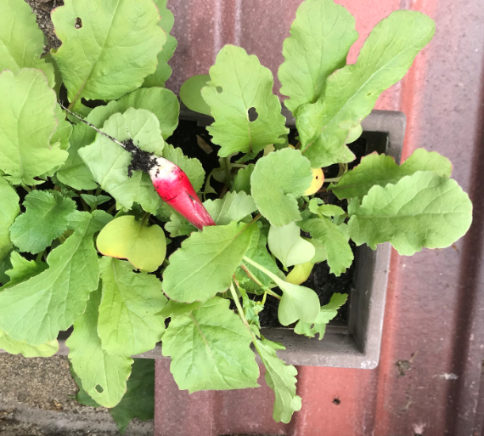Message from staff: Hello everyone. This week I have put a few photos from my house on (Mrs Tomordy). The rabbits are 2 ornaments I have on the window sill where I work. Then the one of the seedlings are my radishes when they first came through. I have just started taking some of them out now as they are fully grown and adding them to my lunch. Everyone in school is very busy with sorting your learning and making sure you are all doing well. It certainly feels like a long time since we were all in our classes together but this way we are all staying safe.

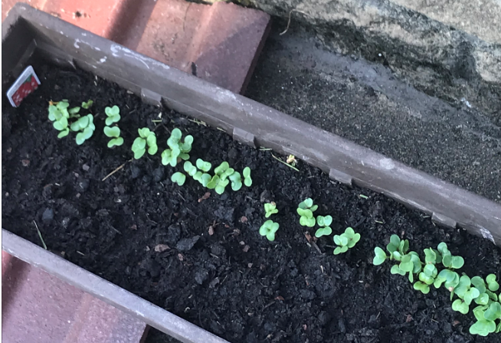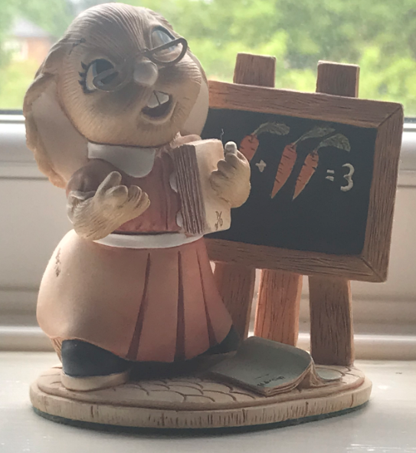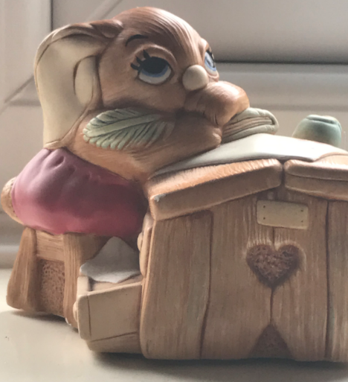

**Your Home Learning this Week:**

Every day (Monday to Friday), make sure you choose a *reading, *writing, *spelling/handwriting, *maths and *theme learning activity. There are also further activities to choose from should you wish to.

Reading Home Learning

|  |  |  |  |  |  |
| --- | --- | --- | --- | --- | --- |
| **Monday** | **Tuesday** | **Wednesday** | | **Thursday** | **Friday** |
| Read the story that is at the end of this pack a couple of times and then try retelling it to someone else | Read the story again and see if you can list how many different animals are in the story. | What is the message the animals are trying to pass on?  Why do they need so many animals to pass this message on?  Is this a happy or sad story, why? | | Create a picture to show the person at the start of the story and how they feel and then again how they might be at the end of the story. | In your reading book, or any other story book you have at home, see if you can create a list of the nouns and then try putting them in alphabetical order. |
| **Easier:**  **Do as many of the above activities as you can. If you are finding some of the activities challenging, try these as they are a little easier:**     * We have attached a story so try and read it using your sounds. * Why was the foal different? Who went to see the foal? What was the weather like when he was born? * Think about what the unicorn might do next and tell someone else your story ideas. | | | **Challenge:**  **If you feel you need a further challenge, try these:**     * Think about who it could be talking to blackbird and also why they start talking to a bird. * How did the other people around feel when they heard all the noise? How would you have felt, why? * Tell me what your favourite story is or favourite book is and why it is your favourite book. Create your own blurb for it and say what sort of people would like this book. | | |

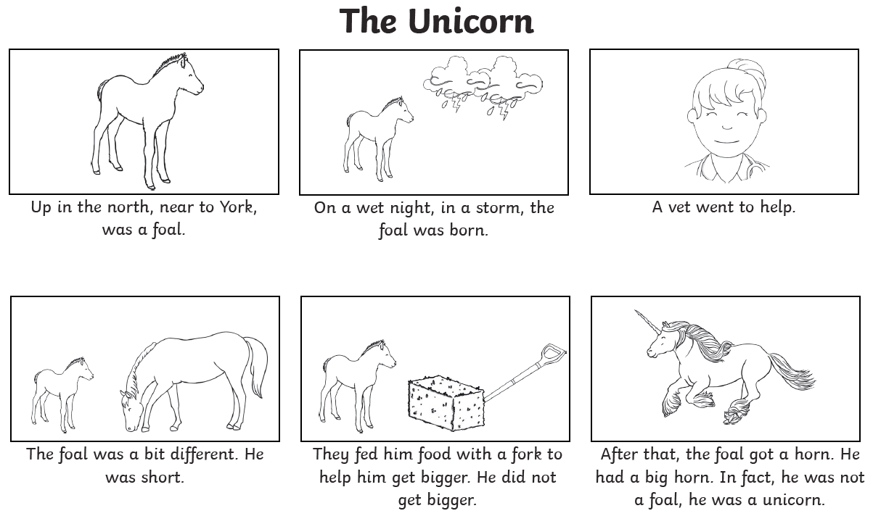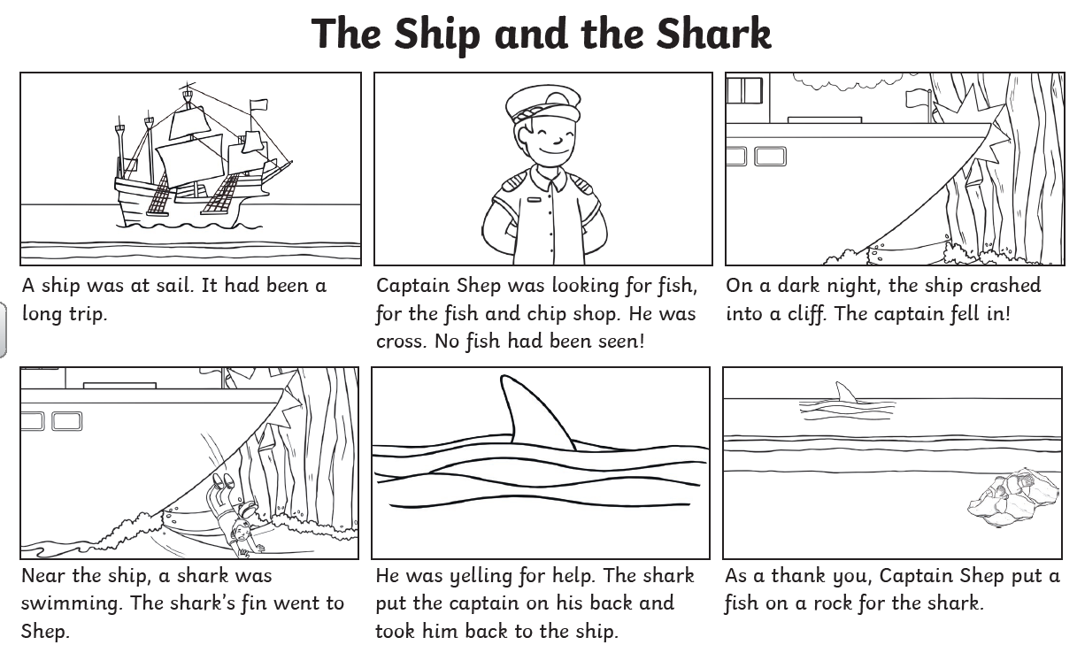

Writing Home Learning

|  |  |  |  |  |  |
| --- | --- | --- | --- | --- | --- |
| **Monday** | **Tuesday** | **Wednesday** | | **Thursday** | **Friday** |
| Look at the picture of the ‘shed’ below that just appeared in front of your house. Tell me about   * who you think lives there, * what it is like inside * where you think it came from | This morning a strange man appeared through the door of the cottage.  What would you ask him? He says you can only ask him 5 questions. | The man is a wizard and he says “Come follow me …… she is upstairs.”  Tell me about who is upstairs and what you find. Try to put detail in this with lots of adjectives about how you are feeling and how the other people are feeling. Do they like you? Are you in danger? | | Whilst you were in the ‘shed’ it moved and when you go to leave it has gone to a different place.   * Where has it gone? * Are the people with you? * What is there? * What adventure do you have? * Who else do you meet? * How will you try to get home? | You are now safely back home but your grandma wants to know what has been happening to you. Write her a postcard which will show her where you have been and tell her all about your adventures. |
| **Easier:**  **Do as many of the above activities as you can. If you are finding some of the activities challenging, try these as they are a little easier:**     * Draw your own shed and label it for me with the different parts and try sounding out some adjectives to describe it too * Now draw your own wizard and label him, what is he like as a person too? * Create some sentences from the other activities starting with * The ……… wizard is………. and ……….. . | | | **Challenge:**  **If you feel you need a further challenge, try these:**     * Convert this into a story where the main character is an evil wizard who wants to take all children who are 6 or 7 to his world and use them for an experiment. What could it be, how is he going to collect them all and how will you all escape? * Can you think of an adjective for every letter of the alphabet some letters will be much harder than others? * Where is the path going to? How did it get there? Who will you meet as you go along it and what would you say to them? | | |

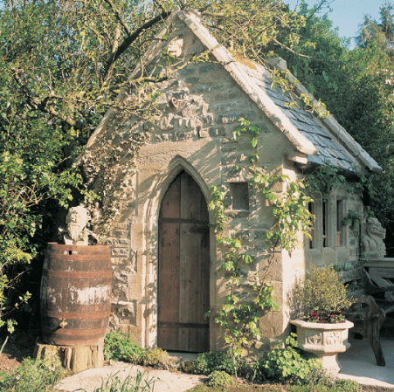

Spelling/Handwriting Home Learning

|  |  |  |  |  |  |
| --- | --- | --- | --- | --- | --- |
| **Monday** | **Tuesday** | **Wednesday** | | **Thursday** | **Friday** |
| This week we are going to get confident at writing words with ‘el’ and ‘al’ endings:  travel, jewel, tinsel, towel, cruel, animal, metal, final, local, magical, signal, global, survival.  Read these words and check you know their meanings. | Today we are going to write the words and draw a picture to show what they mean.  tinsel C:\Users\cnicholson\AppData\Local\Microsoft\Windows\INetCache\Content.MSO\39BE2792.tmp  magical  C:\Users\cnicholson\AppData\Local\Microsoft\Windows\INetCache\Content.MSO\3AC9FD70.tmp | Now let’s put the words into sentences with the focus being on how we write these out. Make sure the g and f goes below the line. Try to join all the letters except the r. Keep practising the joins and you will get there. | | Choose one of the words and try breaking it into sounds or syllables to remember it.   |  |  |  | | --- | --- | --- | | cr | ue | l | | Ask someone to test you!  Pass a ball to another person saying the letters of the word. |
| **Easier:**  **Do as many of the above activities as you can. If you are finding some of the activities challenging, try these as they are a little easier:**     * Read these words and circle the picture that matches.       Let’s practise each sound. Do the following words with rainbow writing:   * + - * + three,         + chick         + wing         + path         + king         + chair         + shell and fish | | | **Challenge:**  **If you feel you need a further challenge, try these:**  **These are homophones – words that sound the same but mean something different and they are spelt differently.**  **Cut out and match them, then try practising writing the words after you have read the definition:** | | |

Maths Home Learning

|  |  |  |  |  |
| --- | --- | --- | --- | --- |
| **Monday** | **Tuesday** | | **Wednesday** | |
|  |  | |  | |
| **Thursday** | | **Friday** | |
|  | |  | |
| **Easier:**  **Do as many of the above activities as you can. If you are finding some of the activities challenging, try these as they are a little easier:** | | **Challenge:**  **If you feel you need a further challenge, try these:** | |

Theme Home Learning

|  |  |  |  |  |  |
| --- | --- | --- | --- | --- | --- |
| **Monday** | **Tuesday** | **Wednesday** | | **Thursday** | **Friday** |
| **History**  Look at the photos below of the seaside from the past and the seaside from nowadays. What’s different/the same? How have they changed? | **Science**  Complete the habitats worksheet below for where the mini beasts like to live. | **Art**  Find a leaf and draw a picture of it. Make sure you look closely at the shape, all the lines and detail on the leaf and draw those too. | | **D&T**  Draw a plate and draw food on it that would make a healthy meal. Think about the healthy food that you like to eat. | **Geography**  Look at the seaside photo below and circle all of the things that would be a danger. Can you say why they are dangerous? |
| **Easier:**  **Do as many of the above activities as you can. If you are finding some of the activities challenging, try these as they are a little easier:**     * Draw and label a picture of the seaside. * How many mini beasts can you find in your garden or on your walk? * Use empty bottles and boxes to build an animal. | | | **Challenge:**  **If you feel you need a further challenge, try these:**     * Can you label the food on your healthy plate into these – fats, protein, carbohydrates, fruit and veg. * Why do you think animals live in the habitats on the sheet? * Who is there to help us stay safe from the dangers at the seaside? How do they do this? | | |

Other Activities

|  |  |  |  |  |
| --- | --- | --- | --- | --- |
| **Music**  How many instruments can you think of?  Draw a picture of them and label. | **PSHE**  Think about your best friend from school. Draw a picture of them and write about why they are your friend. What makes them special? | **RE**  Think about our lessons on belonging. Who do you belong with? Draw yourself and who you belong with. | **Geography**  Draw a map of how you get to school. Start from your house and finish at school. Can you include the street names too? | **Science**  How do you look after yourself? Think about everything you do and everything you need to make sure you are healthy. |

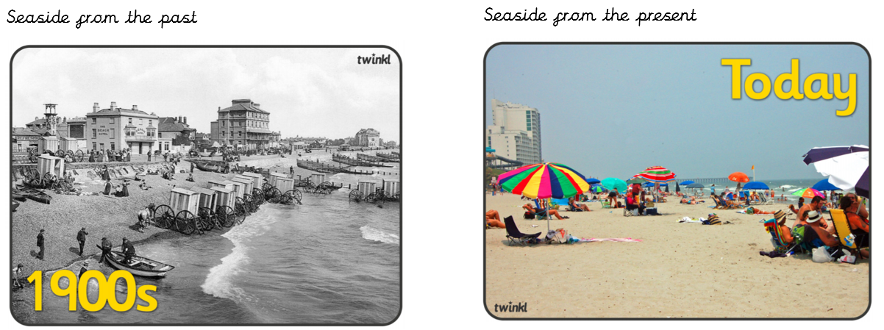

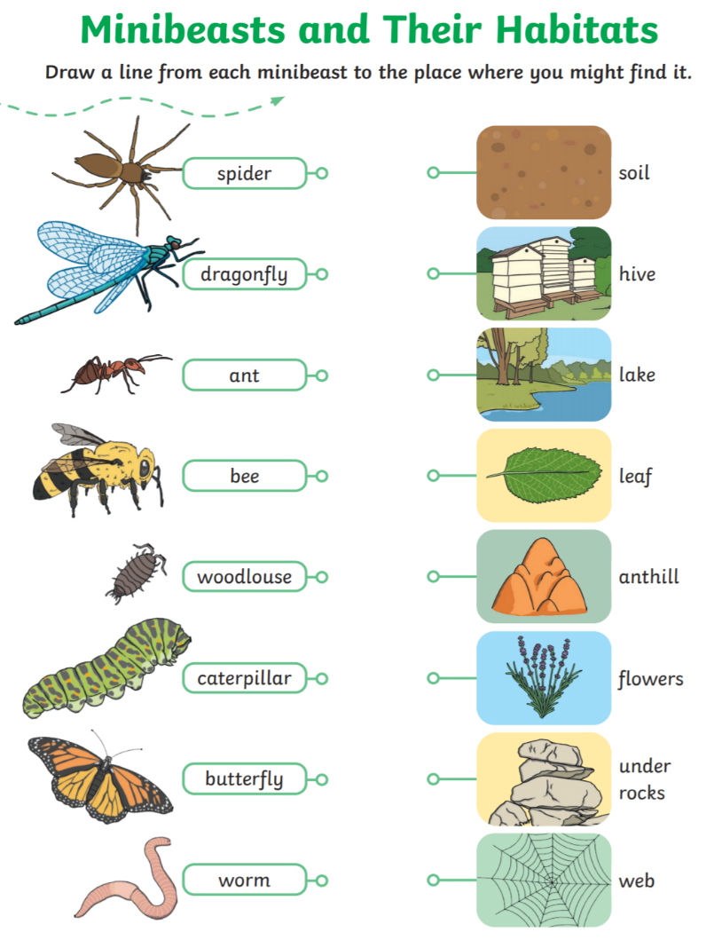

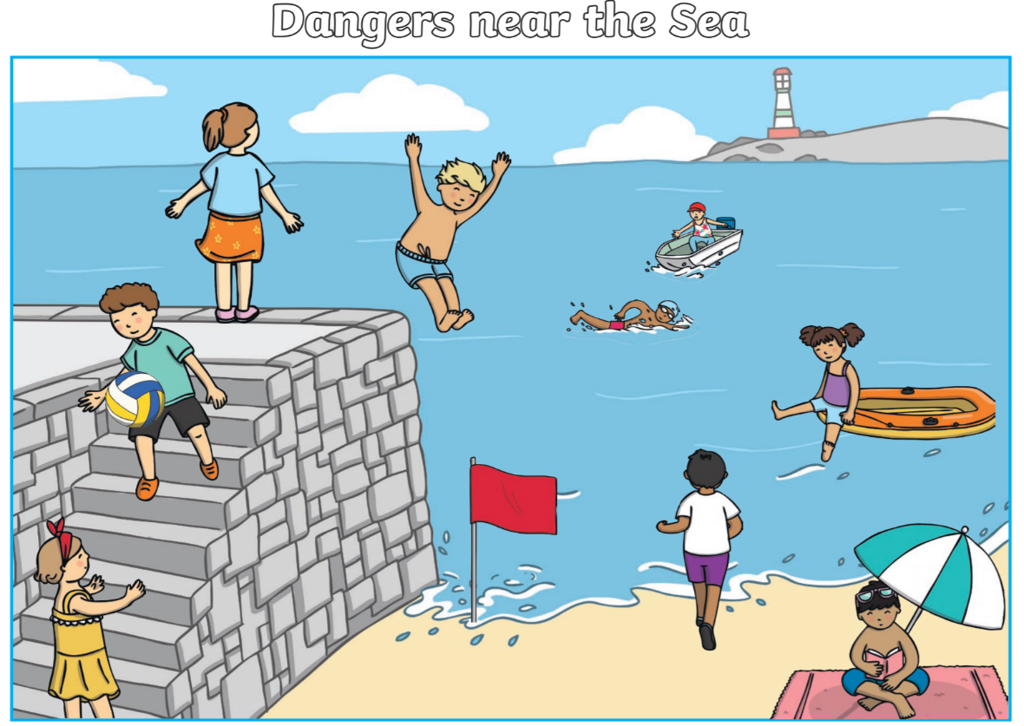

Key skills to continue practising weekly:

* Times Table Rock Stars – I have checked and not many of you are doing this and it is fun to do plus keeps your skills going. If you have forgotten your log on details, then just email the school.
* Oxford Owl – lots of books to read
* Telling the time throughout the day to the nearest 5 minutes
* Play shops and work out the change
* Common exception words both reading and spelling

If you are able to access the internet, try these useful websites:

* <https://www.bbc.co.uk/bitesize/primary>
* <https://www.bbc.co.uk/bitesize/clips/z4tmhyc>
* New lessons are uploaded every day for children to interact with
* <https://scratch.mit.edu/>
* A chance to have a go at computer programming and create your own games, all completely free.
* Plus remember to check the list of other useful websites which are under home learning on a separate sheet.
* This link will take you to a book all about the coronavirus for children and explains a lot of what is happening in a child friendly way.

<https://nosycrow.com/blog/released-today-free-information-book-explaining-coronavirus-children-illustrated-gruffalo-illustrator-axel-scheffler>

If you or your child has any further queries regarding their learning projects, please contact admin@hardwick.derby.sch.uk, clearly stating your child’s name and class teacher, and the staff will be in touch to support you and your child.

Thank you and stay safe.

