Phonics and Key Words

Key Words

Practise reading these phase 2 key words:

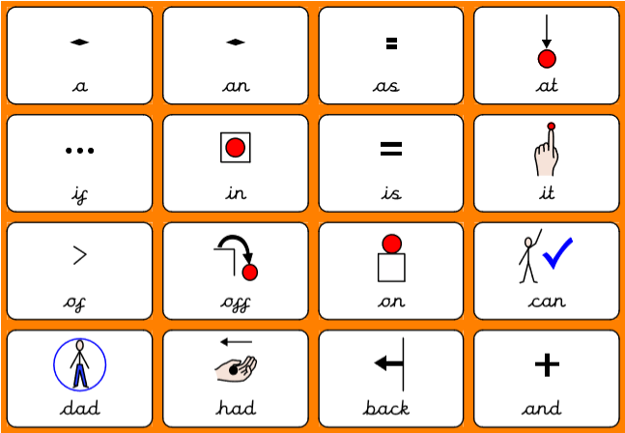
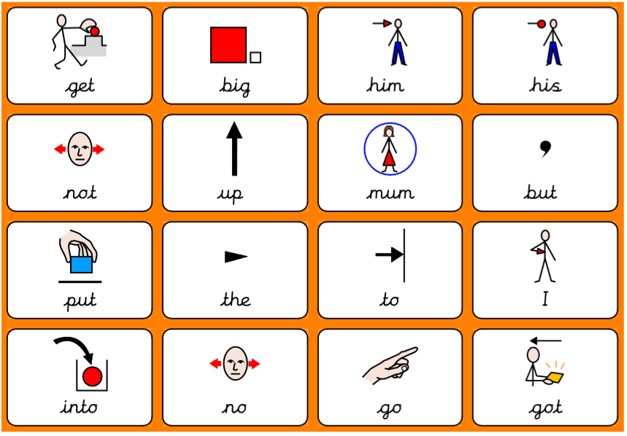

Practise reading these phase 3 key words:

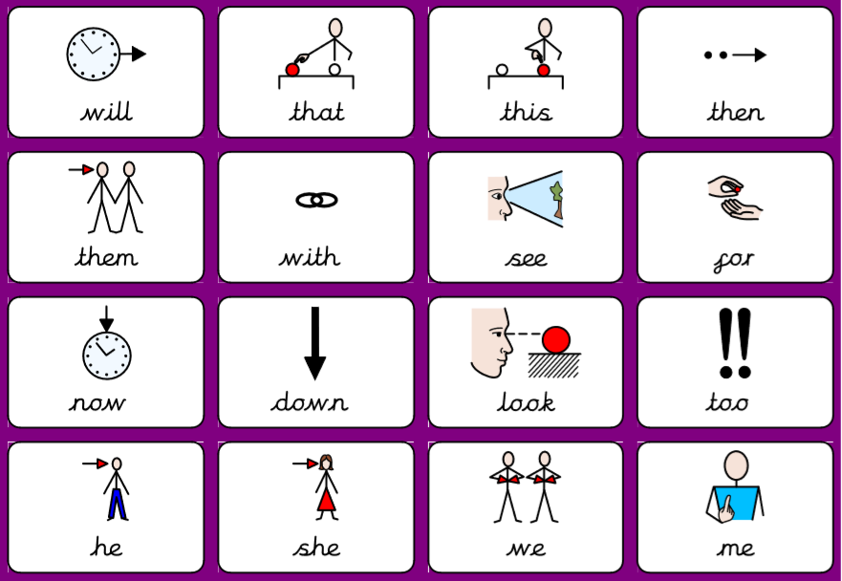
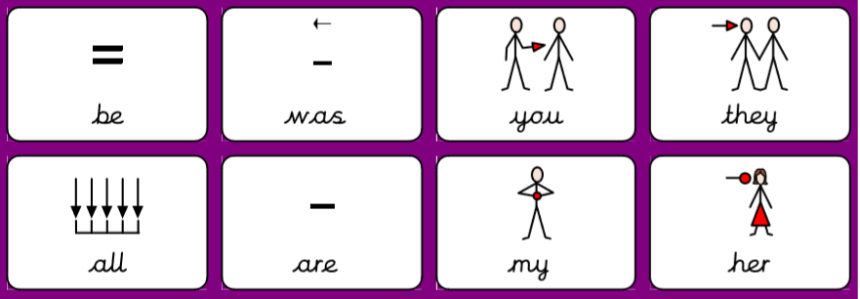

Practise reading these phase 4 key words:

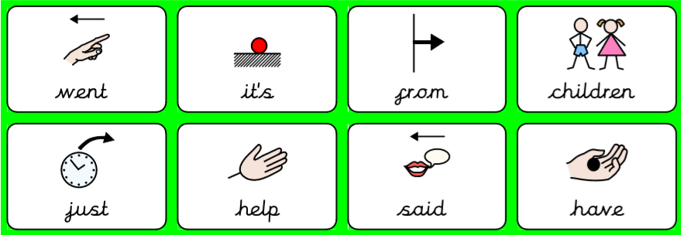
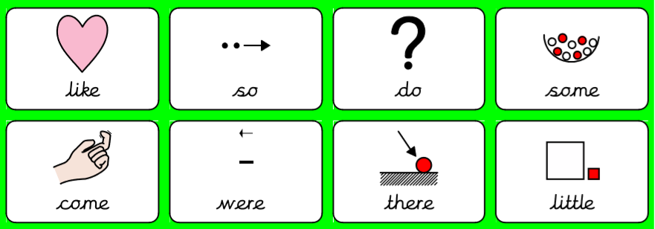
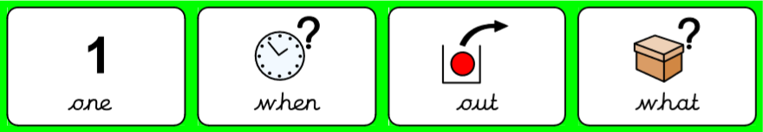

Practise writing as many of these key words as you can. You can use extra paper if you need too!

Phonics:

Review - read the following questions and words. Underline the GPCs oo oo ar or.

Is it too hot?
Can you put a cat in the zoo?
Is the moon big?
Will we cook jam?
Can we cook with food?
Is my mum at the market?
Can we play in the park?
Can you play a cornet?
Can you sort the cord?

Copy some of the sentences below. Remember the question mark!
_________________________________________________________________________________________________________________________________________________________________________________________________________________________________________________________________________________________________________________________________________________________________
Read and write the following words. First segment the words e.g. cat – c – a – t. Then, try and read the words without segmenting them!

Focus GPCs = ‘ur ow oi’

ur | ow | oi
fur | now | oil
burn | down | boil
urn | owl | coin
burp | cow | coil
curl | how | join
hurt | bow | soil
surf | pow! | toil
turn | row | quoit
turnip | town | poison
curds | towel | tinfoil

Give it a go reading the following questions. Remember to try and not segment the key words in RED.

It can burn them.
They can see down the hill.
Dad has got oil for the car.

Which sentence do you think goes with which picture?
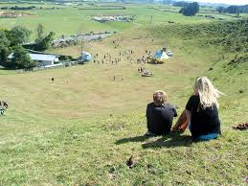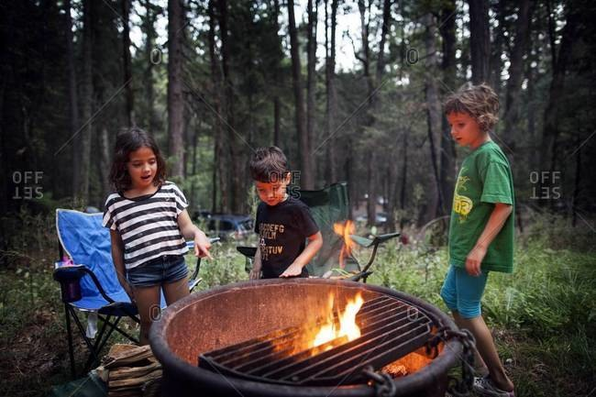

Handwriting:

Keep practising your handwriting – remember to write on the line! You can practise on any paper! If your paper does not have line – draw some!
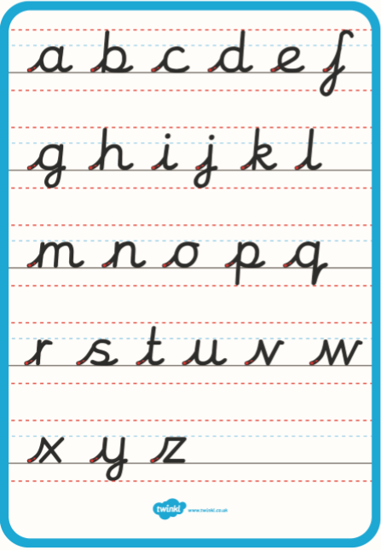
Practise your handwriting with the following words:

turnip
towel
poison
tinfoil

Everyday English:

Look at the following picture. What can you see? What are they doing? See if you can get someone to read you the questions.

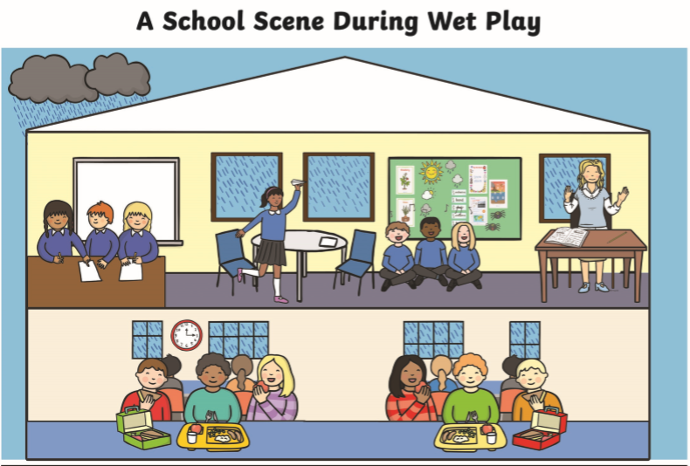
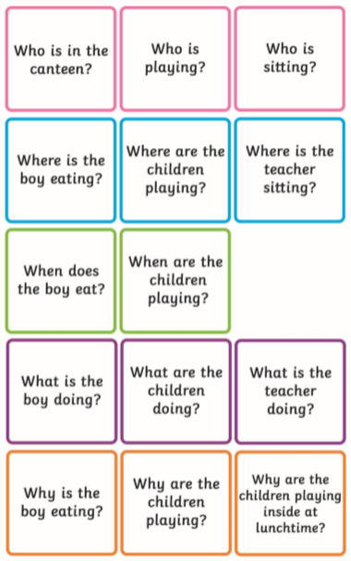

Try and use the following phrases:

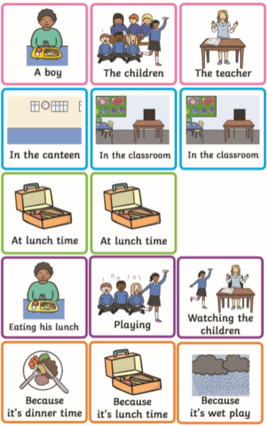

Park words labelling. Look at the words and label the picture.
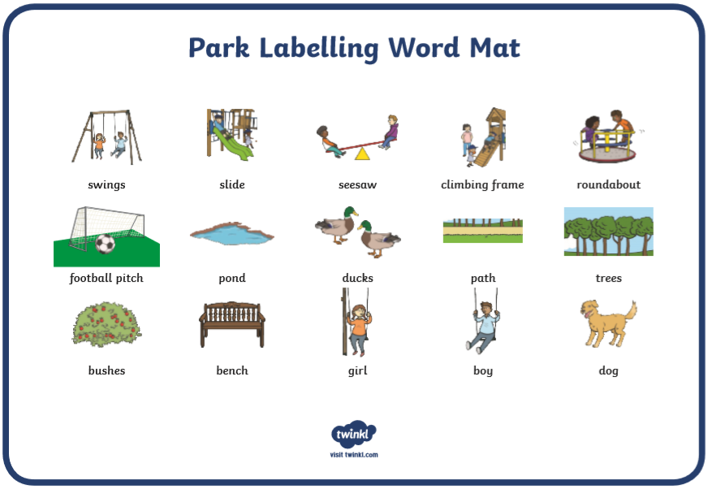
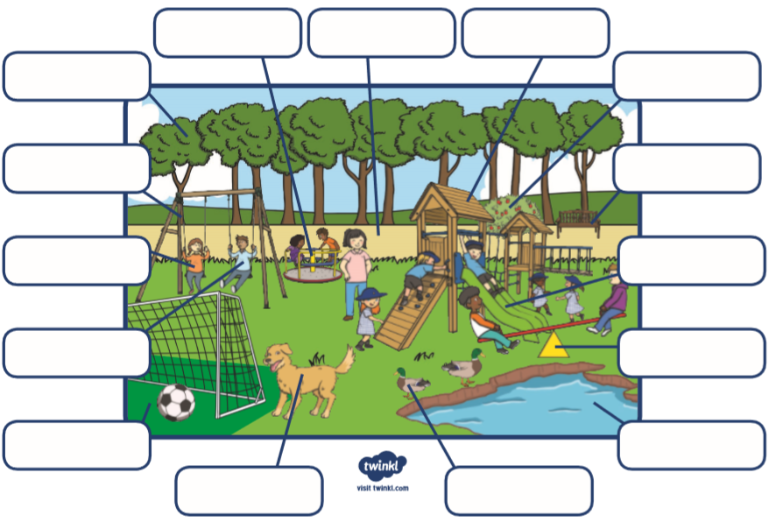

Talk!

Discussion of the week!
Look at the following question and discuss it with someone. Tell them WHY!
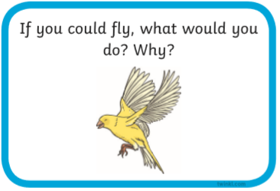

Useful websites:

Have a look at the following websites

- https://www.bbc.co.uk/cbeebies/shows/alphablocks - great phonics videos!
- https://www.bbc.co.uk/cbeebies/shows/numberblocks - great number videos!
- https://www.phonicsplay.co.uk/# - free to sign up!
- https://www.youtube.com/channel/UCP_FbjYUP_UtldV2K_-niWw - start from reception and work your way through!


I hope you enjoy the work and have a great week!

