Year 6Home Learning
Week Commencing: 4^{h} May 2020
Year 6 teachers: Mrs Haider, Miss Qayoom, Mr Nowak
Year 6 TA: Mrs Yar-Khan
Message from staff:
It seems very strange not being able to welcome you back to school in person and chat with you all.
Although you are staying at home, you can still have fun. Art is never boring and you do not really need any special equipment to create something amazing. You could glue/tape recycled things together to make a sculpture or bake cookies and decorate them. Simply, work through the stress by creating. We hope that you stay safe during these difficult times and look forward to seeing you all soon!

If you want to use Purple Mash to play games and do some fun activities, please ask your teacher for your login details.

Your Home Learning this Week:
Every day (Monday to Friday), make sure you choose a *reading, *writing, *spelling/handwriting, *maths and *theme learning activity. There are also further activities to choose from should you wish to.

Reading Home Learning
Read a report about Lego Star Wars and then revise features of reports. | Read another report and look again at the features of reports. | Read a fun poem | Read a poem about rolling down the hill. | Read for pleasure for 30 minutes.

Writing Home Learning
Read three more reports about different games and identify and explore the technical vocabulary. | Write a report about anything of your choice, drawing on the features of reports to do so. | Revise present and past tense. Use the Portrait Poem template to write your own version. | Identify and use the progressive form of verbs (-ing). | Use the PowerPoint if you can access it. Identify perfect form and then use this in writing your own version of a poem, based on one read.

Spelling/Handwriting Home Learning
superhuman  collision  television  supercomputer  supertanker  superstructure  impatient  confusion  imperfect  decision  pyramid  trouble | impolite  library  perhaps  bicycle  superstar  superman  erosion  impeccable  immortal  invasion  optician  country  parachute | appear  material  possess  caught  expansion  immature  impossible  improbable  imbalance  supermarket  mail  male | division  abrasion  sentence  various  regular  immovable  supersonic  superfine  superficial  excursion  piece  vein  incomplete | Ask your parents to test you on the words covered this week.

Maths Home Learning
Complete multiplying by 5 st. | Complete multiplying or dividing st. | Read the information about naming shapes.  Complete recognising polygons st. | Read information about regular and irregular shapes.  Complete irregular shapes st.  Complete odd one out st. | Revise over what you know about shapes form the activities completed.  Complete classifying shapes st.

Theme Home Learning
Science/English  WALT write a biography for a year 4 child to read.  See a good example of a Biography by logging into Twinkle (see below)  Free Access Code: UKTWINKLHELPS  Use it at www.twinkl.co.uk/offer  In the search box type in Biography  List the features of a biography.  To check, use Google. Type into the search box ‘Features of a biography.’ | You will be writing a Biography based on Charles Darwin.  https://www.bbc.co.uk/teach/charles-darwin-evolution-and-the-story-of-our-species/z7rvxyc  https://www.dkfindout.com/uk/science/famous-scientists/charles-darwin/  Write an introduction based on who Charles Darwin was and his date of birth as well as date of death.  Write about what inspired him with the work he contributed in Science as well as his family life.  Don’t forget to include key dates and use paragraphs.  Write key dates and main events. | If you wish to use other webpages, that is fine (check parental consent) but make sure you understand what you are reading. Check also that you understand what you write.  Continue to collect notes for the biography. You can include pictures if they help the reader to understand.  You should have enough notes to complete two A4 sides. | Use the notes/phrases and sentences you have made to write a biography.  Remember:  You need to fill two A4 sheets of paper. This will include pictures. | Create a poster based on Charles Darwin discoveries/his contribution to science and the dates.  (Use the websites listed in this row).  You can also use websites of your own if you wish.

Other Activities
Summarise the story using ‘Home-CBBC Newsround’  Newsround story 1 | Year 6  Home learning packs from Twinkle  Free Access Code: UKTWINKLHELPS  Use it at www.twinkl.co.uk/offer  Mindfulness  Try out some of the activities attached to help you relax. | Research other British Scientists and how they have contributed to the world of Science.  https://www.dkfindout.com/uk/science/famous-scientists/  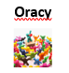  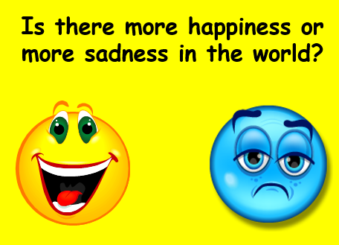 | Odd one out  The image below shows models of four mammals:  - Rhinoceros  - Whale  - Elephant  - Hippopotamus  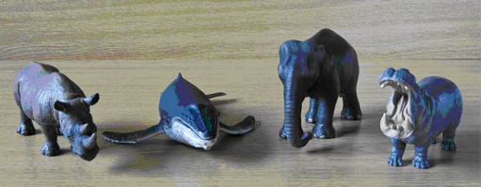  Figure 1  Which of these four do you think is the ‘odd one out’? Why? | Create a fact file booklet on animal adaptation. Base the booklet on the animals of your choice. Choose up to 20 different animals.

Key skills to continue practicing weekly:
-spellings
-grammar (go through revision booklets)
-speed reading
-speed writing (count the number of words you can write in one minute)
-neat and joined up handwriting
-timetables (build up speed)

Useful websites:
Maths:
https://www.mathplayground.com/math-games.html
https://claritymaths.uk/
http://www.icteachers.co.uk/children/children_sats.htm
https://www.sheppardsoftware.com/math.htm

English
http://www.icteachers.co.uk/children/children_sats.htm
http://www.crickweb.co.uk/ks2literacy.html
http://www.keystage2literacy.co.uk/spellings-menu.html
https://www.spellzone.com/games/index.cfm?wordlist=2255

If you or your child has any further queries regarding their learning projects, please contact admin@hardwick.derby.sch.uk, clearly stating your child’s name and class teacher, and the staff will be in touch to support you and your child.

Thank you and stay safe.

