, 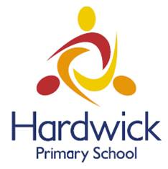

Parent Governors Needed

The Governor’s at Hardwick Primary School are looking to elect new Parent Governors to their board.

Parent governors are appointed for a period of four years irrespective of whether their children remain in school during this period.

There will be a requirement to attend a full governor meeting approximately once a month with additional meetings as and when required.

The board do have a governor allowance available to them which may be used to cover childcare if required.

All that is required is a little time, commitment, the ability to question and analyse, and a willingness to learn. The Governing Board members have between them a range of skills and experience, and to add to this range we are particularly keen to recruit, if possible, a parent governor with professional experience in any of the following areas.

- Prior knowledge of Education
- Business management
- Links with the community.

There is no need to worry if you do not have experience in any of these arears or previous experience of a governing role, there will be training available and lots of support.

If you would like the opportunity to speak with the Chair of Governors or Executive Head Teacher about this post, please contact the Clerk to Governors (detail below).

If you wish to stand as a governor or nominate someone else, please contact Pam Miles, the Clerk to the Governors, via the email address on the Governors page of the school web.

CLOSING DATE FOR APPLICATIONS Monday 2nd July 2018

