Phonics and Key Words

Key Words

Practise reading these key words:

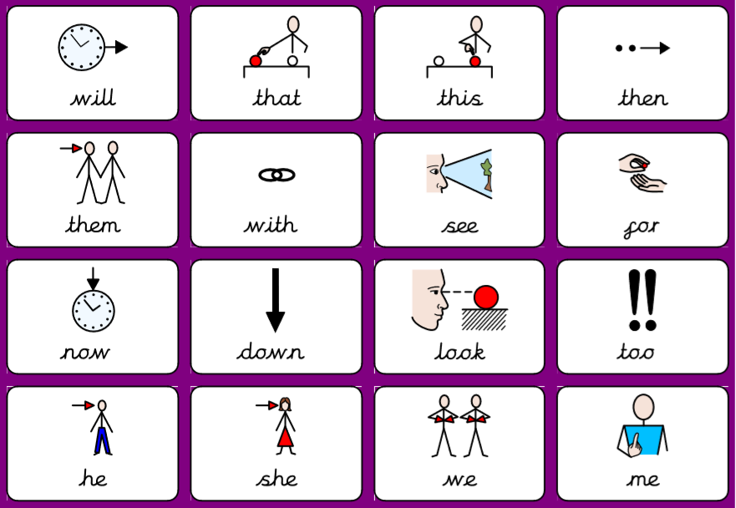

Practise writing these key words. The first two you can look to make sure you are spelling it right. Next, give it a go without looking. Lastly, check is you spelled it right!

Key word | Practise 1  (copy into space) | Practise 2  (copy again) | Practise 3  (fold and hide) | Can spell word  (check and correct)
will
that
this
then
not

Key word | Practise 1  (copy into space) | Practise 2  (copy again) | Practise 3  (fold and hide) | Can spell word  (check and correct)
them
with
see
for
now

Key word | Practise 1  (copy into space) | Practise 2  (copy again) | Practise 3  (fold and hide) | Can spell word  (check and correct)
down
look
too
he
she
we
me

Phonics:

Practise reading these sentences using words containing sets 1–7 GPCs and he, we and she. Circle y z zz qu.

She will fill the bucket at the well.
If the dog has a bad leg, the vet can fix it.
Will Azam and Liz win the quiz? Yes!
He did up the zip on Zinat’s jacket.
The fox and the vixen had cubs in the den.
We can get the big bed into the van.

Read and write the following words. First segment the words e.g. cat – c – a – t. Then, try and read the words without segmenting them!

Focus GPCs = ‘ch, sh, th, ng’ – Consonant Digraphs

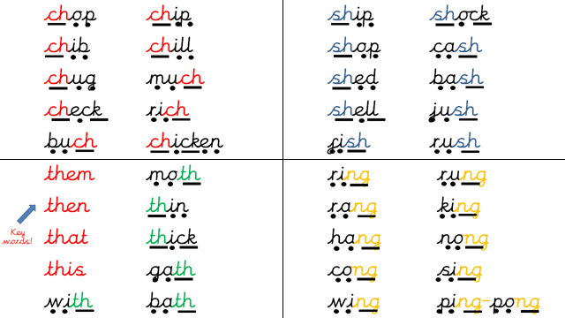

Practise reading these sentences with set 1 – 7 letters plus the four consonant digraphs and some tricky key words.

I am in such a rush to get to the shops.
A man is rich if he has lots of cash.
Natasha sang a song to me.
The van will chug up the long hill.

Handwriting:

Keep practising your handwriting – remember to write on the line! You can practise on any paper! If your paper does not have line – draw some!
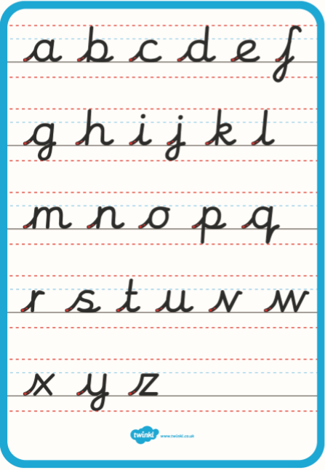

Practise your handwriting with the following words:

chop
ship
with
ring
chicken

Everyday English:

Look at the following picture. What can you see? What are they doing? See if you can get someone to read you the questions.

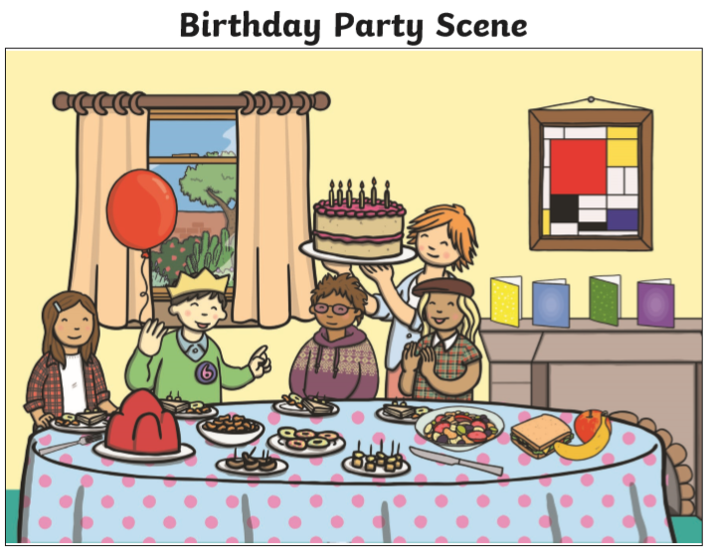

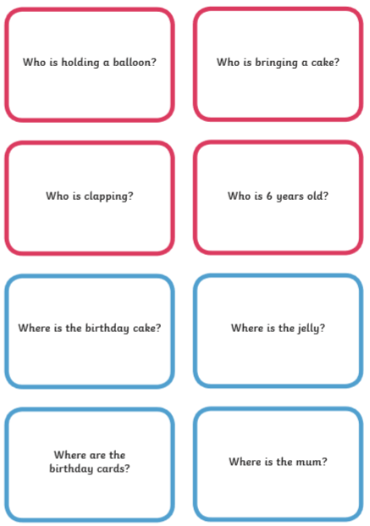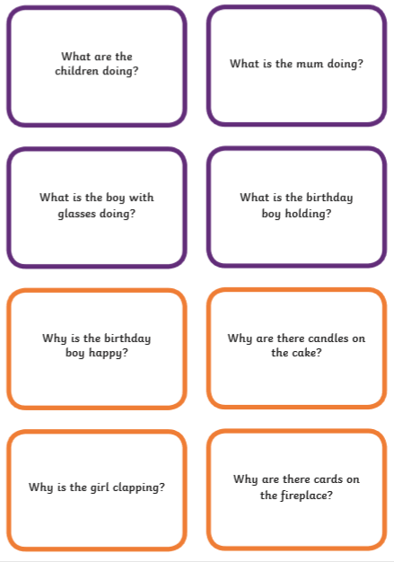

Try and use the following words:

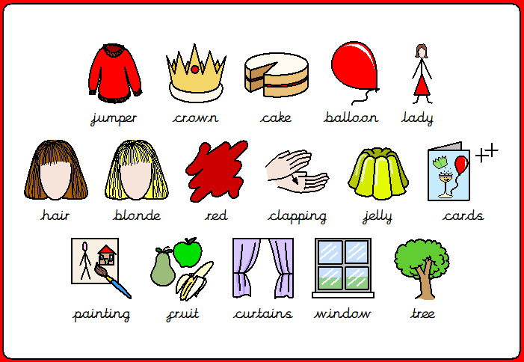
I-spy game!

Play I-spy with someone in your house. Then, complete the sheet. You can write the answers on any piece of paper.
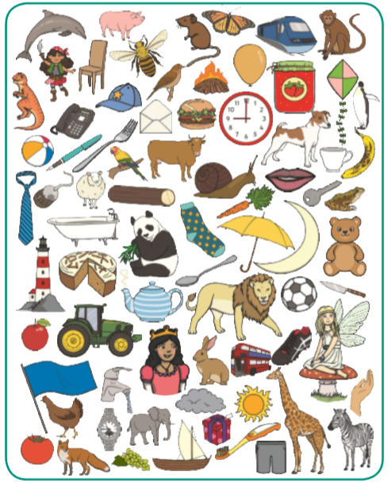

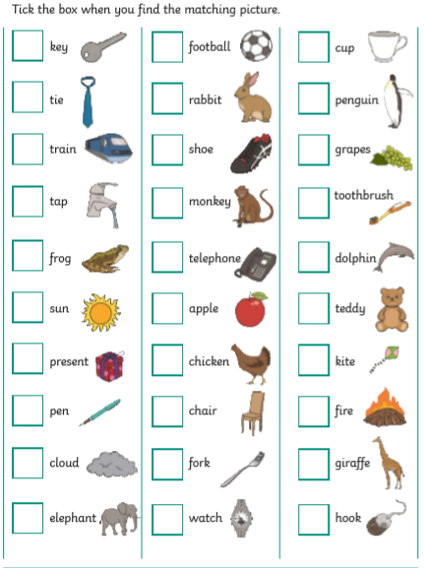

Talk!

Discussion of the week!
Look at the following question and discuss it with someone. Tell them WHY!
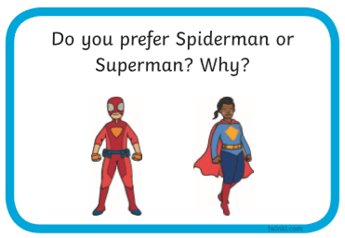

Useful websites:

Have a look at the following websites

- https://www.bbc.co.uk/cbeebies/shows/alphablocks - great phonics videos!
- https://www.bbc.co.uk/cbeebies/shows/numberblocks - great number videos!
- https://www.phonicsplay.co.uk/# - free to sign up!
- https://www.youtube.com/channel/UCP_FbjYUP_UtldV2K_-niWw - start from reception and work your way through!



I hope you enjoy the work and have a great week!

