Year 3 Home Learning
Week Commencing: 15th June 2020
Year 3 teachers: Mrs Begg, Mr Rogers, Mrs Lumsden and Mrs Priestland
Year x TAs: Miss Batool, Mrs Stringer
Message from staff:
Hello everyone. We hope you are keeping well and staying safe. This week for your learning, there is a mixture of activities but the Reading and Writing is based on a diary entry from a trip to the jungle. You can make up your own adventure to the jungle or another place you would like to go.
We understand it is quite hard to keep working through this but all we ask you to do is try your best and do the work you are able to do. Mrs Priestland and Mr Rogers will be calling you this week to see how you are and what you have been up too. Mrs Lumsden will be checking you work on Purple Mash (you should have received your individual log on details by email) and creating further home learning work.

Stay safe and look after yourselves.

Your Home Learning this Week:
Every day (Monday to Friday), make sure you choose a *reading, *writing, *spelling/handwriting, *maths and *theme learning activity. There are also further activities to choose from should you wish to.

Reading Home Learning
Monday | Tuesday | Wednesday |  | Thursday | Friday
Read the diary entry called Jungle log. Underline any words you do not understand. Use a dictionary to find the meaning of the words. | Complete the activity Let’s be explorers. | Find some examples of good adjectives in the diary.  Write a list of the adjectives. |  | Read the story-  Draw four pictures to tell the story.  Write a sentence to go with each picture.  Remember to pick the VIPs - very important parts. | If you could go on any adventure, where would you go? Draw a picture of where you would like to go.
Easier:  Do as many of the above activities as you can. If you are finding some of the activities challenging, try these as they are a little easier:  Ask mum or dad to read the story to you  - Where is the story set?  - Where did the person go?  - What did the person put on their feet?  - What time did they leave camp?  - Name the insect the person saw. What did it look like?  - What colour is the water?  - What colour are the fish?  - What colour is the grass??  - How did the explorer feel at the end of the day? |  |  | Challenge:  If you feel you need a further challenge, try these:  - Complete the synonym sheet in the pack.  - What can you remember now?  ★ Underline the correct definition of the words below.  - Does mesmerising mean ‘something that is boring’ or ‘something that is really exciting’?  - Is turquoise close to the colour blue or close to the colour red?  - Does trek mean ‘to run quickly’ or ‘to go on a difficult journey’?  - Does discovery mean ‘something you do all the time’ or ‘finding something for the first time’?
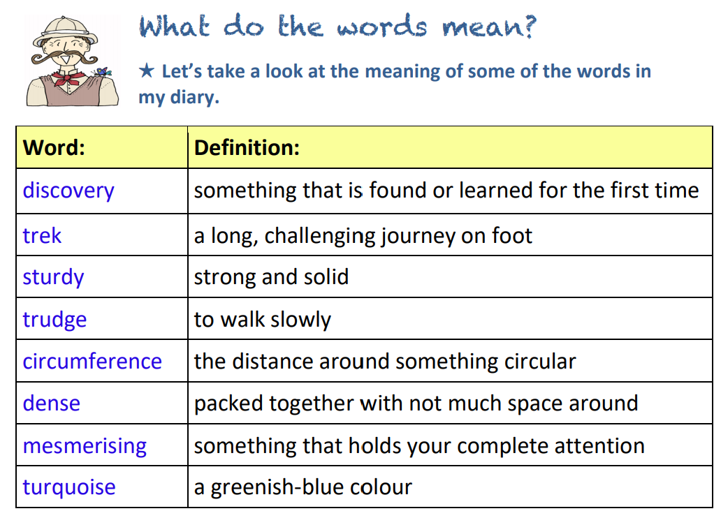
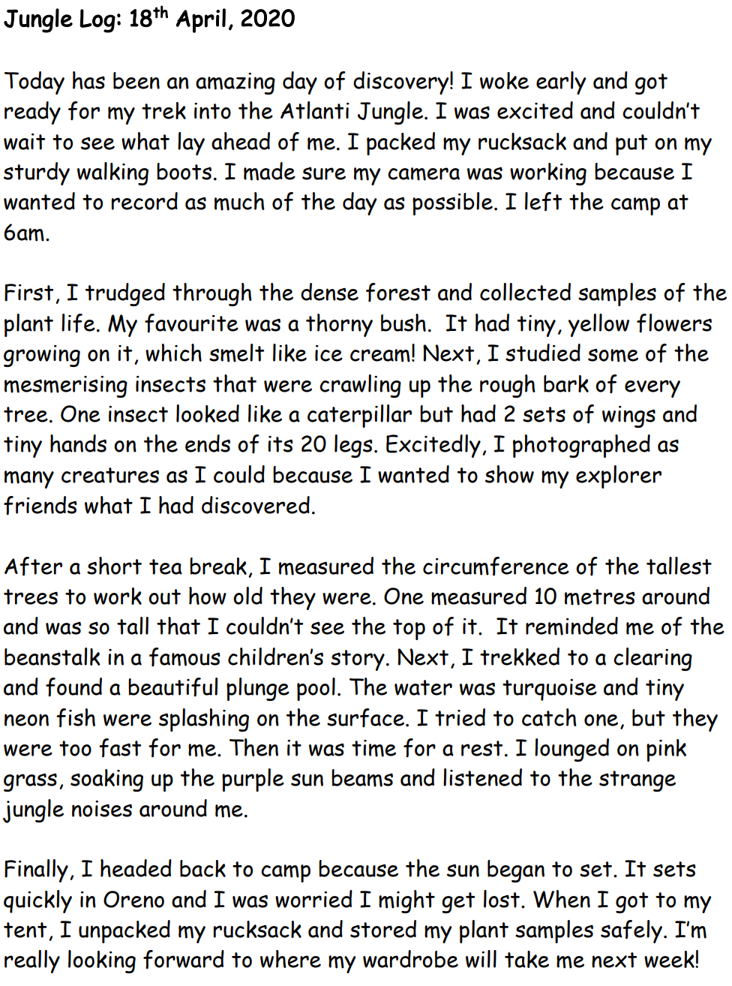

Writing Home Learning

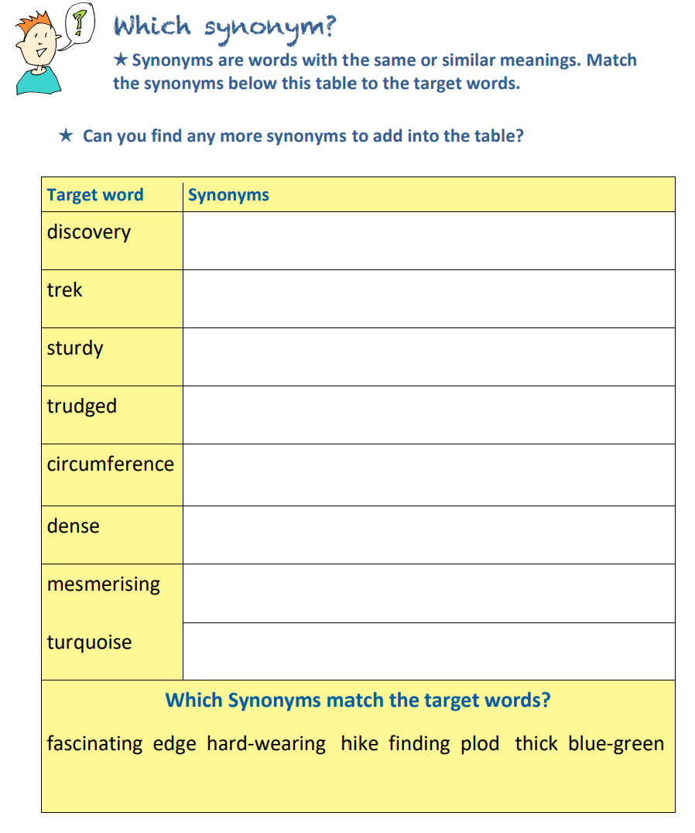
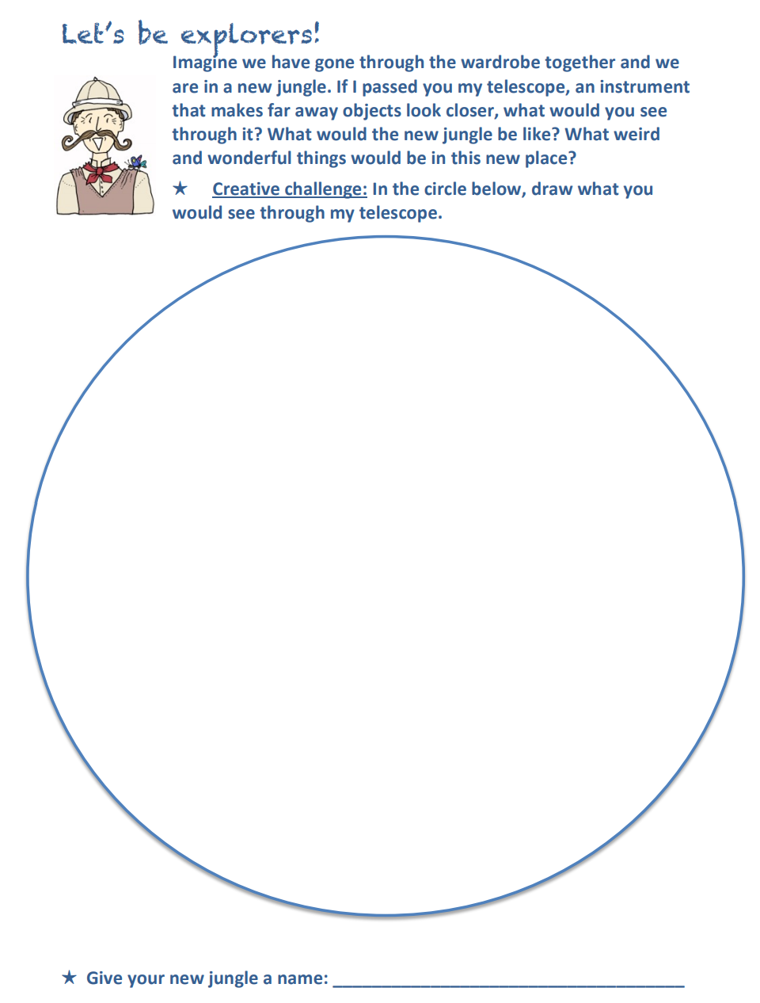

Writing Home Learning

Writing Home Learning
Monday | Tuesday | Wednesday |  | Thursday | Friday
You need to take a backpack on a trek in the jungle. Write down 10 things you need to have with you. Use the template under the work to create your backpack. | Use the plan below to think about what you got up to on your adventure in the jungle. | Write some sentences using and/but about your jungle adventure.  I tried to catch a fish but they were too fast for me. |  | The log uses sentence signposts to tell the reader when something happened in the journey. These include: First, Next, After that, Then, Afterwards, After a while, Finally, When  For example:  1. Next, I trekked to a clearing and found a beautiful plunge pool.  2. Finally, I headed back to camp because the sun began to set.  Write some sentences using the words in bold about your jungle trek. | Now, write your diary entry about your adventure in the jungle using the plan you did on Tuesday.
Easier:  Do as many of the above activities as you can. If you are finding some of the activities challenging, try these as they are a little easier:  - Draw a picture of your in your jungle setting and label it with what you saw.  - Write simple sentences about your jungle using adjective (colour, size) The jungle is huge. I saw green leaves. The jungle has creepy insects.  - Now join the sentences together using and The jungle is huge and I saw lots of green leaves. In the jungle, I saw a green frog and a scary fish. |  |  | Challenge:  If you feel you need a further challenge, try these:  - When writing your diary, try and use because in the sentences.  - Imagine you met a talking animal in the jungle. Write a conversation you would have with the animal.

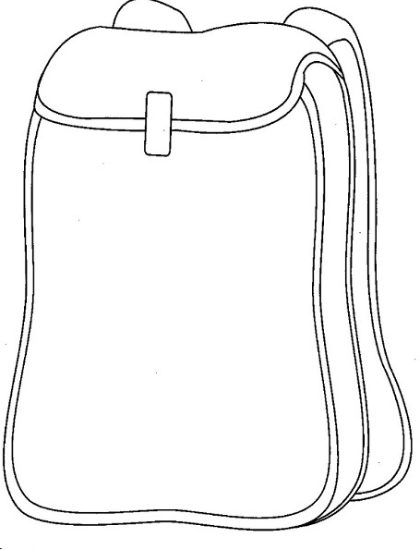

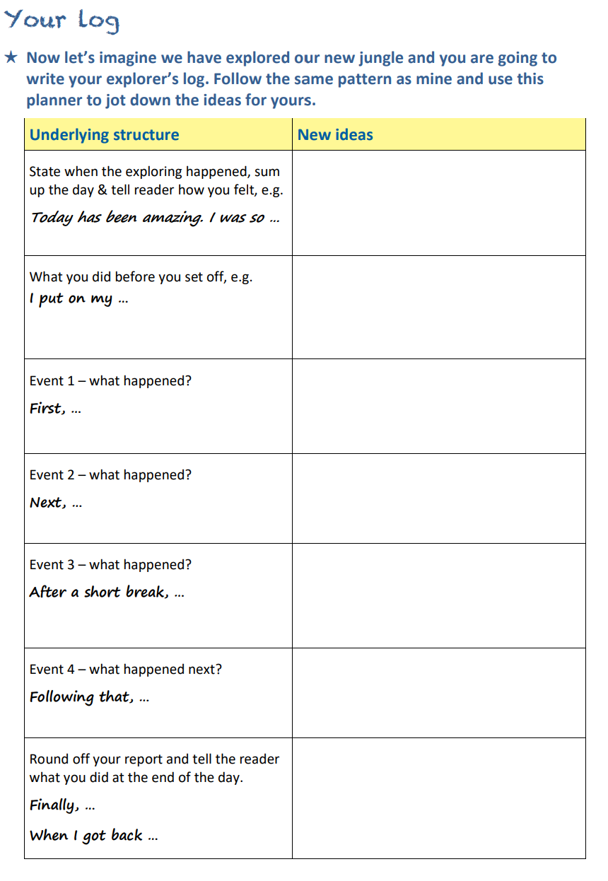

Spelling/Handwriting Home Learning
Monday | Tuesday | Wednesday |  | Thursday | Friday
Colour write the key words below:  enough exercise  extreme experience  imagine increase  important straight | Pyramid write the words from Monday | Write the words from Monday in a sentence. |  | Complete the correct spelling work below | Complete the spelling word search.
Easier:  Do as many of the above activities as you can. If you are finding some of the activities challenging, try these as they are a little easier:  Practise writing the days of the week and months of the year.  Write down the numbers 1-20 as words. Write them in different colours. (see the sheets below) |  |  | Challenge:  If you feel you need a further challenge, try these:

Each sentence below has one word that is incorrect. Write the correct spelling of the word in the box.
1. Lily’s birthday is in Februry.
2. The doctor gave the girl some medisin to make her feel better.
3. The class really enjoyed the science expirimint.
4. What hite is Dad compared to Mike?
5. 100 years is the same as a sentuary.
6. That scarf is difrent to that one!
7. Kim went to the librie and got four books out.
8. It’s not posibil.
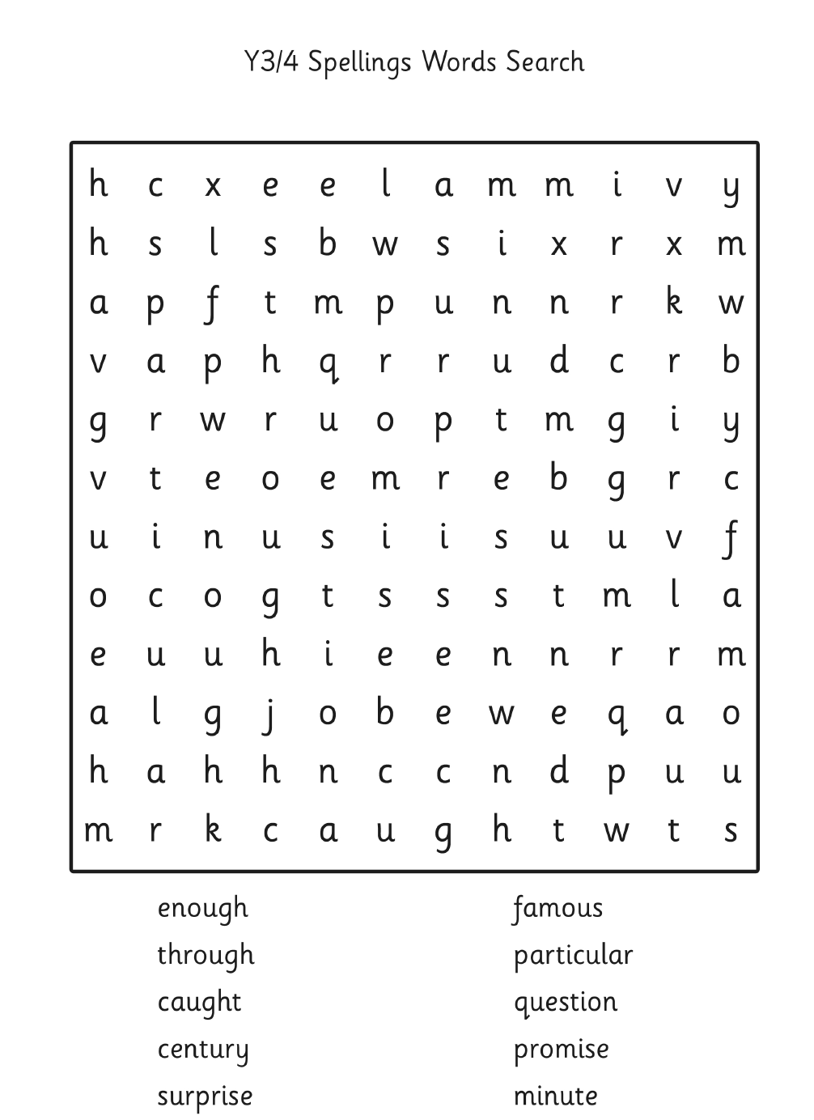

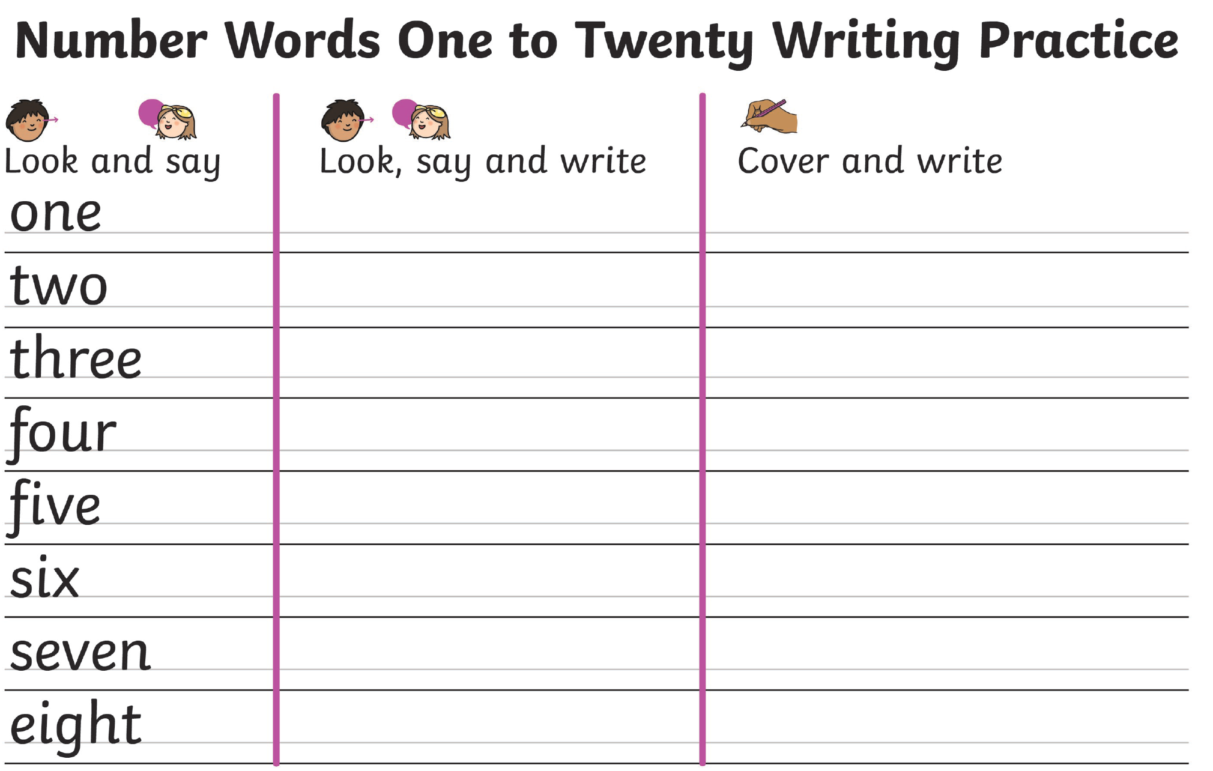

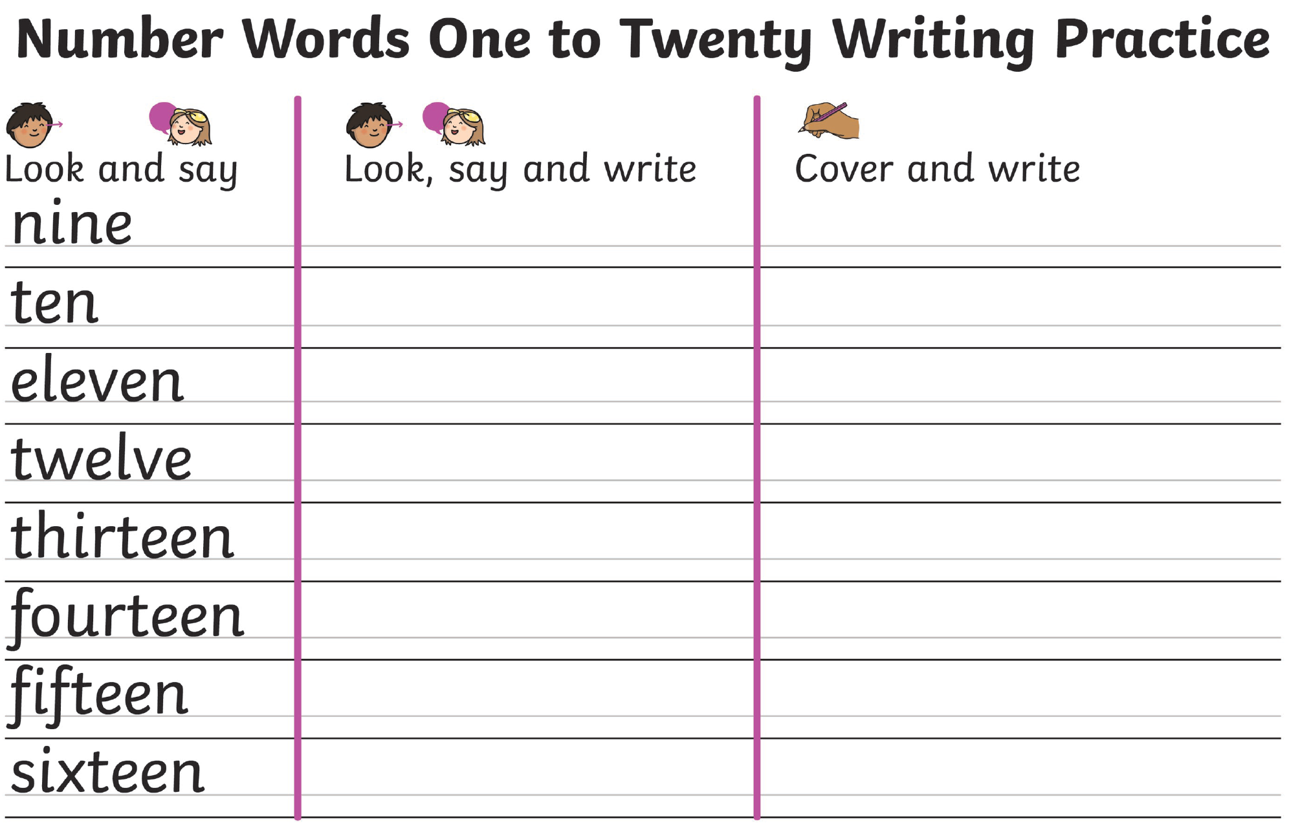

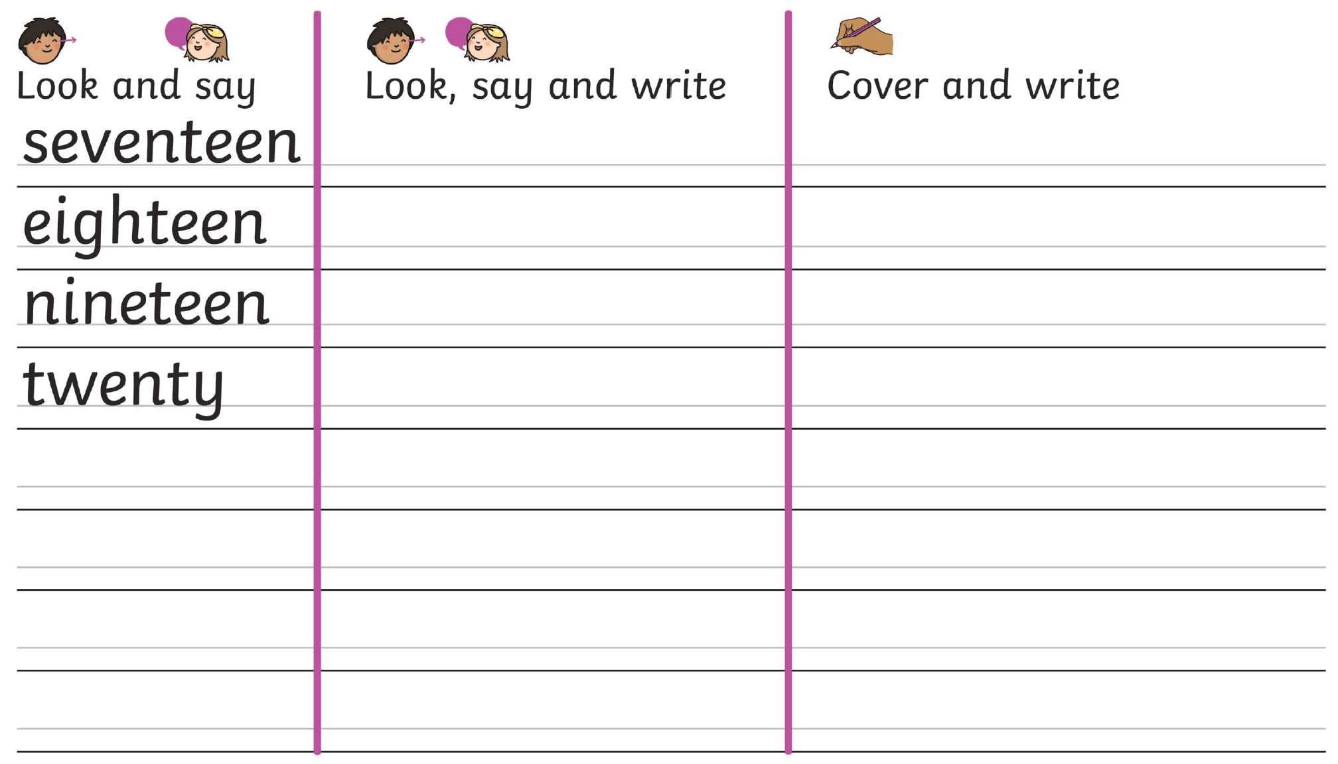

Maths Home Learning- This week we will look at making graphs
Monday | Tuesday | Wednesday |  | Thursday | Friday
Complete the sheet below about reading tables (Drawing Picture graphs) | Complete the sheet below about bar charts | Ask people in your family what their favourite fruit is and collect the information in a table |  | Use the table from yesterday to make a bar chart to show your information. | Write 5 questions about your bar chart to ask your family. This could be questions like how many people like….., which is the most popular/least popular
Easier:  Do as many of the above activities as you can. If you are finding some of the activities challenging, try these as they are a little easier:  Number work:  Write down all your + and – number bonds to 20 |  |  | Challenge:  If you feel you need a further challenge, try these:  Have a go at the True or False? And read the graph problems.
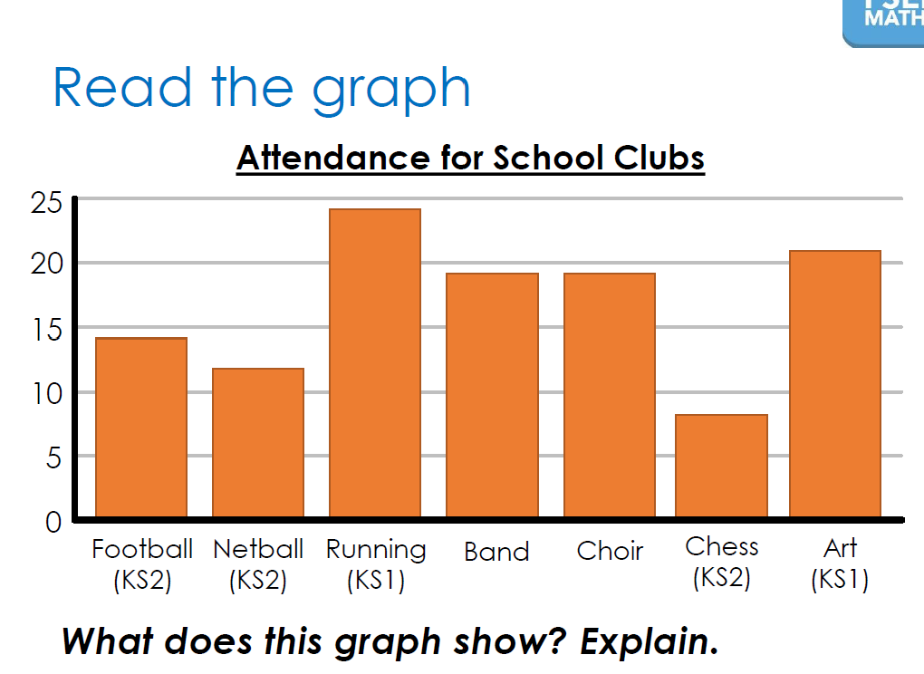
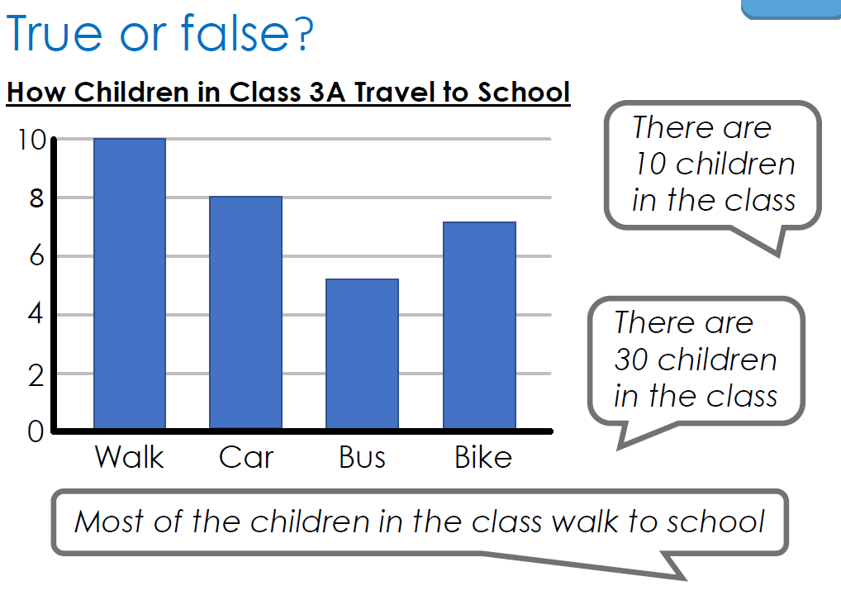

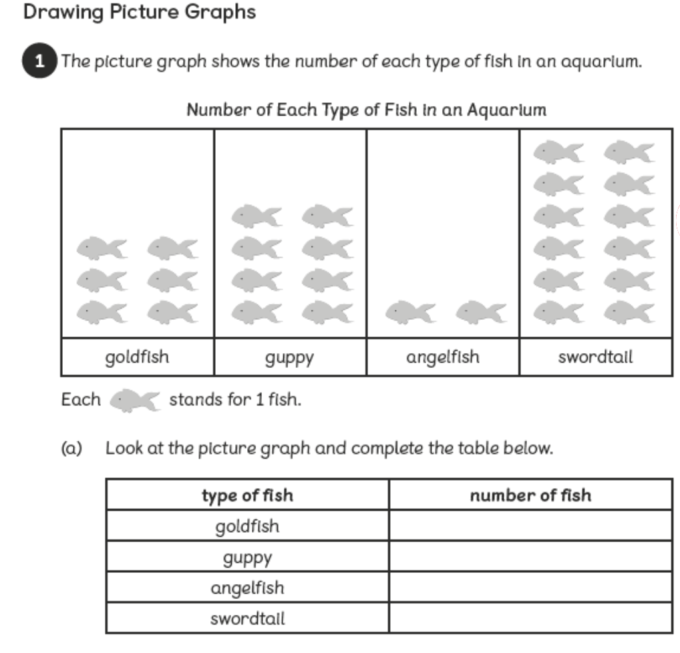

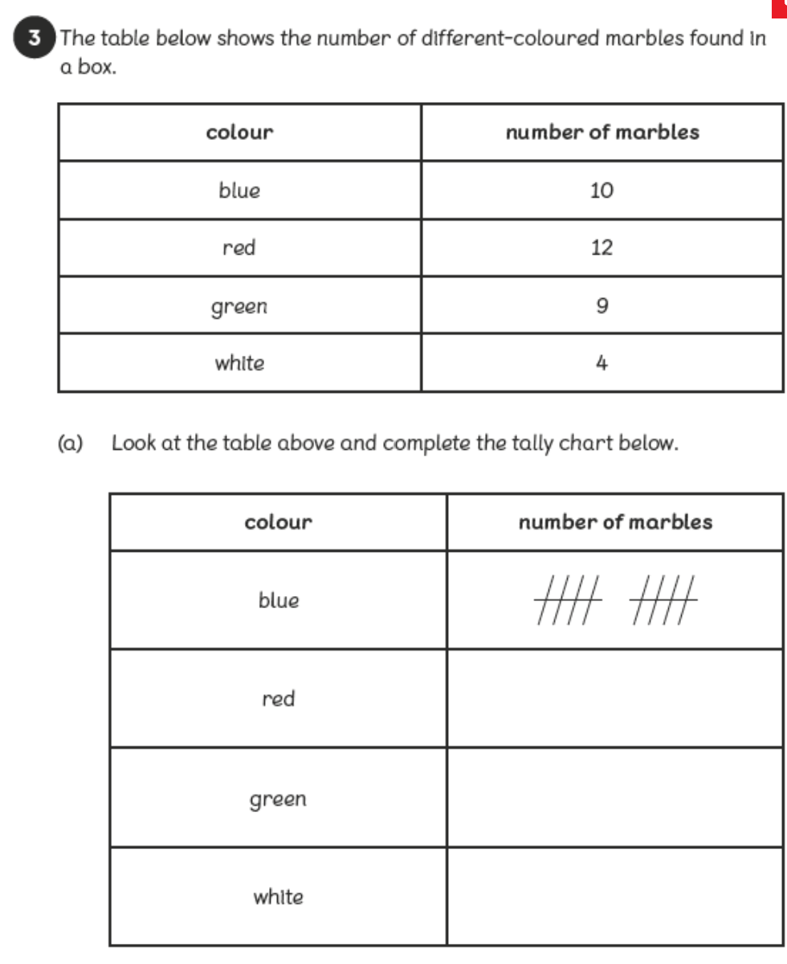
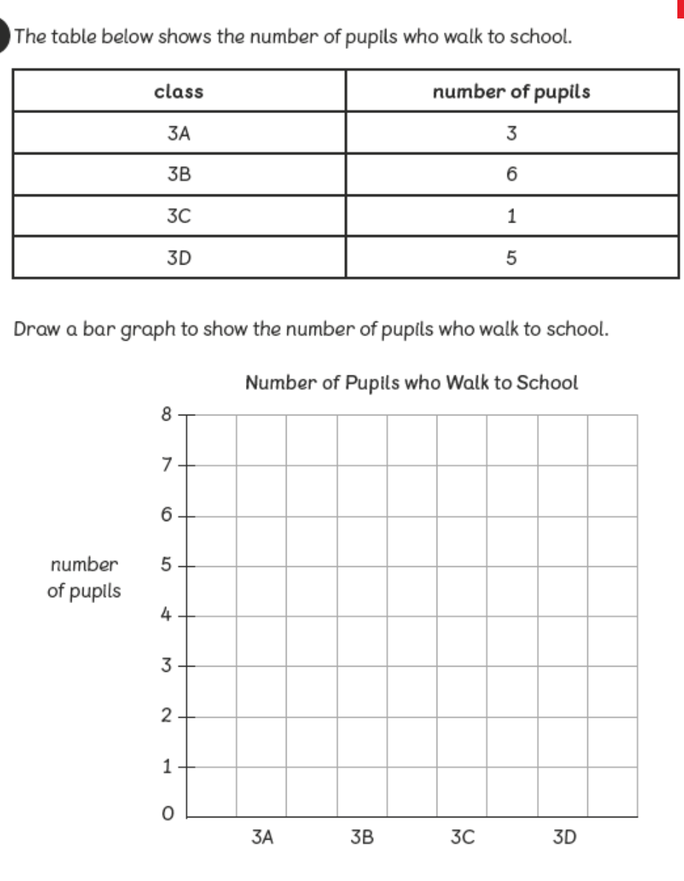
Tuesday

Theme Home Learning
Celebration food- write down some foods you might eat on special occasions like Eid, birthday, Christmas, weddings. | Design your own fruit. What would it be? You can merge two fruits together and give it a new name. Write about your fruit? Name, where does it grow, describe it. | Look at different packaging for food. Find some examples of food coming in a bag, box, wrapped up etc. Design a new packaging for your fruit you have designed. | Make a list of all the food in your cupboard. Sort them into healthy and unhealthy food. | Mrs Priestland loves to bake, and she recently made a birthday cake for her little boy. Have a go at designing a birthday cake for someone in your family. If you want to, why not make it for them, take a photo to show your teacher when you come back.

Other Activities This week we will investigate two more types of automatic negative thoughts you might have.
Complete the sheet that teaches you all about 2 more types of automatic negative thoughts, how many examples can you think of?  Remember to do some mindful breathing at home. | Learn about why attachment to thoughts and expectations may cause you to suffer.  Remember if you have an automatic negative thought to ‘catch it’ ‘check it’ ‘change it’ and let it go.  Practise the ‘grounding’ technique. | Draw or write your experience of a grounding technique.  Remember to notice the tiny details to help you stay in the present instead of the future or the past. | Design your own grounding technique.  Draw your own symbols for it.  Then practise it to see if you like it. | Begin to visualise your ‘happy’ place.  Remember, you do not need to explain it to anyone else. It is where you feel safe, calm and happy.  Draw it on the large piece of paper. Then practise visiting it in your mind.

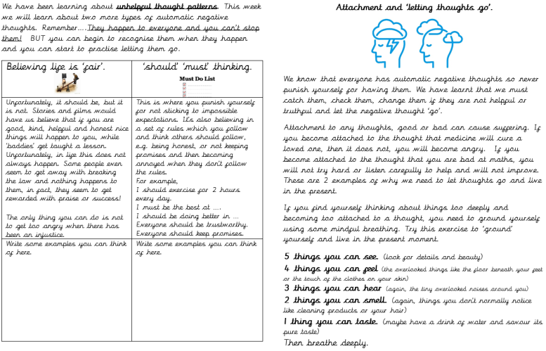
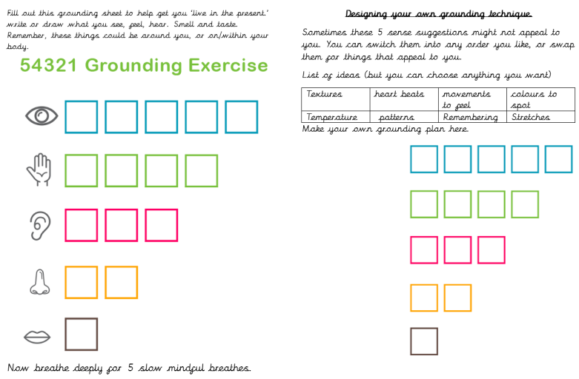
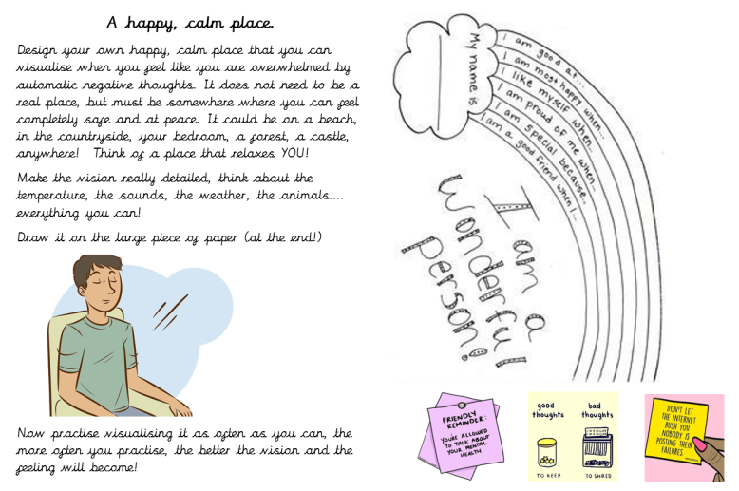
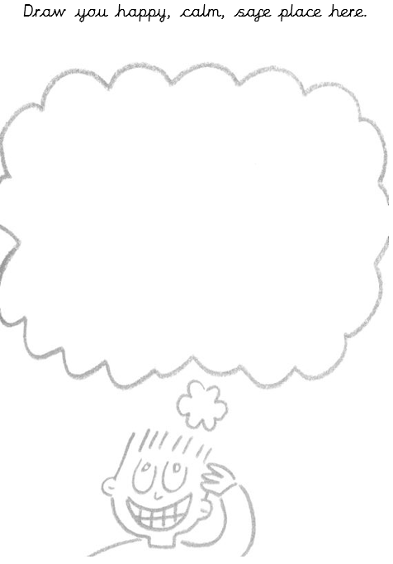
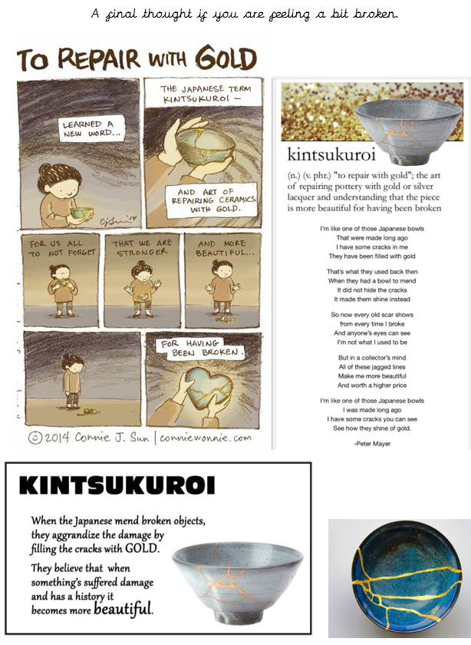
Key skills to continue practising weekly:
- 2, 3, 4, 5, 8, 10 times tables
- Quick addition and number facts 9+7 11 - 5
- Year One, two and three spelling sheets
- Reading any books, newspapers, cereal packets, websites you can find

If you are able to access the internet, try these useful websites:
- BBCbitesize/daily lessons
- https://www.youtube.com/user/CosmicKidsYoga- Cosmic Yoga is amazing. There are lots of yoga stories, mindfulness activities and active exercises for you to do.
- https://scratch.mit.edu/- we would be doing this if we were at school. Have an explore of Scratch and learn how to code. Make the cat move, speak and even dance. Create new characters, change the background and have some fun.

If you or your child has any further queries regarding their learning projects, please contact admin@hardwick.derby.sch.uk, clearly stating your child’s name and class teacher, and the staff will be in touch to support you and your child.

Thank you and stay safe.

