Phonics and Key Words

Key Words

Practise reading these key words:

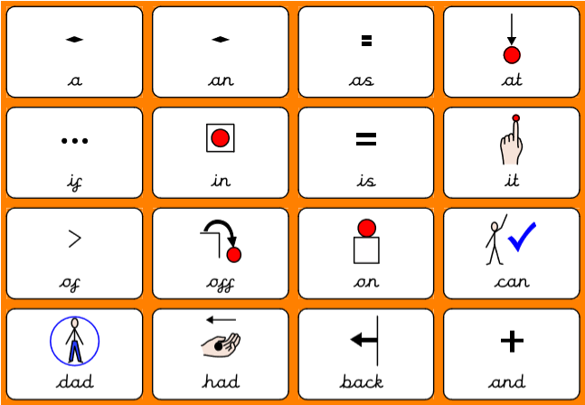

Practise writing these key words. The first two you can look to make sure you are spelling it right. Next, give it a go without looking. Lastly, check is you spelled it right!

Key word | Practise 1  (copy into space) | Practise 2  (copy again) | Practise 3  (fold and hide) | Can spell word  (check and correct)
a
an
as
at
if

Key word | Practise 1  (copy into space) | Practise 2  (copy again) | Practise 3  (fold and hide) | Can spell word  (check and correct)
in
is
it
of
off

Key word | Practise 1  (copy into space) | Practise 2  (copy again) | Practise 3  (fold and hide) | Can spell word  (check and correct)
on
can
dad
had
back

Phonics:

Read and write the following words. First segment the words e.g. cat – c – a – t. Then, try and read the words without segmenting them!

Focus GPCs = ‘J V W X’

j | v | w | x
jam | van | will | mix
Jill | vat | win | fix
jet | vet | wag | box
jog | Vic | web | tax
jack | Ravi | wig | six
Jen | Kevin | wax | taxi
jet-lag | visit | cobweb | vixen
jacket | velvet | wicked | exit

Give it a go reading the following sentences. Remember to try and not segment the key words in RED.

It will be with jam.
She is at the vet.
They will look at the web.
It was all in my box.
Which sentence do you think goes with which picture?
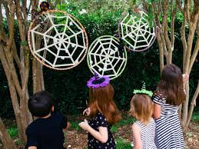

Handwriting:

Keep practising your handwriting – remember to write on the line! You can practise on any paper! If your paper does not have line – draw some!
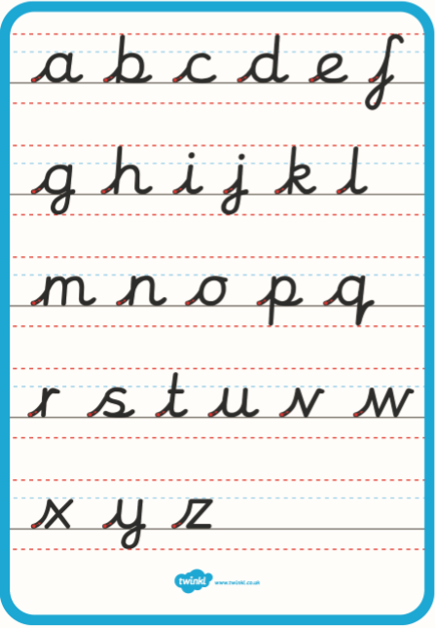
Everyday English:

Look at the following picture. What can you see? What are they doing? See if you can get someone to read you the questions.
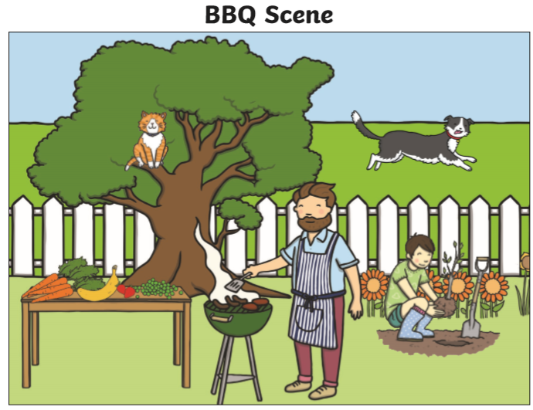

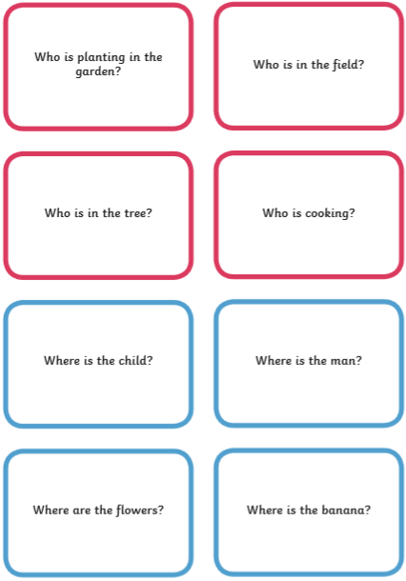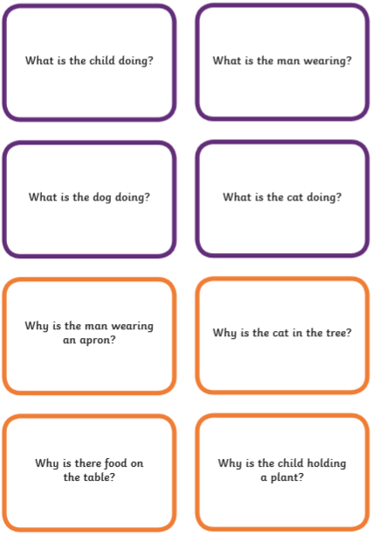
I-spy game!

Play I-spy with someone in your house. Then, complete the sheet. You can write the answers on any piece of paper.
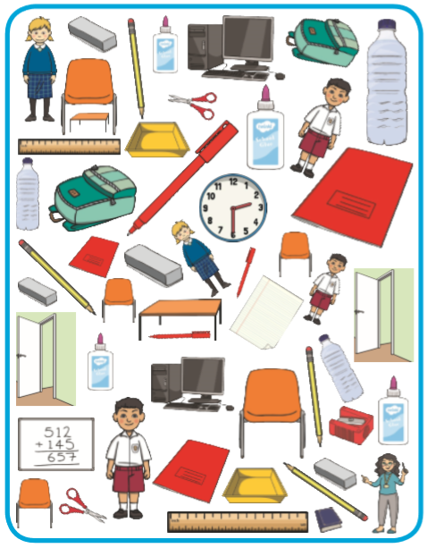

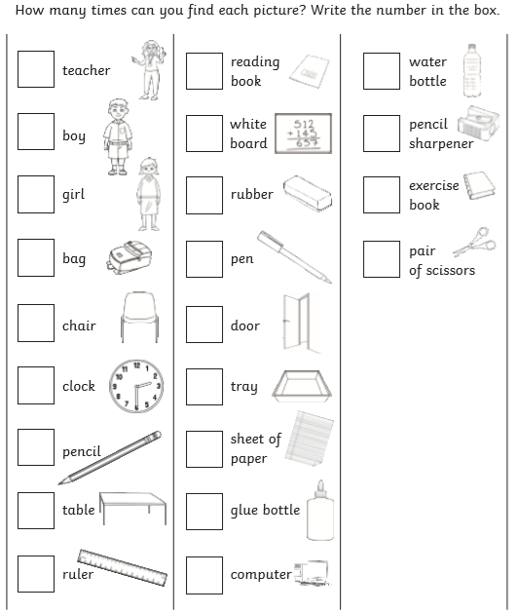

Talk!

Discussion of the week. Look at the following question and discuss it with someone. Tell them WHY!

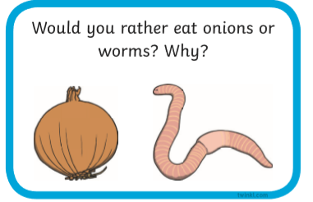

Useful websites:

Have a look at the following websites

- https://www.bbc.co.uk/cbeebies/shows/alphablocks - great phonics videos!
- https://www.bbc.co.uk/cbeebies/shows/numberblocks - great videos for number!
- https://www.phonicsplay.co.uk/# - free to sign up!



I hope you enjoy the work and have a great week!

