Year 2 Home Learning
Week Commencing: 6th July 2020
Year 2 teachers: Mrs Nicholson and Mrs Tomordy
Year 2 TAs: Mrs Rowland and Ms Shaista
Message from staff: Hello everyone.
TRUE or FALSE
The record for the height of cheese and onion crisps stacked up on each other is 1.4 metres.
There is no record for cheese and onion crisps but there is one for the tallest stack of tortillas! 389 tortillas were stacked on top of each other to reach the height of 68.5 metres.

Make sure you are reading every day!
Where is the most unusual place you have read?

Your Home Learning this Week:
Every day (Monday to Friday), make sure you choose a *reading, *writing, *spelling/handwriting, *maths and *theme learning activity. There are also further activities to choose from should you wish to.
Reading Home Learning
You will be reading a text about animals in a sports day. Make connections with what you already know about sports days. Have you been in a sports day? Which races are usually in a sports day? Which animals do you think would be good in sports’ day races?  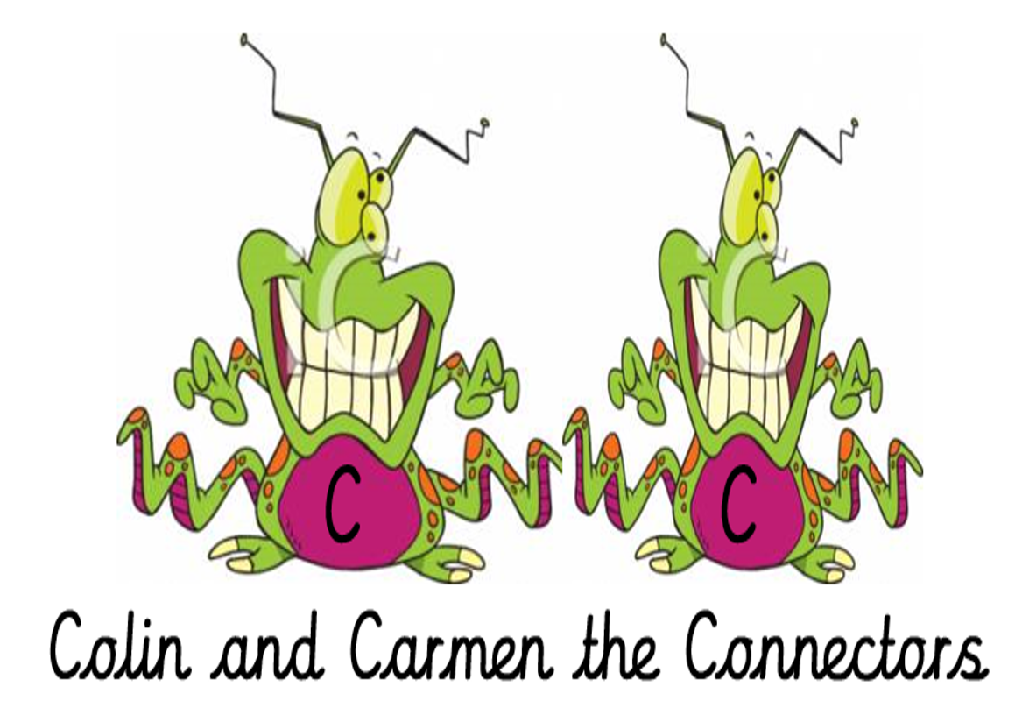 | Read ‘The Terrible Trip-up!’, using reading skills to help you understand as you go through it. Highlight any words you do not understand and find the meaning of them.  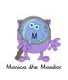 | Summarise what you have read in the text. A summary covers the very important parts of the text (VIP). Which parts in the text do you think are important?  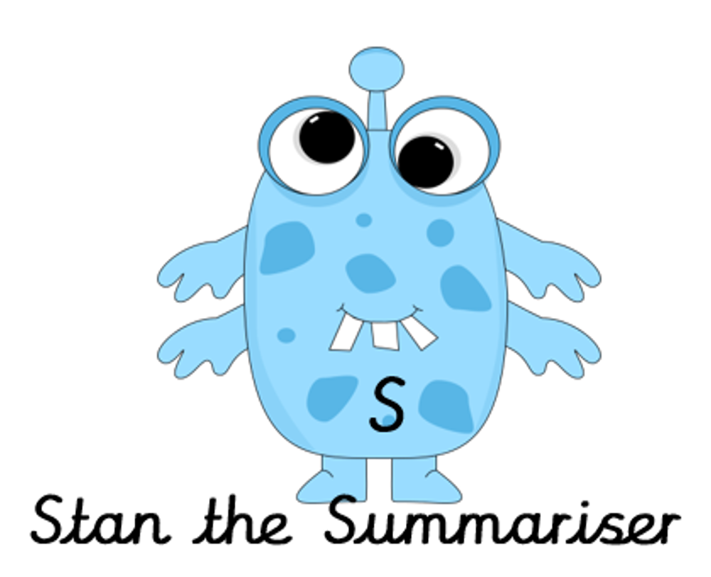 |  | Now try answering these questions:  - Who was boasting about being so good?  - Who was worried about not being good at anything?  - What happened to the koalas in the three-legged race?  - Which race did the zebras win?  - Who won the three-legged race?  - Which team fell on top of the foxes?  - How did the rabbits win the race? | After reading the text on ‘The Terrible Trip-up!’, think of any questions you may have. Is there anything you were left wondering that was not answered? Write these questions down. Reread the text again and this time, try to answer the questions you have. Can you answer them? 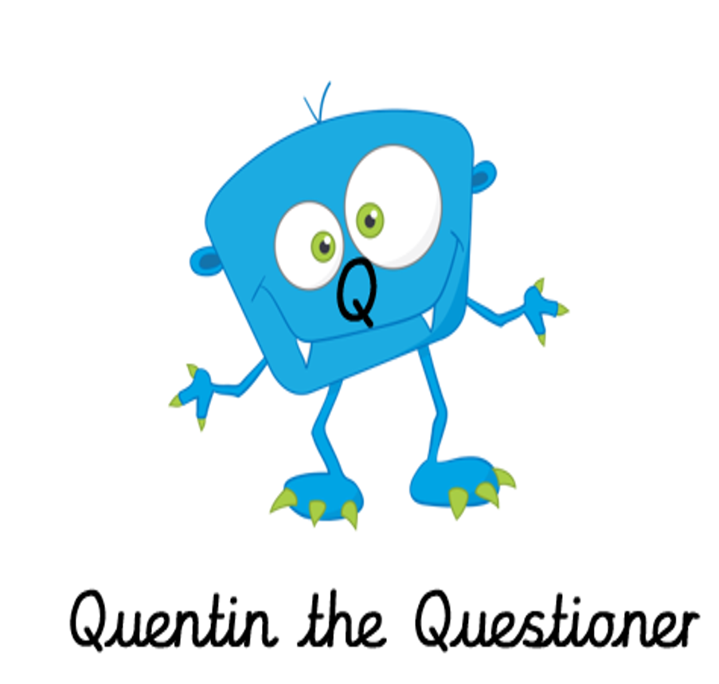
Easier:  Do as many of the above activities as you can. If you are finding some of the activities challenging, try these as they are a little easier:  Look at the information on farm animals.  Which animals has wool for its coat? ____________________________________________________________________________________________  Which animal has an udder? ____________________________________________________________________________________________  Which animal has a beard? _________________________________________  Which animal can run and bark? _________________________________  Which animal has hooves? _______________________________________  Match where each animal sleeps:  With the farmer  cow  dog  In a barn  sheep  In a pen  goat  In a shed |  |  | Challenge:  If you feel you need a further challenge, try these:  - Which races would you enter in a sports day?  - How would you work in a team to win a relay race?
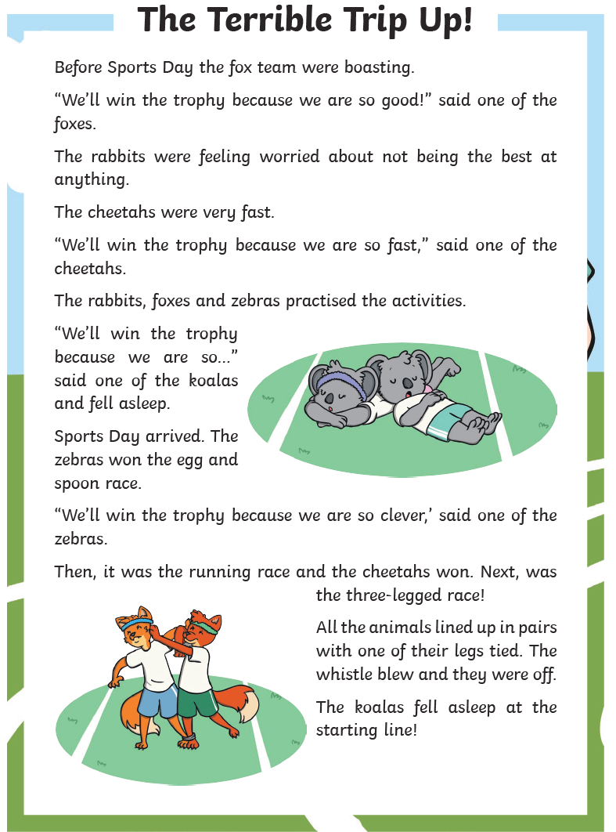  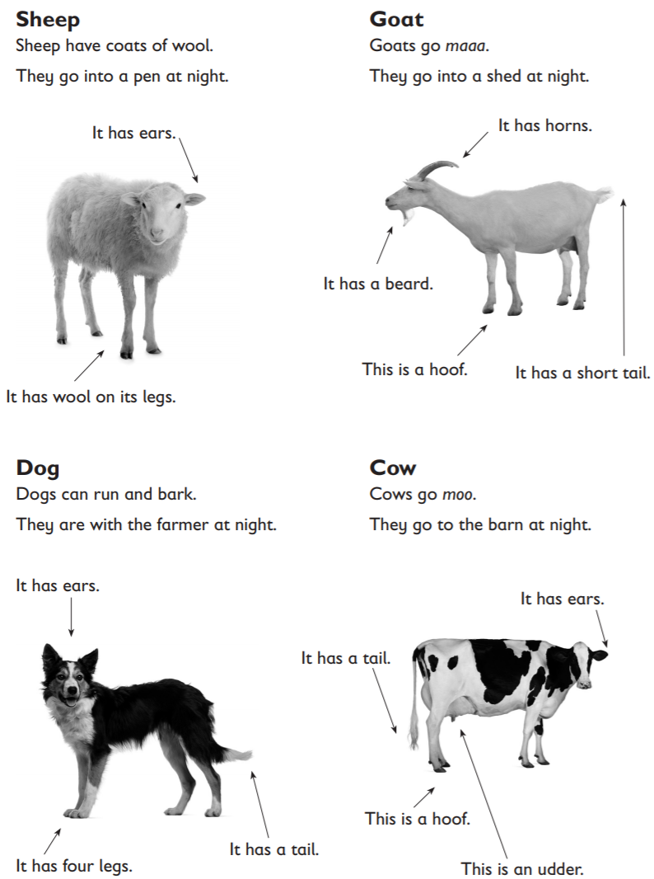 |  |  | 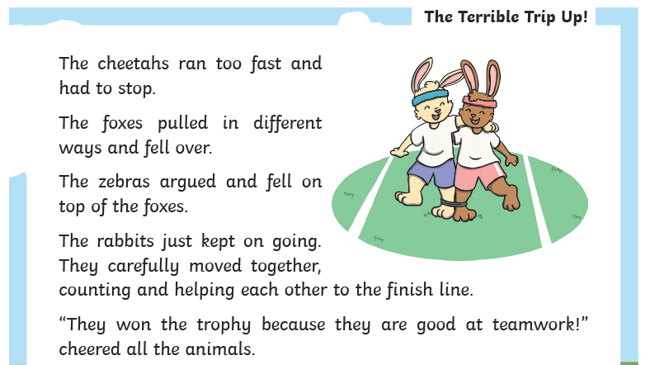
Writing Home Learning
Task 1  Talk about the picture.  What happens next?  Try to use because and when in you sentences.  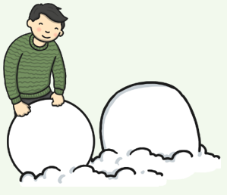 | Task 2  Write a sentence using a possessive apostrophe. Remember this is when something belongs to someone. One has been done.  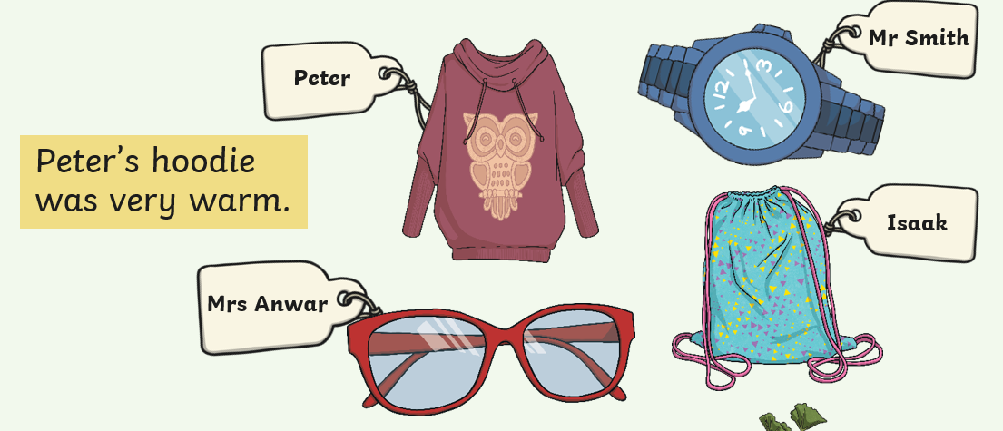 | Task 3  Match these words to make compound words. Write them in a sentence.  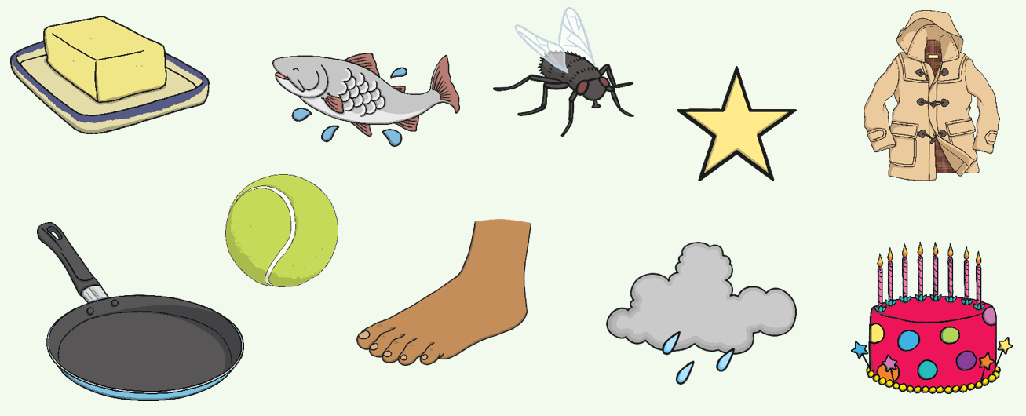  pan star foot ball  cake coat butter rain  fish fly |  | Task 4  Look at the picture. What words and sentences does it make you think of? Write some sentences based on the picture.  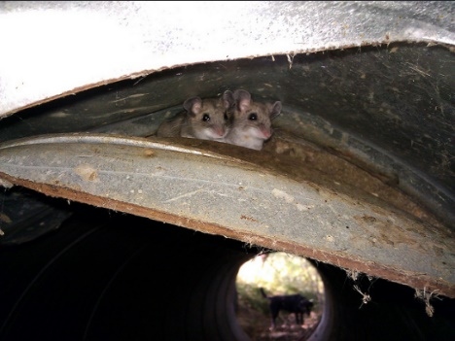 | Task 5  Read the sentences below. Can you give a dictionary definition for each of the underlined words? You may not know what the word means so you must use the clues within the sentence to help you to work it out.  Jessica listened carefully as she thought she could hear a faint scratching sound coming from the nearby tree trunk. As she looked inside, Jessica saw two tiny mice, timidly looking back at her with shivering whiskers.
Easier:  Do as many of the above activities as you can. If you are finding some of the activities challenging, try these as they are a little easier:  - Use the word bank below to help you create and write a story about the boy in the picture above.  What is the boy’s name? Is he building a snowman? Is it winter? How will he make the snowman? What will he use?  - Read and check your story.  - Read your story to someone else.  - Draw a picture for your story.  snow fairy snowman  boy build carrot  winter coat hat  scarf buttons gloves |  |  | Challenge:  If you feel you need a further challenge, try these:  Task 1  Continue the story from above:  Jessica listened carefully as she thought she could hear a faint scratching sound coming from the nearby tree trunk. As she looked inside, Jessica saw two tiny mice, timidly looking back at her with shivering whiskers.  Task 2  Add some noun phrases to your story:  small, velvet ears;  juicy, red berries;  long, delicate tails.
Spelling/Handwriting Home Learning
Monday | Tuesday | Wednesday | Thursday | Friday
This week’s spellings are all about silent letters. We are going to look at the kn and gn when they are at the start of a word.  So with each of the following words see if you can use look, cover, write and check to do each words 10 times and so learn them and know how to spell them without having to look.  knight  know  knew  knobbly  knit  knock  gnat  gnaw  gnome | Have a go at ladder writing each of these words so you remember the beginning of them.  k  kn  kni  knig  knigh  knight | Have a go at the word search below that has some of the words in. Now you have learnt how to spell them they should be easier to find. | Handwriting time.  Try writing each of these words in a sentence in your very best handwriting. The k is one of the hardest letters to get right so be careful that it does not look like a capital R. | 3 of the words are homophones. Knight, knew and know. Can you spell the other version of them correctly and use them within a sentence so that they make sense?
Easier:  Do as many of the above activities as you can. If you are finding some of the activities challenging, try these as they are a little easier:  - How would you do the ‘i’ sound when it is at the end of a word? So is it cri? Fli? Of course not! You need to use a ‘y’ when you hear this sound at the end of a word. To practise this see if you can carry on this sequence – twenty, thirty, ……one hundred.  - Can you spell all of the year 1 common exception words now? Have a go, the sheet of them all is below along with the year 2 ones so you can be practising them. |  | Challenge:  If you feel you need a further challenge, try these:  - Mr Whoops needs your help. He has had a go at writing a passage, but he is sure some of the words do not look right. Can you underline the words he has spelt wrong and create list for him of how to spell them?  - Now can you write out the passage again with the correct spellings?  - There are 14 that are spelt wrongly.
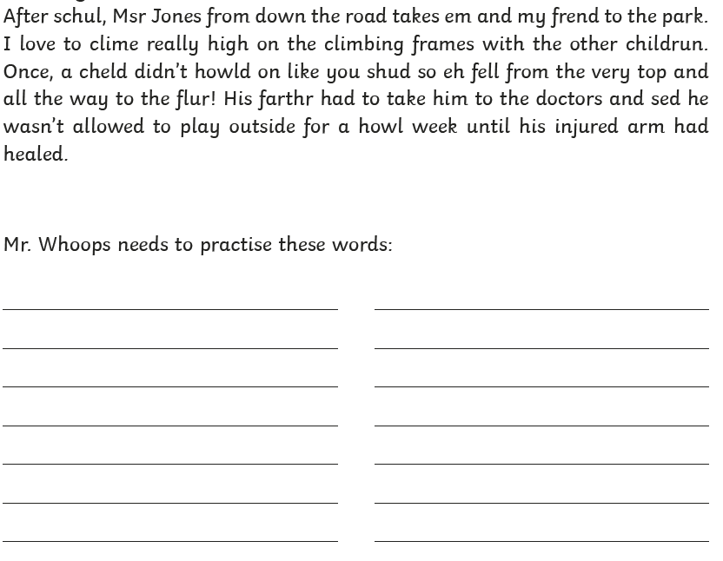
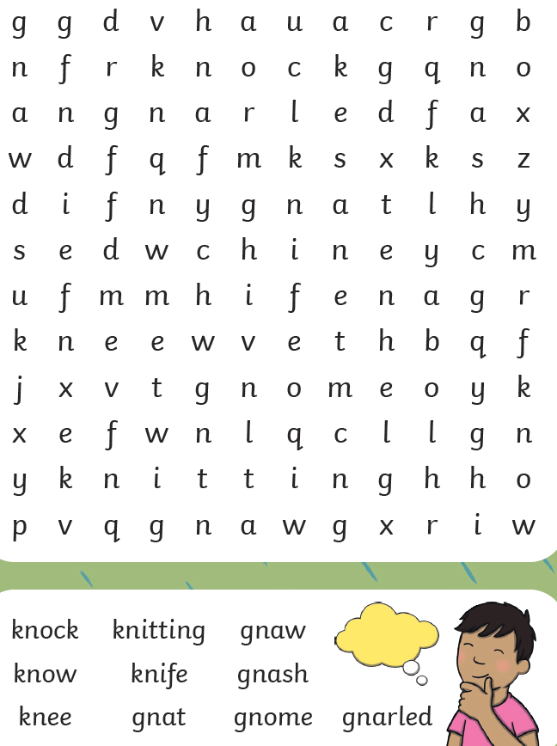
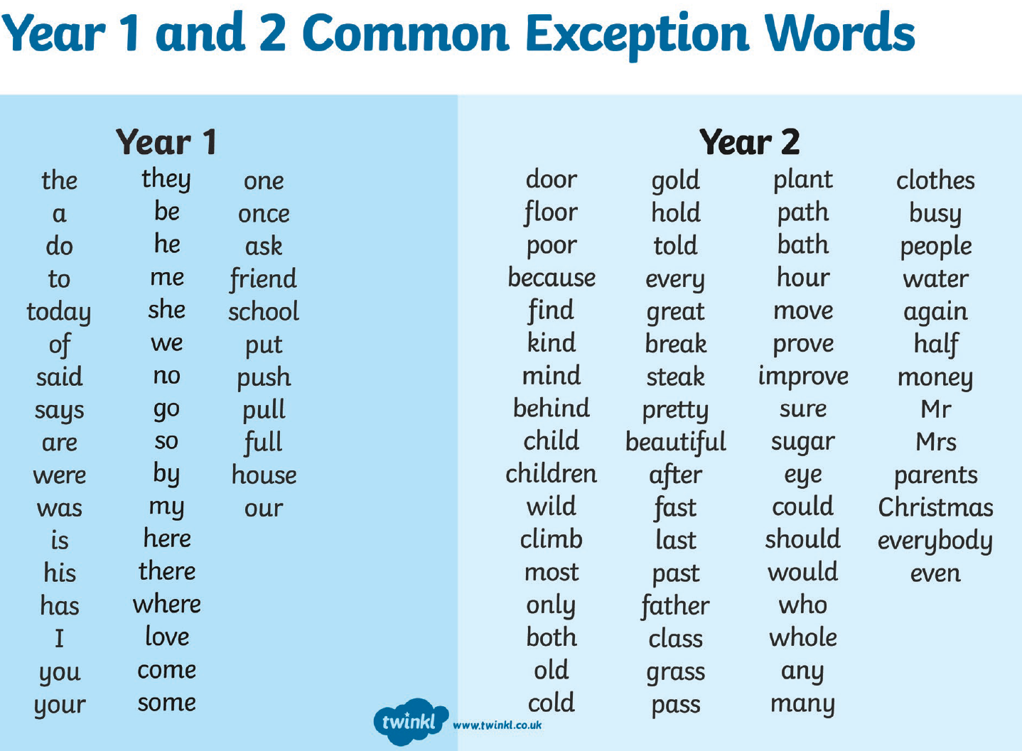
Maths Home Learning
Monday | Tuesday |  | Wednesday
Times Tables  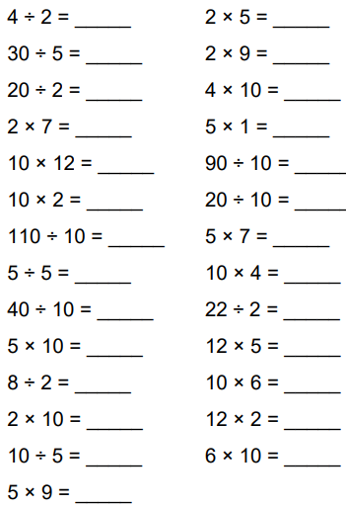 | Counting in 2s 5s and 10s  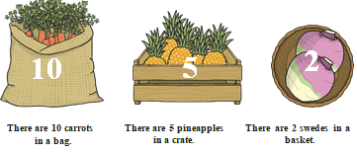  - How many swedes are there in 6 baskets?  - How many swedes are there in 10 baskets?  - How many baskets are needed for 14 swedes?  - How many pineapples are there in 5 crates?  - How many pineapples are there in 9 crates?  - How many crates are needed for 30 pineapples?  - How many carrots are there in 3 bags?  - How many carrots are there in 7 bags?  - How many bags are needed for 60 carrots? |  | 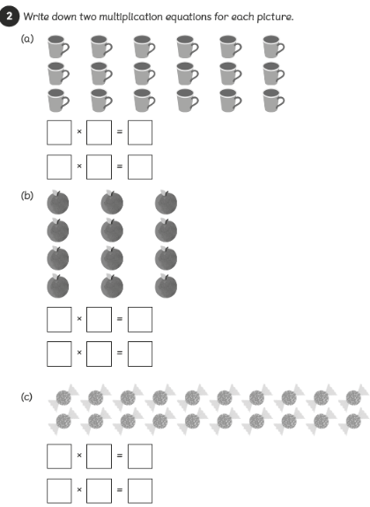
Thursday |  | Friday
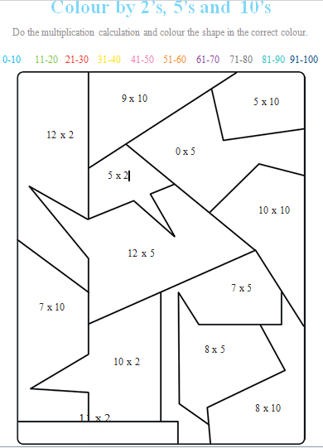 |  | 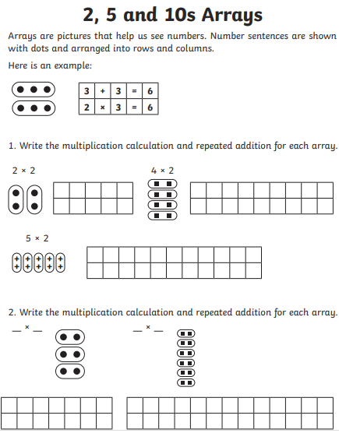

Easier:  Do as many of the above activities as you can. If you are finding some of the activities challenging, try these as they are a little easier:  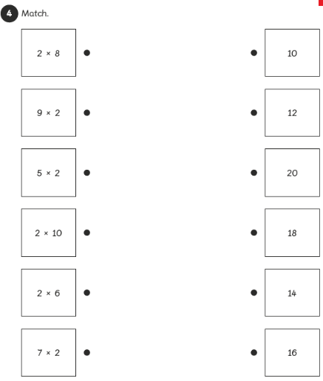  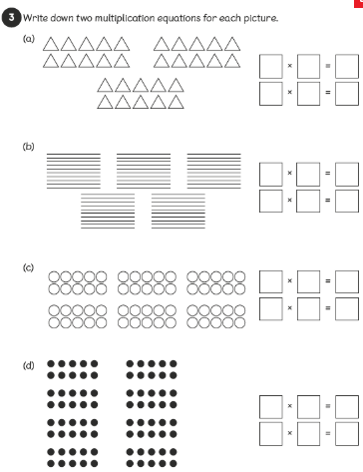 | Challenge:  If you feel you need a further challenge, try these:  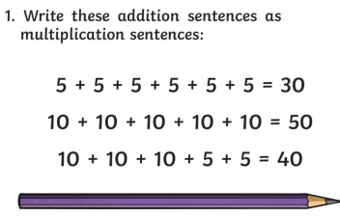  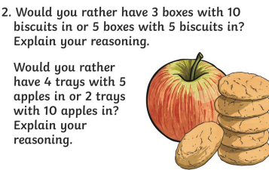

Theme Home Learning
Monday | Tuesday | Wednesday |  | Thursday | Friday
Science  Complete the table below by choosing the right food to be eaten. | Science  Write a recipe of any of your favourite food. | D&T  Follow the recipe below to make ‘Traffic light lollies’ |  | Geography  Look at the map of the United Kingdom below. Label the different countries and bodies of water in the blank boxes | Geography  Complete the information about your location on the map below.
Easier:  Do as many of the above activities as you can. If you are finding some of the activities challenging, try these as they are a little easier:  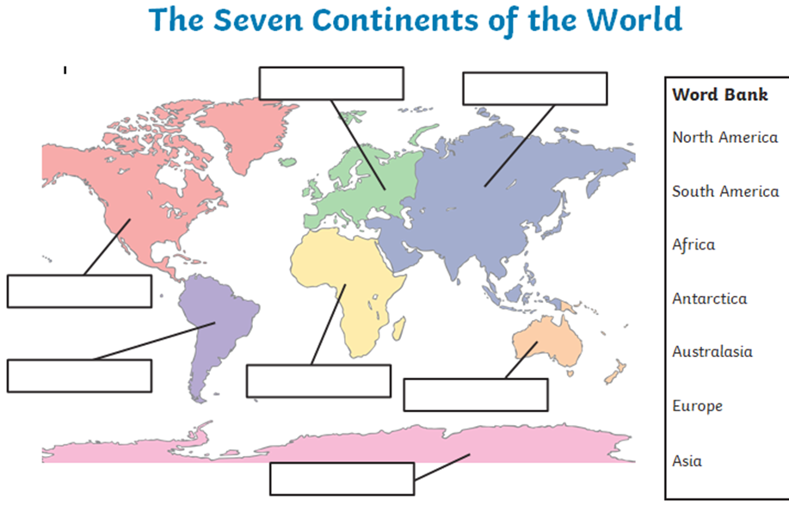 |  |  | Challenge:  If you feel you need a further challenge, try these:  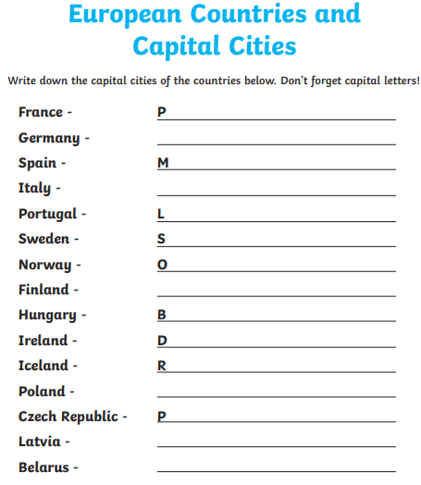

Science
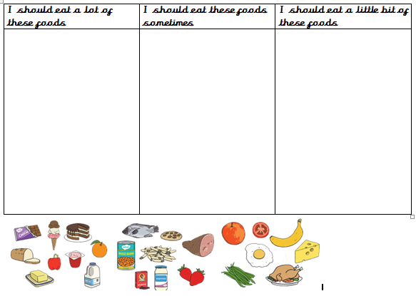

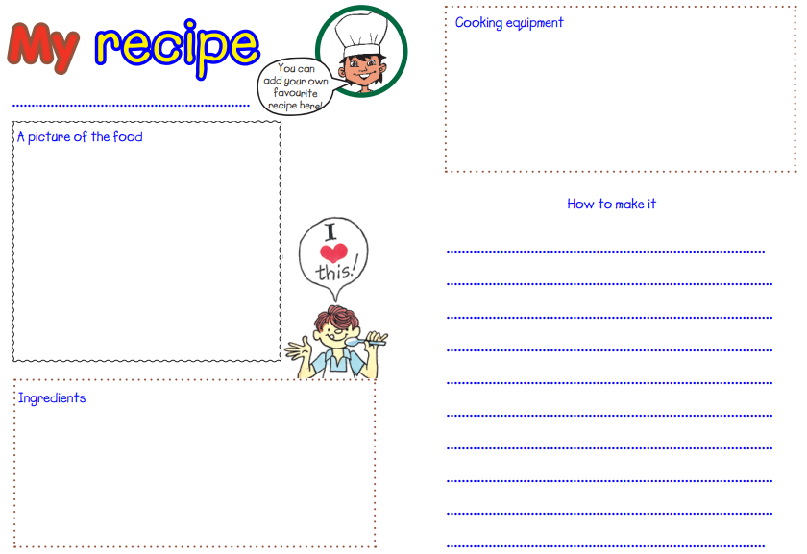
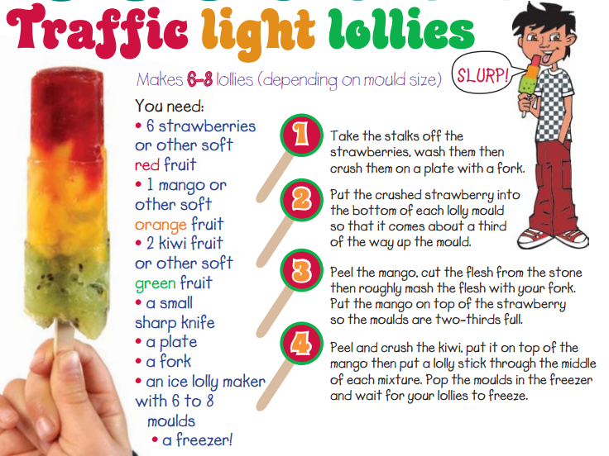

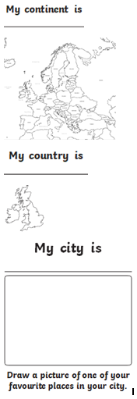
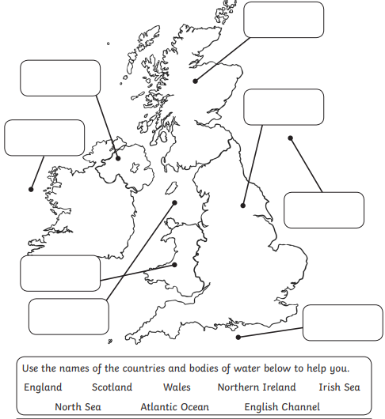
Where am I on the the map?

Other Activities
Art  What do you think is happening in the picture? Who is in the picture? What are they doing?  Thomas Benjamin Kennington  ‘The pinch of poverty’  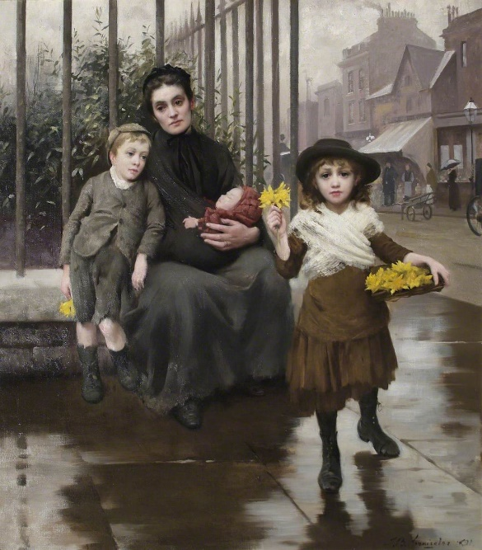 | PSHE  Write a guide for reception children all about road safety. What do you need to do and remember?  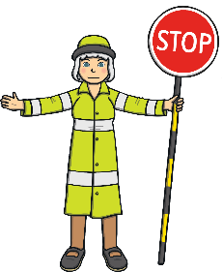 | PE  Create a sports day in your garden or house. Use things you find around the house. Your toys can take part!  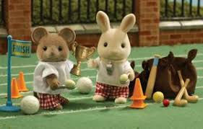 | History  What do you remember about castles?  Create a poem using the first letters:  C  A  S  T  L  E | Science  Draw a tree and label the following:  roots, branches, trunk, leaves.  Match them with what their job is:  - They turn energy into food.  - They absorb water and support the tree.  - Supports the tree.  - Takes water to the leaves.

Key skills to continue practicing weekly:
- Times Table Rock Stars – I have checked and not many of you are doing this and it is fun to do plus keeps your skills going. If you have forgotten your log on details, then just email the school.
- Oxford Owl – lots of books to read
- Telling the time throughout the day to the nearest 5 minutes
- Play shops and work out the change
- Common exception words both reading and spelling

If you are able to access the internet, try these useful websites:
- https://www.bbc.co.uk/bitesize/primary
- https://www.bbc.co.uk/bitesize/clips/z4tmhyc
- New lessons are uploaded every day for children to interact with
- https://scratch.mit.edu/
- A chance to have a go at computer programming and create your own games, all completely free.
- Plus remember to check the list of other useful websites which are under home learning on a separate sheet.
If you or your child has any further queries regarding their learning projects, please contact admin@hardwick.derby.sch.uk, clearly stating your child’s name and class teacher, and the staff will be in touch to support you and your child.
Thank you and stay safe.

