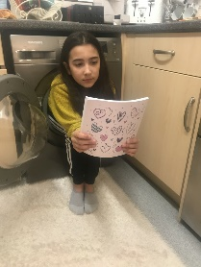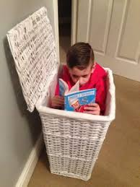

Find out where Greece is. Draw a map to show where in Europe it is. Find pictures of Greece today. What is the land like? Find out about the climate (what the weather is like), what kind of plants grow there. Why do people go on holiday there? What kind of activities can you do if you have a holiday there? What kind of food would you eat?

Pentagons have five straight sides. How many different pentagons can you draw?

Write a list of clues to describe objects, for example:

1. it is hard
2. it is transparent
3. you hold liquids in it.

Answer a glass

Write some other clues for other objects.

What time is it now? Learn to tell the time quarter past, quarter to, minutes past and minutes to. Keep a diary for the day - noting what you do at different times.

Use one of these creatures to write a story. Imagine you are a Greek hero or heroine and you have to fight it. Remember to describe the beast. Who were you trying to protect? Do you win or lose? What weapons did you have?

Woodlands website – lots of maths ideas <http://www.primaryhomeworkhelp.co.uk/maths/index.html>

15 – 46 =

Explain why you cannot work this out.

Use the internet to find out about Greek mythical creatures.

Take some photos of you reading in odd ‘extreme reading’ places.

Write a letter or email to someone in your family who you cannot go to see. Send it…I’m sure that they’ll send one back.