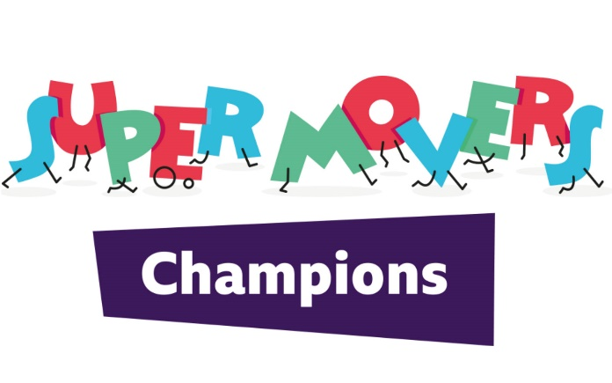
HARDWICK PRIMARY SCHOOL

Active Homes
Learning Outcome
I will learn about different ways that I or my family can get active both Indoors and outdoors.
Activities
What’s your super statue?
Step 1: Move to the music.
Step 2: When the music stops, freeze in a super statue shape that represents a physical activity or sport you like doing.
Step 3: Move again and each time the music stops try a different super statue.
See if you can identify your family’s statues.
Balloon Bonkers
Tap a balloon back and forth in pairs. When you hear ‘stop’ whoever is receiving the balloon must catch it and talk to their partner about the question posed. Then repeat.
Family Fitness Fun
Step 1: In small groups, come up with four moderate to vigorous super moves you think your family might enjoy taking part in.
Step 2: Test the movements out by trying to perform each for 30 seconds each.
An idea of a little circuit you could do at home - https://www.derbycountycommunitytrust.com/wp-content/uploads/2020/04/Family-Fitness-Circuit-1.pdf

What physical activities could you encourage your family to get involved with?
Outdoor activities
What physical activities could you encourage your family to get involved in outdoors?
• Take the dog for a walk
• Play a game or sport together
• Jump on the trampoline
• Go for a bike ride
• Others?
Indoor activities
What physical activities could you encourage your family to get involved in indoors?
• Clean the house to music
• Do physical challenges during TV adverts, e.g. star jumps
• Play active video games
• Play an active game, e.g. Musical Statues, Simon Says etc.
• Others?

Follow these links

KS1 Active Maths - https://www.bbc.co.uk/teach/supermovers/ks1-maths-collection/z6v4scw

KS1 Active Maths - https://www.bbc.co.uk/teach/supermovers/ks1-english-collection/zjsghbk
Derby County Community Trust activities - https://www.derbycountycommunitytrust.com/programmes/resource-documents/

