**WB 30.3.20** **Termly topic: Can I have a dog?**

Can you recognise the following numbers?

Can you show them on your fingers?

Follow the following link: <https://www.youtube.com/watch?v=7D4K9oi7oBM>

Ask your child to tell you about the front cover of this book:

What can you see?

How does it make you feel?

What do you think will happen next?

Practice forming the letters in your name.

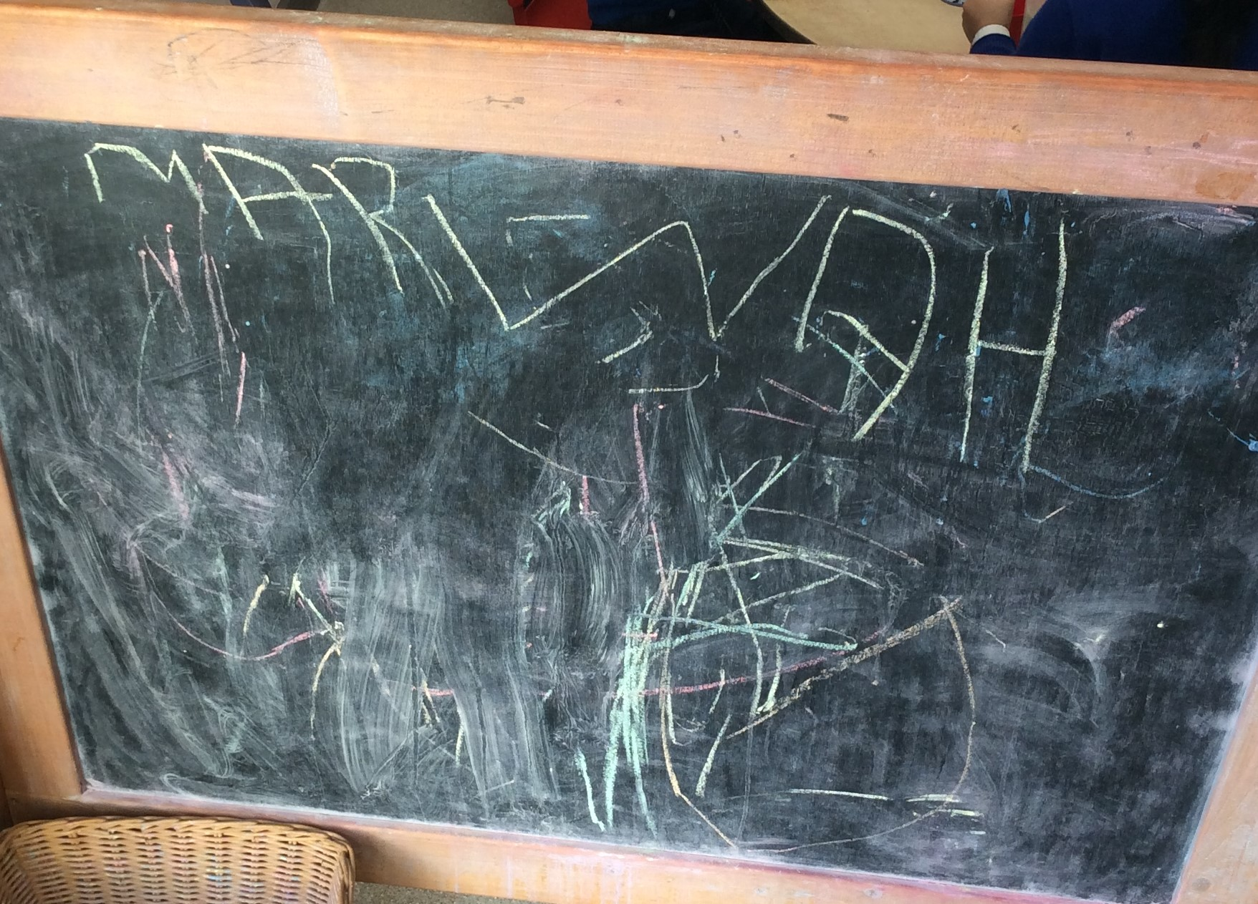

8

7

9

2

1

0

5

4

3

6

10

Develop your fine motor skills by using a knife to spread butter and jam to make a sandwich for lunch.

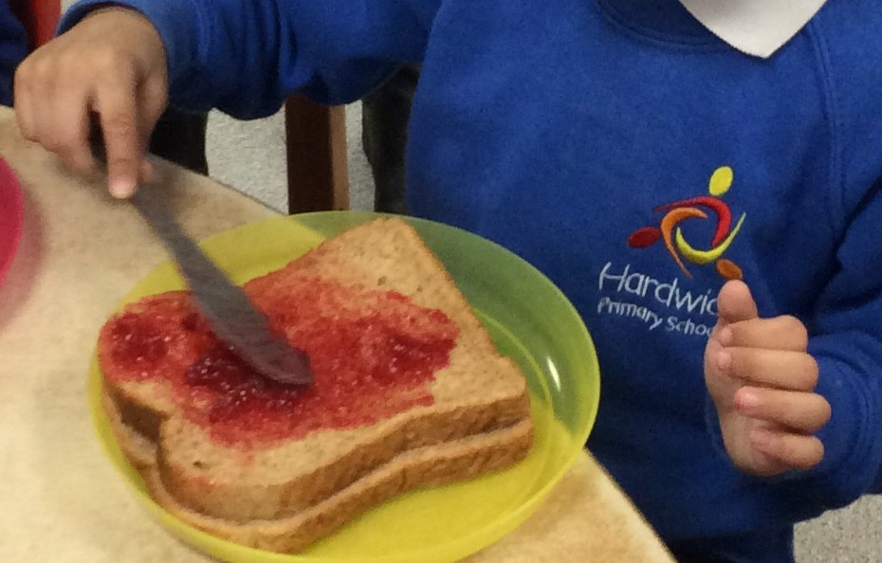

Draw or paint your favourite animal. Tell an adult all about your animal.

Follow the following link to listen to the story ‘I AM A TIGER’:

<https://www.youtube.com/watch?v=QE-ZeusK6bE>

