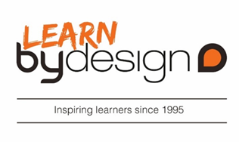

19 November 2018
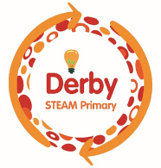
Our Ref: HP7338

Dear Parent/Guardians

We are excited to inform you that your child is going to be taking part in an exciting programme this year called ‘Fully Charged’ which is funded through the Derby Opportunity Area Grants fund.

The programme is to excite young people about Science, Technology, Engineering, Arts and Maths and will be delivered by a leading STEAM communication Company called Learn by Design.

The first part of the programme is an event being held on Friday 30th November at the Riverside Centre in Derby. At this event your child will experience a range of hands on workshops, a show and they will also visit some interactive shows to explore the concepts around Power and Energy.

We will be travelling by coach, leaving school at 9.25 am and arriving back at school at approximately 3.00 pm.

Your child will need to bring a packed lunch in on this day. Please do not send fizzy drinks or drinks in glass bottles for safety reasons. (A school packed lunch will be provided for those pupils who are entitled to free school meals.
Your child should come to school wearing their school uniform as usual.

Following the event, Learn by Design will visit Hardwick on three separate occasions to further develop the children’s understanding of STEM subjects and to develop some projects that they will display at the Big Bang STEM fair at the Derby Arena in June.

Yours sincerely

Mrs R Sandhu
Head of School

