Home Learning
Week Commencing: 29th June 2020
Teachers: Mrs Bletcher
TAs: Mrs White
Message from staff:

Hello! We hope you have been having a lovely week at home enjoying the gorgeous sunshine. It has been so hot: Remember to always wear sun cream and a hat if you are playing in the garden, and to drink lots of water to stay hydrated! We still cannot believe the end of the year is almost here but we are so proud of all of you. We cannot wait to see you all again soon (and your lovely families!) Big big hugs always, Mrs Bletcher and Mrs White xx
If you have any queries over home learning please don’t hesitate to get in touch via admin@hardwick.derby.sch.uk and we will get back to you quickly!

Your Home Learning this Week:
Every day (Monday to Friday), make sure you choose a *physical, *communication, *reading/phonics, *writing and *maths learning activity. There are also further activities to choose from should you wish to.

Physical Home Learning
Monday | Tuesday | Wednesday |  | Thursday | Friday
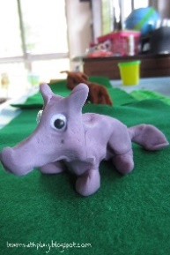  Using our playdough recipe attached, develop your fine motor skills by sculpting the wolf from Little Red Riding Hood out of playdough. | Using our playdough recipe attached, develop your fine motor skills by sculpting Little Red Riding Hood out of playdough. | Using our playdough recipe attached, develop your fine motor skills by sculpting the fruits LRRH might have in her basket out of playdough. |  | Develop your fine motor skills by fastening the buttons on your cardigan, or zip on your hoody, by yourself. | Develop your fine motor skills by dressing yourself in the morning and putting your pyjamas on at night.
Easier:  Do as many of the above activities as you can. If you are finding some of the activities challenging, try these as they are a little easier:  - Practise your toileting by not wearing a nappy, and using the toilet with a grown-up.  - Explore rolling a ball out of playdough in the palm of your hands.  - Try taking your socks off by yourself and putting them back on again.  - Try taking your jumper off by yourself. |  |  | Challenge:  If you feel you need a further challenge, try these:  - Link strips of paper together in circles to make a paper chain.  - Use scissors to cut out a picture that you have drawn.  - Make a sandwich independently for lunch, using a knife to spread filling and cut the bread.
Communication Home Learning
Monday | Tuesday | Wednesday |  | Thursday | Friday
Retell the story of our quality text Little Red Riding Hood to a grown-up using the folllowing time connectives:  First  Next  Then  Last | How do you think Little Red Riding Hood feels when she enters the woods?  Example: I think Little Red Riding Hood feels scared because she is by herself. | If you were packing the basket, what sort of delicious foods would you put in for Grandma? Why?  Example: I would put in teddy crisps for Grandma because they would make her feel better. |  | How do you think Grandma looks in the picture below? Why do you think this?  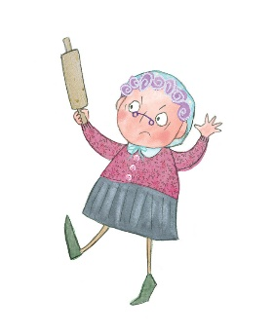 | How would you feel if the wolf knocked on your door? Why?  Example: I would feel surprised if the wolf knocked on my door because I didn’t know he was coming.
Easier:  Do as many of the above activities as you can. If you are finding some of the activities challenging, try these as they are a little easier:  - Can you find the picture of the wolf from LRRH? Say what you can see. Example: I see the wolf.  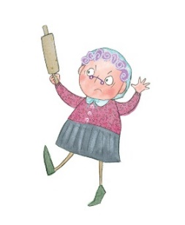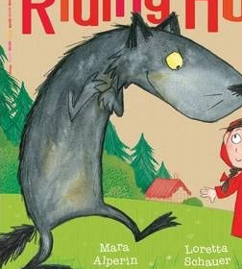 |  |  | Challenge:  If you feel you need a further challenge, try these:  - How does Grandma feel when the wolf turns up at her door? Why do you think this?  - How do you think LRRH feels when she realises it is the wolf dressed up as Grandma? Why do you think this?
Reading/Phonics Home Learning
Monday | Tuesday | Wednesday |  | Thursday | Friday
Can you think of a word that starts with the following sounds:  -S (Examples: Snake)  -A (Example: Apple)  -T (Example:  Tiger)  -P (Example: Penny)  -I (Example: Igloo)  -N (Example: Nugget)  See link below to pronounce each phoneme (unit of sound) correctly)  Remember, alliteration is when words start with the same sound. | Listening carefully to your grown up, have a go at sounding out the following CVC words we looked at last week:  a-t (at)  s-a-t (sat)  c-a-t (cat)  m-a-t (mat)  r-a-t (rat)  b-a-t (bat)  i-t (it)  s-i-t (sit)  i-p (ip)  t-i-p (tip)  sh-i-p (ship)  Can you use your fingers to count the phonemes (sounds) in the words? | Listening carefully to your grown up, have a go at sounding out the following CVC words we looked at last week:  a-p (ap)  s-a-p (sap)  m-a-p (map)  a-n (an)  p-a-n (pan)  m-a-n (man)  i-n (in)  p-i-n (pin)  b-i-n (bin)  sh-i-n (shin)  w-i-n (win)  Can you use your fingers to count the phonemes (sounds) in the words? |  | See if you can blend words by yourself by listening carefully to the instructions!  You will need a grown-up to help read out the following instructions:  Touch your t-oe-s (toes)  j-u-m-p in the air (jump)  r-u-n on the spot (run)  Go to s-l-ee-p (sleep)  Can you use your fingers to count the phonemes (sounds) in the words? | See if you can blend words by yourself by listening carefully to the instructions!  You will need a teddy and a grown-up to help read out what teddy would like to eat!  Teddy would like to eat some…  ch-ee-se (cheese)  f-i-sh (fish)  p-ie (pie)  s-ou-p (soup)  e-g-g (egg)  Can you use your fingers to count the phonemes (sounds) in the words?
Easier:  Do as many of the above activities as you can. If you are finding some of the activities challenging, try these as they are a little easier:  - Explore making sounds with your body (Example: Clapping, stomping, tapping)  - Fill a bottle with rice or pasta to make a musical shaker. Explore making quiet and loud sounds.  - Have a go at singing your favourite Nursery Rhyme by yourself. |  |  | Challenge:  If you feel you need a further challenge, try these:  - Have a go at matching a sound to its corresponding letter in the alphabet.  - Have a go at breaking words down into individual phonemes (Example: Cat to c-a-t). Can your grown up guess what you are trying to say?  - Do you recognise the following letters s, a, t, p, i, n. Can you say each sound? Can you write them down?

Writing Home Learning
Monday | Tuesday | Wednesday |  | Thursday | Friday
Retell your own story map on our quality text: Little Red Riding Hood  Below is an example of a previous story map.  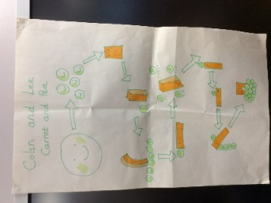 | Draw a map from Little Red Riding Hood’s house to Grandma’s house.  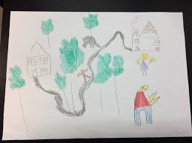 | Practise writing your full name by yourself. Can you write how old you are underneath?  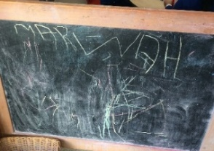 |  | Draw or paint a picture of Grandma’s house. | Create your own story map about a wolf.  Below is an example of a previous story map.
Easier:  Do as many of the above activities as you can. If you are finding some of the activities challenging, try these as they are a little easier:  - Explore drawing circles and lines when shown by a familiar adult.  - Explore drawing circles and lines in the air with your finger.  - Practise forming zigzags, crosses, spirals and circles when shown by a familiar adult.  - Have a go at forming the first letter in your name with playdough. |  |  | Challenge:  If you feel you need a further challenge, try these:  - Can you identify the initial sound and write the initial grapheme of Grandma? (G)  - Can you identify the initial sound and write the initial grapheme of Wolf? (W)  - Have a go at writing the letters of any words you have sounded out. (Example: c-a-t to cat)  - Can you find any objects in your home that start with the sounds s, a, t, p, i, n? Can you write their names down, matching sounds to letters correctly?

Maths Home Learning
Monday | Tuesday | Wednesday |  | Thursday | Friday
Do you recognise the following shapes? Can you name them correctly? Talk to your grown up about what you can see!  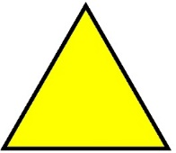 | Shape Hunt: Find three objects in your house that are circles (or spheres!) | Shape Hunt: Find three objects in your house that are squares (or cubes!) |  | Shape Hunt: Find three objects in your house that are triangles (or pyramids!) | Shape Hunt: Find three objects in your house that are rectangles (or cuboids!)
Easier:  Do as many of the above activities as you can. If you are finding some of the activities challenging, try these as they are a little easier:  - Have a go at representing 0, 1, 2, 3, 4 and 5 on your fingers.  - Sing ‘1 potato, 2 potato, 3 potato, 4, joining in with actions and vocalisations.  - Count 0-10 as rockets.  - Have a go at counting five toys by yourself.  - Have a go at recognising the numerals 0, 1 and 2 by yourself. |  |  | Challenge:  If you feel you need a further challenge, try these:  - Do you recognise the following shape? Can you count the sides? Can you find anything in your house that is the same shape?  Hexagon

Other Activities
Sing one of your favourite Nursery Rhymes every day.  Examples include:  -Wind the bobbin up  -Miss Polly had a Dolly  -Two little Dickey birds | Ask your grown-up to put on your favourite songs to dance to and join in with. | Draw a picture of what you have done at home every day. | Develop your fine motor skills by helping your grown- up make breakfast, lunch, and dinner. | Think about what your favourite thing to do at Nursery is. Draw a picture of it, tell your grown up, and then email us so we can make sure we do it when we get back!

Key skills to continue practising weekly:
- Children should be practising being independent with their toileting at home.
- Children should starting to be more independent in dressing/removing clothes themselves. Examples include: Taking their jumper off when hot, putting on shoes on, and starting to do zips and buttons
- Encouraging children to use at least four words in their sentences (Example: ‘I ate toast for breakfast’. This can be supported through modelling.

If you are able to access the internet, try these useful websites:
- Alphablocks: Alphablocks is excellent for blending CVC words!
- Letters and Sounds overview: This is what we follow in Phonics!
- Singing Hands: Singing hands are fantastic at providing Makaton actions for familiar Nursery Rhymes!
- Youtube ‘Little Red Riding Hood by Mara Alperin’ to watch a great animated version of our quality text.

If you or your child has any further queries regarding their learning projects, please contact admin@hardwick.derby.sch.uk, clearly stating your child’s name and class teacher, and the staff will be in touch to support you and your child.

Thank you and stay safe.

